MINISTRY OF EDUCATION, CULTURE AND RESEARCH
OF THE REPUBLIC OF MOLDOVA
Technical University of Moldova
Faculty of Computers, Informatics and Microelectronics
Department of Software Engineering and Automation

Done by: st. gr. FAF-242, Temciuc Adelina

Report
on laboratory work no. 4
Operating Systems
Topic: The xv6 Shell from the Outside

Checked by:
Reiţman Patricia, university assistant
DISA, FCIM, UTM

Chișinău – 2026
AIM OF THE WORK
Purpose of the laboratory work
The purpose of this laboratory work is to understand, by experiment, what a command shell must do and what a full shell such as bash adds on top of that minimum. The xv6 shell (user/sh.c, about 500 lines) is used side by side with bash, and a small program that prints its own arguments shows which part of the system expands *, removes quotes and splits the command line into words.
The laboratory work aims to:
- update the sleep program from Lab 2 for the current xv6, where the system call sleep() was renamed to pause();
- run the same command lines in bash and in the xv6 shell and compare redirection, pipes, grouping, sequences, background jobs, globbing, variables, quotes, PATH and history;
- write a program that prints argc and argv for xv6 and for Linux and use it to find out who expands * and removes quotes;
- read the source code of the xv6 shell and find the command kinds it knows, where each kind is executed and how cd is handled.
THEORETICAL BACKGROUND
The shell as an ordinary user program
A shell is not part of the kernel. It is an ordinary user program that reads a line, splits it into words, recognises special characters and then asks the kernel to create processes with fork() and to load programs with exec(). Everything the user sees as "the command line" (pipes, redirection, variables, wildcards) is implemented by the shell itself on top of a few system calls: fork, exec, wait, open, close, dup, pipe and chdir.
The xv6 shell
In xv6 the whole user interface is the program user/sh.c. It parses a line into a tree of commands of five kinds: simple commands (EXEC), redirections (REDIR), pipes (PIPE), lists separated by ; (LIST) and background commands (BACK); parentheses group commands into a block. The tree is executed by the recursive function runcmd() in a child process. The xv6 shell has no variables, no wildcards, no quote handling, no search path and no history.
Arguments, argv and exec
A program receives its command line as an array of strings, argv, with argc elements; argv[0] is the name the program was started with. The kernel does not interpret these strings: exec(path, argv) only copies them onto the stack of the new program. Any transformation of the line (wildcard expansion, variable substitution, quote removal, word splitting) must therefore happen in the shell before exec is called.
Built-in commands
Some commands cannot be separate programs because they must change the state of the shell process itself. The most important one is cd: the current directory is a property of a process, so if cd ran in a child process only the child would change directory and the change would be lost when the child exits.
PART 1. FIX SLEEP FOR THE CURRENT XV6
All the work for this laboratory was done on my current laptop, Fedora Linux 44, as my own user adelina, with the xv6 tree in ~/xv6-riscv; all the figures in this report were taken there, in the Ptyxis terminal.
1.1 Which name does the tree use
In August 2025 the xv6 authors renamed the system call sleep() to pause(). To find out which name the local tree uses, the declaration was searched for in user/user.h:
cd ~/xv6-riscv
grep -n "pause\|sleep" user/user.h
The output was 25:int pause(int);, so the tree is a current one: only pause is declared and the old call sleep() from Lab 2 no longer compiles.
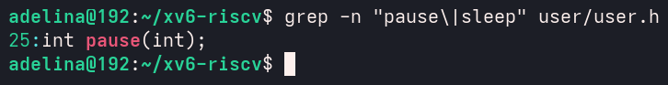
Figure 1.1 – The grep result in user.h
1.2 The updated sleep.c
The call in user/sleep.c was changed from sleep() to pause(). The program checks that exactly one argument was given, prints a usage message to standard error (file descriptor 2) otherwise and exits with status 1:
#include "kernel/types.h"
#include "user/user.h"

int
main(int argc, char *argv[])
{
if(argc != 2){
fprintf(2, "usage: sleep <ticks>\n");
exit(1);
}
pause(atoi(argv[1])); // was sleep() before Aug 2025
exit(0);
}
The line $U/_sleep\ was added to UPROGS in the Makefile, directly after $U/_sync\, starting with a TAB and with nothing after the backslash (line 154 in Figure 1.2).
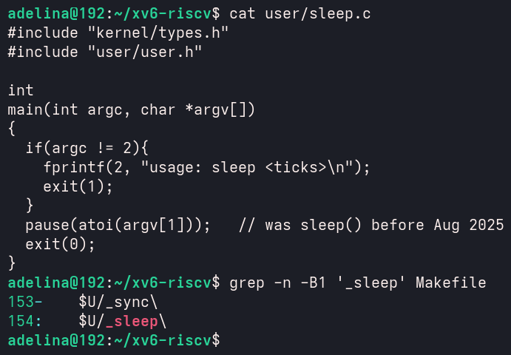
Figure 1.2 – The updated sleep.c and the UPROGS line
1.3 Build, boot and test
xv6 was built and started with make qemu. At the $ prompt, sleep 20 paused the shell for 20 ticks (about two seconds) and then the prompt returned; sleep without an argument printed the usage message. QEMU was left with Ctrl-A X, which prints QEMU: Terminated.
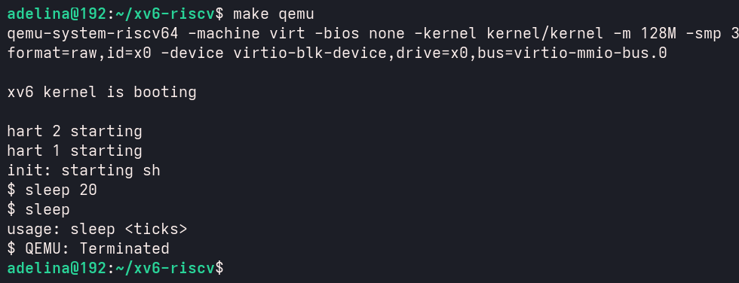
Figure 1.3 – sleep running in xv6, with and without an argument
PART 2. BASH VERSUS THE XV6 SHELL
2.1 Running the commands in both shells
Every command from the table was run twice: once in bash, in an empty test folder that contains only the file README (mkdir ~/shtest && cd ~/shtest && touch README), and once at the xv6 $ prompt after make qemu. The results are summarised in table 2.1.
Table 2.1 – The same commands in bash and in the xv6 shell
Command | Tests | bash | xv6 | Why
echo hello > f ; cat < f | redirection | hello | hello | Both shells open the file and connect it to stdout or stdin before exec.
ls | grep READ | pipe | README | README 2 2 2441 | Both create a pipe; xv6 ls also prints type, inode and size.
(echo a; echo b) | wc | grouping, list | 2 2 4 | 2 2 4 | Both support ( ) and ;. Only the spacing of wc differs.
echo one ; echo two | sequence | one  two | one  two | Both run the commands one after another.
echo bg & | background | [1] 53770  bg  [1]+ Done | bg | Both run it without waiting; only bash has job control, so only bash prints the job number and "Done".
ls * | globbing | f README | ls: cannot open * | bash replaces * with the file names; xv6 passes the character * to ls unchanged.
echo $HOME | variables | /home/adelina | $HOME | xv6 has no variables, so $HOME is an ordinary word.
echo "a b" | quotes | a b | "a b" | bash removes the quotes and keeps one word; xv6 keeps the quotes and splits the text into two words.
mkdir d ; cd d ; ls .. | PATH | d f README | exec cd failed, then the listing of / | xv6 treats cd as a built-in only at the start of a line; here it tries to exec a program cd, which does not exist.
arrow up, Tab, Ctrl+R | history, completion | recalls, completes and searches commands | exec ^[[A failed | xv6 has no line editor, history or completion; the escape code of the arrow is run as a command name.

In bash (Figure 2.1), Tab completed ls ../RE to ls ../README, the up arrow recalled that command again, and Ctrl+R opened the reverse history search: after typing echo o it found echo one ; echo two, as shown in the last line of the figure.
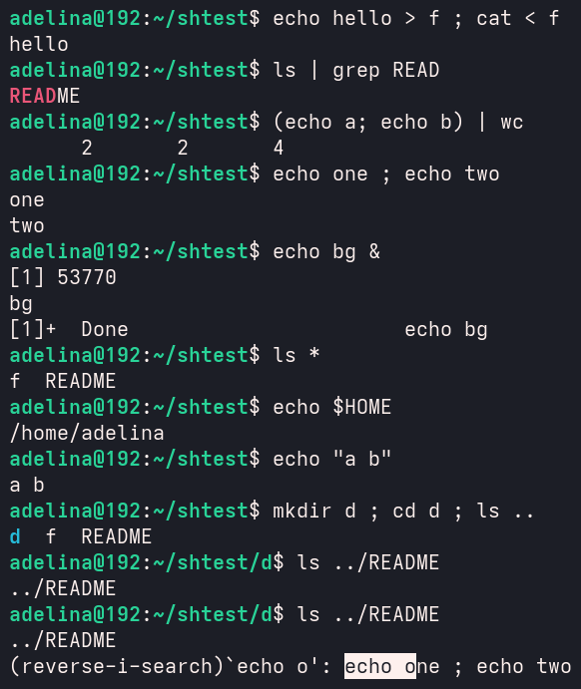
Figure 2.1 – The commands run in bash
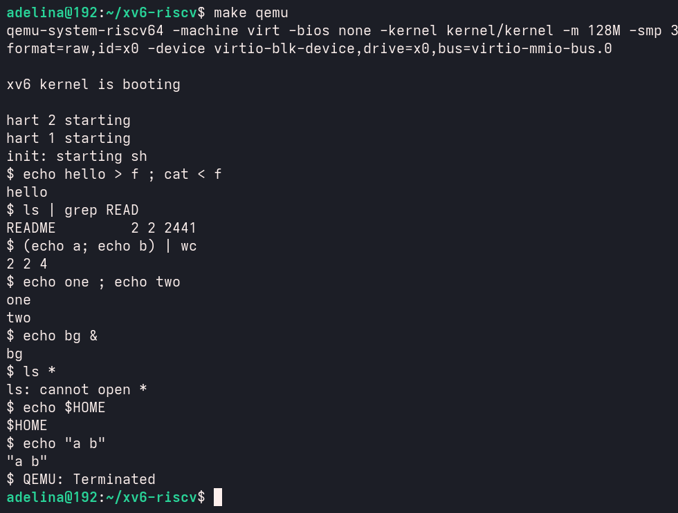
Figure 2.2 – The same commands run in xv6
Figure 2.3 shows the second part of the xv6 run (after a new make qemu; the file system image keeps the file f from the first run). Because cd was not at the beginning of the line, xv6 printed exec cd failed, stayed in / and ls .. listed the root directory, where the programs sleep and args, the new file f (6 bytes, "hello" and a newline) and the new empty directory d (32 bytes, the entries . and ..) appear.
Then the keys up arrow, Tab and Ctrl+R were pressed, followed by Enter. The xv6 console has no line editor, so it simply echoes the characters it receives. The up arrow is the escape sequence ESC [ A; when it is echoed, the terminal itself executes it and moves the cursor one line up, so the following text overwrote the end of the line of d. The shell then took ESC [ A as a program name and printed exec ^[[A failed, which is the word "failed" that appears in that line of the figure.
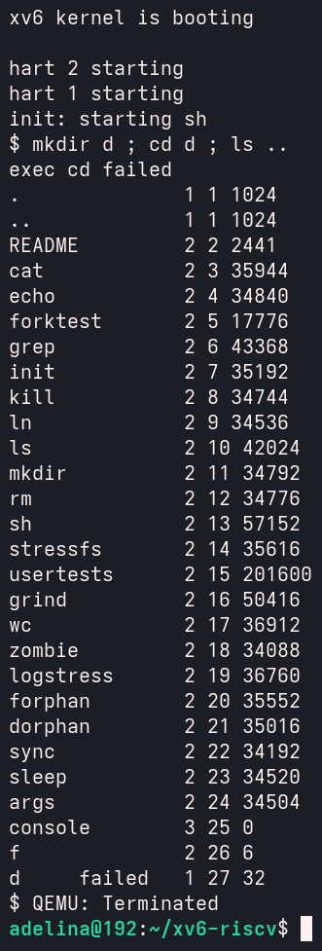
Figure 2.3 – ls .. after the failed cd, and the history keys in xv6
In a third run, cd d was typed alone on a line, so the built-in worked, and ls was tried inside d. It failed with exec ls failed. Giving the path of the program, /ls or ../ls, made it work and listed the two entries of d.
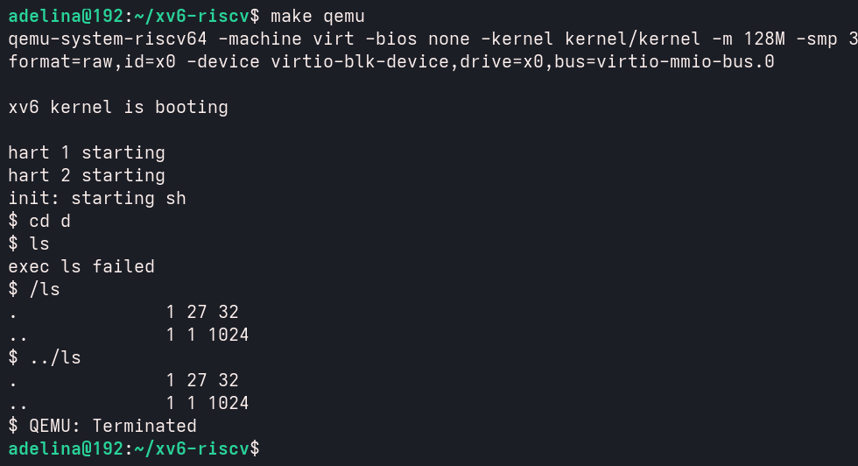
Figure 2.4 – ls failing after cd d, and the working alternative
2.2 Answers to the questions
1. Which features do both shells have, and which ones only bash has?
Both shells can run programs with arguments, redirect input and output with <, > and >>, connect commands with pipes |, run sequences with ;, group commands with parentheses, start commands in the background with & and change the directory with the built-in cd.
Only bash has wildcards (globbing), variables and $ expansion, quote removal, a search path (PATH), job control (job numbers, jobs, fg, "Done" messages), && and ||, command history, Tab completion and history search, and a full scripting language with if, for and functions.
2. Why does ls stop working after cd d, and how can it be run anyway?
The xv6 programs live in the root directory /, and the xv6 shell has no PATH: it calls exec with exactly the name that was typed. exec("ls") is a relative path, so the kernel looks for ls in the current directory. In / it is found, but in /d there is no file ls, so exec fails. The program can still be run by giving its location: /ls (absolute path) or ../ls (relative path), as shown in Figure 2.4.
3. Which missing feature would you miss most, and which would be easiest to add?
In daily work I would miss history and Tab completion the most, because they save a lot of typing, together with wildcards. The easiest feature to add is a simple PATH: if exec(argv[0]) fails and the name does not contain a /, the shell can try again with "/" in front of the name. That is only a few lines in the EXEC case of runcmd() and would fix the ls problem from question 2.
PART 3. WHO EXPANDS *? A PROGRAM THAT PRINTS ITS ARGV
3.1 The args program for xv6
The program user/args.c prints the number of arguments and every argument between square brackets, so that spaces and quotes inside an argument are visible. The line $U/_args\ was added to UPROGS after $U/_sleep\.
#include "kernel/types.h"
#include "user/user.h"

int
main(int argc, char *argv[])
{
printf("argc = %d\n", argc);
for(int i = 0; i < argc; i++)
printf("argv[%d] = [%s]\n", i, argv[i]);
exit(0);
}
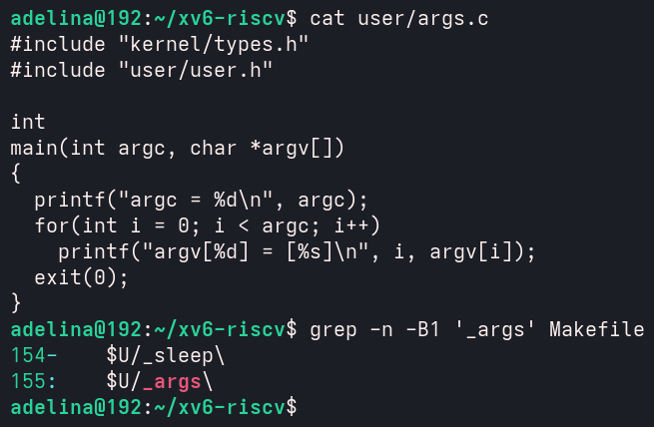
Figure 3.1 – args.c and the UPROGS line
3.2 The same program for Linux
For Linux, the file args_linux.c includes <stdio.h> instead of the two xv6 headers and ends with return 0 instead of exit(0). It was compiled with gcc -o args args_linux.c in the folder ~/lab4, which also contains the files args.c, args_linux.c and sleep.c.
#include <stdio.h>

int
main(int argc, char *argv[])
{
printf("argc = %d\n", argc);
for(int i = 0; i < argc; i++)
printf("argv[%d] = [%s]\n", i, argv[i]);
return 0;
}
3.3 Running the same lines in both shells
The following lines were run in xv6 and, with ./args, in bash:
args one two three
args *.c "x y"
args $HOME
args 'single quoted'
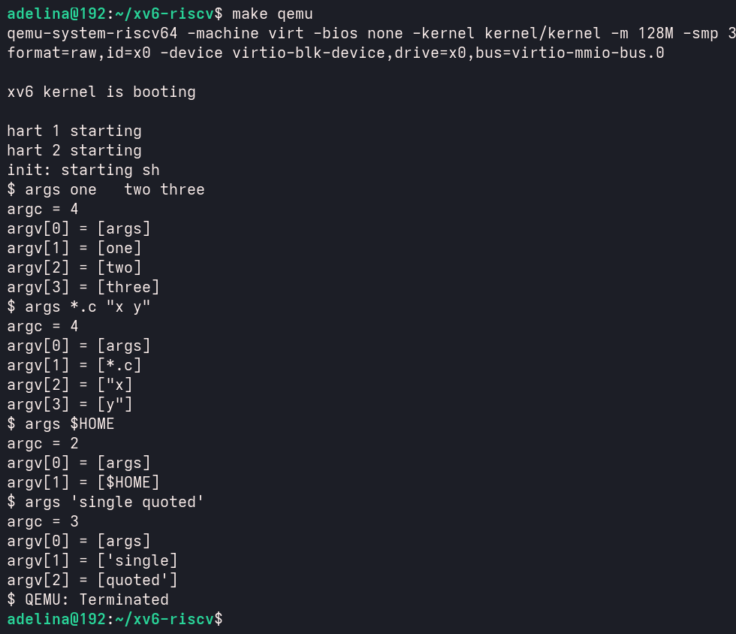
Figure 3.2 – args output in xv6
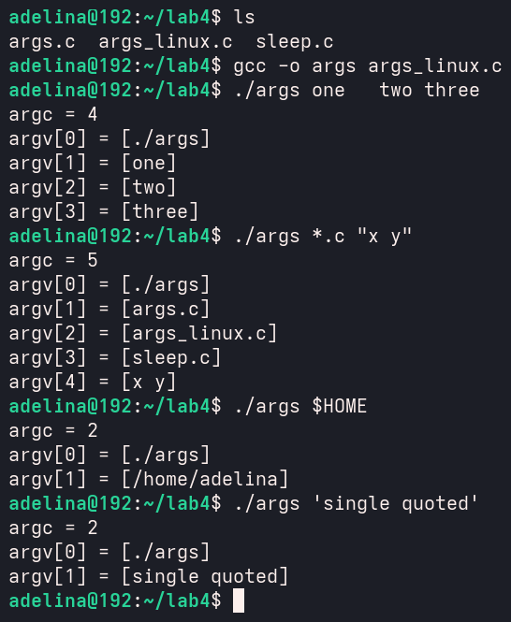
Figure 3.3 – args_linux output in bash
3.4 Answers to the questions
1. Both outputs for args *.c "x y". How many arguments did each program receive?
In xv6:
argc = 4
argv[0] = [args]
argv[1] = [*.c]
argv[2] = ["x]
argv[3] = [y"]
In bash:
argc = 5
argv[0] = [./args]
argv[1] = [args.c]
argv[2] = [args_linux.c]
argv[3] = [sleep.c]
argv[4] = [x y]
In xv6 the program received 4 arguments: *.c unchanged, and "x and y" as two separate words with the quote characters still in them. In bash it received 5 arguments: the three .c files of the folder instead of *.c, and x y as one argument, without quotes.
2. Who turns *.c into file names and removes the quotes?
The shell. The program is the same in both cases and only prints what it receives, and the kernel only copies the argv array given to exec. The difference comes only from the shell: bash expands *.c, substitutes $HOME (it printed /home/adelina) and removes quotes before calling exec, while the xv6 shell does none of this, so the program sees the raw words ($HOME, 'single and quoted').
3. What happened to the extra spaces in one two three?
They disappeared in both shells. The shell uses spaces only as separators between words, so any number of spaces between two words produces just one boundary, and the program received exactly three arguments: one, two and three. To keep the spaces they must be quoted in bash ("one two"); in xv6 this is impossible, because it does not handle quotes.
PART 4. READ THE SHELL
4.1 Commands executed
Inside ~/xv6-riscv the following commands were run:
wc -l user/sh.c
grep -n "#define" user/sh.c # the kinds of commands
grep -n "case " user/sh.c # where each kind is run
grep -n "cd" user/sh.c | head
The file user/sh.c has 499 lines. Lines 8–12 define the five command kinds.
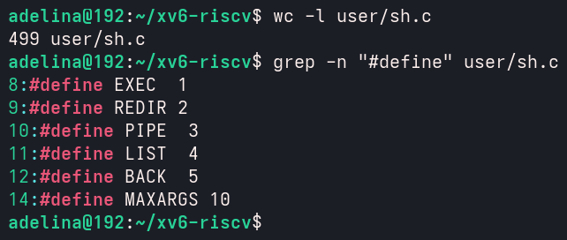
Figure 4.1 – The command kinds defined in sh.c
The cases on lines 75–125 are in runcmd(), which executes each kind. Lines 284–294 are in gettoken(), which recognises the special characters, and lines 469–493 are in nulterminate(), which finishes the parsed tree.
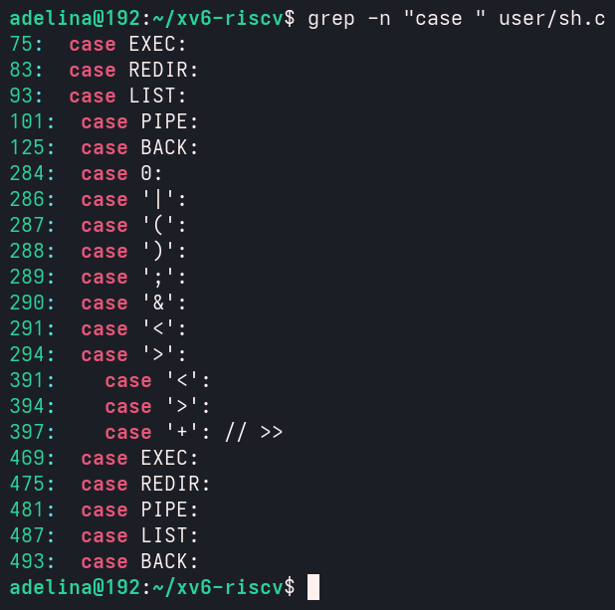
Figure 4.2 – Where each kind is run
grep -n "cd" finds only the error message on line 170, because the code tests the characters c and d separately. Searching for chdir shows the whole block in main().
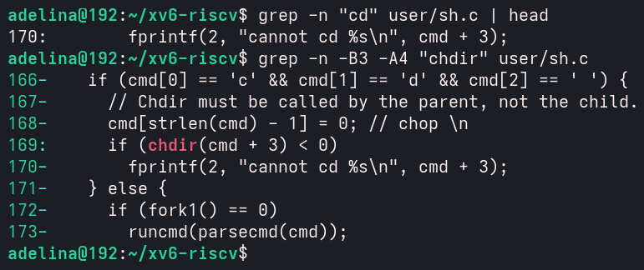
Figure 4.3 – The code that handles cd
Finally, sh.c was searched for any code that handles * or $, that is for the character constants '*' and '$'. Both searches found nothing (grep exit code 1); the only special characters the shell knows are listed in the arrays whitespace and symbols on lines 268–269.
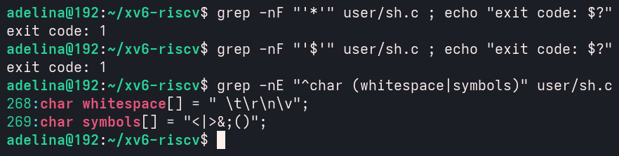
Figure 4.4 – No code for * or $ in sh.c
4.2 Answers to the questions
1. The five kinds of command and the character that produces each
- EXEC (1) – a simple command, a program name with its arguments; it needs no special character;
- REDIR (2) – redirection, produced by <, > or >>;
- PIPE (3) – a pipe, produced by |;
- LIST (4) – a sequence, produced by ;;
- BACK (5) – a background command, produced by &.
Parentheses ( ) only group commands into a block; they do not create a sixth kind.
2. Where is cd handled, and why is it not run as a separate program?
cd is handled in main(), on lines 166–170, before the shell forks: if the line starts with the characters c, d and a space, the shell calls chdir(cmd + 3) itself and prints cannot cd if it fails. It is not a separate program because every other command runs in a child process created by fork(). A child that called chdir would change only its own current directory, and the change would be lost when the child exits, so the shell would stay where it was. The comment in the code says it directly: "Chdir must be called by the parent, not the child". This is also why cd in the middle of mkdir d ; cd d ; ls .. failed: there it is parsed as a normal EXEC command.
3. Is there any code that handles * or $? What does that explain about Part 2?
No. The tokenizer only knows the whitespace characters " \t\r\n\v" and the symbols <|>&;(); there is no code for *, $, quotes or PATH. Every other character is just part of a word. This explains the results of Part 2 and Part 3: ls * passed the character * to ls, echo $HOME printed $HOME, echo "a b" kept the quotes and split the text into two words, and ls could not be found outside /.
CONCLUSION
In this laboratory work the xv6 shell was studied from the outside, by using it side by side with bash and by reading its source code.
In the first part, the sleep program from Lab 2 was updated for the current xv6, where the system call is called pause(). After adding it to UPROGS it built and worked: sleep 20 paused the shell and sleep without an argument printed the usage message.
In the second part, the same commands were run in both shells. Both support redirection, pipes, grouping, sequences, background commands and cd, which are exactly the features that need only fork, exec, pipe, dup and chdir. Everything that is about text processing of the command line (wildcards, variables, quotes, PATH, history and completion) exists only in bash. The xv6 shell also showed that cd is a built-in only at the beginning of a line, and that without PATH a program in / must be called with its full path from any other directory.
In the third part, the args program proved that the program and the kernel do not change the arguments: for args *.c "x y" the xv6 program received 4 raw words, while the bash version received 5 arguments with the file names expanded and the quotes removed. The shell alone is responsible for expansion, quote removal and word splitting.
In the fourth part, reading user/sh.c (499 lines) showed the five command kinds EXEC, REDIR, PIPE, LIST and BACK, the function runcmd() that executes them, the special handling of cd in the parent process and the absence of any code for * or $, which explains all the differences observed in Part 2.
REFERENCES
- Cox R., Kaashoek F., Morris R. xv6: a simple, Unix-like teaching operating system. MIT, 2024. [online]. Available: https://pdos.csail.mit.edu/6.1810/2024/xv6/book-riscv-rev4.pdf
- mit-pdos/xv6-riscv – source code. [online]. Available: https://github.com/mit-pdos/xv6-riscv
- bash(1) – Linux manual page. [online]. Available: https://man7.org/linux/man-pages/man1/bash.1.html
- GNU Bash Reference Manual. Free Software Foundation. [online]. Available: https://www.gnu.org/software/bash/manual/bash.html

