MINISTRY OF EDUCATION, CULTURE AND RESEARCH
OF THE REPUBLIC OF MOLDOVA
Technical University of Moldova
Faculty of Computers, Informatics and Microelectronics
Department of Software Engineering and Automation

Done by: st. gr. FAF-242, Temciuc Adelina

Report
on laboratory works no. 7 and 8
Operating Systems
Topic: Processes, Redirection and Pipes on Linux and in xv6

Checked by:
Reiţman Patricia, university assistant
DISA, FCIM, UTM

Chișinău – 2026
AIM OF THE WORK
Purpose of the laboratory work
The purpose of these two laboratory works is to see how a process is born, where a program writes its output and how two programs are connected with a pipe. In Lab 7 this was done on a real Linux system with three short C programs that repeat what the shell does for ls -l, ls -l > out.txt and ls /etc | wc -l. In Lab 8 the same system calls were used inside xv6, the small teaching operating system, to show that they are the same, and two processes were made to talk through pipes.
The laboratory works aim to:
- run the three steps of the shell (fork, exec, wait) and see what happens when exec fails;
- create a zombie process on purpose and see how wait removes it;
- redirect the output of ls into a file by changing file descriptor 1 before exec;
- build the pipeline ls /etc | wc -l by hand with pipe, fork and dup, and see why the unused pipe ends must be closed;
- run the same fork/exec/wait program inside xv6 and write the program pingpong, which sends one byte forth and back between two processes.
THEORETICAL BACKGROUND
Creating a process: fork, exec, wait
On Unix-like systems a new program is started in three steps. fork() makes an almost exact copy of the calling process. It returns twice: 0 in the child and the PID of the child in the parent, or -1 on error. A function from the exec family (here execlp on Linux and exec in xv6) replaces the program of the current process with a new one; the PID stays the same, but the code, the data and the stack are new. If exec succeeds it never returns, so the code after it runs only when exec failed. Finally wait() or waitpid() makes the parent sleep until the child ends and gives it the exit status of the child.
Zombie processes
When a process ends, the kernel keeps a small entry for it in the process table (its PID and its exit status) until the parent reads this status with wait. A process that has ended but was not yet waited for is called a zombie; ps shows it with the letter Z and the mark <defunct>. If the parent ends without waiting, the child is adopted by the process with PID 1, which waits for it.
File descriptors and redirection
Every process has a table of open files, and a program uses them through small numbers called file descriptors: 0 is the standard input, 1 the standard output and 2 the standard error. Programs like ls simply write to descriptor 1 and do not know whether it is the terminal, a file or a pipe. open() and dup() always return the smallest free descriptor number, and the table of descriptors is kept by exec. Because of this, the shell can redirect the output of a program by closing descriptor 1 in the child and opening a file before exec.
Pipes
pipe(p) creates a buffer in the kernel with two ends: p[0] for reading and p[1] for writing. The data goes only in one direction. After fork both processes have both ends, so the writer moves p[1] to its descriptor 1 and the reader moves p[0] to its descriptor 0, and every process closes the ends it does not use. read() on an empty pipe blocks until some data comes, and it returns 0 (end of file) only when all the write ends of the pipe are closed.
xv6
xv6 is a small Unix-like teaching operating system for RISC-V, written at MIT. It runs inside the QEMU emulator and has no C library such as glibc: user programs call the system calls of the kernel directly (fork, exec, wait, pipe, read, write and others). A new user program is a file user/NAME.c plus a line $U/_NAME\ in the UPROGS list of the Makefile.
PART 1. FORK + EXEC + WAIT (LAB 7)
1.1 The program run.c
The work for Lab 7 was done on Fedora Linux 44 in the folder os-lab7, with gcc 16.2.1. The program run.c does what the shell does for the command ls -l: it copies itself with fork, the copy becomes ls with execlp, and the original waits for it with waitpid.
#include <stdio.h>
#include <stdlib.h>
#include <unistd.h>
#include <sys/wait.h>

/* the three steps of the shell for the command: ls -l */
int main(void)
{
printf("parent: my PID is %d\n", getpid());
fflush(stdout);

pid_t pid = fork(); /* step 1: copy myself */
if (pid < 0) { perror("fork"); return 1; }

if (pid == 0) { /* only the child runs this */
printf("child: my PID is %d, my parent is %d\n", getpid(), getppid());
fflush(stdout);
execlp("ls", "ls", "-l", (char *)NULL); /* step 2: become ls */
perror("exec"); /* runs only if exec failed */
exit(127);
}

int status;
waitpid(pid, &status, 0); /* step 3: wait for the child */
printf("parent: child %d ended with status %d\n", pid, WEXITSTATUS(status));
return 0;
}
1.2 Running the program
The program was compiled with gcc -Wall -Wextra without any warnings and run. First the parent prints its PID, then the child prints its PID and the PID of its parent, then ls -l prints the listing, and at the end the parent prints the exit status of the child.
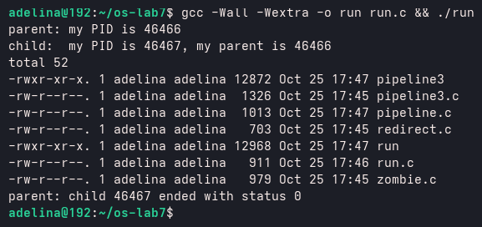
Figure 1.1 – run.c with the child running ls -l
After that, the execlp line was changed so that the child runs date, and then a program that does not exist:
execlp("date", "date", (char *)NULL);
execlp("nosuchprog", "nosuchprog", (char *)NULL);
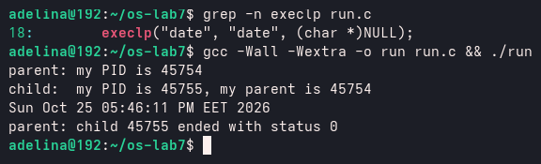
Figure 1.2 – run.c with the child running date
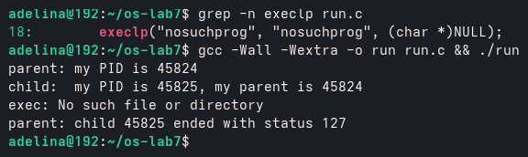
Figure 1.3 – run.c with a program that does not exist
1.3 Answers to the questions
1. Why is perror("exec") printed only with nosuchprog?
When execlp succeeds, the code of run in the child is replaced by the code of ls or date, so the lines after execlp do not exist any more and are never reached. With nosuchprog the program cannot be found, execlp returns -1, and the child continues with the next line, perror("exec"), which prints exec: No such file or directory.
2. Which number does the child print as "my parent", and whose PID is it?
The child prints 46466 (Figure 1.1). It is the PID of the parent, the ./run process, which printed the same number in the first line.
3. What status does the parent see with ls, and what status with nosuchprog?
With ls the status is 0, because ls ended successfully. With nosuchprog the status is 127, because after the failed exec the child calls exit(127).
PART 2. A ZOMBIE, ON PURPOSE (LAB 7)
2.1 The program zombie.c
zombie.c is a copy of the original run.c (the version with ls) with only one new line: the parent sleeps 20 seconds before waitpid. The child ends almost at once, but nobody takes its exit status for 20 seconds.
int status;
sleep(20); /* the new line */
waitpid(pid, &status, 0); /* step 3: wait for the child */
2.2 Commands executed
The program was started in the background with its output sent to /dev/null, and the process table of the terminal was shown after 2 seconds and again after 20 more seconds. The figure shows the shell (bash), ps itself, zombie and its child ls; at the end bash also reports that the background job is Done.
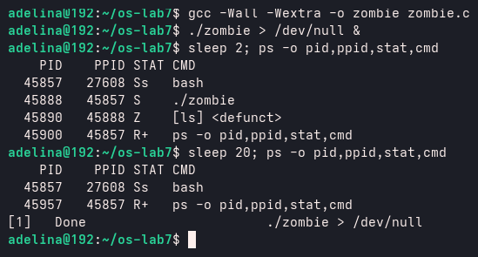
Figure 2.1 – The zombie child of zombie.c, and the process table 20 seconds later
2.3 Answers to the questions
1. Which letter does ls have in the STAT column, and what does it mean?
ls has the letter Z, which means zombie. It is also marked [ls] <defunct>: the process has already ended, but it stays in the process table because its parent (PID 45888) has not called wait yet.
2. After 20 seconds, is the [ls] <defunct> line still there? Which line made it disappear?
No, the line is gone, and ./zombie itself has ended too. The line waitpid(pid, &status, 0); made it disappear: the parent read the exit status of the child, and then the kernel removed the child from the process table.
PART 3. REDIRECTION: LS -L > OUT.TXT (LAB 7)
3.1 The program redirect.c
redirect.c does what the shell does for ls -l > out.txt. In the child it closes descriptor 1, opens the file out.txt, prints to the standard error which number it got, and then runs ls -l. The important part is the child:
if (pid == 0) {
close(1); /* descriptor 1 is now free */
int fd = open("out.txt", O_WRONLY | O_CREAT | O_TRUNC, 0644);
if (fd < 0) { perror("open"); exit(1); }
fprintf(stderr, "open gave descriptor %d\n", fd);
execlp("ls", "ls", "-l", (char *)NULL); /* ls writes to 1, as always */
perror("exec");
exit(127);
}
3.2 Commands executed
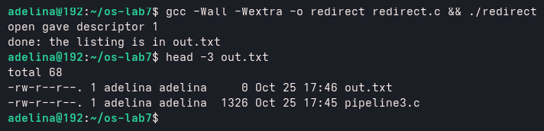
Figure 3.1 – redirect.c and the first lines of out.txt
Nothing from ls appeared on the screen. The listing is in out.txt, and out.txt itself is in the listing with size 0, because it was created by open before ls started to write in it.
3.3 Answers to the questions
1. Which number did open give, and why exactly that one?
open gave descriptor 1. It always returns the smallest free number; descriptor 0 (standard input) was still open, and 1 had just been closed, so 1 was the smallest free one.
2. ls was not changed at all. Why does its listing not appear on the screen?
ls always writes to descriptor 1. The descriptors are kept by exec, and in the child descriptor 1 now points to out.txt instead of the terminal, so the whole listing goes into the file.
3. To redirect the errors instead (like 2> err.txt), which descriptor would you close before open?
Descriptor 2, the standard error. Then open would return 2 and all the error messages would go into the file.
PART 4. A PIPE: LS /ETC | WC -L (LAB 7)
4.1 The program pipeline.c
pipeline.c builds the pipeline by hand with one pipe and two children. In the ls child descriptor 1 becomes the write end p[1], and in the wc child descriptor 0 becomes the read end p[0]. dup copies a descriptor into the smallest free number, the same way as open. Every process closes the pipe ends it does not use.
#include <stdio.h>
#include <stdlib.h>
#include <unistd.h>
#include <sys/wait.h>

/* does the same as the shell command: ls /etc | wc -l */
int main(void)
{
int p[2];
if (pipe(p) < 0) { perror("pipe"); return 1; }

if (fork() == 0) { /* ls: its 1 becomes p[1] */
close(1);
dup(p[1]); /* smallest free number: 1 */
close(p[0]);
close(p[1]);
execlp("ls", "ls", "/etc", (char *)NULL);
perror("exec ls");
exit(127);
}

if (fork() == 0) { /* wc: its 0 becomes p[0] */
close(0);
dup(p[0]); /* smallest free number: 0 */
close(p[0]);
close(p[1]);
execlp("wc", "wc", "-l", (char *)NULL);
perror("exec wc");
exit(127);
}

close(p[0]); /* the parent uses neither end */
close(p[1]);
wait(NULL);
wait(NULL);
return 0;
}
4.2 Commands executed
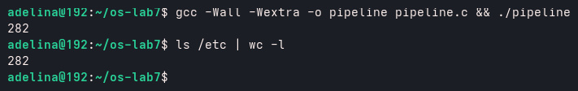
Figure 4.1 – pipeline.c compared with the real shell
Then the line close(p[1]); in the parent was turned into a comment, so the parent kept the write end of the pipe open:
close(p[0]); /* the parent uses neither end */
/* close(p[1]); */
After this change the program did not print anything and did not end. While it was hanging, the list of its children showed that only wc -l was still alive; ls had already ended and was waited for. Then the parent ./pipeline was stopped with kill -INT, which sends the SIGINT signal, the same signal that Ctrl-C sends. As soon as the parent died, the kernel closed its copy of p[1]; that was the last open write end of the pipe, so wc finally received end of file, printed 282 and ended. This confirms the answer to question 3 below.
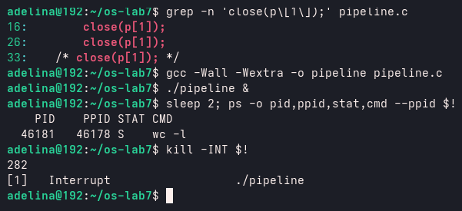
Figure 4.2 – With p[1] open in the parent, only wc is left and never ends
4.3 Answers to the questions
1. Did ./pipeline and ls /etc | wc -l give the same number?
Yes, both printed 282 (Figure 4.1).
2. After the change, which of the two children never ends, ls or wc?
wc never ends. ls writes its listing into the pipe and ends normally.
3. Why: what is wc waiting for?
wc reads until end of file, and a pipe gives end of file only when all its write ends are closed, but the parent still keeps p[1] open, so wc waits forever.
4.4 Optional: three stages
The optional program pipeline3.c builds ls /usr/bin | grep x | wc -l with two pipes and three children. Every child closes all four pipe ends after its dup, and so does the parent. It printed the same number as the shell, 248.
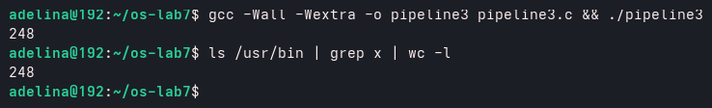
Figure 4.3 – pipeline3.c compared with the real shell
PART 5. RUN, INSIDE XV6 (LAB 8)
5.1 Preparation
For Lab 8 the xv6 tree from github.com/mit-pdos/xv6-riscv was used in ~/xv6-riscv. The RISC-V cross compiler and the emulator were installed from the Fedora packages gcc-riscv64-linux-gnu, binutils-riscv64-linux-gnu and qemu-system-riscv. Two lines were added at the end of the UPROGS list of the Makefile, each starting with a TAB:
UPROGS=\
$U/_cat\
...
$U/_sync\
$U/_run\
$U/_pingpong\
5.2 The program user/run.c
user/run.c repeats the three steps of run.c from Lab 7, but for xv6: there is no glibc, only the headers of the kernel, and the child becomes echo.
#include "kernel/types.h"
#include "user/user.h"

// the three steps of the shell, inside xv6: echo hello from the child
int
main(int argc, char *argv[])
{
printf("parent: my pid is %d\n", getpid());

int pid = fork(); // step 1: copy myself
if(pid < 0){
printf("fork failed\n");
exit(1);
}

if(pid == 0){ // only the child runs this
printf("child: my pid is %d\n", getpid());
char *args[] = { "echo", "hello", "from", "the", "child", 0 };
exec("echo", args); // step 2: become echo
printf("exec failed\n"); // runs only if exec failed
exit(1);
}

int status;
wait(&status); // step 3: wait for the child
printf("parent: child %d ended with status %d\n", pid, status);
exit(0);
}
5.3 Running the program
xv6 was built and started with make qemu, and run was typed at the $ prompt. To leave xv6, Ctrl-A X was used.
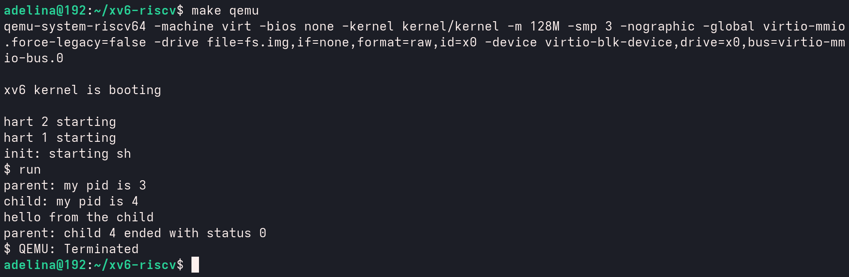
Figure 5.1 – run inside xv6, with the child running echo
Then the child was changed to run ls, and after that a program that does not exist:
char *args[] = { "ls", 0 };
exec("ls", args); // step 2: become ls

exec("nosuchprog", args);
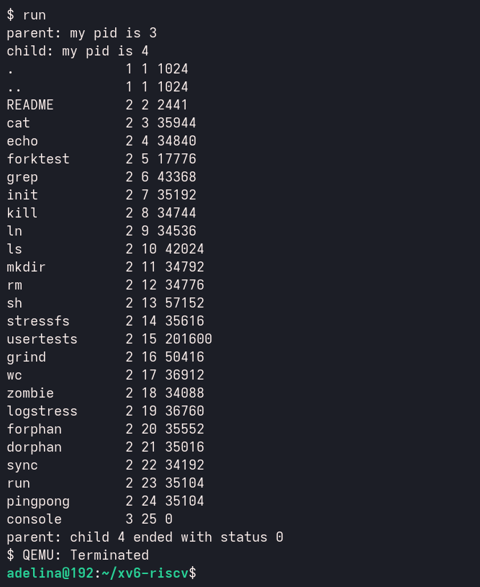
Figure 5.2 – run inside xv6, with the child running ls
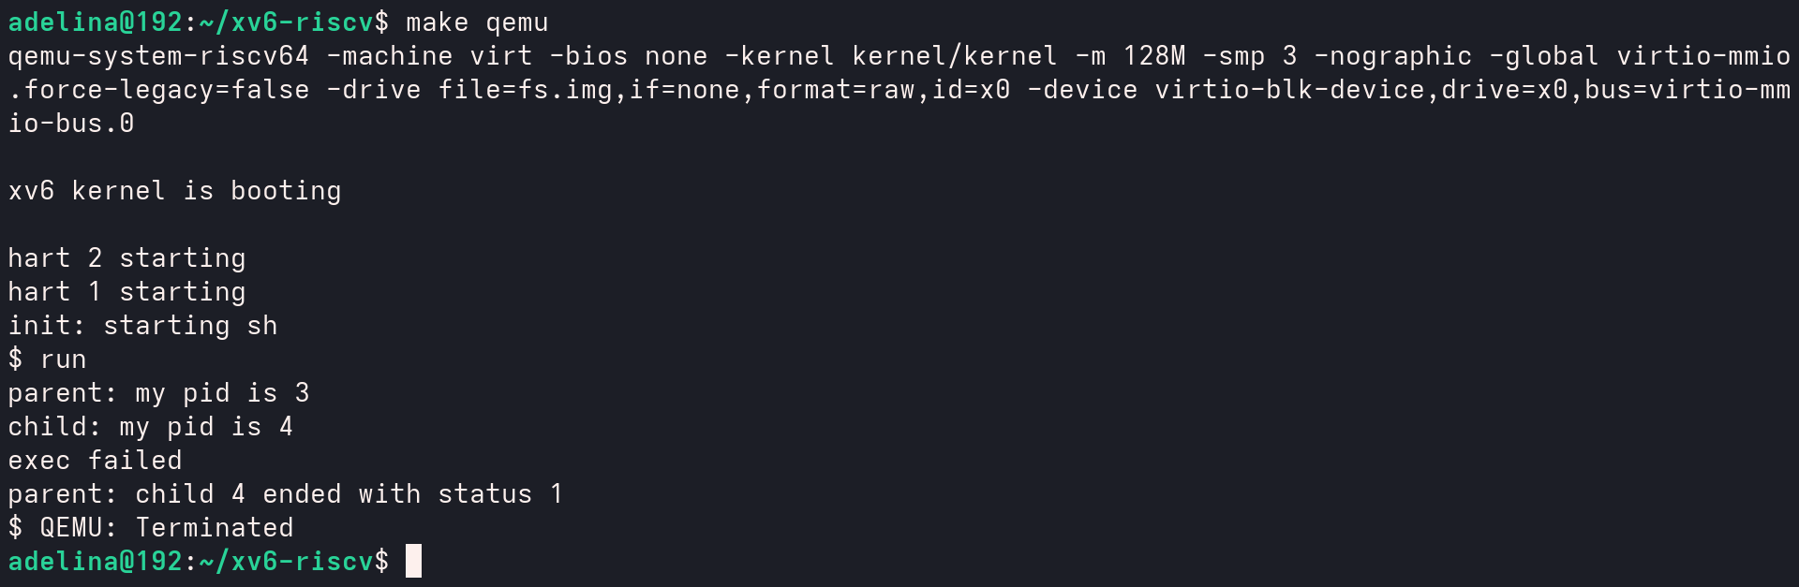
Figure 5.3 – run inside xv6, with a program that does not exist
5.4 Answers to the questions
1. The three calls of run.c in xv6 and on Linux. What is the same?

Step | Linux (Lab 7) | xv6 (Lab 8)
copy the process | fork() | fork()
become another program | execlp("ls", "ls", "-l", NULL) | exec("echo", args)
wait for the child | waitpid(pid, &status, 0) | wait(&status)

The three steps and their order are the same: fork copies the process, exec turns the child into another program and returns only on error, and the parent waits for the child and gets its exit status. fork is exactly the same; only exec and wait have slightly different names and arguments, because glibc on Linux gives more variants of them.
2. Who prints "hello from the child": the code of run, or echo?
echo prints it. After exec the child is no longer run, it is echo, and "hello from the child" are just the arguments that run gave to echo in args.
3. Why is the status 1 here and 127 on Linux?
The status is the number that the child gives to exit. After the failed exec, the xv6 program calls exit(1), while the Linux program in Lab 7 called exit(127). The parent just shows this number.
PART 6. PINGPONG (LAB 8)
6.1 The program user/pingpong.c
The parent sends one byte to the child through the pipe p2c. The child reads it, prints <pid>: received ping, writes the byte back through the second pipe c2p and exits. The parent reads the byte, prints <pid>: received pong and waits for the child. The four TODO lines were completed with read(fd, &b, 1) and write(fd, &b, 1).
#include "kernel/types.h"
#include "user/user.h"

int
main(int argc, char *argv[])
{
int p2c[2], c2p[2]; // parent-to-child, child-to-parent
char b;

pipe(p2c);
pipe(c2p);
if(fork() == 0){
close(p2c[1]); close(c2p[0]); // the ends the child does not use
read(p2c[0], &b, 1); // read 1 byte from p2c[0] into b
printf("%d: received ping\n", getpid());
write(c2p[1], &b, 1); // write the byte b into c2p[1]
exit(0);
}
close(p2c[0]); close(c2p[1]); // the ends the parent does not use
b = 'x';
write(p2c[1], &b, 1); // write 1 byte into p2c[1]
read(c2p[0], &b, 1); // read 1 byte from c2p[0] into b
printf("%d: received pong\n", getpid());
wait(0);
exit(0);
}
6.2 Running the program
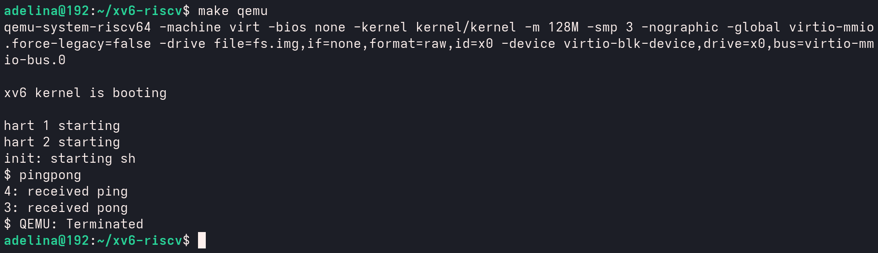
Figure 6.1 – pingpong inside xv6
The child (PID 4) prints "received ping" first, and only after that the parent (PID 3) prints "received pong".
6.3 Answers to the questions
1. Why do you need TWO pipes, and not one for both directions?
A pipe carries data only in one direction, from the write end to the read end. If one pipe were used for both directions, the parent could read back its own byte before the child takes it, and the two processes could not know whose byte is in the pipe. So one pipe is used for parent to child and the other for child to parent.
2. Which call makes the parent wait until the child has replied?
read(c2p[0], &b, 1). When the pipe is empty, read blocks, so the parent stays in this call until the child writes the byte into c2p[1]. In the same way the child waits in its read until the parent sends the ping.
CONCLUSION
In these two laboratory works the creation of processes, the redirection of output and pipes were studied on Linux and inside xv6.
In Lab 7, run.c showed the three steps of the shell: fork makes a copy, exec turns the child into another program and never returns if it works, and waitpid gives the parent the status of the child, 0 for ls and 127 when the program does not exist. zombie.c showed that a child that ended stays in the process table as Z <defunct> until its parent calls wait. redirect.c and pipeline.c showed that redirection and pipes are done only by changing descriptors 0 and 1 before exec, using the rule that open and dup take the smallest free number; ls and wc were not changed at all. Leaving one write end of the pipe open was enough to make wc wait forever.
In Lab 8, the same program ran inside xv6 with fork, exec and wait, with the same behaviour as on Linux; only the exit code after a failed exec was different (1 instead of 127). The program pingpong showed that two processes can talk through two pipes, one for each direction, and that a blocking read is enough to make one process wait for the other.
These system calls are the basis of every Unix-like shell, and xv6 shows that a small kernel needs only a few of them to start programs and connect them together.
REFERENCES
- Cox R., Kaashoek F., Morris R. xv6: a simple, Unix-like teaching operating system, chapter 1 "Operating system interfaces". MIT, 2024. [online]. Available: https://pdos.csail.mit.edu/6.1810/2024/xv6/book-riscv-rev4.pdf
- mit-pdos/xv6-riscv – source code. [online]. Available: https://github.com/mit-pdos/xv6-riscv
- MIT 6.1810 Operating System Engineering. Lab: Xv6 and Unix utilities (pingpong). [online]. Available: https://pdos.csail.mit.edu/6.1810/2024/labs/util.html
- Linux manual pages: fork(2), execve(2), wait(2), pipe(2), dup(2), open(2). [online]. Available: https://man7.org/linux/man-pages/
- Operating Systems course, FCIM/FAF, UTM, 2026–2027. Lab 7: Three Small Programs: Processes, Redirection, a Pipe.
- Operating Systems course, FCIM/FAF, UTM, 2026–2027. Lab 8: The Same Calls, Inside Your Own OS.

