

**Capstone Portfolio**

**Group 9**

Table of Contents:

Introduction

Present and Justify a Problem and Solution Requirements

Egypt Grand Challenges

Problem to be Solved

Research

Other Solutions Already Tried

Design Requirements

Generating and Defending a Solution

Selection of Solution

Selection Prototype

Constructing and Testing a Prototype

Materials and Methods

Test Plan

Data Collection

Evaluation, Reflection, Recommendations

Discussion

Recommendations

Learning Outcomes

# Introduction:

To start this Capstone project, the team has determined the main rules to be followed by each member, which are:

* During the meeting, no kidding or carelessness should be shown by any member.
* The members should not be late on any meeting for more than 3 minutes so as not to waste the time of each other.

The next thing to do was to determine the rule of each member in the team and this was done by the volunteering of each individual to the rule he could do best to ensure the perfection of the work.

Then there was our country to know the most important information about it:

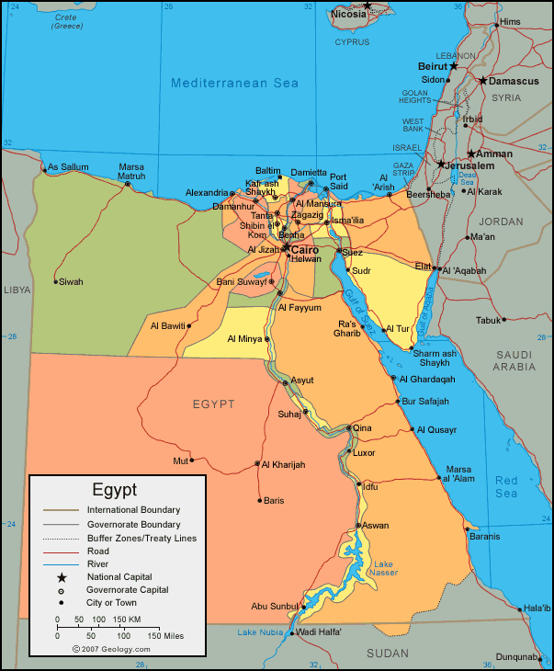Location:

Northern Africa, bordering the Mediterranean Sea, between Libya and the Gaza Strip, and the Red Sea north of Sudan, and includes the Asian Sinai Peninsula

Geographic coordinates: 27 00 N, 30 00 E

Area:

total: 1,001,450 sq. km

land: 995,450 sq. km

water: 6,000 sq. km

climate:

desert; hot, dry summers with moderate winters

Terrain:

Figure 1 the map of Egypt

vast desert plateau interrupted by Nile valley and delta

**Elevation extremes:**

lowest point: Qattara Depression -133 m

highest point: Mount Catherine 2,629 m

Natural resources:

petroleum, natural gas, iron ore, phosphates, manganese, limestone, gypsum, talc, asbestos, lead, rare earth elements, zinc

**Land use:**

agricultural land**:**3.6%

arable land 2.8%; permanent crops 0.8%; permanent pasture 0%

forest: 0.1%

other: 96.3% (2011 est.)

Irrigated land:

34,220 sq. km (2003)

Total renewable water resources:

57.3 cu km (2011)

Natural hazards:

periodic droughts; frequent earthquakes; flash floods; landslides; hot, driving windstorms called khamsin occur in spring; dust storms; sandstorms

Population:

88,487,396 (July 2015 est.)

country comparison to the world: 16

1. **Present and Justify a Problem and Solution Requirements:**

The main Grand challenges that face Egypt are:

1. Population overgrowth.
2. Pollution.
3. Arid areas.
4. Urban congestion.
5. Improve the industrial base.
6. Recycling.
7. Health issues.
8. Water resources.
9. Alternative energy resources.
10. Improve the use of technology.
11. Climate change.

**Egypt’s Grand Challenge**

The grand challenge we are facing this semester is to improve the food supply in Egypt by the use of water, the food supply includes animals, fish and plants.

The water that we have to use is fresh water which can be used for agriculture.

It’s of the most importance to face this problem because the independence of any country starts with their food independence, and because Egypt has a lot of resources that need to be utilized in order to solve this challenge, food supply is not a problem that faces two or three persons or even thousands of people, but it faces the whole country, over 90 million persons will suffer the consequences of this problem unless we move to solve it.

**Problem to be solved**

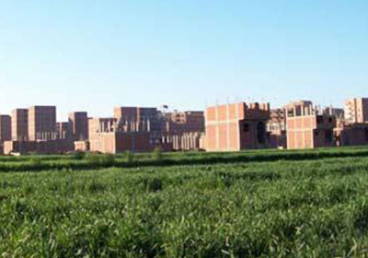**Egypt suffers from increasing in population every year and this overpopulation requires more food to saturate the prongs needs. As we know we are depending on the agricultural crops and the animals productions. But here is the problem, we have the same area of the agriculture land and subsequently we don't have any increment in the crops however we have increment in consuming the crops**

**On the other hand,**

**1- many people especially (farmers) started to build on the agricultural land and this helps in decreasing the total area of the land.**

**We also have lack in animals production due to the bad feeding of animals and the animals infection with difference diseases.**

**2-The studies showed that area of agriculture land equals only 4% of Egypt land and the rest is desert and aquatic areas. That made Egypt has a crisis in some crops like wheat that pushed it to export its needs of crops.**

**3- Inefficient Irrigation**

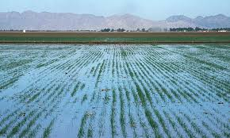 **Egypt receives less than 80 mm of rainfall a year, and only 6 percent of the country is arable and agricultural land, with the rest being desert. This leads to excessive watering and the use of wasteful irrigation techniques such as flood irrigation [an outdated method of irrigation where gallons of water are pumped over the crops]. Nowadays, Egypt’s irrigation network draws almost entirely from the Aswan High Dam, which regulates more than 18,000 miles of canals and sub-canals that push out into the country’s farmlands adjacent to the river. This system is highly inefficient, losing as much as 3 billion cubic meters of Nile water per year through evaporation and could be detrimental by not only intensifying water and water stress but also creating unemployment. A further decrease in water supply would lead to a decline in arable land available for agriculture, and with agriculture being the biggest employer of youth in Egypt, water scarcity could lead to increased unemployment levels.**

**4- Pollution**

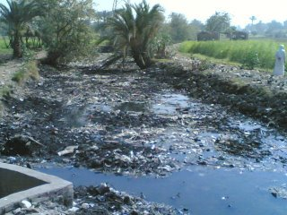**Agricultural runoffs, industrial effluents and municipal sewage are being recklessly dumped into the Nile River, gradually making its water unfit for human consumption. Sewage water from slums and many other areas in Cairo is discharged into the river untreated due to lack of water treatment plants. Agricultural runoffs frequently contain pollutants from pesticides and herbicides, which have negative effects on the river and the people using it. Industrial effluents are often highly toxic, containing heavy metals that can combine with the suspended solids in domestic wastewater to form muck. All of these factors combine together to make Nile a polluted0 river which may spell doom for the generations to come.**

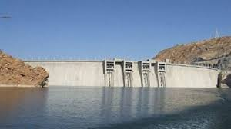

**5- El-Nahda dam represents one of the most dangers on River Nile water in Egypt as it 145 meters high and its length is 1800 meter. The first danger that Egypt portion of water from River Nile will decrease nearly 12 billion cubic meter and this will destroy nearly 200,000 feddan.**

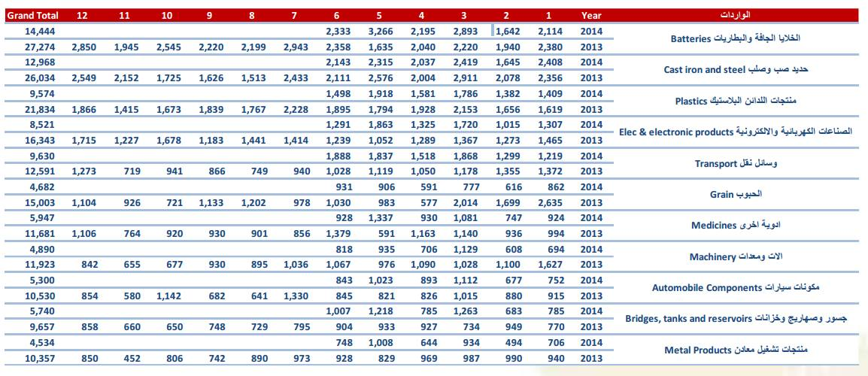

**6- The huge dispersion between the imports and exports of grains and fresh food. The ministry of trade and industry reported the amounts of the imports and exports in 2013 and 2014. The average price of grain imports in Egypt in 2013 – 2014 is 9.5 billion USD. so one of our method in the project is to decrease the difference between exports and imports of grains.**

### If this problem is not solved:

If this problem isn’t solved, we expect that Egypt will face another unbearable problems

1. The food supply will continue to decrease and this will harm the population and will cause hunger.
2. Egypt will continue to import its food requirements from other countries.
3. This will harm the economy of Egypt.

### While if it is solved:

1. The food production will increase in Egypt.
2. It will saturate the needs of the people and we will be able to stop importing food from other countries.
3. The economy of Egypt will be improved because the imports will reduce.
4. Egypt will be able to export a lot of crops.

**Research**

### The main topics related to the problem we needed to research are:

### Problem related researches:

* Agriculture in Egypt.
* Food supply in Egypt.
* Water supply in Egypt.
* Crops in Egypt.
* Weather suitable for agriculture in Egypt.
* Agricultural areas in Egypt.

### Solution related researches:

* Genetically modified rice.
* Water treatment.
* Organic fertilizers.
* Desert in Egypt.
* Irrigation systems.
* Desalination.
* Distillation.
* Irrigation with salt water.
* Moisture sensors.
* Rain sensor.
* Indoors agriculture.
* Arduino C.

### Resources:

* Crops, Rice. (2008, December 4). Retrieved from <http://www.gmo-compass.org/eng/grocery_shopping/crops/24.genetically_modified_rice.html>
* **Barclay, A., & Clayton, S. (n.d.). The state of play: Genetically modified rice. Retrieved from** <http://irri.org/rice-today/the-state-of-play-genetically-modified-rice>
* **Haider, D. (2014, November 5). Health Benefits of Eating Cassava Leaves (Yuca Leaves). Retrieved from** <http://community.omtimes.com/profiles/blogs/health-benefits-of-eating-cassava-leaves-yuca-leaves>
* **South valley development project. (n.d.). Retrieved from** <http://www.mwri.gov.eg/project/toshka.aspx>
* **Scott, K. (2009, May 1). Irrigation system can grow crops with salt water. Retrieved from** <http://www.wired.co.uk/article/irrigation-system-can-grow-crops-with-salt-water>
* **Tonkin, M. (n.d.). SUBSURFACE VAPOR TRANSFER IRRIGATION. Retrieved from** <http://www.launch.org/innovators/mark-tonkin>
* **Rice, Milled 2016. (n.d.). Retrieved October, 2016, from** <http://www.pecad.fas.usda.gov/cropexplorer/cropview/commodityView.aspx?cropid=0422110>

What our researches taught us about the problem we are addressing:

The researches taught us that the problem we are facing is very big and many countries have faced it, this problem caused hunger and death like what happened in Somalia. Other countries succeeded in finding solution, therefore we know that many approaches have been made toward solving this problem but not all of them can be of use in Egypt because of the peculiar conditions we have in Egypt like (weather – soil- moisture...) .

What our research taught us about the solutions that have been tried:

We found that most of the solutions achieved all over the world in the previous years provided the food supply but in some countries these solutions don't saturate the whole need, others don't have high efficiency, others require high cost. In our solution we need to make a combination of all these solutions to avoid any disadvantage was found in the previous solutions.

**Other Solutions Already Tried**

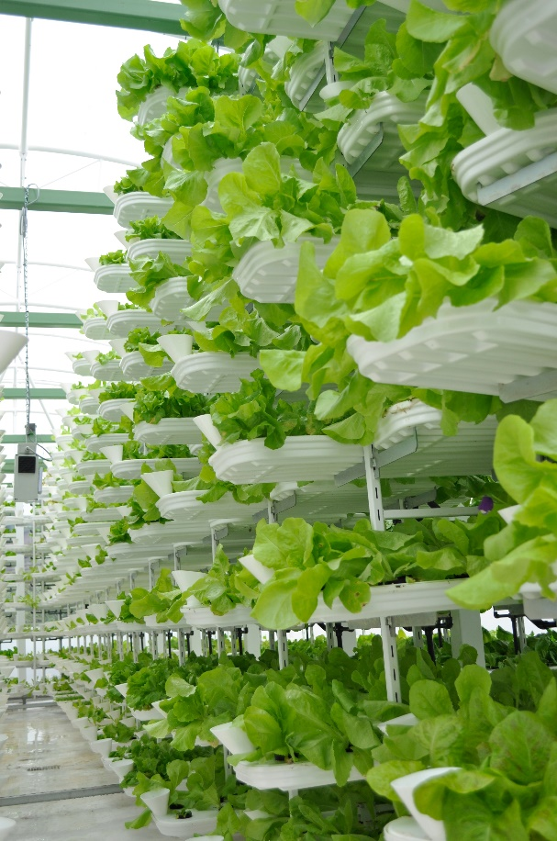 **Vertical farming** is the practice of producing food in vertically stacked layers, vertically inclined surfaces and/or integrated in other structures. The modern idea of vertical farming uses controlled-environment agriculture (CEA) technology, where all environmental factors can be controlled. These facilities utilize artificial control of light, environmental control (humidity, temperature, gases...) and fertigation. Some vertical farms use techniques similar to greenhouses, where natural sunlight can be augmented with artificial lighting and metal reflectors.

Problems:

* A detailed cost analysis of start-up costs, operation costs and revenue has not been done. The extra cost of lighting, heating, and powering the vertical farm may negate any of the cost benefits received by the decrease in transportation expenses.
* Large energy usage.
* The amount of pollution created will be much higher than that from field produce. The amount of pollution produced is dependent on how the energy used in the process is generated.

Advantages:

* Preparation for the future. It is estimated that by the year 2050, close to 80% of the world’s population will live in urban areas and the total population of the world will increase by 3 billion people.so we will need more areas that is provided in this way easily.
* Increased crop production.
* Protection from weather-related problems.
* Urban growth.
* Good Impact on human health.

**This solution had a huge success in japan and was a big part of their plan to succeed. In the beginning it was expensive for the country, but they skipped the problems and started applying. In the same time china started applying this successful solution and North Korea also started using it. Scientists think that after few years this solution will be applied all over the world.**

**Organic fertilizers**

**Different types of fertilizers, such as chemical fertilizers, organic fertilizers, and natural fertilizers are available on the market. The type of fertilizer you use has a large impact on the quality of your product. Farmers all over the world use chemical fertilizers, but many are now shifting to organic fertilizers due to the apparent benefits of the latter.**

**Organic fertilizers are carbon-based compounds that increase the productivity and growth quality of plants. They have various benefits over chemical fertilizers, which include the following:**

**Non-toxic Food: Use of these organic fertilizers ensures that the food items produced are free of harmful chemicals. As a result, the end consumers who eat these organic products are less prone to diseases such as cancer, strokes, and skin disorders, as compared to those who consume food items produced using chemical fertilizers.**

**On-Farm Production: The majority of organic fertilizers can be prepared locally or on the farm itself. Hence, the cost of these fertilizers is much lower than the cost of chemical fertilizers.**

**Low Capital Investment: In addition to the on-farm production possibilities of organic fertilizers, organic fertilizers help in maintaining the soil structure and increasing its nutrient-holding capacity. Therefore, a farmer who has practiced organic farming for many years will require far less fertilizer, because his soil is already rich in essential nutrients.**

**Fertility of Soil: Organic fertilizers ensure that the farms remain fertile for hundreds of years. Land located at the site of ancient civilizations, such as India and China, are still fertile, even though agriculture has been practiced there for thousands of years. The fertility is maintained because organic fertilizers were always used in the past. However, with the increased use of chemical fertilizers today, land is rapidly becoming infertile, forcing many farmers to further increase their use of chemical fertilizers or even leave the farming industry entirely.**

**Safe Environment: Organic fertilizers are easily bio-degradable and do not cause environmental pollution. On the other hand, chemical fertilizers contaminate both the land and water, which is a major cause of diseases for human beings and is the force behind the extinction of a number of plant, animal, and insect species.**

**This solution nearly succeeded as it has some advantages.**

**The Advantages of Organic Farming**

**1. No Poison Is Always Great**

**Organic farming does not use any type of harmful chemicals to keep pests away, unlike the majority of industrial farming. They use all natural methods that do not harm the consumer or the environment that they are grown in. Herbicides, pesticides, and artificial growth hormones are all forbidden on an organic farm.**

**2. Closely Regulated**

**In order for a food to be labeled as organic, the entire process of which is was created is thoroughly investigated. The organic food industry is internationally regulated, which means that organic means the same standards where followed, no matter where in the world it was made. This helps the consumers to know that they are truly getting what they think that they are.**

**3. Better Taste and More Nutrition**

**Fruits and vegetables that are organically raised have a much better taste than other mechanically farmed ones. This is due to the fact that they are given a much longer time to develop and are not pumped with artificial things. The sugar structures in these crops have more time to mature and develop into a tasty and nutritious product.**

**4. Costs Are Lowered**

**There is a deep stigma around anything organic that it had to have cost an arm and a leg to cultivate. This is actually the opposite of the truth. When you cut out the time that is spent to farm organic crops, the actual costs are minimal. These farmers do not have to shell out large amounts of money for expensive chemicals and massive amounts of water, unlike industrial farmers.**

**5. The Environment Doesn’t Suffer**

**Another thing that benefits from the use of organic farming is the environment! In industrial farms, the chemicals that are used are seep into the ground and contaminate the soil and local water sources. Humans, animals, and plant life are all affected negatively by this. With organic farming, there are no chemicals used, so no pollution occurs either.**

**There are also some disadvantages for this solution .**

**The Disadvantages of Organic Farming**

**1. It’s a Whole Lot More Work**

**It takes a whole lot of hard work to successfully grow crops organically. There is a high amount of farmer interaction time with their crops. Whether it be to ensure that the plants remain pest free in an organic way, or to act as weed prevention, the time required is significantly higher than plants and crops produced industrially.**

**2. The Consumer Pays the Price**

**Organic foods in the supermarket are infamously higher than others. This is one of the biggest reasons that people do not fully support the use of organic farming, and not nearly enough people are enjoying the great benefits that it could bring. For example, a pound of nonorganic red peppers cost right around $2.76, while a pound of organic red peppers run a whopping $5.89! That’s double the price!**

**3. Cross Breeding Happens**

**GMO crops, also known as genetically modified crops, are plants whose DNA structure have been altered. These seeds, once planted, create GMO crops. These crops then produce seeds and the patter continues. It is very difficult to truly tell if an organic seed has not been affected by GMO’s in anyway. This cross breeding could completely wipe out the idea of organic and non GMO crops very soon.**

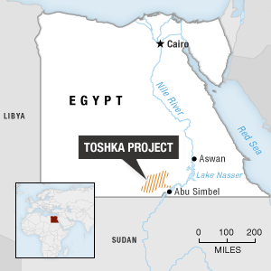**Toshka project:**

**The project is located 225 km south Aswan and it aims to add 600 thousand fedans of agriculture lands that are irrigated with surface water of nile and underground water and it integrates lots of the latest technological systems like the escade system.**

**The project has been finished and 21 hydraulic units have been tested**

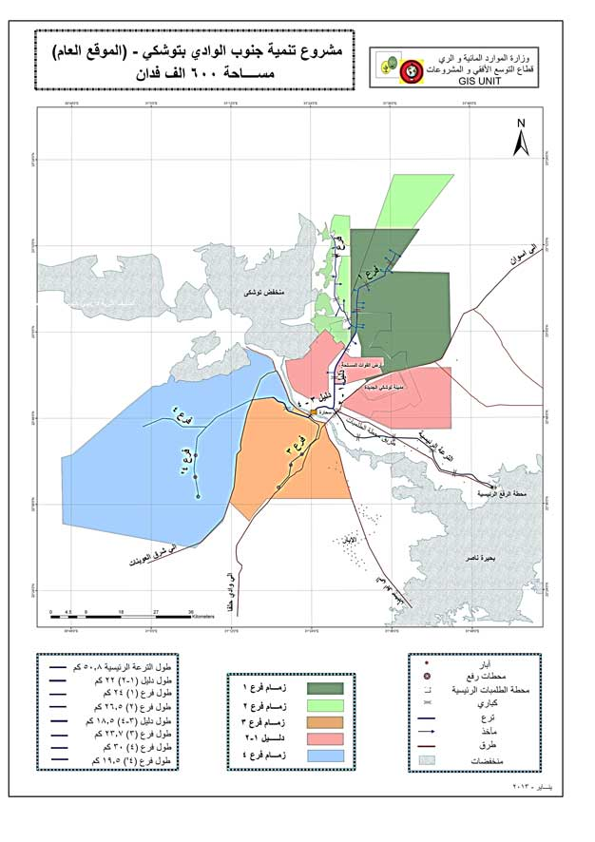

## The current solution:

The current solution for water and food problem is through designing a new way for plants to reduce the amount of water needed for them known as irrigation system, this would distribute the water needed for irrigation in a better way, or introducing a new genetic modification for a plant that is important for the Egyptians in their everyday food, such as rice, wheat and potatoes.

## **Design requirements**

We followed the EDP process in our work and this is the step where we choose the design requirements for our project:

* 1. Decrease the amount of water for agriculture.
  2. Identify a plant that is important for the country.
  3. Productivity and modest cost.
  4. Make a good use of the plant auxiliary.
  5. Safety for crops, farmers and consumers.

1. **Generating and Defending a Solution**

## **Selection of** **Solution**

According to our researches, we found that rice consumes about 70% of total water used for cultivation in Egypt, and so we set ourselves to solve this problem and work on a solution that:

* Reduces the amount of water used for it.

On the long term, we’re going to use the technique of “Selective breeding”.

Firstly, we will reduce the amount of water used to grow the first generation and the offspring will become adapted to the new amount of water, then we’re going to repeat this for the next generations so that we’ll reach the least amount of water.

* replace its resources

from freshwater to become brackish water, and thus keep the freshwater for other more important uses like drinking, cooking, and growing other crops for which their water type can’t be changed.

## Egyptian rice:

***About Rice:***

***Rice is life***for thousands of millions of people and it is the second important crop after Wheat in Human Food. It is deeply embedded in the cultural heritage of their societies. It is the staple food for more than half of the world population.

Rice production was probably introduced into Egypt in the 7th Century. Today, rice production takes place only in the Lower Valley of the Nile River. Due to the intrusion of sea-water, about 25 to 30% of the land in the lower Nile Valley is affected by different degrees of salinity. In these areas, rice production helps to leach the salt from upper soil layers and thus reclaim the land for agricultural activities.

***Egypt*** is the largest rice producer in the Middle East region and it is one of the most important agricultural crop which Egypt export to different countries around the world “about 60 country” due to the Egyptian competitive prices comparing to other exporter countries like Italy, Spain, Australia and USA.

Egyptian farmers, with the help of Egyptian researchers, are producing one of the world's highest rice yields.  According to records, the average Egyptian

rice farm yield in 2006 – 2007 was 3.5 tons per Fadden with total production about 5.5 million tons/ year.

And as per our records, rice consumption per person in Egypt in 2006 was 45 kg/ yr while the total local consumption was around 3.5 million ton/ year so the total amount available for export is about 2 million tons/ year and it is increasing year after year due to the improving of the productivity which pay the attention of the shipping agencies and make them to determine regular trips between the Egyptian exporting ports and the importing countries ports.

Thus, Improving the productivity of rice systems would contribute to hunger eradication, poverty alleviation, national food security and economic development as rice provides 27% of dietary energy supply and 20% of dietary protein intake.

***Egyptian Rice Types and time of planting and harvesting:***

The high solar radiation, the long days and the cool nights between May and September are favorable to a high rice yield.

 So, the Egyptian Rice cultivates from the beginning of May till the end of June and its harvest season starts in the middle of August till the middle of October

 The Egyptian Rice considered from the type of Short and Medium round grain.  Most of the planted rice varieties are japonica and the most famous variety are Sakha “101, 102, 104” and Giza “177, 178”.

Rice is the first main product that we are specialized in exporting it.

We can supply Rice in different types like Natural White Rice , Camolino Rice “Oiled rice”, Brown/ Cargo Rice and also Broken Rice.

***Standard Egyptian Rice specifications:***

|  |  |  |  |  |  |  |
| --- | --- | --- | --- | --- | --- | --- |
| **Grade** | **Broken** | **Red Grains** | **Damaged & Yellow Grains** | **Immature Grains** | **Foreign Matters** | **Paddy** |
| 1 | 3% | 1.5% max | 0.25% max | 2.00% max | 0.05% max | 0.00% |
| 2 | 5% | 2.00% max | 0.50% max | 2.50% max | 0.10% max | 0.00% |
| 3 | 10% | 2.50% max | 1.00% max | 3.50% max | 0.20% max | 0.03% |
| 4 | 20% | 3.00 % max | 1.50% max | 5.00% max | 0.30% max | 0.04% |
| 5 | 30% | 3.50% max | 2.00% max | 8.00% max | 0.60% max | 0.10% |
| 6 | 40% | 4.00 % max | 2.50% max | 2.50% max | 0.70% max | 0.20% |

As we see, the rice amounts in Egypt is enough for the local needs but the problem is its consumption of water, rice grows in water with different low salinity and requires 1432 Liters of water to grow 1kgm and thus it shows that it consumes a huge amount of water to satisfy the needs.

And rice has its own growth conditions which are:

1. **Rainfall**

Rainfall is the most important weather element for successful cultivation of rice. The distribution of rainfall in different regions is greatly influenced by the physical features of the terrain, the situation of the mountains and plateau. Rice cultivation is possible only in areas with good rainfall, as the crop requires standing water for growth. A monthly rainfall of 100-200 mm is a must and about 125 cm is during vegetative season. And there should be no water at ripening stage.

1. **Temperature**

Temperature is another climatic factor which has a favorable and in some cases unfavorable influence on the development, growth and yield of rice. Rice being a tropical and sub-tropical plant, requires a fairly high temperature, ranging from 20° to 40°C. The optimum temperature of 30°C during day time and 20°C during night time seems to be more favorable for the development and growth of rice crop. . Rice cultivation is conditioned by temperature parameters at the different phases of growth. The critical mean temperature for flowering and fertilization ranges from 16 to 200C, whereas, during ripening, the range is from 18 to 320C. Temperature beyond 350C affects grain filling.

1. **Day length or Sunshine**

Sunlight is very essential for the development and growth of the plants. In fact, sunlight is the source of energy for plant life. The yield of rice is influenced by the solar radiation particularly during the last 35 to 45 days of its ripening period. The effect of solar radiation is more profound where water, temperature and nitrogenous nutrients are not limiting factors. Bright sunshine with low temperature during ripening period of the crop helps in the development of carbohydrates in the grains.

 Therefore, the rice growing seasons vary in different parts, depending upon temperature, rainfall, soil types, water availability and other climatic conditions. If the mean temperature is found favorable for rice cultivation throughout the year then, two or three crops of rice are grown in a year. Where rainfall is high and winter temperature is fairly low, only one crop of rice is grown.

There are three seasons for growing rice. These three seasons are named according to the season of harvest of the crop.

Autumn Rice/Pre-autumn Rice

Summer Rice/Spring Rice

Winter Rice/Autumn Rice

1. **Rice Soils**

Rice grows on a variety of soils like silts, loams and gravels. However, clayey loam is well suited to the raising of this crop.

Generally, Rice cultivation has been carried into all regions having the necessary warmth and abundant moisture favorable to its growth, mainly subtropical rather than hot or cold.

Experts point out that, rice is grown in such varied soil conditions that it is difficult to point out the soil on which it cannot be grown. However, soils having

   1- Good water retention capacity.

   2- Good amount of clay and organic matter are considered ideal for rice cultivation.

It grows well in soils having a pH range between 5.5 and 6.5. The classification of soils has been done depending upon the soil texture, color of the soil etc.

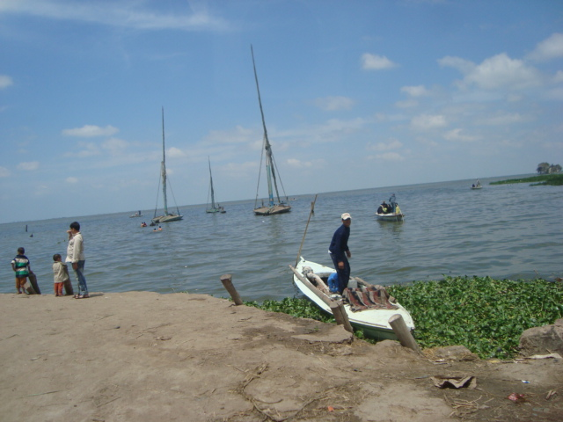And we found that rice has a strange history, it didn’t require much water for cultivation, but the crops suffered from weeds and pests and so they started to increase the amount of water used for irrigation bit by bit. Rice adapted to this water accretion and now it can’t grow without it.

Hence, we aim to reverse this process and start decimating this huge sum of water through decreasing the amount of water for a generation and the selectively breed it together until we reach the required level of reduction for water needs for growing a good rice grain.

To do this, we identified our water resource as EL Burullus lake that contains brackish water with average salinity of 6,000 ppm. So, we need a good water treatment system:

## Treatment system:

The treatment system we have depends on hydrophilic membranes that will let water pass but will prevent salts and any other substance from passing. The membranes will be set to oppose the water current and make use of the pressure made by the pump to make water pass successfully. They will work only when water supply is needed to the crops, here we need to identify the times in which we will have to water the crops:

## Irrigation system:

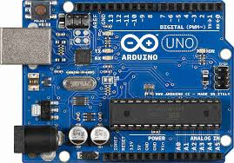To do this, we have to design an irrigation system that will deliver suitable water for rice and supply the needed amounts. And we chose Arduino to control this system, it will have moisture sensors that read the amount of moist(water) in the soil and the system will decide itself whether it lets the water flows or not. This system will automatically control the irrigation and will save the farmers’ time and then the time will come when we tell you about the pumping plan:

## Pumps plan:

Pumps will depend on two things:

1. The natural orientation of the cultivation land to make the pumps set on the points relatively high in the land and set them to pump water to the rest of the field with no need to more pumps.
2. The power of the pumps and their ability to work until the field is flooded.

The performance of a pump varies depending on how much water the pump is moving and the pressure it is creating. This is an important relationship not only because it determines whether the pump is suitable for your irrigation system, but also because these pump characteristics allow you to control the operation of your pump. The primary relationship to understand is that as the flow INCREASES, the pressure DECREASES. Here are the standard formulas used to estimate flow, pressure, and horsepower for all electric pumps. Note: these formulas have been simplified to assume a pump efficiency of 55% which is a good average figure to work with if you don't know the exact efficiency of your pump. Pressure for pumps is measured in feet of head, one foot of head is equal to 0.433 pounds per square inch. The formula is:

FT.HD. = HP x 2178 / GPM

GPM = HP x 2178 / FT.HD.

HP = GPM x FT.HD. / 2178

Minimum Pressures for Irrigation Systems

|  |  |  |
| --- | --- | --- |
| Drip Irrigation | = | 70 feet head (30 PSI) |
| Spray Type Sprinkler Heads | = | 93 feet head (40 PSI) |
| Rotor Type Sprinkler Heads | = | 104 feet head (45 PSI) |

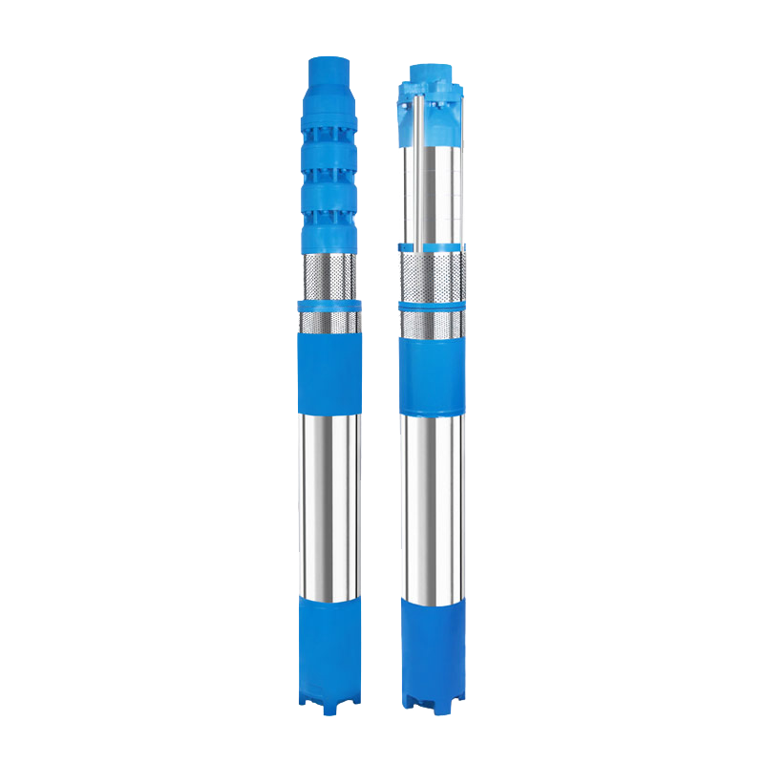The pump which we are using is called submersible pump and it’s shown in the photo to the right.

The submersible pump type is a pump that is drowned under the water supply and pushes water upwards.

The reasons of choosing this type of the pump are:

1. It’s more efficient than other pump types.
2. It gives better results and has a longer lifetime because it only pushes water upwards.

## Why selective breeding not GMO?

Epigenetic responses to drought stress in rice

We made researches on the Epigenetic responses to drought stress in rice. We found an applied project to test the behavior of the gens of rice under controlled input of water and under drought. They used several genotypes of rice in the experiment. We got the following:

“The rice genome of drought stressed and control plants were relatively quantified for cytosine methylation using MSAP. A number of studies in plants have shown that epigenetic mechanisms like DNA methylation, histone modifications and RNA interference assist plats to cope up with different kind of biotic and abiotic stresses. These epigenetic mechanisms modulate the gene expression in response to the change in environment via activating specific defense mechanisms and various adaptation processes.”

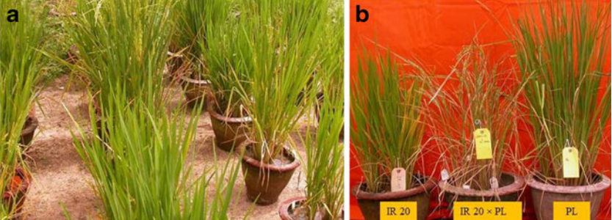

The photo a is the rice under controlled water and figure b is the rice under drought.

The following graphs illustrates the difference between the plant that was under drought and the plant that was under controlled water system:

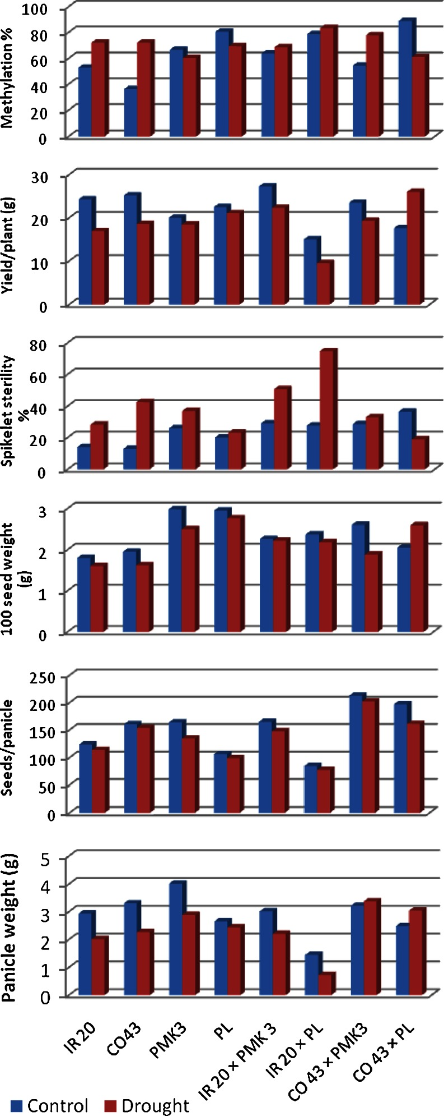

So, we chose CO 43 x PL Genotype as it has good qualities.

But GMO is costly and its consequences aren’t verified, in addition to this, some countries don’t allow the usage of GMOs by their people because they are still under studies and this will oppose exporting rice crops to other countries as Egypt exports a lot of rice to many countries.

And this photo represents rice quality compared with the salinity of soil and water:

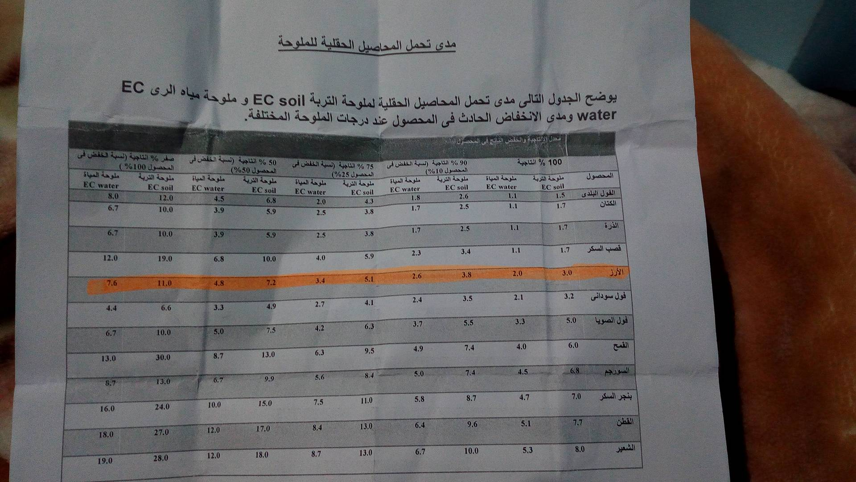

Our solution will meet the design requirements because on using brackish water instead of fresh water we decrease the amount of fresh water used, and with selective breeding we decrease the amount of water used to grow rice on the long term.

We also identified a plant that is important to the country as we all know that rice is an essential meal for all the Egyptians.

Productivity will not be increased in terms of amounts, but the project cost will be decreased and so the productivity will increase and the cost will be a little and selective breeding is costless at all.

We will use the plant auxiliary in our agriculture process. Rice straws will cover the seeds and the field during the agriculture period.

**Selection of** **Prototype**

We identified some design requirements for our prototype which are:

1. Automation: prototype has to work independently without the interference of farmers or third party.
2. Water supply: the water supplied by the prototype will vary according to the needs of the field.
3. Safety: we must isolate the pump and any water source from electricity to avoid short circuits and electrocutions.

**We can test the prototype by setting it and connecting all the wires and observing whether it works alone or not, measuring the amounts of water it supplies to know if the water support is enough.**

**We can also test its safety by testing the current passing through the wires and flowing to the pump and making sure that there aren’t any cuts in the wires and current isn’t high in order not to destroy any instruments.**

**So, we find that our prototype can be tested to determine whether it meets the design requirements or not.**

**There will be a part of our prototype that will be represented by simulation because it needs high technology.**

**It will represent the treatment stage and the selective breeding process.**

1. **Constructing and Testing a Prototype.**

## **Materials And Methods:**

## Safety precautions:

For any project to be successful, awareness should be well considered as we know a stitch in time saves nine and from this perspective we had set some main safety precautions for the whole team to follow and they are:

1. Don’t set fire beside any of the prototype materials or tools.
2. Take care when using any sharp stuff so as not to harm yourself.
3. When conducting experiments, there should be an instructor who has got a plenty of experience about the subject.
4. Repeat all measurements to be sure.
5. Before cutting any amount of the material, take care and reassure of the amount you need so as not to waste the material and reduce the needed cost as possible.
6. Keep dry when getting close to any electric current supply.
7. Keep water away when conducting experiments related to electricity.

Methods

Firstly: we prepared the previous mentioned materials and we studied the use and the mechanism of each one.

We started to construct the prototype by some steps

1-we tested the Arduino Board by a led to ensure that the board is working.

2- we connected the soil moisture sensor with the Arduino Board using the male-male jumpers and female-female jumpers and then we write the code with Arduino C language and we tested the read of the sensor in different soils.

3-after we checked the sensor and the board, we started to connect the sensor with the bread board by the jumpers.

4- on the other hand, we connected the relay with the breadboard and with the Arduino board (signal) to control the working of the relay and then we connected the relay with the 9-volt battery from the positive pole.

5- we connected the pump with the positive pole of the battery which is connected to the relay and then negative pole is connected to the negative pole of the battery.

6- we connected the positive pole of the breadboard to the 5V pin and the negative pole with ground pin in the Arduino .

7- we write the needed code for the operation so that the water pump can pump water if the read of the sensor reached to specific value .

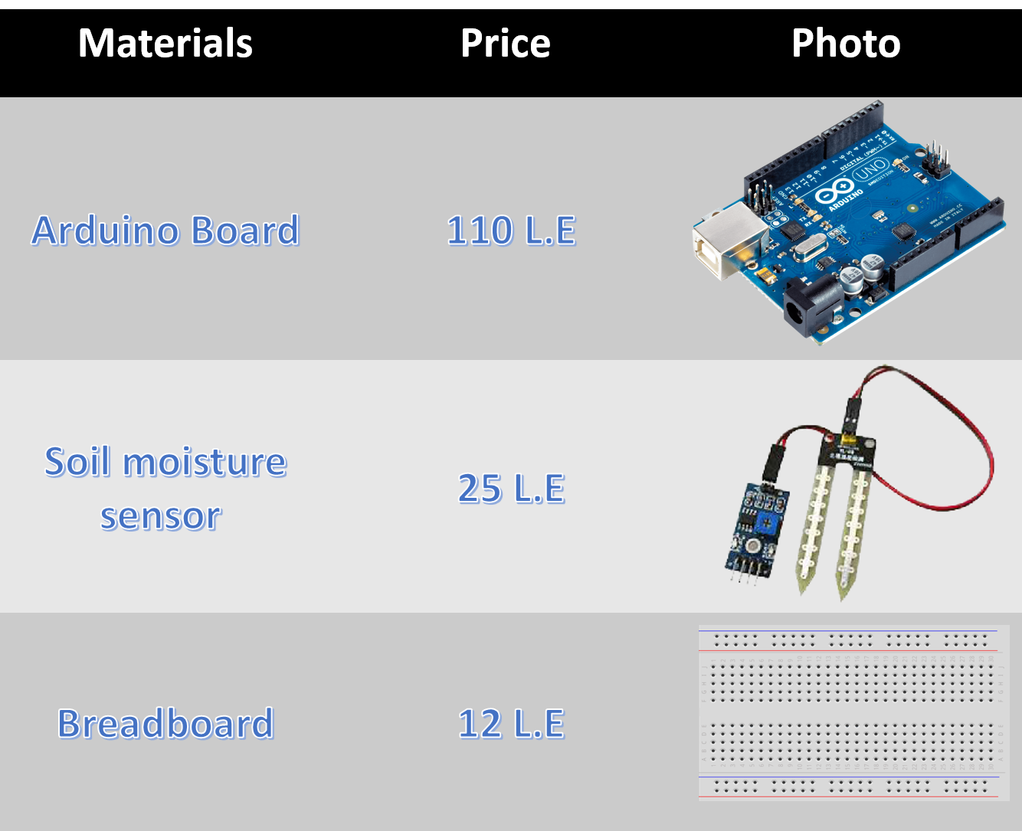

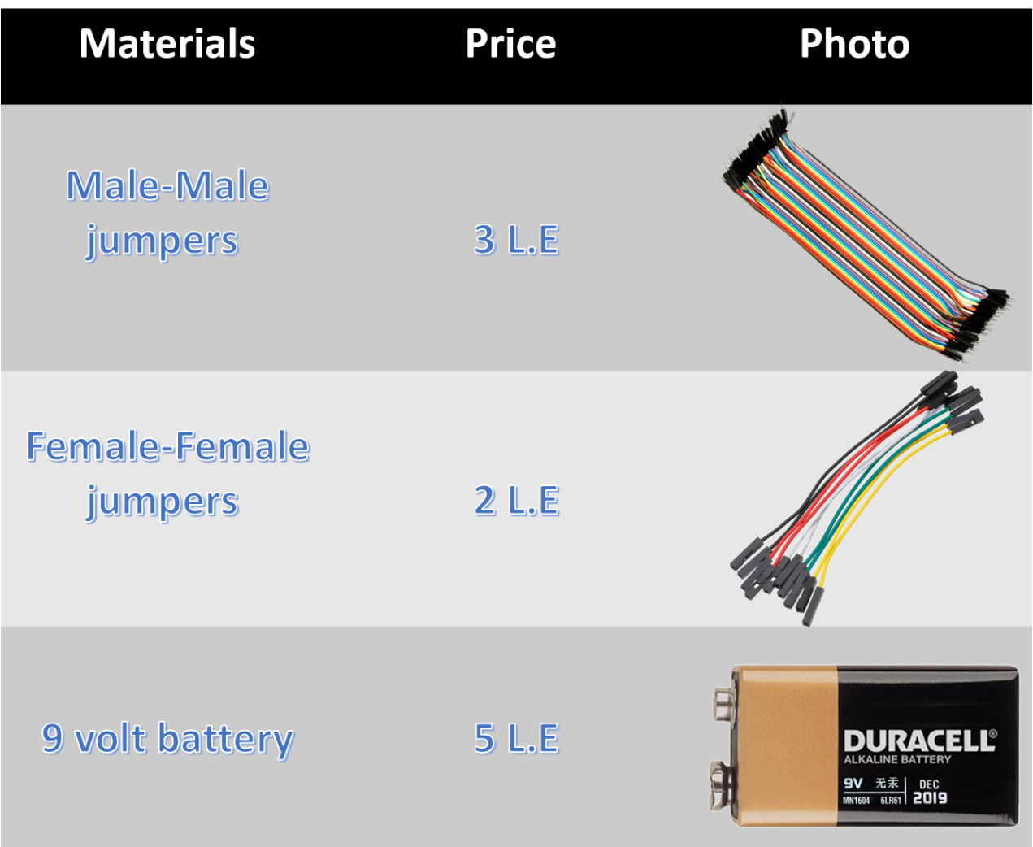

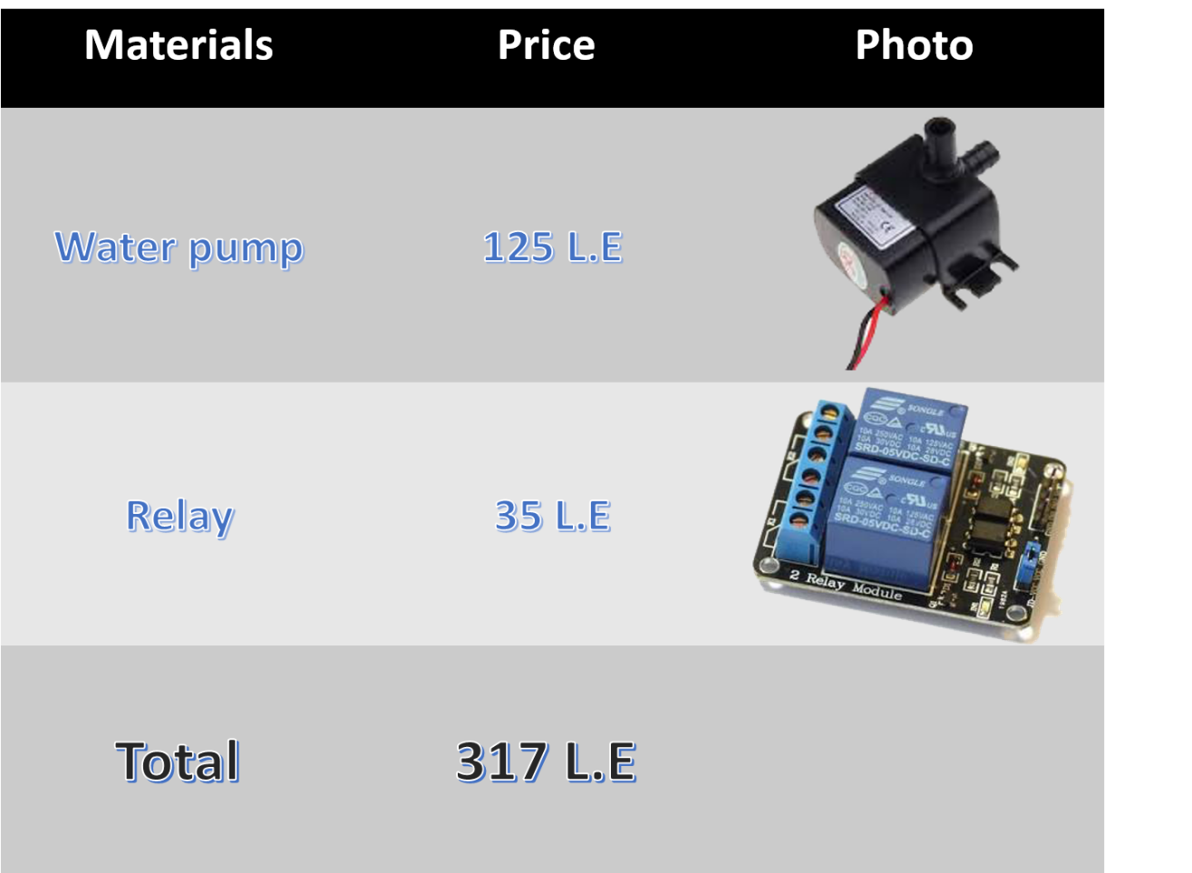

## **Test Plan**

These are the requirements we chose to test:

1. Automation: prototype has to work independently without the interference of farmers or third party.
2. Water supply: the water supplied by the prototype will vary according to the needs of the field.
3. Safety: we must isolate the pump and any water source from electricity to avoid short circuits and electrocutions.

We tested all the design requirements by following the steps below:

1. We wrote the code using Arduino C language
2. We 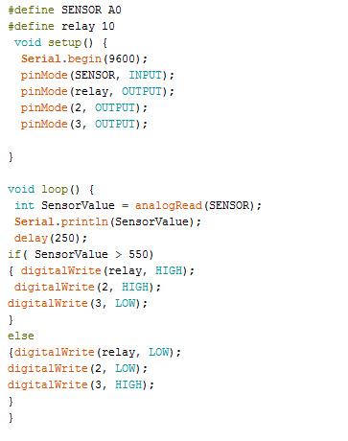  
   connected the Arduino wires altogether.
3. Tested the wires for safety.
4. After that, connected the pump to the Arduino board.
5. Then, the sensor and pipes were put in the soil sample in a three soil states (dry, wet, very wet)
6. 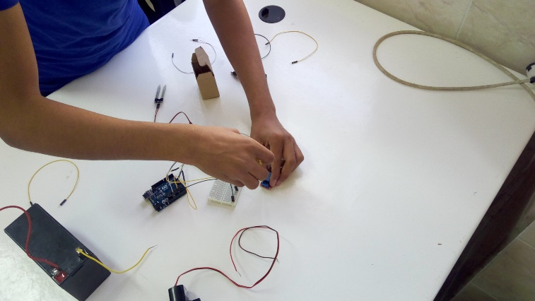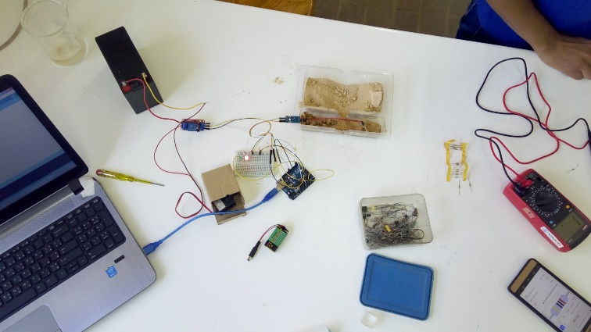Finally, electricity was connected to the board and observations were made with changing the soil sample states to test its sensibility.

Anyone who has the basic knowledge of Arduino can conduct this experiment by following the previous steps.

## **Data Collection**

**After applying our test, we recorded the results as the following table:**

|  |  |
| --- | --- |
| The state of the soil | The moisture range measured by the sensor |
| Very dry | 950 - 1000 |
| Wet | 450 - 500 |
| Very wet | 250 - 300 |

**According to the results we made our optimum value in the Arduino code 500 as the read gets more than 500 the pump starts pumping water and when it gets lower than 500, the pump stops pumping the water until the water run out.**

**We used the moisture sensor as a measurement tool it measures the moisture in the soil and after that we compare the outputs**

**We considered an error of ±5 In measurement.**

**This graph illustrates the sensor reads every 250 milliseconds in the very dry soil. It ranges from 950 to 1000.**

**This graph illustrates the sensor reads every 250 milliseconds in the wet soil. It ranges from 450 to 500.**

**This graph illustrates the sensor reads every 250 milliseconds in the very wet soil. It ranges from 250 to 300.**

**This graph illustrates the sensor reads every 250 milliseconds. As the value increases, the soil needs more and more water.**

1. **Evaluation, reflection, and recommendations**

## Discussion:

Our conclusions:

We concluded from our tests that the prototype can work independently, save the farmers a lot of time, and is able to give clear data for the soil, will supply the soil water that saturates it and is able to do this as long as it’s connected to electric supply.

We also concluded that on decreasing the time interval between each sensor reading we get a more accurate result and use less water.

It’s also the most suitable solution according to the financial state of Egypt now because Egypt exports rice and when we grow more rice without using more fresh water we make more profit and save more water.

Other solutions may have increased rice yield, but this solution is the only one that also decreases the amount of water used and make use of wasted resources such as El-Burullus Lake.

Our measurements were done by using moisture sensor that we checked for ourselves it’s validity and compared it to other ph and tds sensors to verify that it measures the moisture in the soil correctly, and we used graduated beakers that are graduated by the ml scale to measure the amounts of water taken by the pump for each soil. Hence, we deduce that our measurements were as accurate as it could be and we tried to avoid errors by repeating the test 3 times.

From the data we collected we can say that the prototype has succeeded the tests and meets the design requirements set for it.

In addition to this, we found also that the simulation we made for the selective breeding part works successfully and can predict the quality and amounts of rice crops for the following generations.

## **Recommendations**

For future work on this problem we recommend the following:

1. Usage of Raspberry Pi computer systems to control the irrigation system instead of Arduino because Raspberry Pi has much more controls and efficiency but it’s more expensive and we tended to decrease the costs as much as we could, we hope it becomes cheaper in the future.
2. Involving Cassava plant as a side food to the solution, this plant is very healthy and can be used besides any other food but the problem with it is that it’s poisonous and needs public awareness about how to cook it and get rid of its poison.
3. Using turbine pump instead of submersible pump: turbine pump contains two pumps, one of them which is put in the water source like the submersible pump, while the other one is put above the water surface to give the coming water more pressure. It’s better used when more pressure is needed or when working on a wider area.
4. Using sea water, sea water desalination methods do exist, but they are very expensive and would require narrower membranes and stronger pumps which increase the total cost, but other treatment methods are under experiments and will see the light soon.

For any team working on this problem, we want to say: work hard and try to find other resources to increase the cultivated area and increase the agriculture in Egypt to saturate people needs.

## **Learning Transfer**

|  |  |  |  |
| --- | --- | --- | --- |
| Subject | L.O. Code: | Concepts we learned from: | What we learned |
| Biology | BI.2.01 | -Genetically modified organisms.  -Selective breeding. | How we can use GMO to modify the plants to reach the slandered requirements |
| Chemistry | CH.2.01 | - TDS - molarity   - normality - mole fraction  - mass percentage | Determine the components of the water to specify whether the water is healthy or not |
| Chemistry | CH.2.01 | - EDTA  - Filtration  - Adsorption  - Sedimentation  - Oxygenation  - Osmosis and reverse osmosis | Knowing the previous and classic ways to purify the water |
| Chemistry | CH.2.02 | - water in the environment - properties and types  - pH  - effect of solutes on physical properties | Determine the PH of the soil in order to control the amount of water going into the soil. |
| Computer Science | CS.1.09 | - Understanding computer basics  - programs  - Understanding the terms of programming toolkit | Understanding How to write a program code that we used in programing the Arduino board. |
| Earth Science | ES.2.03 | - Water management methods  - water supplies | Use the water management methods to decrease the amount of water required in the soil |
| Earth Science | ES.2.04 | - vulnerability of water resources to pollution  - water-treatment processes  - how pollutants reach the groundwater | Knowing the different types of pollutants and the water-treatment processes |
| Physics | PH.2.01 | - Newton's Law of Universal Gravitation  - Gravitational field - Field Force | Using the gravitational force in the water treatment processes. |
| Physics | PH.2.03  And  PH.2.04 | - Potential difference & voltage.  - Electrical resistors - Ohm's law.  - Electric energy and power. - Dynamic electricity.  - Kirchhoff's current law. - Kirchhoff's voltage law.  - internal resistance.  - terminal voltage. | How to connect a correct circuit and calculating the required resistance in the circuit in order not to burn out. |
| Mechanics | ME.2.01 | -Kinetic friction - Static friction | How to set the pump firmly in the soil to acquire the highest friction that will prevent its movement during the pumping process |
| Math | MA.2.01  And  MA.2.02 | - Algebraic function - Polynomial functions. - Rational polynomial expressions  - Sketch rational functions | Simulate the yield and express it as a function and graph the yield as a function of time. |