CSE211 Web Programming, Fall Semester 24/25
Assignment #1: Websites conceptual Design and mock-up
Adel Mahmoud Soudi-221100060
2.3.1Part 1:resarch

1.Defining Characteristics of Web 2.0 to Web 4.0
- Web 2.0: Known as the "Social Web," this phase focuses on user-generated content, interactivity, and social networking. Key features include blogs, social media platforms, and content sharing.
- Web 3.0: Known as the "Semantic Web," Web 3.0 aims to provide a more personalized browsing experience using AI and machine learning to interpret data more contextually. It focuses on data integration, meaning, and AI-driven insights.
- Web 4.0: Often referred to as the "Intelligent Web," this phase emphasizes a seamless integration between humans and machines. It includes the Internet of Things (IoT), automation, and smarter AI capabilities, leading to highly personalized interactions.

2. Key Features of Web 2.0 and How It Empowers Networks
- Features: User-generated content, social networking, tagging, and community collaboration.
- Empowerment: By allowing users to create, share, and interact with content, Web 2.0 transformed the web from a one-way information channel into a two-way interactive platform. It enabled individuals and businesses to connect and build communities around shared interests.

3. Key Features of Web 3.0 and How It Empowers Data and Knowledge Connections
- Features: Semantic search, personalization, machine learning, and data-driven insights.
- Empowerment: Web 3.0 enables the web to understand and interpret user data in a way that leads to more relevant results and recommendations. This approach enhances knowledge connections by creating a more meaningful interaction between users and content.

4. Key Features of Web 4.0 and How It Empowers Intelligence Connections
- Features: Integration of AI, IoT, automation, real-time communication, and virtual assistants.
- Empowerment: Web 4.0 creates an intelligent ecosystem where devices and systems can communicate seamlessly, allowing for real-time responses and actions. It empowers "intelligence connections," making interactions more intuitive and tailored to individual needs.

5. Importance of Collective Intelligence, Social Networking, Social Media, and Social Bookmarking
- Collective Intelligence: The combined knowledge and insights from a large number of users help create more accurate information and innovative ideas.
- Social Networking: Enables users to connect, share, and collaborate on a massive scale, fostering communities and professional networks.
- Social Media: Platforms where people can share content and ideas, contributing to a diverse, global conversation.
- Social Bookmarking: Allows users to save and organize content, making it easier to access resources and share valuable information with others. All of these elements contribute to creating a more connected and knowledge-driven web environment.

6. How These Technologies Empower Current and Future Business Plans
- Current Business: The technologies in Web 2.0 to Web 4.0 allow businesses to interact with customers more effectively, personalize user experiences, and use data-driven insights to improve decision-making.
- Future Business: Future businesses will benefit from even more automated, intelligent processes and deeper insights into consumer behavior. This can lead to more innovative business models and increased efficiency in meeting customer needs.

7. How You Intend to Use the Latest Technologies in Your Profession
- Describe how advancements in the web (such as AI, IoT, or big data) could be applied to your field. For example, if you’re in marketing, you might use Web 3.0 and Web 4.0 technologies for personalized advertising and real-time customer engagement. If you’re in healthcare, you might discuss the role of IoT and AI in improving patient care and managing health data.

2.3.2.Part 2:website planning

1. Define the purpose of your intended website:
- The purpose of the "Sweet Delights" website is to showcase our family bakery, providing information about our products, services, and story. It will serve as a platform for customers to learn about our offerings, place orders, and connect with our community.

2. What would you like the website to accomplish?
The website aims to:
- Promote our bakery and unique baked goods.
- Facilitate online ordering for pickup or delivery.
- Provide information on special events, promotions, and seasonal offerings.
- Share our story and values to build a connection with customers.

3. Who is your intended audience?
The intended audience includes:
- Local residents looking for quality baked goods.
- Event planners seeking catering options for special occasions.
- Families interested in custom cakes for birthdays and celebrations.
- Individuals looking for gluten-free or vegan options.

4. What opportunities, problems, or issues does your planned website address?
Opportunities include:
- Expanding our customer base by reaching people online.
- Increasing sales through online ordering and delivery options.
- Building brand loyalty through storytelling and community engagement.
Problems addressed:
- Customers not knowing about our offerings or location.
- Inconvenience for customers unable to visit the bakery in person.
- Difficulty in managing orders and inquiries through phone calls.

5. What kind of content could be incorporated on your website?
The website could include:
- A product gallery showcasing our baked goods (photos and descriptions).
- An online ordering system for cakes, pastries, and breads.
- A blog featuring baking tips, recipes, and behind-the-scenes stories.
- Customer testimonials and reviews.
- Information on events, promotions, and catering services.

6. How will the site serve the client?
The site will serve clients by:
- Providing a user-friendly interface for browsing products and placing orders.
- Offering easy access to information about our bakery and its values.
- Allowing customers to sign up for newsletters and promotions to stay informed.

7. What's the best method for the user to do what's wanted?
The best method for users to engage with the site includes:
- A clear navigation menu for easy access to different sections (products, about us, contact).
- Prominent call-to-action buttons for ordering and signing up for newsletters.
- A search function to quickly find specific products or information.

8. How will users find the function?
Users will find functions through:
- An intuitive layout that highlights key features (ordering, contact, events).
- SEO-optimized content to improve visibility in search engine results.
- Social media links and promotions to drive traffic to the website.

9. How will the results of the function be received?
The results of the functions on the website, such as order confirmations and inquiries, will be received through:
- Email notifications sent to both the customer and the bakery for each order placed.
- On-screen confirmation messages displayed after an order is successfully submitted, reassuring customers that their transaction is complete.
- Customer account dashboards (if applicable) that allow users to track their order history and status.

10. What will the receiver do with the received entries?
The receiver (the bakery staff) will:
- Review orders to ensure accuracy and prepare them for fulfillment.
- Respond to customer inquiries and feedback received through the contact form or email.
- Maintain a database of customer orders for inventory management and future marketing efforts.

11. How will the receiver deal with results?
The bakery will deal with results by:
- Organizing orders into daily or weekly batches for efficient production.
- Communicating with customers regarding order status, any issues, or delivery details.
- Collecting and analyzing customer feedback to improve product offerings and services.

12. What follow-up will be needed?
Follow-up activities may include:
- Sending follow-up emails to customers thanking them for their order and inviting them to provide feedback.
- Offering special promotions to previous customers to encourage repeat business.
- Conducting periodic surveys to assess customer satisfaction and gather insights for improvement.

13. List at least two related or similar sites found on the Web. Explain why you chose them.
Here are two similar sites I found:
- Magnolia Bakery
  - Reason for selection: Magnolia Bakery is well-known for its classic American baked goods. The site effectively showcases its products with appealing visuals and a user-friendly online ordering system. It serves as an excellent reference for engaging customers through storytelling and community involvement, similar to what "Sweet Delights" aims to achieve.
- Flour Bakery
  - Reason for selection: Flour Bakery features a clean, attractive design and offers a wide range of bakery items along with catering services. Its website emphasizes the bakery's commitment to quality and community, which aligns with the values of "Sweet Delights." Additionally, it provides insights into effective online ordering and customer engagement strategies.
14. Planning Analysis Sheet
a. Website Goal
The goal of the "Sweet Delights" website is to establish an online presence that showcases our bakery's unique offerings, allows customers to place orders easily, and builds a community around our family business through engagement and storytelling.
b. Working Title of Pages
- About Us
- Our Products
- Online Ordering
- Special Offers
- Events & Catering
- Blog
- Customer Testimonials
- Contact Us
- FAQs
- Gallery
c. Description of Contents for Each Page
Homepage
- Content: Brief introduction to the bakery, featured products, and a promotional banner for current offers. Includes high-quality images of baked goods, a short welcome video, and prominent call-to-action buttons for online ordering and signing up for the newsletter.
About Us
- Content: The bakery's history, mission, and values. Text content paired with family photos and behind-the-scenes images. A short video telling the story of the bakery and its founders.
Our Products
- Content: Detailed listings of all available products with descriptions, pricing, and high-quality images. Option to filter by category (e.g., cakes, pastries, breads). User inputs for selecting quantities.
Online Ordering
- Content: An interactive order form where customers can select products, specify customizations (e.g., cake flavors, dietary options), and input delivery details. Includes a summary of the cart and a checkout process with payment options.
Special Offers
- Content: Information on seasonal promotions, discounts, and loyalty programs. Text and visuals that highlight current deals, with an option for users to subscribe to get alerts on future offers.
Events & Catering
- Content: Details about catering services and special events hosted at the bakery. Images from past events, a downloadable catering menu, and a contact form for inquiries.
Blog
- Content: Regularly updated posts featuring baking tips, recipes, community stories, and news about the bakery. Includes images and optional audio snippets for specific recipes.
Customer Testimonials
- Content: A collection of quotes and reviews from satisfied customers, alongside their photos. A submission form for new testimonials to encourage user engagement.
Contact Us
- Content: Contact form for inquiries, location map, bakery hours, and social media links. Include a FAQ section addressing common questions.
FAQs
- Content: A list of frequently asked questions related to products, orders, and policies, with concise answers. Users can submit additional questions through a form.
Gallery
- Content: A visually rich gallery showcasing product images, events, and community engagement. Users can upload their own photos featuring "Sweet Delights" products.
d. User Forms for Information Collection
Online Ordering Form: Users can select products, specify customizations, and enter delivery details.
Newsletter Subscription Form: Collects email addresses for users to subscribe to updates and promotions.
Contact Form: Allows users to send inquiries or comments directly to the bakery.
Customer Testimonial Submission: A form where customers can submit their own reviews or testimonials.
Event Inquiry Form: Collects information for catering requests or event bookings.

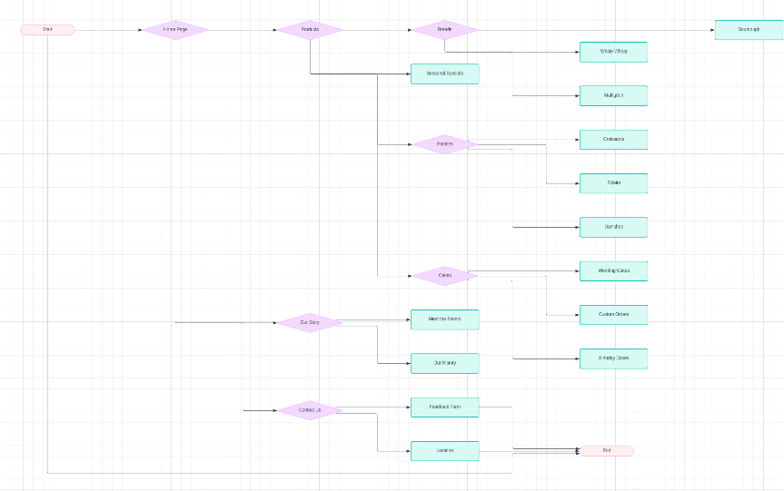
e. Flowchart (Storyboard/Website Organization)

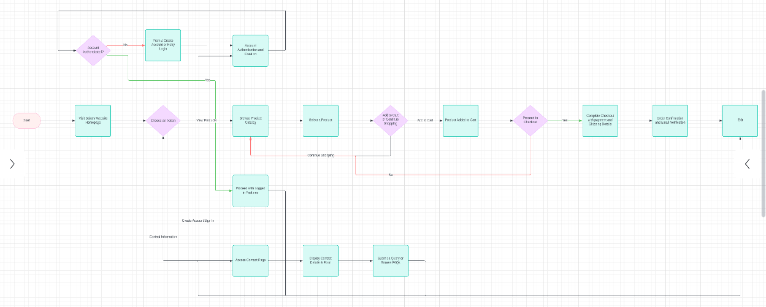

f. Create a wireframe for each page of your website using any computer tool. Make sure the logo, navigation, content, and footer regions are apparent. Save the produced wireframes as jpg or gif files.

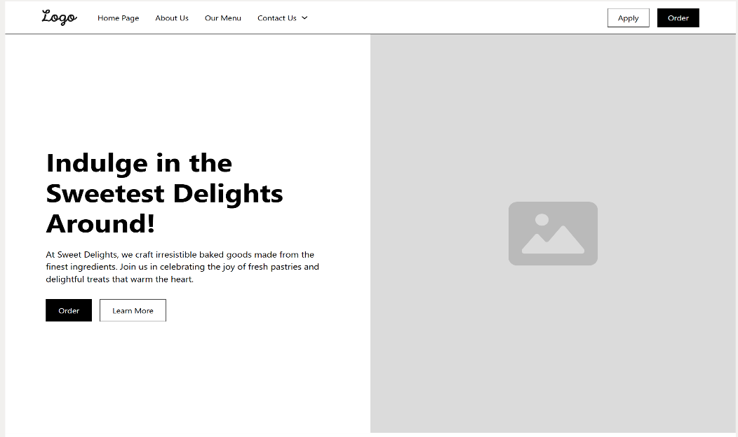

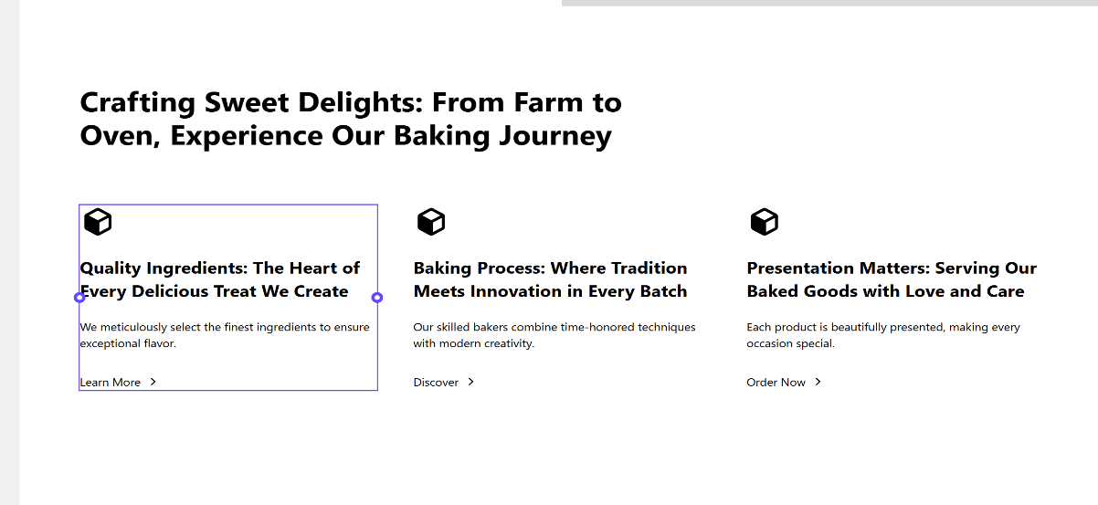

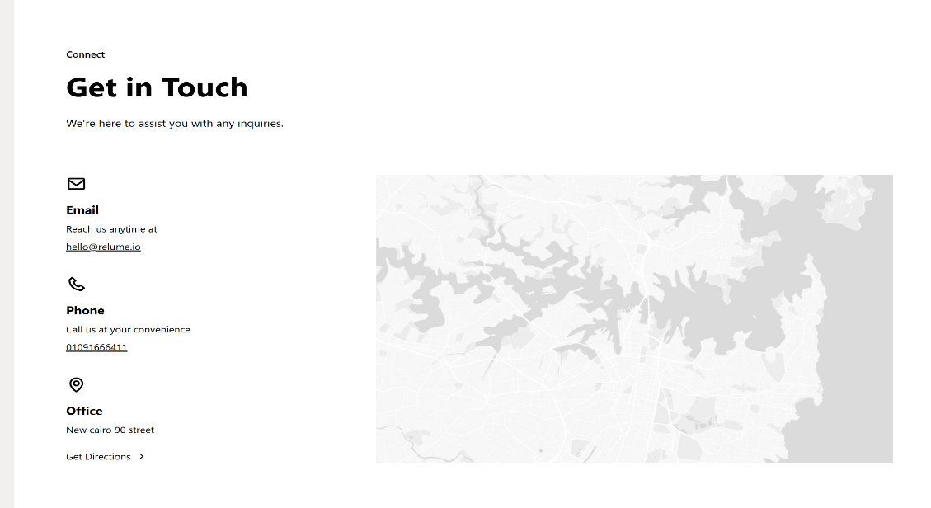

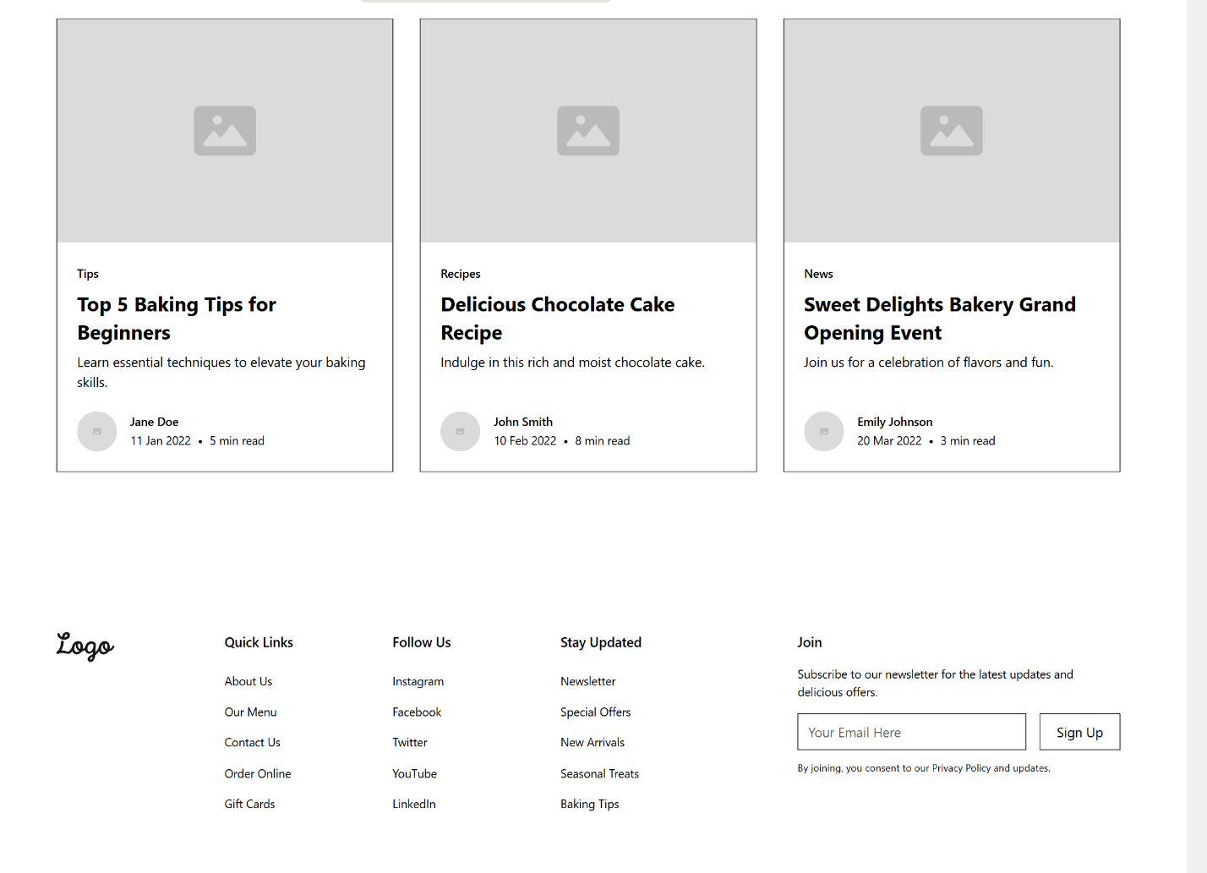
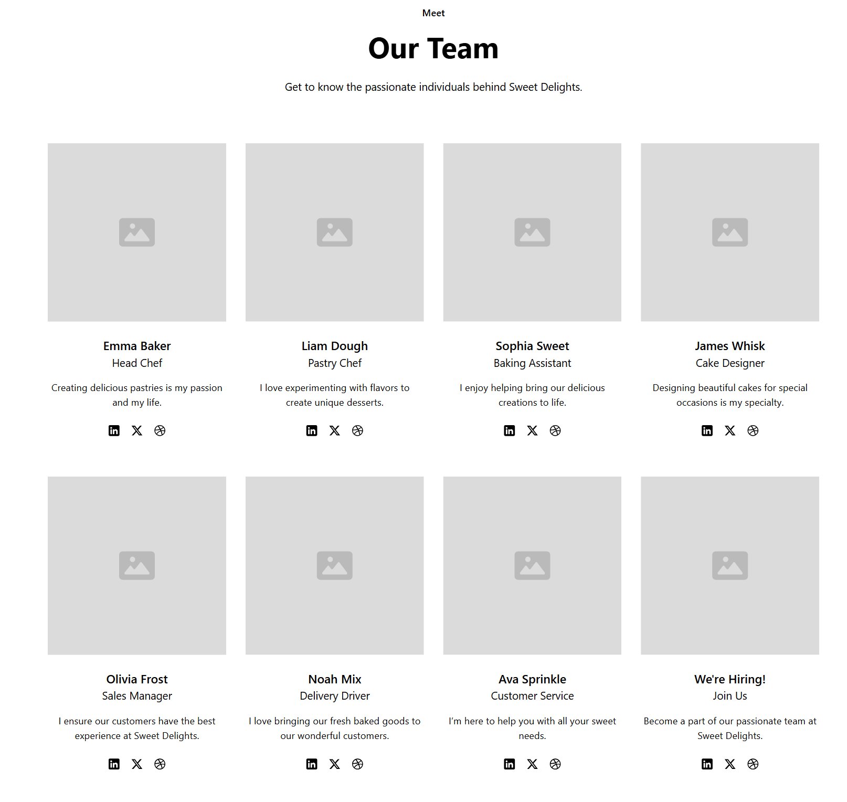
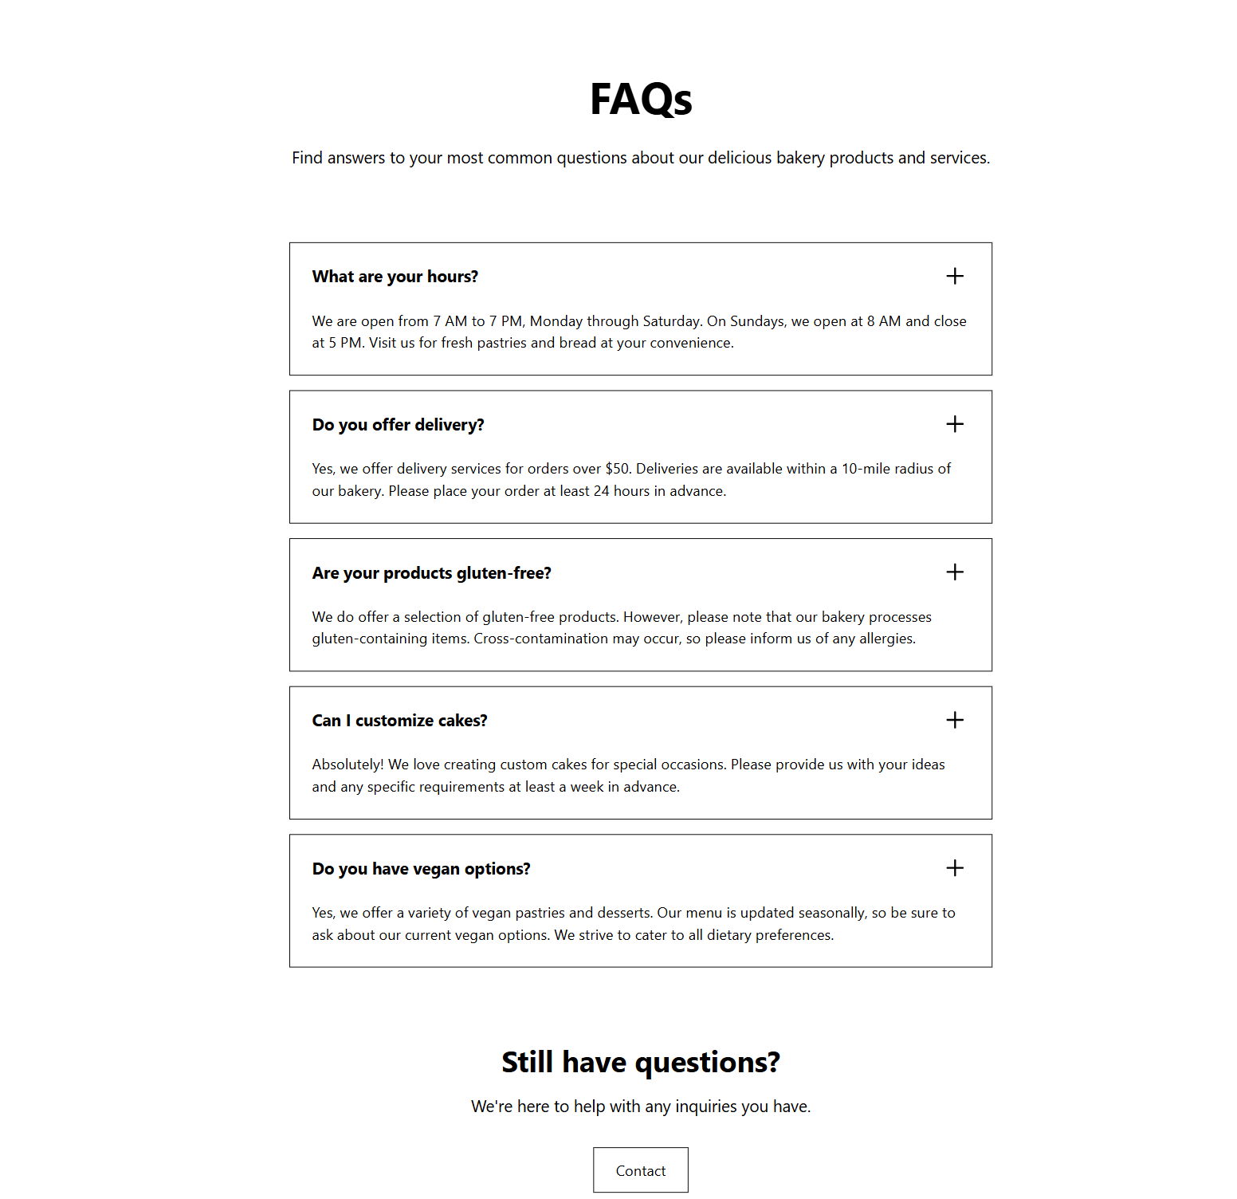

[A] Gestalt Web Design Principles Implementation
1. Law of PRAGNANZ (Good Figure, Law of Simplicity)
- Implementation: Each page will have a clean, simple design with only essential elements to avoid clutter. The layout will focus on presenting information in a straightforward, minimalistic way, using large, clear images of baked goods and concise text.
- Example: On the Our Products page, each product will be displayed with a simple, high-quality image and brief description, helping customers quickly identify items without excessive details or distracting visuals.
2. Closure (Linking Individual Elements to Form a Pattern)
- Implementation: Elements such as product cards, testimonial quotes, and blog posts will be arranged in a grid format to give a sense of unity, even though they are individual items. Users will naturally perceive these individual items as part of a cohesive group.
- Example: On the Gallery page, images will be arranged in a grid with consistent spacing, encouraging users to view them as a collective showcase of bakery offerings, events, and customer photos.
3. Symmetry and Order (Effectively Communicate Information Quickly)
- Implementation: Each page will use balanced layouts and consistent navigation to communicate information in a structured manner, allowing users to quickly understand and engage with content.
- Example: On the Homepage, a balanced three-column layout will separate featured products, recent blog posts, and special offers, enabling users to identify main sections at a glance and navigate intuitively.
4. Figure/Ground (Relationship Between Positive Elements and Negative Space)
- Implementation: Ample white space will be used around images, text blocks, and buttons to distinguish key elements from the background and enhance readability. This separation between content and background makes it easy for users to focus on primary information.
- Example: On the Contact Us page, the form fields and contact information will be positioned with generous spacing around them, making the form fields stand out as the primary interactive area.
5. Uniform Connectedness (Relationship Between Elements)
- Implementation: Elements with similar purposes, such as buttons and links, will be styled uniformly across pages. This consistency reassures users and strengthens their understanding of how interactive elements function.
- Example: Across all pages, buttons like Order Now and Learn More will share the same color and style, indicating they serve a similar purpose of prompting user action. This will help users quickly identify clickable areas.
6. Common Region (Connection Between Elements)
- Implementation: Grouping related content within visual boundaries, such as boxes or shaded backgrounds, will help users recognize relationships between elements. This will make content easier to scan and interpret.
- Example: On the Online Ordering page, each product category will be visually grouped in sections with background color distinctions, helping users understand that products within each section are related.

7. Proximity (Utilizing Empty Space to Create Relationships)
- Implementation: Related elements on each page will be grouped close together with ample space separating unrelated sections. This use of white space will help guide the user’s eye and convey the relationships between different sections.
- Example: On the Our Products page, items in the same category (e.g., cakes, pastries) will be placed closely together, with space between categories, so users can easily understand which items belong together.
8. Continuation (Continuous Perception of Shapes)
- Implementation: The layout will use lines and flow to create a sense of continuity between sections. This encourages users to naturally follow the content as they scroll, ensuring a smooth user experience.
- Example: A continuous scrolling effect on the Homepage will guide users from the welcome message down through the featured products, blog highlights, and promotional offers, creating a fluid and engaging browsing experience.
9. Common Fate (Synchrony: Items Moving or Changing Together are Perceived as Related)
- Implementation: Elements that interact simultaneously will be grouped to enhance user experience. For instance, hovering effects on buttons or images will respond together to emphasize functionality.
- Example: On the Special Offers page, featured offers will zoom slightly or highlight when users hover over them. This creates a sense of interactivity and connects these elements visually, showing they can be clicked or interacted with.
10. Parallelism (Parallel Elements are Seen as More Related)
- Implementation: Parallel structures and aligned elements will be used to show connections between related items or sections, making it easier for users to understand the layout.
- Example: On the Events & Catering page, two columns will be used for event information and catering packages, with each section aligned horizontally. This structure shows that these offerings are parallel services provided by the bakery.
11. Similarity (Elements with Similar Characteristics are More Related)
- Implementation: Consistent design styles, such as colors, shapes, and fonts, will indicate related elements across pages. Repeating these styles will reinforce the brand identity and improve user navigation.
- Example: Buttons across the site (like Order Now, Subscribe, and Learn More) will share similar styling in color and shape, helping users quickly identify actionable items.
12. Past Experience (Utilizing Observer’s Past Experience)
- Implementation: Familiar elements, such as icons and common web patterns, will be used to match user expectations and make the site easier to navigate without a learning curve.
- Example: On the Contact Us page, using a familiar envelope icon for email or a phone icon for contact numbers will ensure that users instantly understand these functions. Similarly, a “cart” icon in the Online Ordering section will align with common e-commerce conventions.

[B] Deployment of Other Design Concepts
1. Screen Resolution
- Approach: The website will be designed to be responsive, meaning it adapts well to various screen resolutions and devices. The primary design focus will be on a mobile-first approach to ensure a seamless experience on mobile devices (e.g., 375x667) and tablets, then scaled up to fit larger screens (e.g., 1366x768, 1920x1080).
- Color Palette
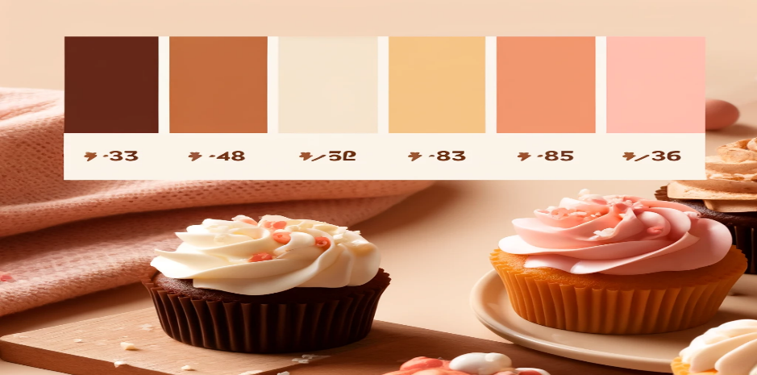

3. Minimum Contrast for Accessibility
- Implementation: To comply with Web Content Accessibility Guidelines (WCAG) standards, the site will maintain a minimum contrast ratio of 4.5:1 for text and background colors. This ensures that text remains legible for users with visual impairments. The color palette will be checked for contrast, especially for text on backgrounds, using tools like Contrast Checker.
4. Front-End Development Technologies
- Technologies: HTML5, CSS3, JavaScript, and React.js (or Vue.js) will be used to create an interactive, responsive, and accessible user interface.
- Frameworks and Libraries: Bootstrap (or Tailwind CSS) for responsive layout, and potentially React for building reusable UI components to enhance interactivity and manage data-driven elements such as the product listings and order form.
5. Content Management Systems (CMS)
- Choice: WordPress or Shopify (for eCommerce-focused needs) would be ideal CMS options, depending on the final site’s functionality.
- Rationale: WordPress offers flexibility and easy customization with plugins and themes, making it suitable for a small business. Shopify would be ideal if the bakery requires more advanced eCommerce capabilities, like inventory tracking and secure payment gateways.
6. Back-End Development Technologies
- Technologies: Node.js and Express for handling server-side requests, with a MongoDB or MySQL database for storing product information, customer orders, and contact form submissions.
- Security: Integration of secure practices such as HTTPS for secure connections and data encryption for user information in transit and at rest.
7. Metrics for Measuring Website Performance
- Key Metrics:
- Page Load Speed: Measured using Google PageSpeed Insights, as faster load times are critical for user experience and SEO.
- Bounce Rate: To understand user engagement and refine site navigation and content.
- Conversion Rate: Particularly for the Online Ordering page, to track the percentage of visitors who complete a purchase.
- User Behavior Flow: Tracking how users navigate between pages to identify drop-off points and optimize flow.
- Accessibility Score: Ensuring the site is accessible to users with disabilities, using tools like WAVE or Lighthouse.
8. HTML5 Page Structure for Every Page
<!DOCTYPE html>
<html lang="en">
<head>
<meta charset="UTF-8">
<meta name="viewport" content="width=device-width, initial-scale=1.0">
<title>Sweet Delights - [Page Title]</title>
<link rel="stylesheet" href="styles.css">
</head>
<body>
<!-- Header Section -->
<header>
<nav>
<a href="index.html">Home</a>
<a href="about.html">About Us</a>
<a href="products.html">Our Products</a>
<a href="order.html">Order Online</a>
<a href="contact.html">Contact Us</a>
</nav>
</header>

<!-- Main Content Section -->
<main>
<section id="hero">
<!-- Hero content specific to the page -->
</section>

<section id="content">
<!-- Main content for each page, such as product listings, blog posts, etc. -->
</section>
</main>

<!-- Footer Section -->
<footer>
<p>© Sweet Delights Bakery - All Rights Reserved</p>
<div>
<a href="privacy.html">Privacy Policy</a>
<a href="terms.html">Terms of Service</a>
</div>
</footer>
</body>
</html>

