Kazakh-British Technical University
Data collection and preparation

STUDENTS' INDEPENDENT STUDY (SIS) №1
What Makes a Bestseller? Analysis of Book Data from Open Library and Wikipedia

Full Name: Nurbergenova Adina, Yessenzhanuly Aidyn,
Satybaldyyeva Gaukhar, Aman Ademi
ID: 24B031930, 23B03034, 23B031430, 24B031636

04.10.2026
Almaty

1. Introduction
This project examines whether publication year, page count, edition count and reader ratings are related to estimated sales of best-selling books. Our four-member team collected data from an API and a web page, cleaned and merged the datasets, and analyzed them in Python using pandas, Matplotlib and Seaborn.

2. Data collection
Gaukhar collected metadata using the Open Library Search API: three pages of 100 records for each of 10 genres (3,000 rows). The data included titles, authors, publication years, page counts, editions and ratings. A separate initial cleaning step produced 2,979 rows.
Aidyn used requests and BeautifulSoup to scrape Wikipedia’s “List of best-selling books” after checking robots.txt. The resulting 169 records included titles, authors, years, genres and approximate sales. Footnotes and number formats were cleaned before export.
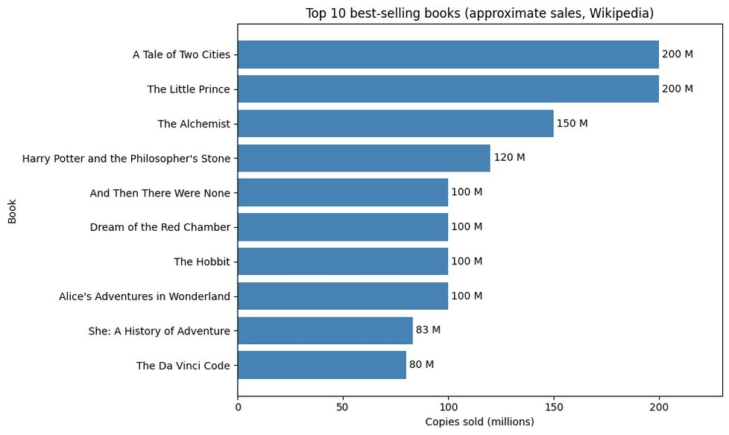
Figure 1. Ten best-selling books from the scraped Wikipedia data.
Figure 1 compares the ten highest sales estimates in the scraped Wikipedia table. These books come from the Wikipedia sample, before the two datasets were merged.

3. Data cleaning and merging
Adema merged two previously cleaned files: Open Library (2,979 rows) and Wikipedia (169 rows). She rechecked missing values and duplicates, filled 44 missing Wikipedia genre values with "unknown", and normalized API titles. After removing repeated titles, 1,949 unique API books remained. An inner join on cleaned titles matched 55 books. For 12 conflicting years, Wikipedia was preferred. The final dataset has 55 rows, 12 columns and no missing values or duplicates.

4. Exploratory data analysis
Adina analyzed the 55 matched books using descriptive statistics and Pearson and Spearman correlations. The average publication year was 1956.93, the average page count 352.73, and average estimated sales 35.53 million copies (median: 21 million).
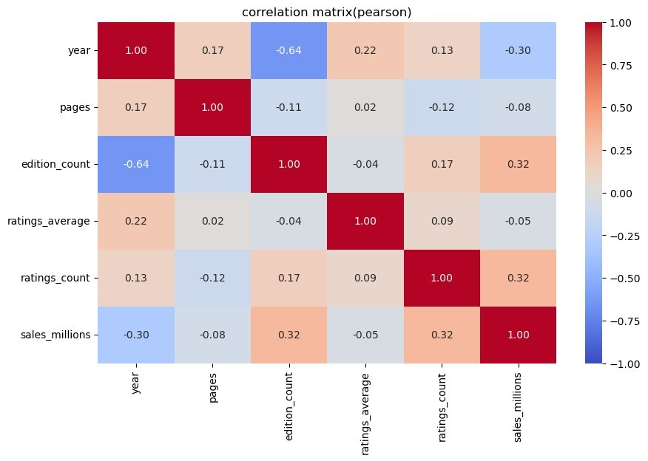
Figure 2. Pearson correlation matrix for the numerical features.
Figure 2 shows a negative Pearson correlation between publication year and edition count (r = −0.641): older books tended to have more editions. The relationship between pages and sales was almost zero (r = −0.080). Edition count and sales had a moderate Spearman correlation (ρ = 0.452).
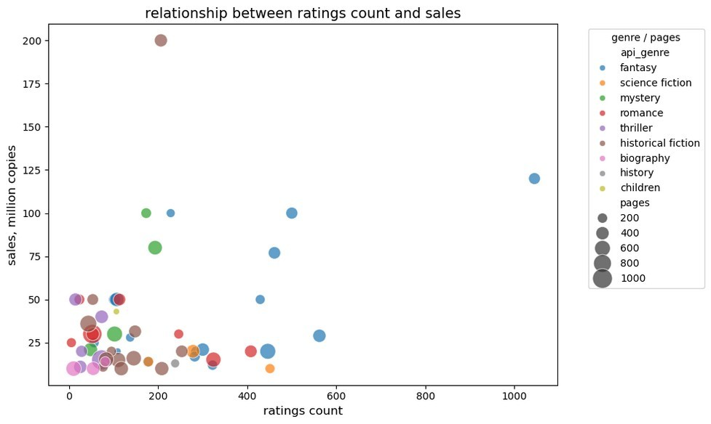
Figure 3. Ratings count and estimated sales, grouped by genre and page count.
Figure 3 compares ratings count and sales. Most books cluster at lower sales, with a few high-selling outliers; the pattern is not consistently monotonic.
5. Key findings
Older books tended to have more editions (Pearson r = −0.641), and books with more editions tended to have higher estimated sales (Spearman ρ = 0.452). Page count showed almost no linear relation to sales (r = −0.080). Ratings count had a positive Pearson association with sales (r = 0.324), but its Spearman association was weak (ρ = 0.093). These patterns do not prove causation.
6. Statistical significance
A p-value measures how surprising a result would be if there were no association. Using p < 0.05, year–editions (Pearson p < 0.0001) and editions–sales (Spearman p ≈ 0.0005) were significant, but pages–sales (Pearson p = 0.559) and ratings count–sales (Spearman p = 0.501) were not. With 55 books and multiple tests, weaker findings require caution.
7. Limitations
1. Small sample: only 55 matched books.
2. Selection bias: Wikipedia focuses on very high-selling titles.
3. Sales geography: estimates may mix national and worldwide markets.
4. Title-based merge: translations or similar titles can be mismatched.
5. API genre: labels follow search queries, not verified classifications. After duplicate removal, only the first encountered genre label was retained for books appearing multiple times, so the result depends on the order of our genre queries.
6. Sparse periods: some publication periods have too few books for reliable comparisons.
8. Conclusion
We completed the API → scraping → cleaning → merging → EDA workflow and identified associations involving publication year, editions and sales, but no clear page-count relationship. Because sales are estimated and the matched sample is small and selective, our conclusions are limited. Future work could add more titles, check titles together with authors, and standardize sales estimates across regions.
Sources: Open Library API — https://openlibrary.org/developers/api; Wikipedia — https://en.wikipedia.org/wiki/List_of_best-selling_books

