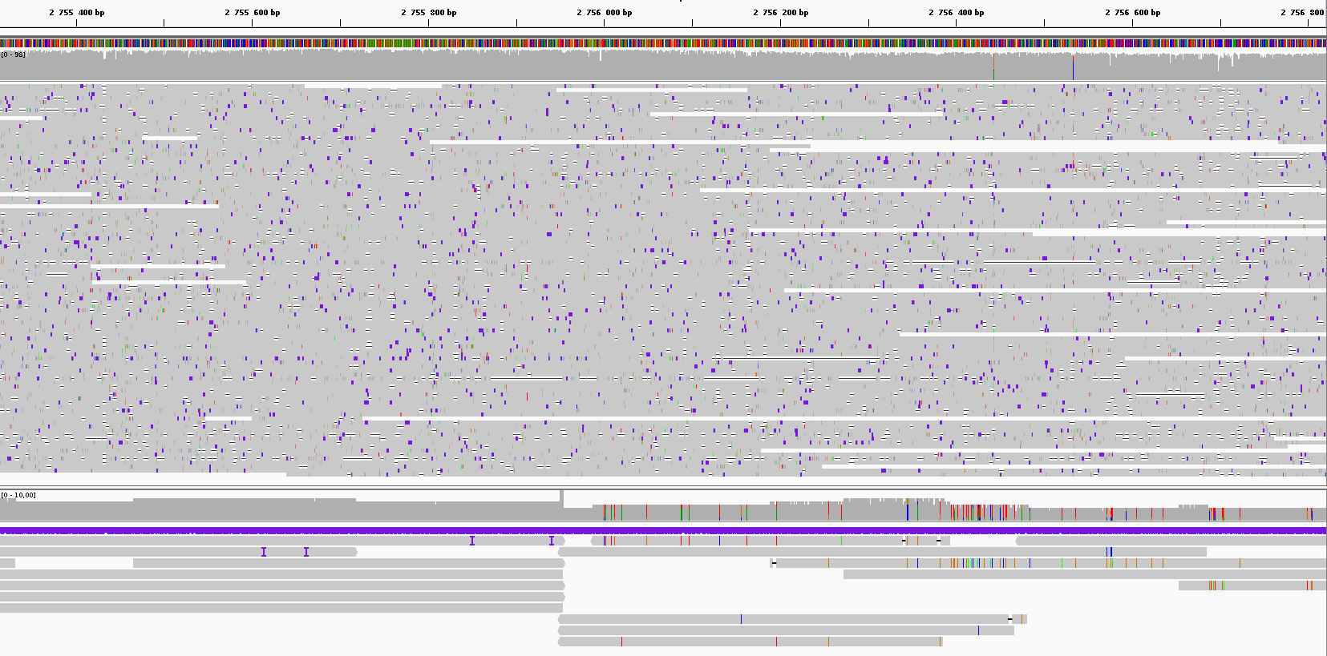
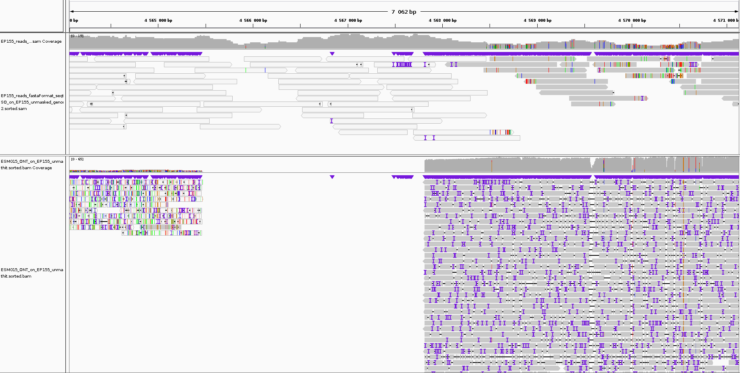
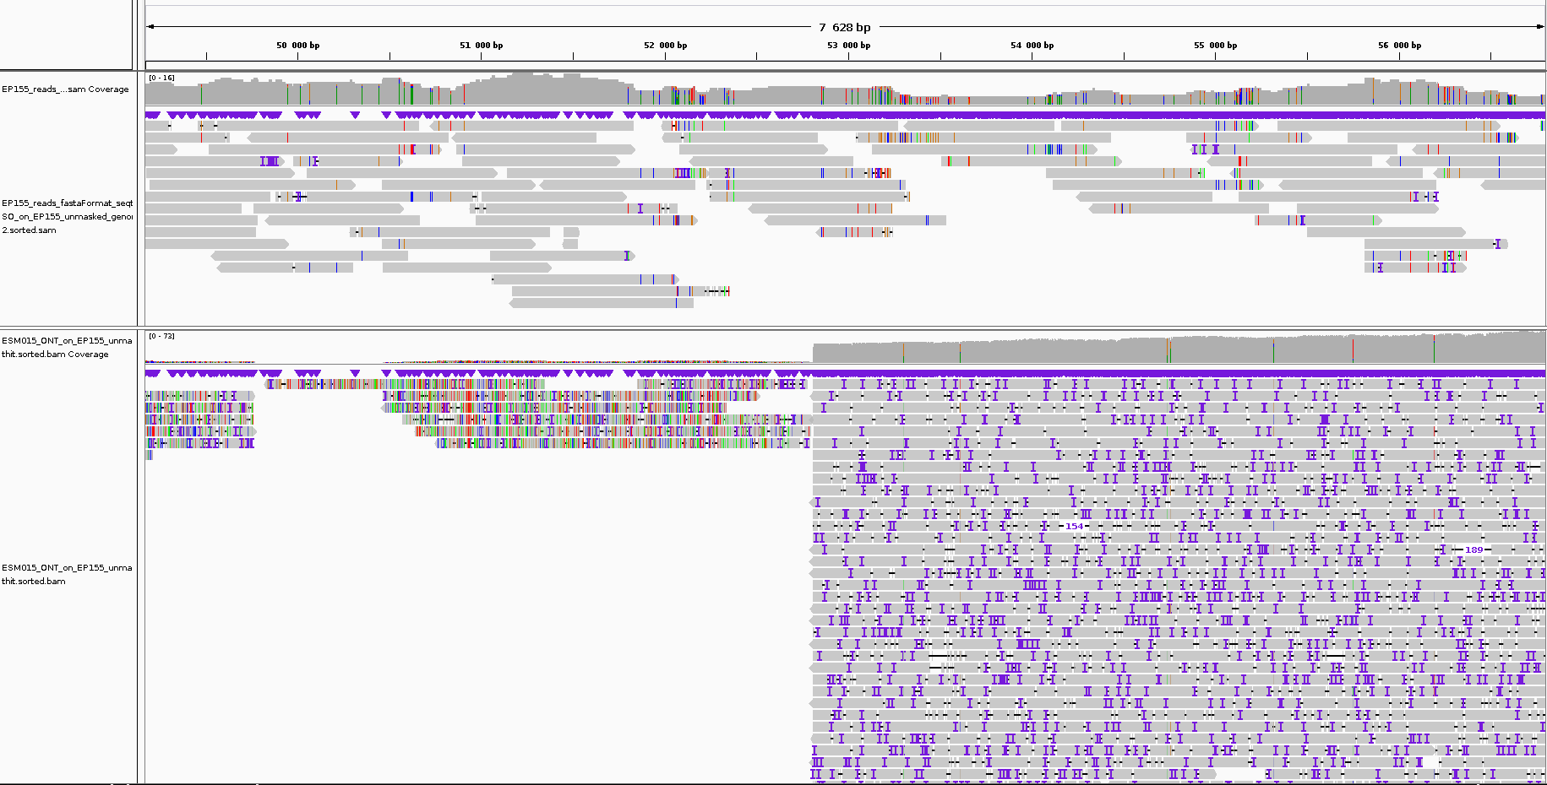
Coverage
Coverage
Mapping
Mapping
ESM015
EP155
ESM_4
Scaffold_1
ESM015
EP155
Scaffold_10
EP155
ESM015
Scaffold used
as reference
Strain of the mapped reads
Synteny break mark
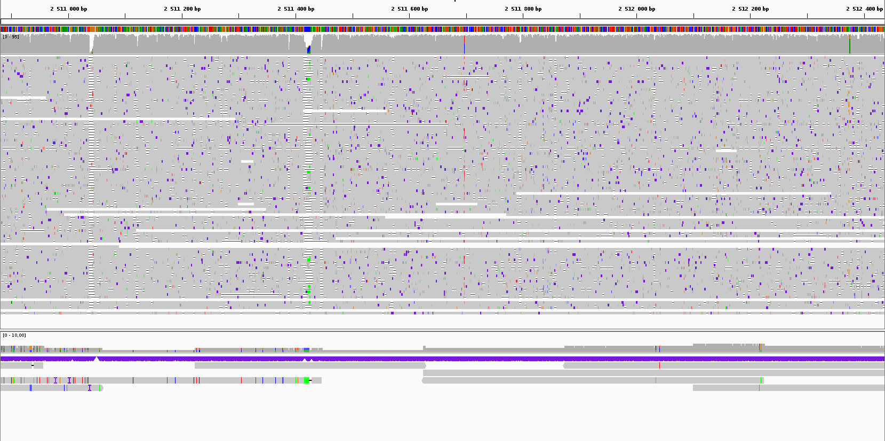
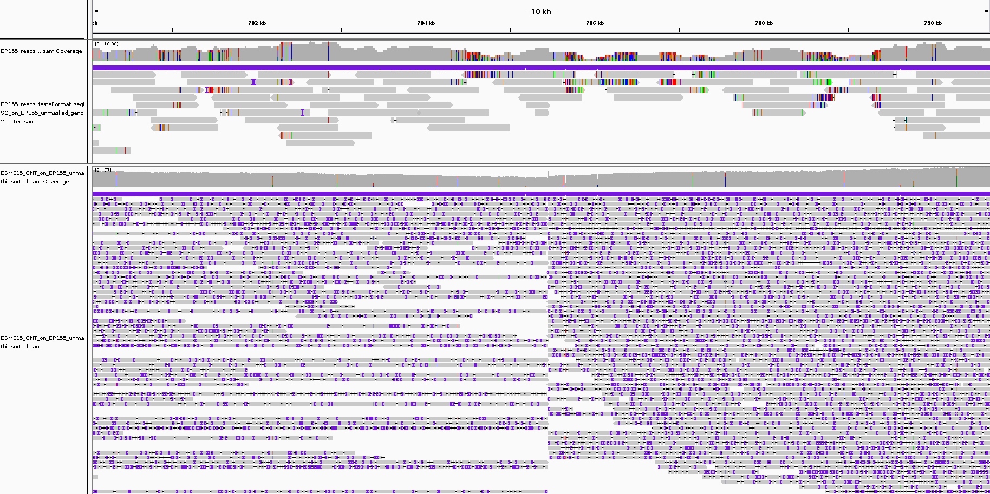
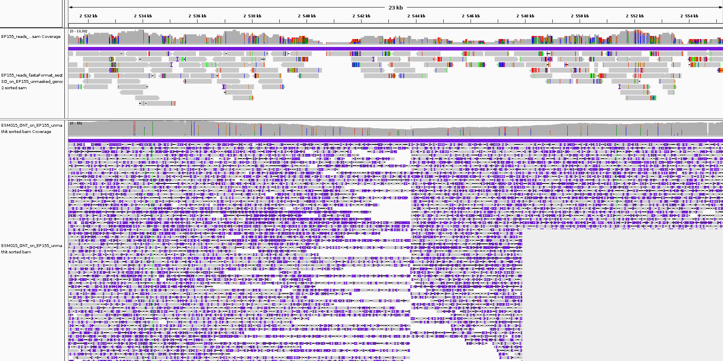
ESM_2
ESM015
EP155
Scaffold_7
EP155
ESM015
Scaffold_5
EP155
ESM015
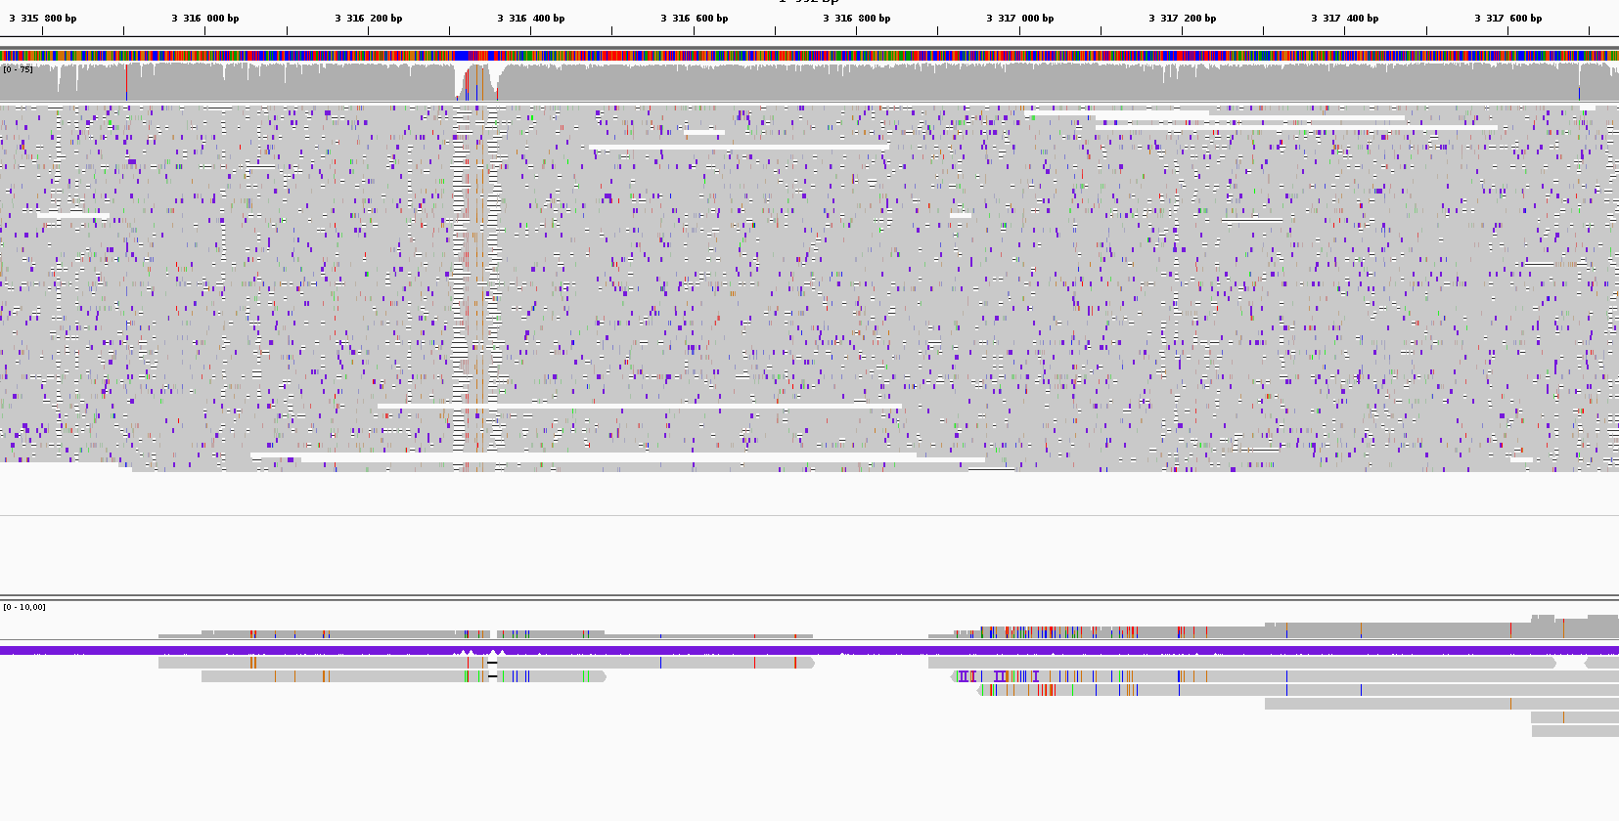
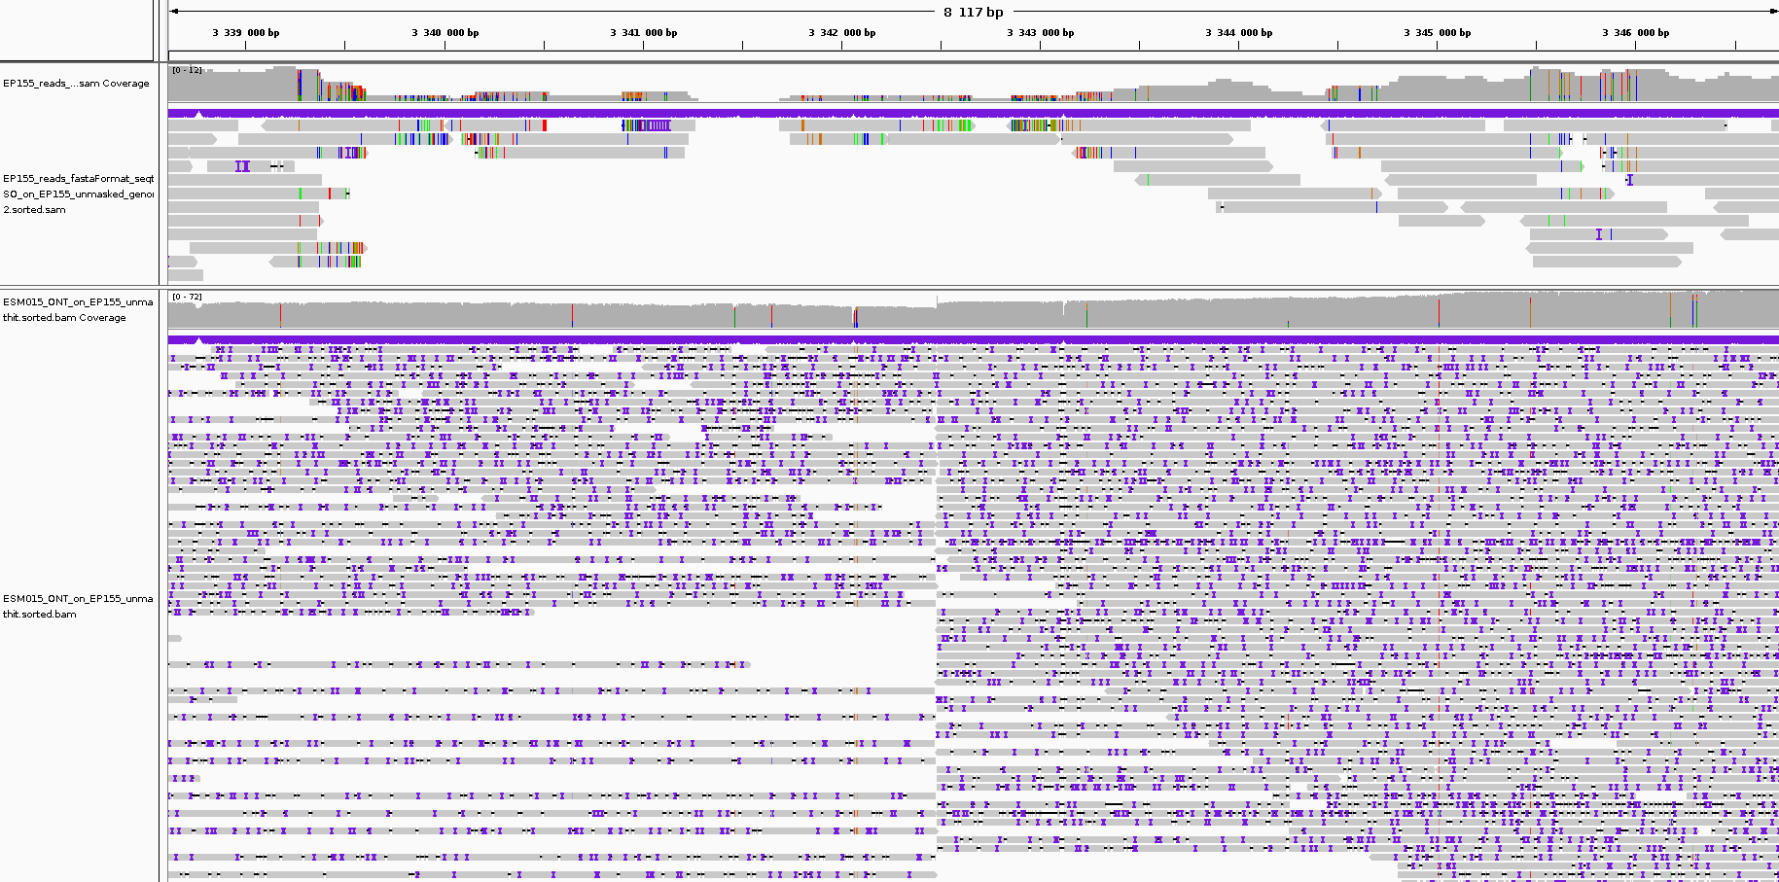
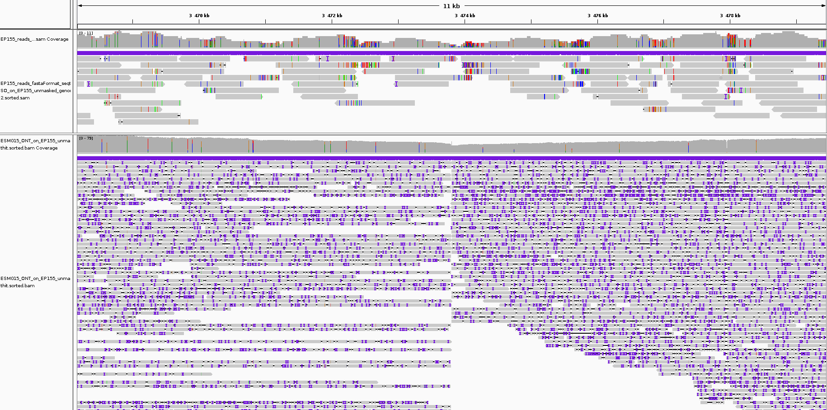
ESM_2
ESM015
EP155
Scaffold_5
EP155
ESM015
EP155
ESM015
Scaffold_2
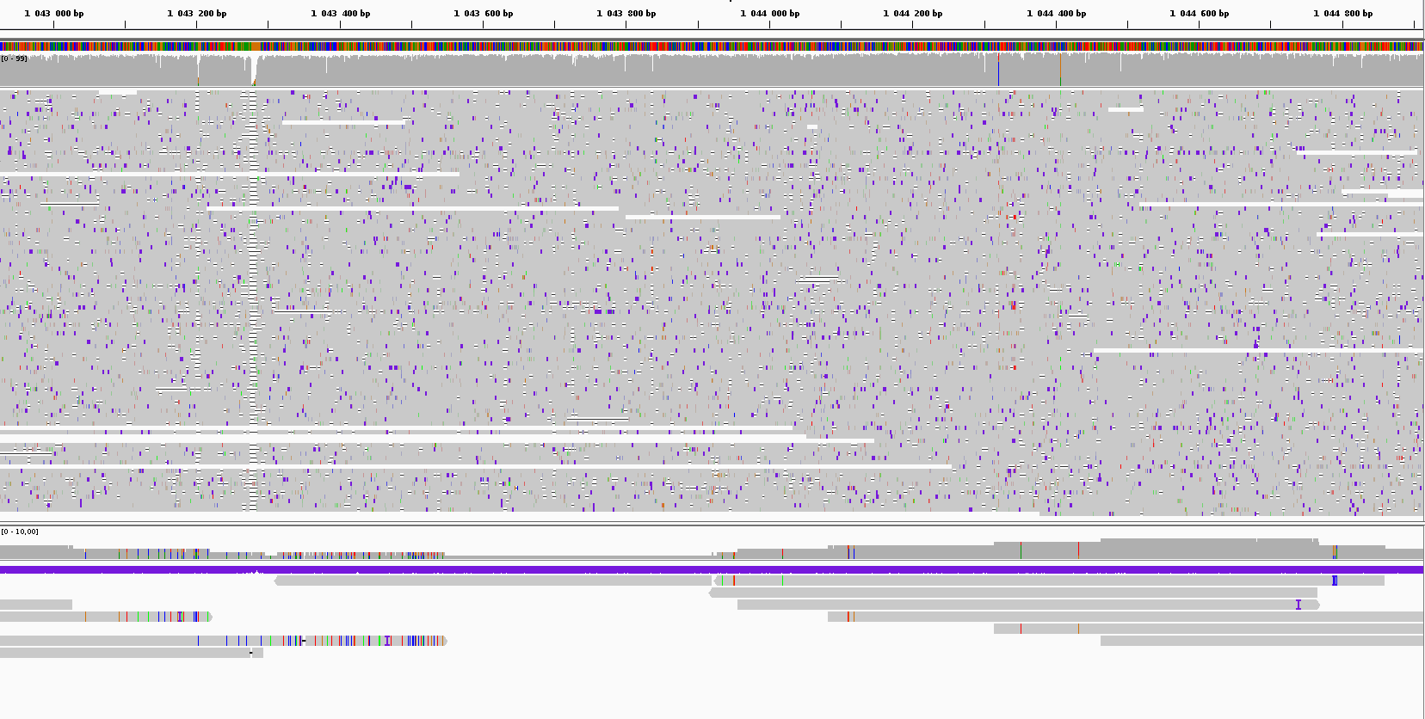
ESM_7
ESM015
EP155
EP155
ESM015
Scaffold_5
ESM015
EP155
Scaffold_2
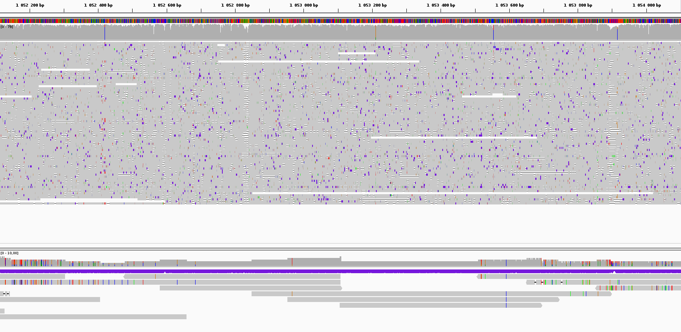
ESM_5
ESM015
EP155
Scaffold_7
ESM015
EP155
Scaffold_5
EP155
ESM015
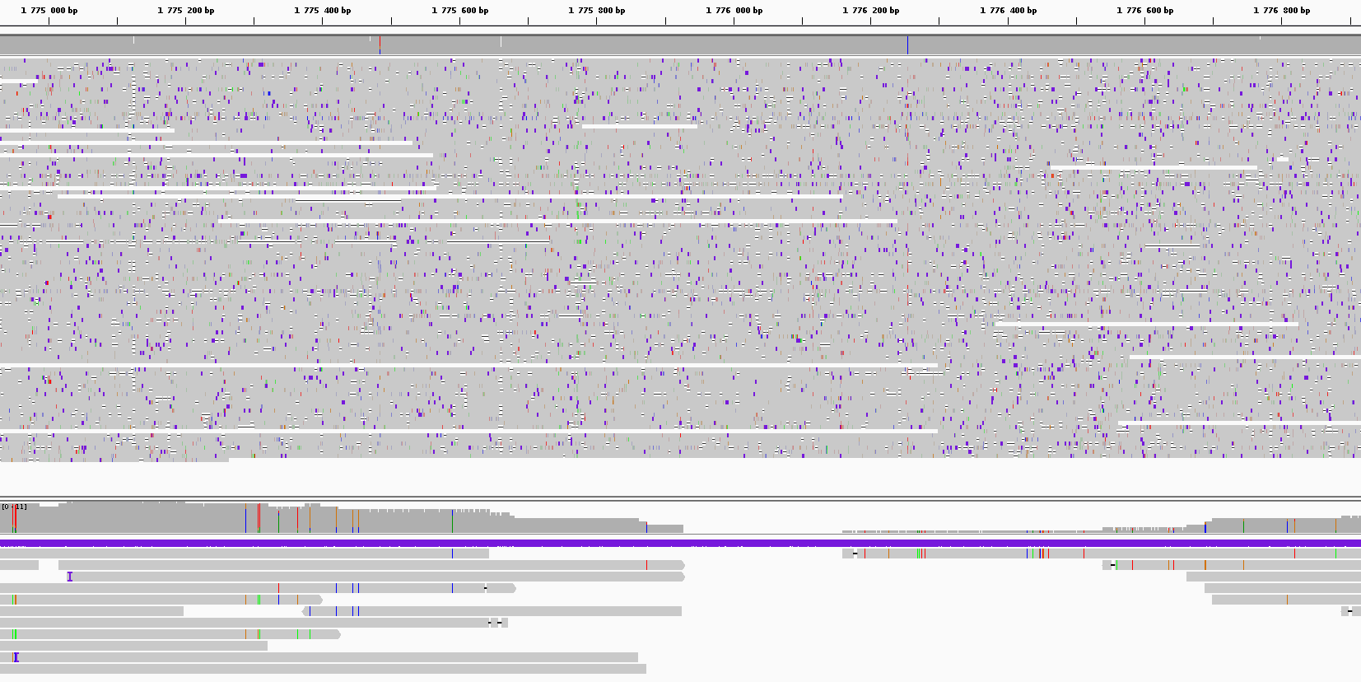
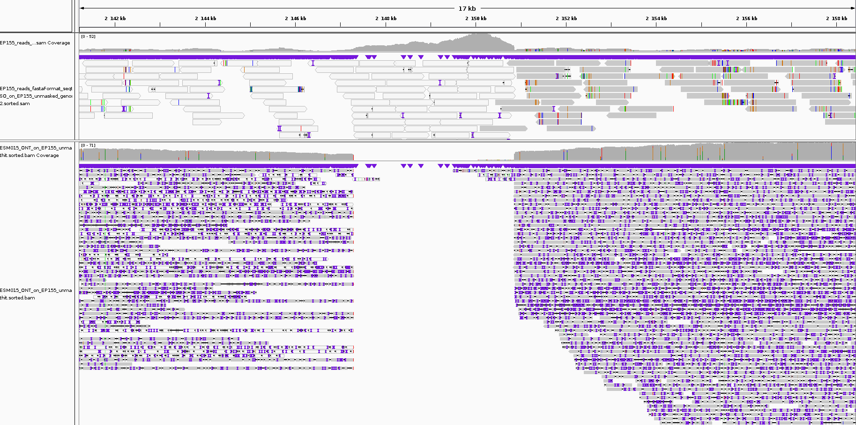
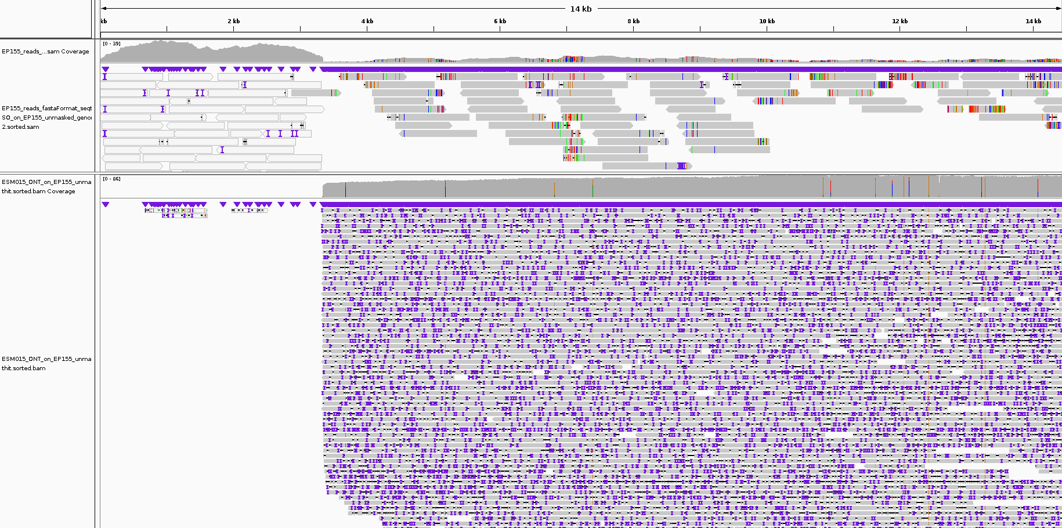
ESM_6
ESM015
EP155
Scaffold_6
EP155
ESM015
Scaffold_6
ESM015
EP155
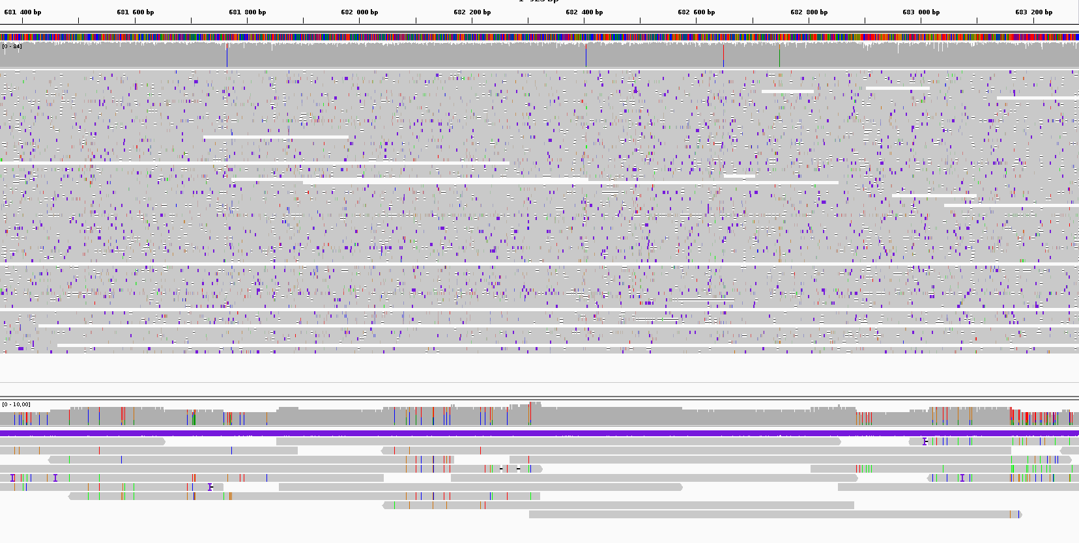
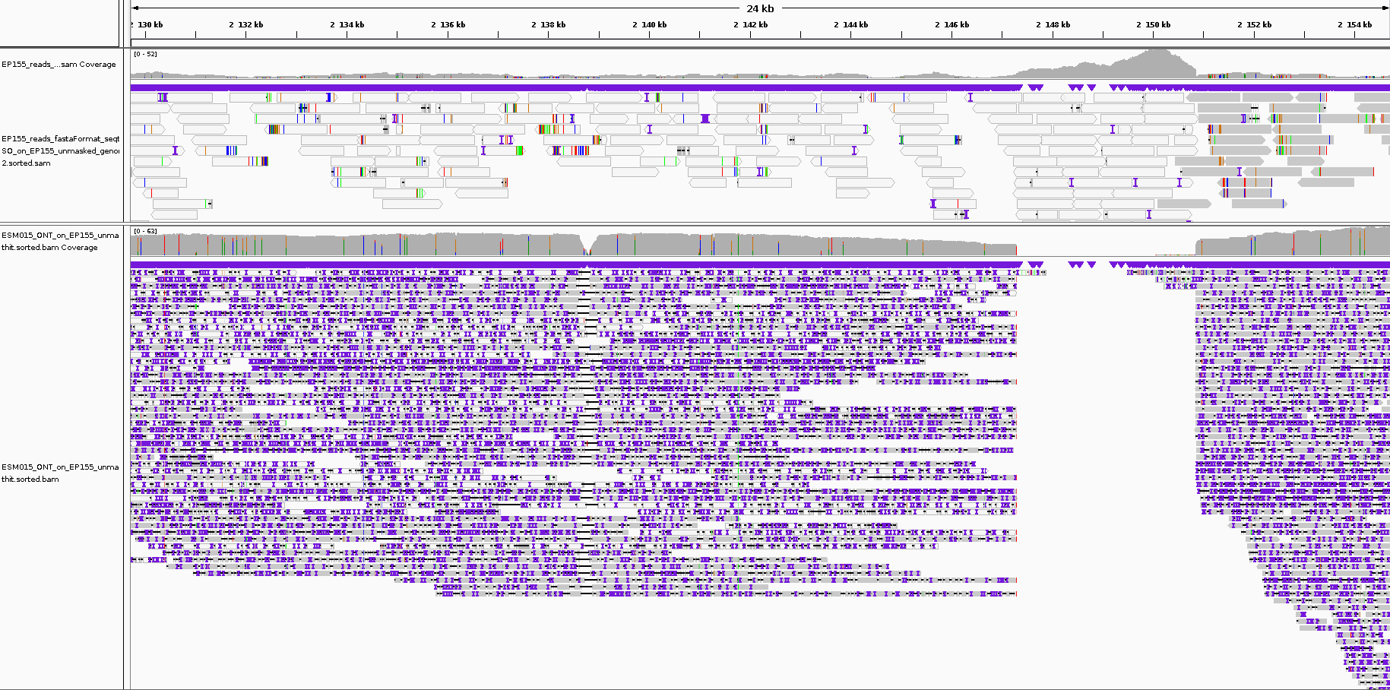
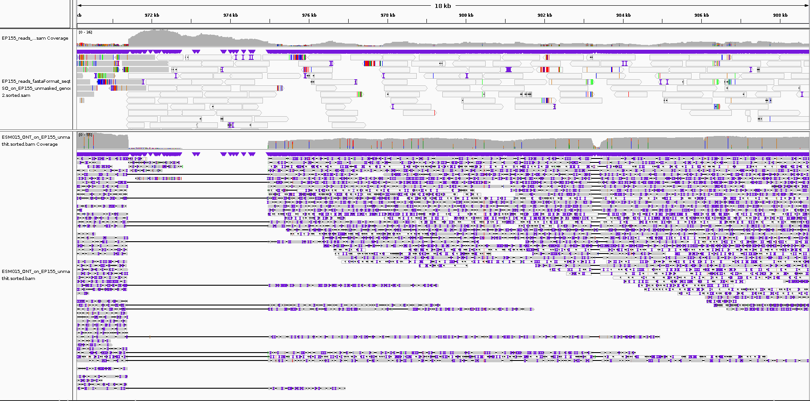
ESM_10
ESM015
EP155
Scaffold_6
ESM015
EP155
Scaffold_11
EP155
ESM015
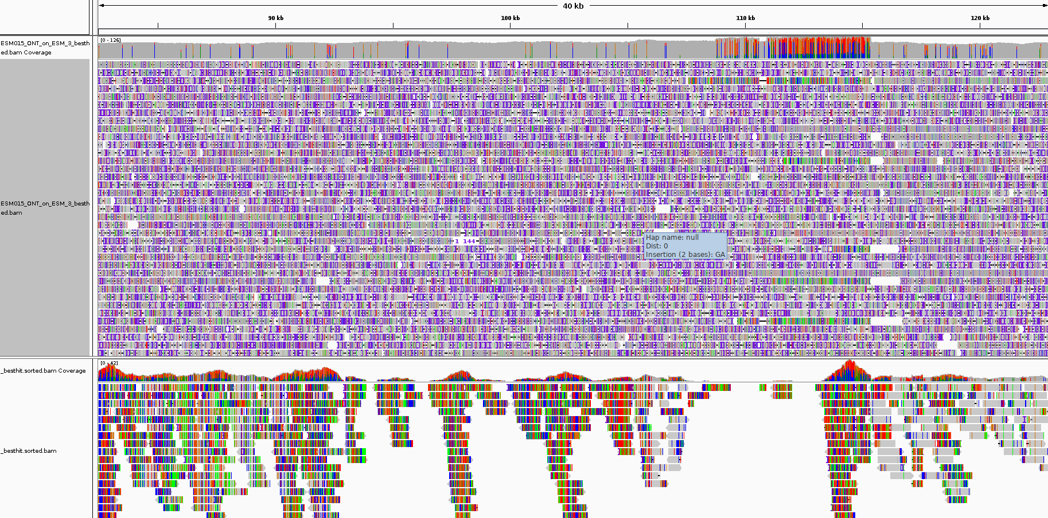
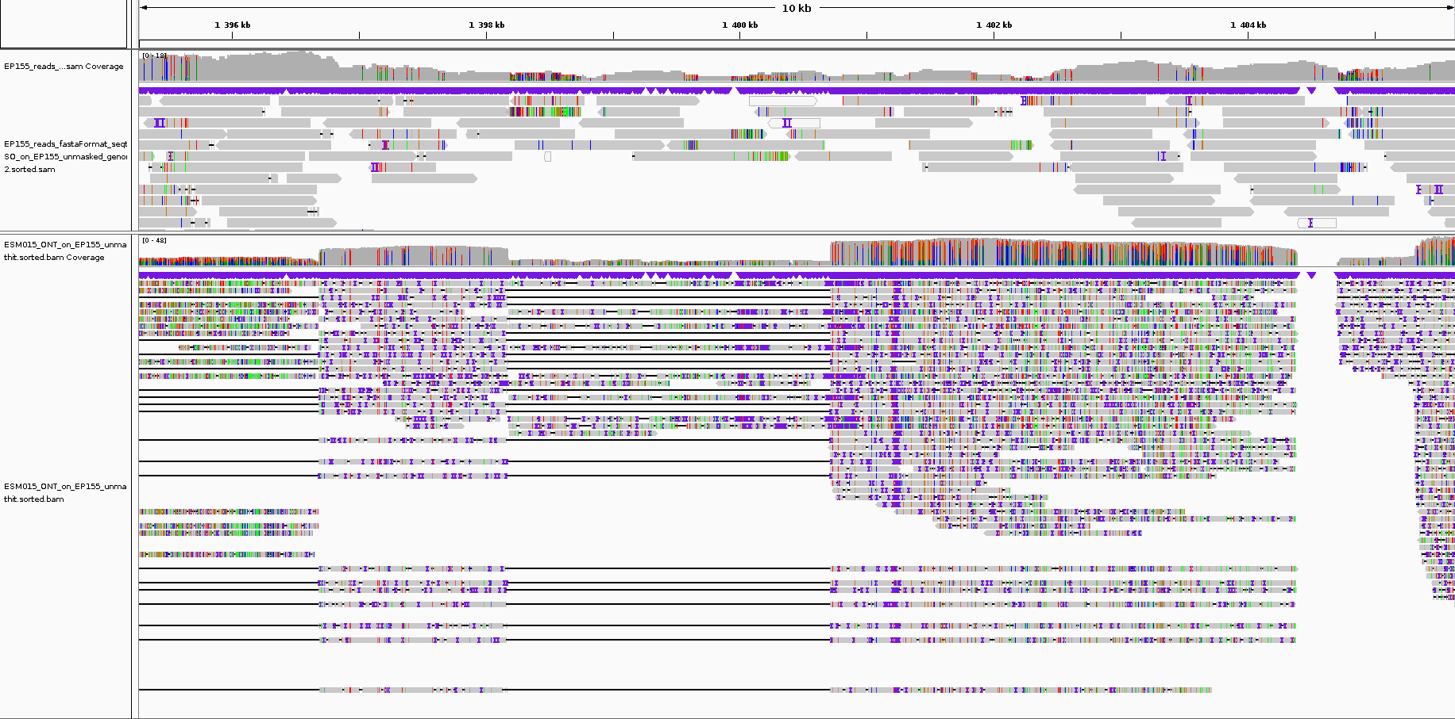
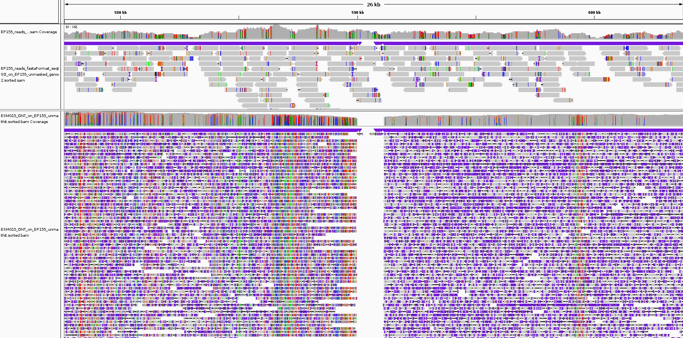
ESM015
EP155
ESM_11
ESM015
EP155
Scaffold_2
EP155
ESM015
Scaffold_2
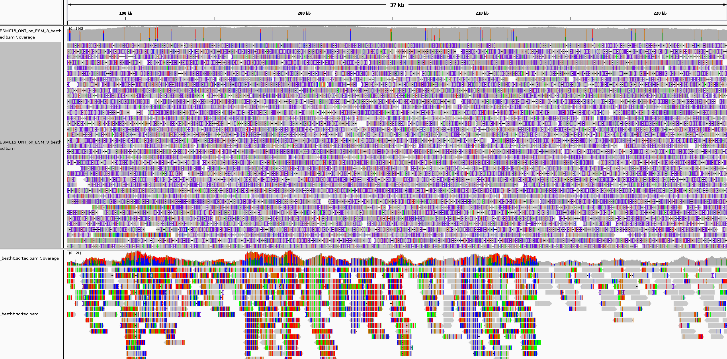
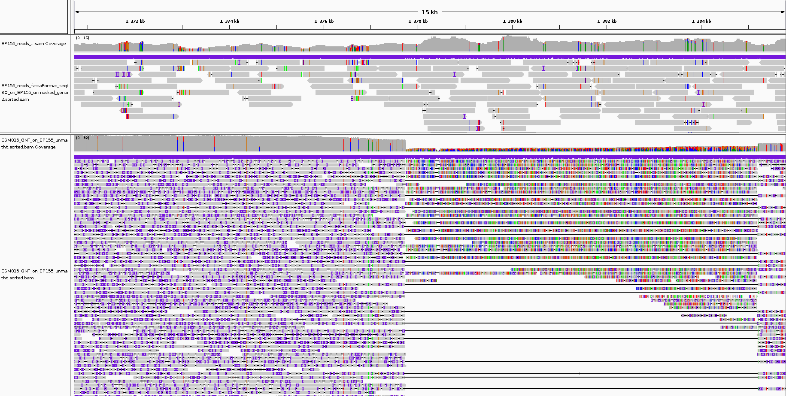
ESM015
EP155
ESM_12
Scaffold_2
ESM015
EP155
Scaffold_2
EP155
ESM015

