MYSHOPEDGE | MSE-CLD-001
Cloud Hosting Document
Where and how the MVP runs, is secured, recovered and paid for
Document ID | MSE-CLD-001
Version and status | 0.1, draft for review
Date | 20 September 2026
Product | MyShopEdge MVP: UK TikTok Shop sellers
Basis | Product Specification v2.0 (requirement IDs such as VIS-1 and BK-2 refer to it)
Related documents | TRD (MSE-TRD-001), Backend Orchestration and Schema (MSE-BOS-001), Data Protection (MSE-DPD-001), QA (MSE-QA-001)

1. Purpose and scope
This document recommends the hosting platform, environments, network and security design, deployment pipeline, monitoring, recovery and capacity plan for the MVP. It is a recommendation for confirmation. Service names refer to AWS; equivalents exist on Azure and Google Cloud.

2. Recommendation in brief
DECISIONS TAKEN
Host on AWS in the London region (eu-west-2), using managed services throughout: containers on ECS Fargate, PostgreSQL on RDS with Multi-AZ, SQS queues, S3 storage, CloudFront and WAF at the edge, Secrets Manager and KMS for secrets and keys.
Backups stay in the UK for now, and all data is backed up. Both are decided (Section 9). Why AWS London: UK data residency for a product holding sellers’ financial data, minimal servers to operate for a small team, and a clear route to scale. Confirm that each service is available in the London region before commitment.

3. Hosting principles
- UK-resident. Primary data and every backup stay in the UK (London region). No copy leaves the UK for now; any change is a deliberate decision reviewed with counsel.
- Managed over self-run. Prefer managed database, queue, secrets and edge services to reduce operational load and risk.
- Private by default. The database and workers have no public addresses. Only the edge and load balancer are public.
- Least privilege. Separate roles per service; no shared credentials; short-lived access for people.
- Everything as code. Infrastructure is defined in code and reviewed like software.
- Cost visible. Every resource is tagged; budgets and alerts are set from the first day.

4. Topology
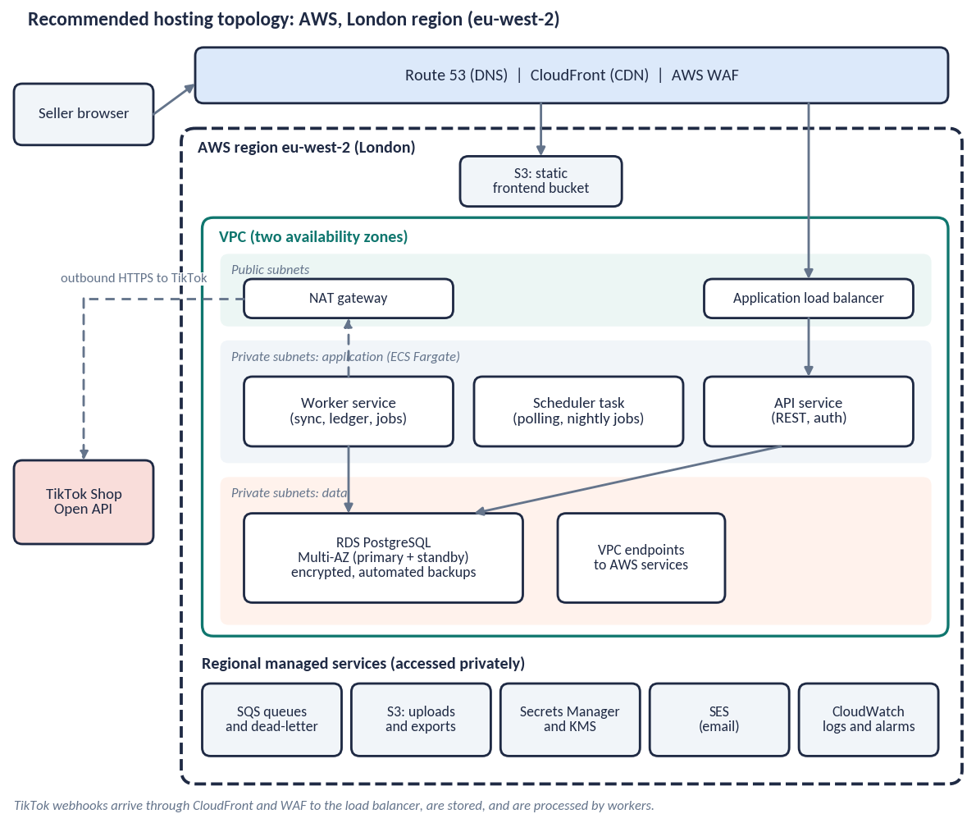
Layer | Service | Role
Edge | Route 53, CloudFront, AWS WAF | DNS, CDN for the frontend, managed rules and rate limiting, webhook path to the load balancer
Frontend | S3 static bucket behind CloudFront | Serves the PWA; long-cached assets; no server
Compute | ECS Fargate: API, worker, scheduler tasks across two availability zones | Runs the containers; scales by task count
Database | RDS PostgreSQL, Multi-AZ, encrypted | Ledger and schema; automated backups with point-in-time recovery
Queues | SQS with dead-letter queues | Ingest, processing, notification and export jobs
Scheduling | EventBridge Scheduler | Polls every 15 minutes; nightly jobs
Files | S3 (uploads, exports) | Private buckets; short-lived signed URLs; lifecycle rules delete files
Secrets and keys | Secrets Manager, KMS | Application secrets; encryption keys per environment; token envelope keys
Identity | Managed identity service | Sign-in and optional MFA (provider to be confirmed)
Email | SES | Verification and critical notices
Observability | CloudWatch logs, metrics, alarms; error tracking | Diagnosis and alerting, scrubbed of personal data

5. Environments
Environment | Account | Data and TikTok | Access
Development | Separate AWS account | Synthetic data; TikTok development shop | Engineers
Staging | Separate AWS account | Golden datasets; TikTok development shop; production-like sizing | Engineers; QA
Production | Separate AWS account | Real seller data; production TikTok app | Named operators; approval and logging
Production data is never copied to lower environments. Test data is synthetic or comes from consented pilot files that have been anonymised.

6. Network and security
Control | Design
Network | One VPC across two availability zones. Public subnets hold the load balancer and NAT gateway. Application and data tiers sit in private subnets. Security groups allow only required flows.
Outbound | Workers reach TikTok through the NAT gateway. AWS services are reached through VPC endpoints.
Edge protection | WAF managed rule sets, rate limits on sign-in, upload and webhook paths, and request size limits.
Identity and access | IAM roles per service; no long-lived keys; engineer access through single sign-on with MFA; production access is time-limited and logged.
Encryption | TLS 1.2 or higher in transit; encryption at rest for database, storage and backups with managed keys; per-environment keys; TikTok tokens use envelope encryption.
Secrets | Held in the secrets service; rotated on a schedule; never in images, code or logs.
Detection | Account-level activity logging, threat detection, configuration rules, and alerts on unusual access.
Supply chain | Container and dependency scanning in the pipeline; minimal base images; signed builds.

7. Delivery pipeline
- Source and review. All infrastructure and application changes go through pull requests with review.
- Build and test. The pipeline builds images, runs unit, golden-dataset, integration and security checks, and blocks on failure.
- Deploy. Automatic to staging; production after approval. Rolling deployment with health checks; database migrations run first as a gated step.
- Rollback. Previous image and a tested migration rollback or forward-fix path; rollback in minutes.
- Feature flags. MVP and Release 2 features are switched by configuration, so code can ship before it is enabled.

8. Monitoring and operations
Signal | Alert when | Response
Sync failures | A shop’s sync fails repeatedly or a dead-letter queue is non-empty | Investigate; notify seller if reconnect needed
Feed freshness | A connected shop has had no successful sync for 24 hours | Banner is shown to seller; operations review
API errors and latency | Error rate or p95 latency above threshold | On-call review
Database health | CPU, storage, connections or replication lag near limit | Scale or tune
Reconciliation check | Nightly recomputation differs from stored metrics | Stop and investigate before next release
Security events | Unusual access, WAF spikes, failed sign-in surges | Security response
Cost | Forecast exceeds budget | Review resources
Service objectives (proposed). Availability 99.5% monthly; webhook to screen under 2 minutes at p95; dashboard API p95 under 500 ms. An on-call rota, runbooks for the common failures and a status page are set up before the pilot.

9. Backup and recovery
Item | Design
Targets (proposed) | Recovery point 15 minutes; recovery time 4 hours.
Scope (decided: all data) | Everything the service holds is backed up: the whole database (ledger, seller-entered data, settings, audit and change logs), uploaded and exported files, and configuration. Secrets and keys are recoverable through the secrets service and key policies; infrastructure and application code are held in version control. Backups follow the retention periods in the Data Protection Document, so “all data” never means keeping data longer than promised.
Location (decided: UK only) | Backups are held in the London region in a separate backup account and vault, encrypted with their own key and protected against deletion. AWS currently offers one UK region, so there is no second UK region to copy to; this is accepted for now and revisited with counsel.
Database | Multi-AZ failover for zone loss; automated backups with point-in-time recovery for 35 days; restore tested each quarter.
Storage | Versioning on file buckets; lifecycle rules per retention schedule.
Region loss | Loss of the whole London region is a low-likelihood event. Recovery would rebuild from infrastructure code and restore from the UK backups once the region returns, or after a decision to allow a copy outside the UK. The residual risk is accepted for now. Data is largely a rebuildable projection of TikTok data plus seller-entered records, so seller-entered data is the priority to protect.
Exercises | A restore test before launch and then quarterly; a tabletop incident exercise before launch.

10. Capacity plan
Starting points to be validated by load testing against the sizing assumptions in the TRD.
Tier | Pilot (about 20 shops) | Launch (about 500 shops) | Growth (about 5,000 shops)
API tasks | 1 to 2 small | 2 to 3 | 4 to 8, autoscaled
Worker tasks | 1 small | 2 to 4, autoscaled on queue depth | 6 to 20, autoscaled
Database | Small instance, Multi-AZ | Medium instance, Multi-AZ | Large instance, Multi-AZ, read replica
Queues | Standard | Standard, separate backfill queue | As launch, with per-shop concurrency limits
Storage | Under 50 GB | Hundreds of GB | A few TB with partitioning of the ledger by month
Backfill of new shops is throttled on its own queue so that it cannot starve live processing.

11. Cost management
A costed estimate follows once sizing is confirmed; it should be produced with the provider’s calculator rather than estimated here. The main cost drivers, in likely order, are:
- Database instance, storage and backups.
- Container compute hours across API, worker and scheduler tasks.
- NAT gateway hours and data processing; VPC endpoints reduce this.
- Edge: WAF rules and requests, CDN data transfer.
- Backup storage across the retention period, which grows because all data is backed up.
- Log storage and retention; error tracking; email volume.
Controls: resource tagging by environment and component, budgets with alerts at 50, 80 and 100 per cent, log retention limits, lifecycle rules on files, and a monthly cost review.

12. Compliance alignment
- UK GDPR Article 32 security of processing: encryption, access control, resilience and testing described above.
- Data residency: primary and backup data in the London region.
- Target certifications for the operating company: Cyber Essentials before launch; ISO 27001-aligned controls, with certification decided later.
- Processor terms with the cloud provider and each sub-processor are listed in the Data Protection Document.

13. Decisions
Decision | Status | Outcome
Cloud provider | Decided | AWS
Region | Decided | London (eu-west-2), UK-resident
Backup location | Decided | Kept in the UK for now; reviewed with counsel if this changes
Backup scope | Decided | All data: database, files and configuration, within the stated retention periods
Identity service and its hosting region | Open | To be chosen; UK or EEA preferred
Independent penetration test provider and date | Open | Before the pilot
On-call arrangement during the pilot | Open | To be agreed

