MYSHOPEDGE | MSE-TRD-001
Technical Requirements Document
Architecture, technology choices and engineering rules for the MVP
Document ID | MSE-TRD-001
Version and status | 0.1, draft for review
Date | 20 September 2026
Product | MyShopEdge MVP: UK TikTok Shop sellers
Basis | Product Specification v2.0 (requirement IDs such as VIS-1 and BK-2 refer to it)
Related documents | SRD (MSE-SRD-001), Backend Orchestration and Schema (MSE-BOS-001), Cloud Hosting (MSE-CLD-001), API Integration (MSE-API-001), QA (MSE-QA-001)

1. Purpose and scope
This document sets out how the MVP shall be built: the architecture, the recommended technology, and the engineering rules that protect the properties the product depends on, above all exact money, a traceable ledger and safe handling of seller data. Technology choices are recommendations with alternatives, for confirmation by the engineering lead.

2. Technical principles
Principle | Engineering consequence
Money is exact | Integer pence, never floating point. One calculation library owns all rounding. Golden datasets guard it.
The ledger is the truth | Append-only ledger; every screen figure is derivable from ledger rows and stock movements; corrections are new entries.
TikTok is the record | TikTok values win on conflict; seller values are kept; the difference is a first-class object.
Idempotent everywhere | Every job and event carries an idempotency key. Retrying can never double-post.
Read-only integration | The TikTok connector holds only read scopes. No code path writes to TikTok.
Minimal personal data | Buyer fields are dropped at the edge of ingestion. Financial data is encrypted and tenant-isolated.
Explainable | Insights and tax figures come from versioned rules with visible inputs; nothing is a black box.
UK-resident | Primary storage and processing in the UK region.

3. Architecture
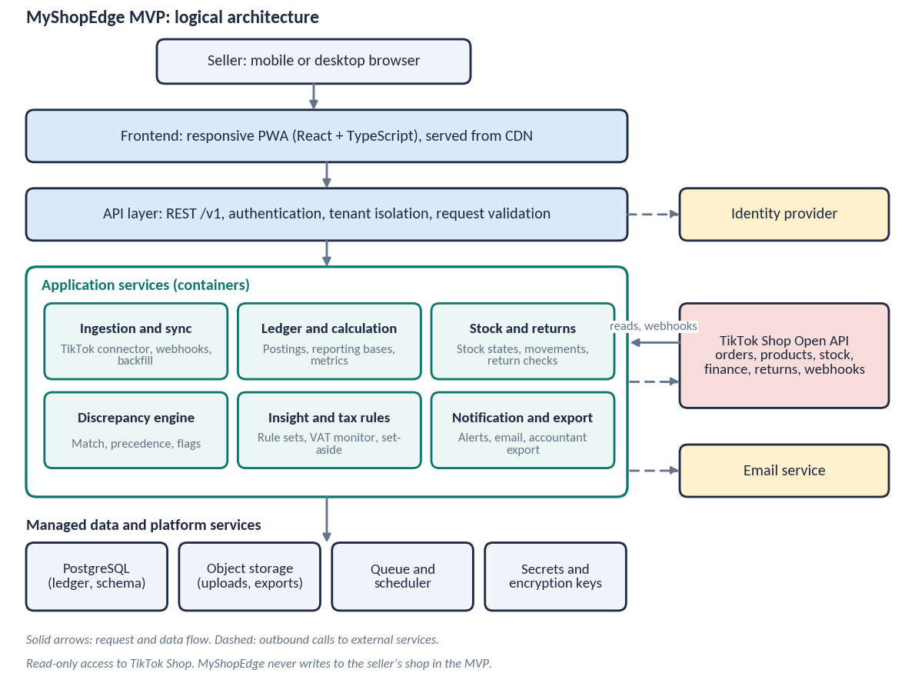
Component | Responsibility | Recommended technology
Frontend PWA | Mobile-first interface; caches last figures for brief offline reading; charts as accessible SVG | React, TypeScript, Vite; CSS variables for design tokens
API layer | Authentication, tenant isolation, validation, REST /v1 | Node.js with TypeScript (NestJS or Fastify); OpenAPI generated
Ingestion and sync | TikTok connector, webhook receiver, backfill, polling, raw event store | Worker processes on the same codebase; queue-driven
Ledger and calculation | Posting rules, reporting bases, daily metrics, month summary | Shared calculation package; PostgreSQL functions only for idempotent writes
Stock and returns | Stock states, movements, return lifecycle | Domain module with database constraints as a second guard
Discrepancy engine | Match, apply precedence, open and resolve flags, change log | Domain module
Insight and tax rules | Versioned rule sets, VAT monitor, set-aside, dates | Rule tables in the database; pure functions
Notification and export | In-app notices, email, Excel and CSV generation | Worker jobs; ExcelJS for files; managed email service
Data stores | Ledger and schema; uploads and exports; queues; secrets | PostgreSQL 15+; object storage; managed queue; managed secrets and keys

4. Technology decisions
Decision | Recommendation | Why | Alternative
Language | TypeScript across frontend and backend | One language, shared types and calculation code | Kotlin or Python for backend
Database | PostgreSQL | Transactions, constraints, row-level security, JSON where needed | MySQL; not recommended for RLS
Queue | Managed queue with dead-letter (SQS) | Simple, reliable, no servers | BullMQ on Redis
Scheduling | Managed scheduler for polls and nightly jobs | No always-on cron host | In-app scheduler
Identity | Managed identity provider with email login and optional MFA | Avoids storing passwords; supports UK region | Self-built auth; not recommended
Hosting | AWS London region on containers | See MSE-CLD-001 | Azure UK South; GCP London
Infrastructure as code | Terraform | Repeatable environments | AWS CDK
Observability | Structured logs, metrics, traces; error tracking | Faster diagnosis; scrubbed of personal data | Vendor APM
Feature flags | Configuration table read at request time | Phase MVP and R2 features safely | Flag service

5. Key technical designs

5.1 Calculation engine
- All amounts are BigInt pence in code and BIGINT in the database. Display formatting rounds half up to two places; percentages to one place.
- Formulas follow Product Specification v2.0 Section 8 exactly. Each formula is a pure function with a golden test.
- Contribution is computed only when a valid cost exists; the function returns “not available” otherwise, never zero.
- Reporting bases: the sales basis groups ledger rows by basis_month; the cash basis groups by settlement_month. A nightly check asserts Net Proceeds = Paid Out + Awaiting Settlement per order month.
- Daily metrics are a cache. They can be rebuilt from the ledger and are compared to a recomputation each night.

5.2 Ledger and stock
- Ledger writes are inserts only. The application role has no update or delete permission on the ledger table.
- A unique index on shop, source, source reference, entry type and category makes reposting a no-op.
- Stock positions are a projection of TikTok stock plus movements. A unique index prevents a return item being applied twice.
- Units in hand equals On the shelf plus Sold, not posted; a test asserts the identity on every recalculation.

5.3 Discrepancy engine
- Seller-supplied values (from cost uploads and confirmations) are compared with TikTok records after each sync.
- On difference the TikTok value is applied, the seller value is stored on the discrepancy, and a notification is created with a dedupe key.
- Resolution writes a change log entry and, where the seller corrects their record, updates only the seller-owned field.

5.4 Insight and tax rules
- Insight rules and tax parameters live in versioned tables (reference_rules and a rules configuration). A rule change is data, not a release.
- Each insight stores its inputs, so the seller can see the figures behind it and QA can replay it.
- The VAT monitor computes rolling 12-month turnover at each month end, projects on the current monthly rate with the oldest months dropping out, and evaluates the 30-day forward test.

5.5 Multi-tenancy and access control
- Every shop-scoped table carries shop_id. Row-level security limits every query to shops owned by the signed-in account.
- The application sets the account context per request inside a transaction. A test suite tries cross-account reads on every endpoint.
- Support staff have no default access to financial data. Any access is time-limited, approved and logged.

5.6 Security architecture
- TikTok tokens use envelope encryption with a managed key; the key version is stored with the token for rotation.
- Secrets are never in code or logs. Logs are scrubbed of tokens and financial values where not needed.
- Web hardening: strict transport security, content security policy, same-site cookies, CSRF protection, input validation at the API boundary, rate limiting on authentication and file upload.
- Uploaded files are scanned, size-limited, parsed in an isolated worker, and deleted after the retention period.
- Dependency and container scanning run in the pipeline; releases are signed.

6. Frontend architecture
- Progressive web app with a responsive single-column layout on phones and a centred column with side detail on larger screens.
- Design tokens from the My Shop Buddy design language: brand orange, fixed cost-category colours, Archivo for figures and Plus Jakarta Sans for text, self-hosted.
- Charts are small custom SVG with text alternatives; no third-party charting service.
- State: server data cached by query key; no financial calculation in the client. The client formats and never computes money.
- Accessibility: keyboard and screen reader support, focus order, contrast, reduced-motion respect, tested in CI with automated checks and by hand before launch.
- Cookies: essential only. Any analytics are first-party events without financial values.

7. Engineering standards
Area | Standard
Code | Strict TypeScript; linting and formatting enforced; code review required; trunk-based with short-lived branches
Testing | Unit and golden-dataset tests on calculation; integration tests against a real PostgreSQL; contract tests on recorded TikTok payloads; end-to-end tests on key journeys (see MSE-QA-001)
Migrations | Versioned, forward-only, reviewed; no destructive change without a two-step release
Environments | Development, staging, production; TikTok development shop attached to non-production
Delivery | Continuous integration; automated deploy to staging; manual approval to production; rollback within minutes
Logging | Structured, correlation IDs across jobs; no personal or token data
Configuration | Environment-specific, typed, validated at start-up

8. Sizing assumptions
Sizing is provisional and drives the cloud plan.
Assumption | Pilot | Launch year | Growth case
Connected shops | 20 | 500 | 5,000
Orders per shop per day | 30 | 30 | 30
Order events per day (all shops) | 600 | 15,000 | 150,000
Ledger rows per order | 6 to 10 | 6 to 10 | 6 to 10
Backfill per new shop | 12 months | 12 months | 12 months
At the growth case the ledger reaches tens of millions of rows a year, which a single PostgreSQL instance with the indexes in MSE-BOS-001 handles, provided reporting reads use daily metrics.

9. Technical risks and spikes
Risk | Spike or control | Exit
TikTok fields differ from assumption | Two-week integration spike on a development shop | Field map signed off
Webhook loss or reorder | Poll and nightly reconciliation; replay tests | Recovery test passes
Rate limits slow backfill | Throttled queue; progress UI | Backfill time measured
Rounding or basis error | Golden datasets; nightly reconciliation | Zero unexplained differences
Cost file variety | Sample files from pilot sellers; mapping tests | Top layouts detected

10. Decisions to confirm
- Decided: AWS in the London region; backups in the UK; all data backed up. Backend framework remains a recommendation for the engineering lead.
- Identity provider choice and MFA policy.
- Whether to store raw TikTok payloads for 90 days or a shorter period (see Data Protection Document).
- Independent security test provider and timing.

