MYSHOPEDGE | MSE-BOS-001
Backend Orchestration and Schema
How data moves from TikTok to the ledger, and how it is stored
Document ID | MSE-BOS-001
Version and status | 0.1, draft for review
Date | 20 September 2026
Product | MyShopEdge MVP: UK TikTok Shop sellers
Basis | Product Specification v2.0 (requirement IDs such as VIS-1 and BK-2 refer to it)
Related documents | TRD (MSE-TRD-001), API Integration (MSE-API-001), Cloud Hosting (MSE-CLD-001), QA (MSE-QA-001). Schema file: MyShopEdge_MVP_schema.sql

1. Purpose and scope
This document defines the backend workflows that turn TikTok events into an exact ledger, stock view and alerts, and the PostgreSQL schema that stores them. The full DDL is supplied as MyShopEdge_MVP_schema.sql and has been parsed and checked for creation order; this document explains its design.

2. Orchestration model
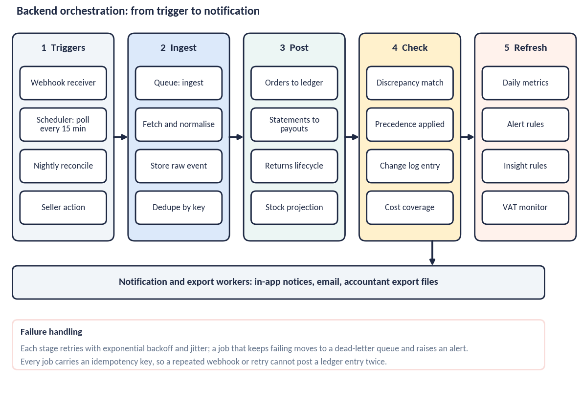
Work is queue-driven. A scheduler and a webhook receiver create jobs; workers execute them in five stages: ingest, post, check, refresh, notify. Each job is small, idempotent and retryable. Jobs for one shop are serialised with a per-shop lock so that events are applied in order.

2.1 Rules that keep it safe
- Persist first, process later. A webhook is verified, stored in raw_events and acknowledged. Processing happens after, so a slow job never causes a TikTok retry storm.
- Idempotency keys. Webhooks use TikTok’s notification ID; polls use shop, domain and cursor; ledger writes use shop, source, source reference, entry type and category.
- Ordering. Per-shop serialisation plus a last_event_at guard: an older event never overwrites newer state.
- Backoff and dead-letter. Retries use exponential backoff with jitter, up to 6 attempts. Exhausted jobs move to a dead-letter queue and alert operations.
- Rate limits. A per-shop token bucket keeps calls within TikTok limits; a 429 delays the job rather than failing it.
- Compensation, not deletion. A wrong entry is reversed by a new entry that references it. Nothing is deleted from the ledger.

2.2 Sync run state machine
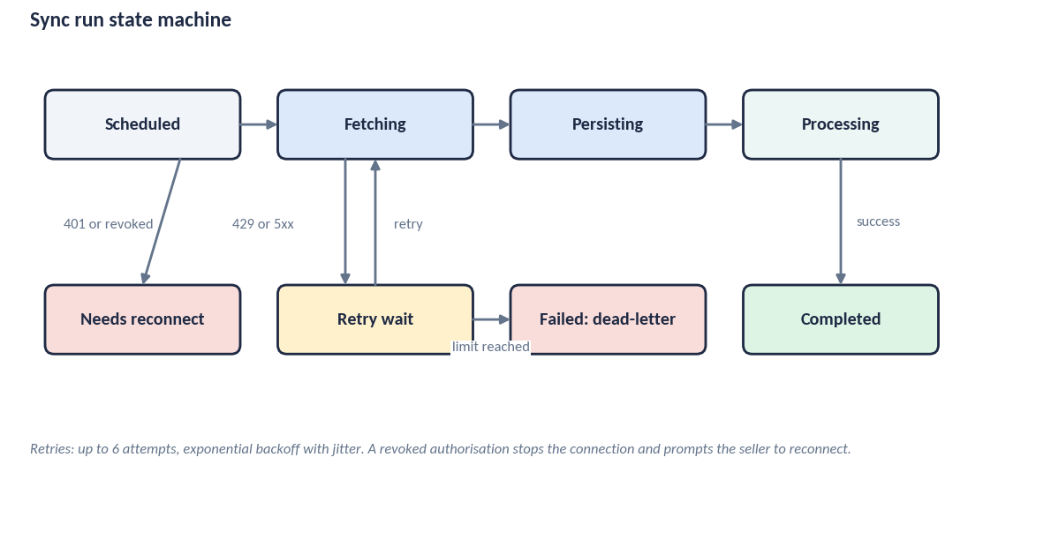

2.3 Job catalogue
Job | Trigger | What it does | Idempotency key
webhook.receive | TikTok webhook | Verify signature; strip buyer fields; store raw event; enqueue; respond | TikTok notification ID
token.refresh | Hourly | Refresh tokens expiring soon; on failure set needs_reconnect and notify | shop + expiry window
sync.backfill | Shop connected | Page through 12 months of orders, statements, payments and returns in windows | shop + domain + window
sync.poll | Every 15 minutes | Fetch changes since the stored cursor for each domain | shop + domain + cursor
sync.reconcile | Nightly | Compare TikTok counts and totals with the ledger for the last 60 days; repair gaps | shop + date
process.order | Raw order event | Upsert order and lines; post sale entry; record stock movements (reserved, posted, cancelled) | shop + order ID + event time
process.finance | Raw finance event | Post deduction entries by category; update order settlement status; record settlements and payouts | shop + transaction ID
process.return | Raw return event | Upsert return and items; set Coming back; on refund completed post a Refund entry | shop + return ID + status
process.stock | Raw stock event or poll | Update TikTok stock in stock_positions | shop + SKU + version
cost.apply | Mapping confirmed | Create current costs, supersede old, compute coverage | upload ID
detect.discrepancy | After processing or cost apply | Compare seller values with TikTok; open discrepancies; create notices | shop + entity + field
metrics.refresh | After processing; nightly | Rebuild daily_metrics for affected days; recompute coverage | shop + date
alerts.evaluate | After metrics | Stock, returns, settlement and discrepancy alerts to notifications | dedupe key
rules.evaluate | Nightly | Insight rules and VAT monitor results | shop + date + rule version
export.generate | Seller request | Build Excel or CSV; store; mark ready; expire later | export ID
retention.purge | Daily | Purge raw events, expired exports and deleted-account data per policy | run date

3. Ledger posting rules
Positive amounts are money to the seller; deductions are negative. Payout entries record cash received and are not part of Net Proceeds.
Event | Entry type | Amount and category | Month fields
Order paid or created | sale | + line gross (price × units) | basis_month = order month
TikTok fee, commission, creator commission, shipping deduction, voucher | platform_deduction | − amount; category commission, affiliate_commission, shipping, promotion, other | basis_month = order month
Order cancelled before dispatch | refund | − sale amount; category cancellation | basis_month = month of cancellation
Refund completed on a return | refund | − refund amount; category return | basis_month = month refund completed
Return postage | return_cost | − amount; category return_shipping; source tiktok or seller | basis_month = month recorded
Return marked Unsellable | write_off | − product cost × units; category product_cost; source system; only if a cost exists | basis_month = month checked
Statement paid | payout | + payment amount; source tiktok | settlement_month = month paid
Correction | adjustment | reverses an entry by reference | as the corrected entry
Net Proceeds = sum of sale, platform_deduction and refund entries for the period. Paid Out = sum of payout entries. Awaiting Settlement = Net Proceeds for orders not yet settled, taken from order_settlements. The nightly check asserts Net Proceeds = Paid Out + Awaiting Settlement per order month.

3.1 Stock projection rules
Event | Effect on stock_positions
Order placed, not yet dispatched | Sold, not posted +units
Order dispatched | Sold, not posted −units; Gone this month +units
Order cancelled before dispatch | Sold, not posted −units; on shelf restored once (movement: cancelled)
Return requested or received | Coming back +units
Return checked Resellable | Coming back −units; adjusted_delta +units (movement: return_resellable, once)
Return checked Unsellable | Coming back −units; Written off +units (movement: write_off, once)
TikTok stock updates | tiktok_stock replaced; on_shelf = tiktok_stock + adjusted_delta

4. Schema

4.1 Design rules
- Money in BIGINT minor units with a CHAR(3) currency. No floating-point columns.
- Timestamps in UTC (timestamptz). Reporting months are stored as dates and derived in the Europe/London time zone.
- Append-only ledger; unique indexes provide idempotency.
- Every shop-scoped table has shop_id and row-level security keyed on the signed-in account through app.account_id.
- No buyer name, address, phone or email column exists in any table.
- Check constraints hold the allowed values (for example status fields) so the database rejects impossible states.
- Seller-owned values (costs, confirmations, profile) are stored apart from TikTok-sourced values so precedence can be applied cleanly.

4.2 Entity relationships
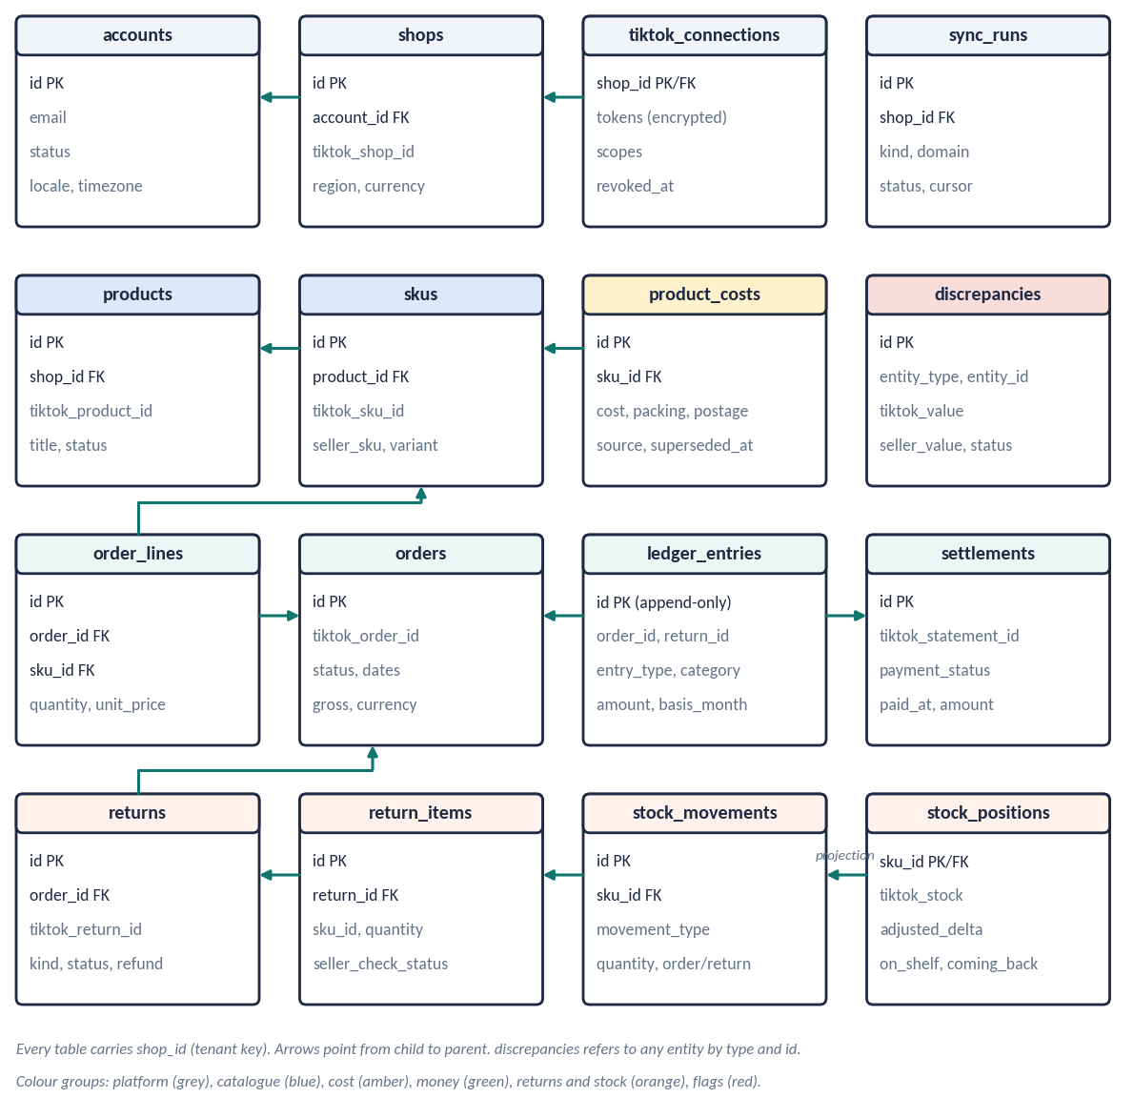

4.3 Table catalogue
There are 29 tables in the MVP schema.
Table | Purpose | Key constraints
accounts | One row per seller sign-in (MVP: one user per account). | email unique; auth_subject unique; locale en-GB; timezone Europe/London
shops | A connected TikTok Shop and its connection state. | account_id FK; unique (platform, tiktok_shop_id); connection_status
tiktok_connections | Encrypted OAuth tokens and scopes for a shop. | tokens encrypted (envelope, key_version); revoked_at
sync_runs | One row per sync job run per domain. | kind; domain; status (state machine); cursor; attempt
raw_events | Every webhook or polled payload, stored before processing. | unique (shop_id, idempotency_key); payload has buyer fields removed
products | TikTok products. | unique (shop_id, tiktok_product_id)
skus | Sellable variants; seller_sku is the cost-matching key. | unique (shop_id, tiktok_sku_id); index on seller_sku
cost_uploads | Product Costs files, mapping and match result. | status; column_mapping; rows matched, unmatched, duplicate
product_costs | Seller-owned unit costs; one current cost per SKU, history kept. | cost_minor >= 0; partial unique index on current cost
orders | TikTok orders. No buyer name, address, phone or email is held. | unique (shop_id, tiktok_order_id); index (shop_id, order_created_at)
order_lines | Items on an order. | unique (order_id, tiktok_line_id); quantity > 0
settlements | TikTok statements and their payment state. | unique (shop_id, tiktok_statement_id); payment_status; paid_at
order_settlements | Where each order sits in the money pipeline. | status uses TikTok sub-statuses; est_settlement_date
returns | Cancellations, refunds and returns from TikTok. | unique (shop_id, tiktok_return_id); kind; refund_minor
return_items | Units in a return and the seller’s condition check. | seller_check_status; return_postage_minor
ledger_entries | Append-only money ledger. Positive = money to seller; deductions negative. | unique idempotency index on (shop_id, source, source_ref, entry_type, category); basis_month
stock_positions | Current stock states per SKU (projection of movements plus TikTok stock). | on_shelf generated; one row per SKU
stock_movements | Every change to stock, linked to an order or return; single-use per return item. | unique (return_item_id, movement_type); reason required for manual
discrepancies | Differences between TikTok and seller records; TikTok value applied. | kind; status open or resolved; resolution
notifications | In-app and email notices; deduplicated. | unique (account_id, dedupe_key); severity; status
alert_settings | Seller thresholds for alerts. | low_stock_days default 14; coming_back_days default 7
tax_profiles | Optional tax profile (TX-1). | business_structure; vat_registered; prior_year_gross json
other_channel_sales | Seller-entered monthly sales outside TikTok (BK-9). | unique (shop_id, channel, month)
reference_rules | Dated tax and VAT reference data (TX-7). Global table. | unique (rule_set, rule_key, effective_from); source_url; reviewed_at
change_log | Record of every change to a figure already shown (BK-5). | entity; reason_code; old and new value
audit_log | Security and administrative actions. | actor; action; no IP address stored
exports | Generated files for month summary and accountant export. | kind; format; expires_at
daily_metrics | Pre-computed daily figures per shop and per SKU. | unique (shop_id, sku_id or none, metric_date); cost_coverage_units
product_events | First-party product analytics for validation measures; no financial values. | account_id pseudonymous; props exclude amounts

4.4 Example: ledger table
create table ledger_entries (
id uuid primary key default gen_random_uuid(),
shop_id uuid not null references shops(id),
order_id uuid references orders(id),
return_id uuid references returns(id),
settlement_id uuid references settlements(id),
entry_type text not null check (entry_type in
('sale','platform_deduction','refund','payout',
'return_cost','write_off','adjustment')),
category text,
amount_minor bigint not null, -- pence; positive = money to seller
currency char(3) not null default 'GBP',
occurred_at timestamptz not null,
basis_month date not null, -- sales basis
settlement_month date, -- cash basis
source text not null check (source in ('tiktok','seller','system')),
source_ref text, -- TikTok transaction or event ID
reverses_entry_id uuid references ledger_entries(id),
reason text,
created_at timestamptz not null default now()
);
create unique index ledger_idempotency_idx on ledger_entries
(shop_id, source, source_ref, entry_type, coalesce(category, ''))
where source_ref is not null;

4.5 Derived views and metrics
- daily_metrics holds pre-computed daily figures per shop and per SKU, including cost coverage. It is a cache rebuilt from the ledger.
- Suggested database views: order economics (one row per order with sale, deductions, refunds, net proceeds), SKU economics (per SKU with units, net proceeds, cost, contribution), and shop money (generated, paid, awaiting).
- Reporting queries read daily_metrics or views, never raw_events.

4.6 Retention hooks
Data | Retention (proposed) | Mechanism
raw_events | 90 days after processing | retention.purge job
exports (files) | 7 days after creation | expires_at; purge job
cost_uploads (files) | Deleted after mapping applied plus 30 days | purge job
ledger, orders, returns, costs | While account is active; deleted on account deletion | deletion workflow
audit_log | 12 months | purge job
product_events | 13 months, then aggregated | purge job
Backups (all data) | 35 days, held in the UK | Managed backup vault
Final periods are set in the Data Protection Document.

5. Migration and change control
- Migrations are versioned and forward-only, applied automatically in staging and with approval in production.
- Destructive changes use two releases: stop writing, then remove.
- reference_rules changes (tax and VAT parameters) are data changes with a named reviewer and an effective date.
- Seed data: reference_rules for VAT threshold, income tax and National Insurance parameters, and Making Tax Digital thresholds, each with a source and review date.

6. Decisions to confirm
- Raw event retention period (90 days proposed).
- Whether order and finance history beyond 12 months is needed for the tax-year view.
- Whether payouts should also reconcile to seller-entered bank credits in Release 2.

