MYSHOPEDGE | MSE-WFW-001
End-to-End Platform Wireframe and Workflow
Screens, journeys and system flows for the MVP
Document ID | MSE-WFW-001
Version and status | 0.1, draft for review
Date | 20 September 2026
Product | MyShopEdge MVP: UK TikTok Shop sellers
Basis | Product Specification v2.0 (requirement IDs such as VIS-1 and BK-2 refer to it)
Related documents | PRD (MSE-PRD-001), SRD (MSE-SRD-001), API Integration (MSE-API-001), Backend Orchestration (MSE-BOS-001), QA (MSE-QA-001)

1. Purpose and scope
This document shows the MVP as a seller experiences it and as the system runs it: 15 low-fidelity screens, one end-to-end workflow and four detailed workflows. Wireframes show structure, content and behaviour, not final visual design. Figures shown are illustrative. Screens reuse the My Shop Buddy design language and the terminology standard in Product Specification v2.0.

1.1 Design language carried forward
Element | Rule
Brand and colour | Warm orange for brand and key actions. Fixed colours for cost categories: stock magenta, postage teal, their cut blue, you keep orange. Colour never carries meaning alone.
Type | Archivo for figures, Plus Jakarta Sans for text, self-hosted.
Layout | Mobile-first single column; five bottom tabs (Today, Stock, Products, Money, Tax); notification bell and “Updated” stamp in the top bar.
Voice | Plain English, UK spelling, “you”, pence in the £. Each card has a title and one line on why it matters.
Labels | “You keep” only with full cost coverage and its standing qualifier; otherwise “Left after TikTok”. Never “profit” for either.
Chips | Confirmed, Estimated, Incomplete beside any affected figure. “Not provided” where cost is missing.

2. Screen map
ID | Screen | Area | Purpose | Wireframe
S1 | Connect TikTok Shop | Onboarding | Read-only authorisation; what is read and not read | Fig 1
S2 | First sync | Onboarding | Progress while 12 months load | Fig 1
S3 | Product Costs choice | Onboarding | Upload, type or skip | Fig 2
S4 | Upload mapping | Onboarding | Confirm columns; see matches | Fig 2
S5 | Tax profile | Onboarding | Optional business details | Fig 3
S6 | Today | Today | What you keep; Shop Money; VAT line; Needs you | Fig 3
S7 | Stock | Stock | Stock states; what runs out first; Coming back | Fig 4
S8 | Return check | Stock | Confirm condition and postage | Fig 4
S9 | Products | Products | Ranking by money kept | Fig 5
S10 | Product detail | Products | One unit pound by pound; insight; returns | Fig 5
S11 | Money | Money | Where every pound went; expected payouts; export | Fig 6
S12 | Tax | Tax | VAT line; set-aside; dates; quarterly check | Fig 6
S13 | Notifications | Top bar | Open and resolved notices | Fig 7
S14 | Discrepancy detail | Top bar | Both values; resolve | Fig 7
S15 | Settings and data | Settings | Connection, set-up, data rights | Fig 8

3. End-to-end workflow
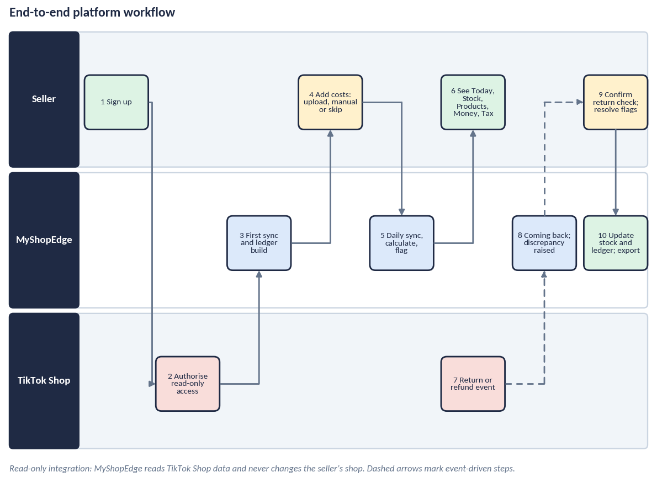
Step | Actor | What happens
1 | Seller | Signs up and verifies email (ACC-1).
2 | TikTok Shop | Seller approves read-only access on TikTok’s page (CON-1).
3 | MyShopEdge | Loads 12 months of orders, finance, returns and stock; builds the ledger (SYN-1).
4 | Seller | Adds product costs by upload or manual entry, or skips (CST-1).
5 | MyShopEdge | Every 15 minutes and on events: syncs, posts to the ledger, refreshes metrics, flags differences.
6 | Seller | Reads Today, Stock, Products, Money and Tax.
7 | TikTok Shop | A buyer requests a return or refund; TikTok records it.
8 | MyShopEdge | Shows the item as Coming back; posts the refund when TikTok completes it; raises any discrepancy.
9 | Seller | Checks the returned goods, marks Resellable or Unsellable, resolves flags.
10 | MyShopEdge | Updates stock once and posts Return Loss; at month end the seller exports for the accountant.

4. Wireframes

Figure 1: Connect and first sync
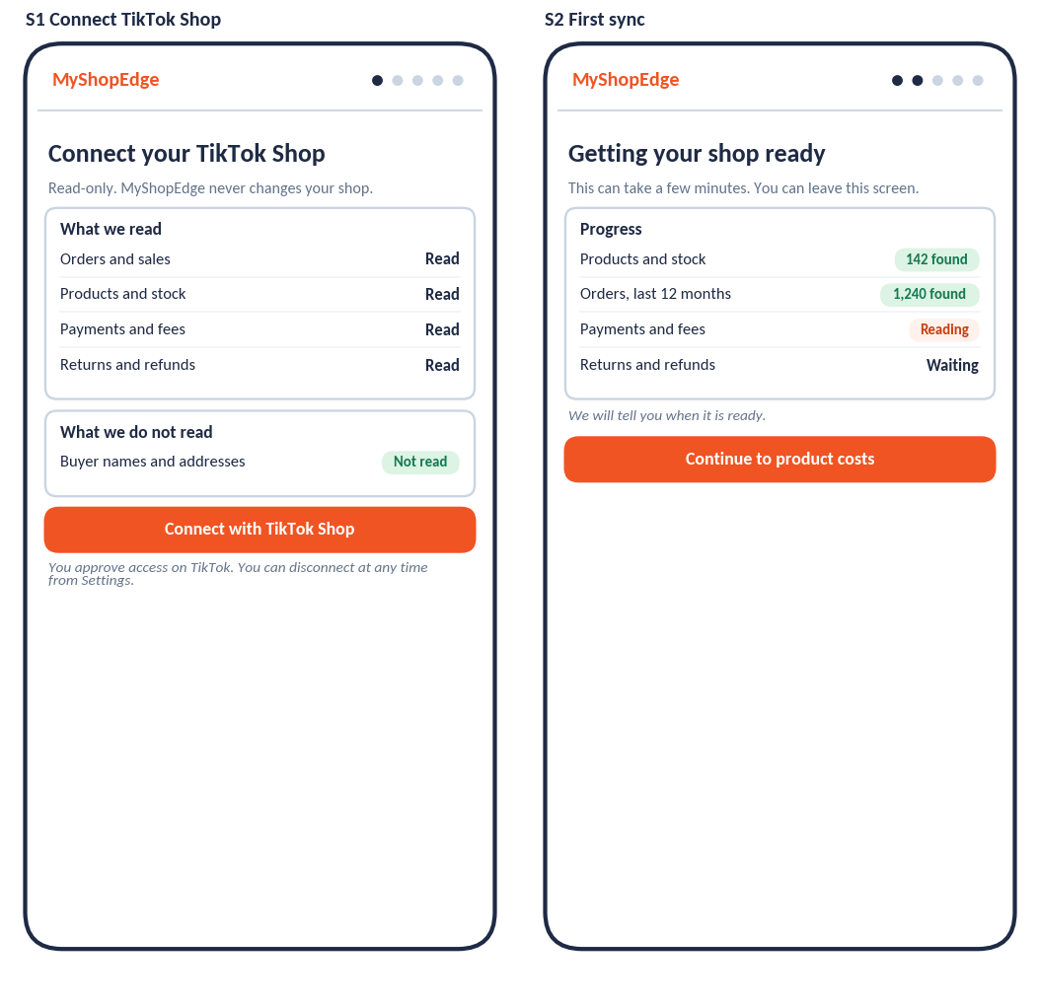
Screen | Key elements | Behaviour and states | Reqs
S1 Connect TikTok Shop | Explains access is read-only; lists what is and is not read; one primary action | Denied or partial consent shows what is missing and a retry (CON-4). Non-GB shop shows an unsupported-region message. | CON-1, CON-4
S2 First sync | Progress per domain; can leave and return; continues to costs | Failure on a domain shows which one and retries automatically; slow sync explains rate limits. | SYN-1

Figure 2: Product Costs
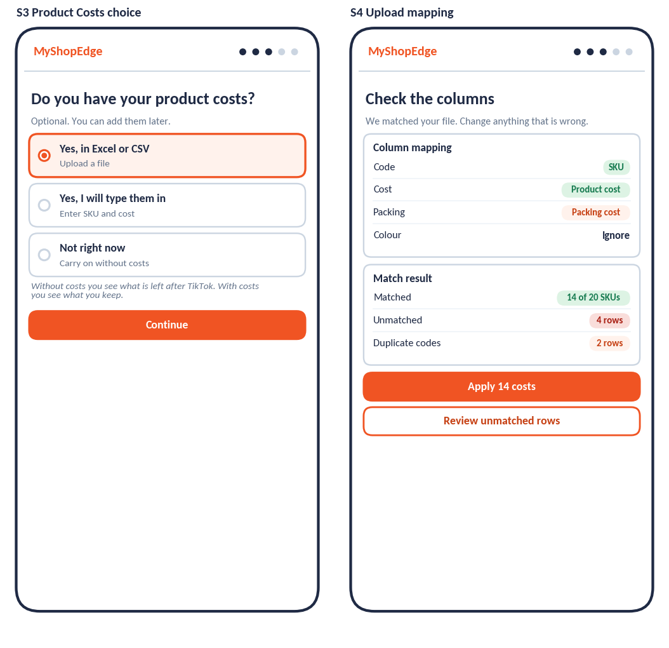
Screen | Key elements | Behaviour and states | Reqs
S3 Product Costs choice | Three options; skip is equal in weight; one-line consequence of each | Skip never blocks. The skipped step is listed later with how to add it. | CST-1
S4 Upload mapping | Detected column mapping the seller can change; match result; apply and review actions | Unmatched and duplicate rows stay visible until resolved. Nothing applies before confirmation. | CST-2 to CST-4

Figure 3: Tax profile and Today
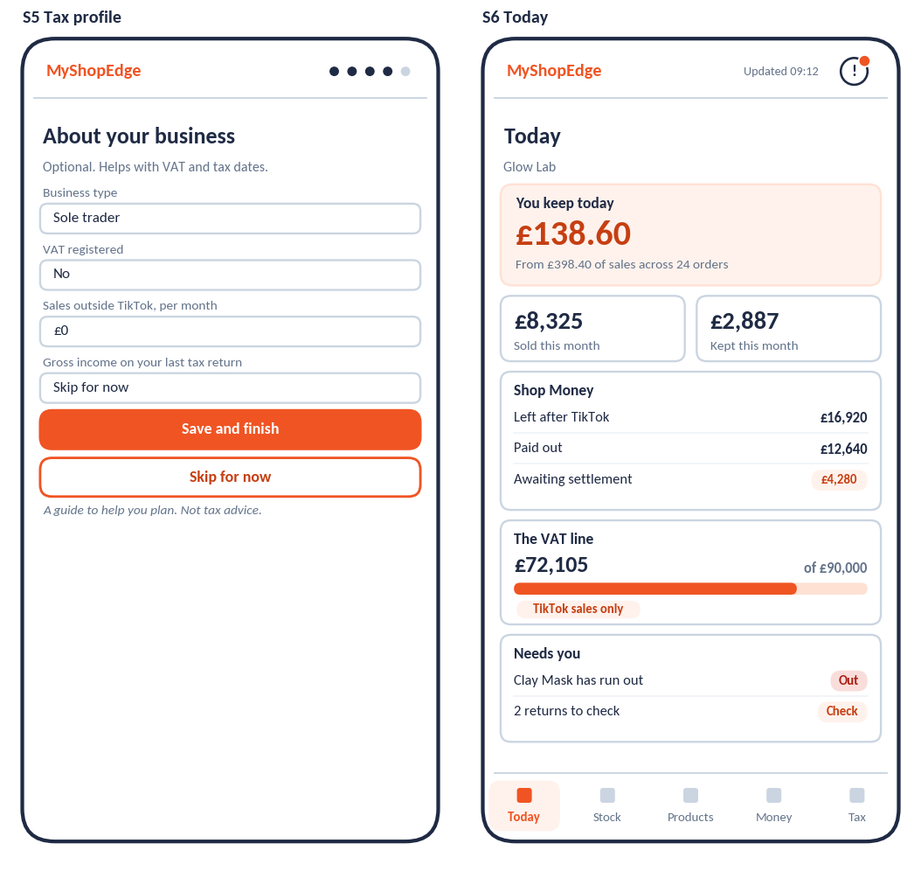
Screen | Key elements | Behaviour and states | Reqs
S5 Tax profile | Four optional fields; save or skip; guide-not-advice line | Empty profile leaves the Tax tab with the VAT line and dates only. | TAX-1
S6 Today | Hero; sold and kept this month; Shop Money; VAT line; Needs you | Hero reads “You keep” only with full cost coverage; otherwise “Left after TikTok” with a prompt. VAT line says “TikTok sales only” until other sales are entered. | DSH-1, DSH-2, TAX-2

Figure 4: Stock and return check
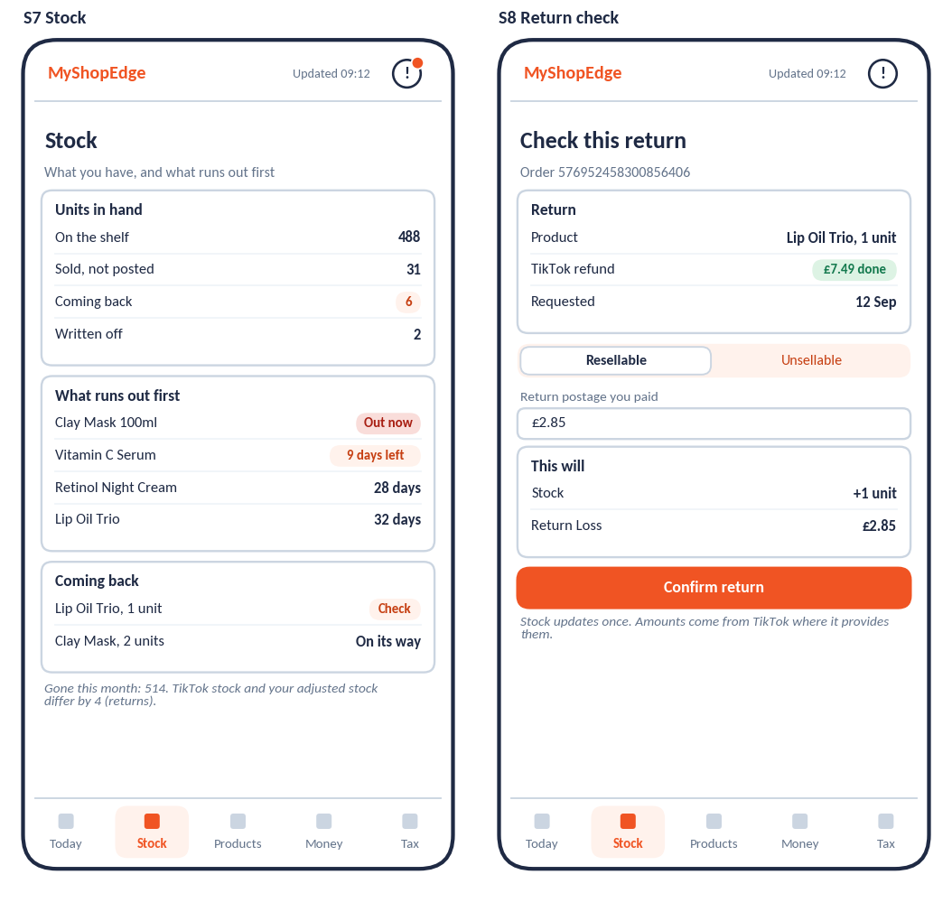
Screen | Key elements | Behaviour and states | Reqs
S7 Stock | Units in hand states; what runs out first; Coming back list; note on TikTok versus adjusted stock | Out now and Low are highlighted; Coming back items unchecked for 7 days are flagged. | STK-1 to STK-7
S8 Return check | Return details from TikTok; Resellable or Unsellable; return postage; preview of effect; confirm | Second confirmation for the same item is refused. Seller confirmation with no TikTok return is held as unmatched. | RET-3 to RET-5

Figure 5: Products and product detail
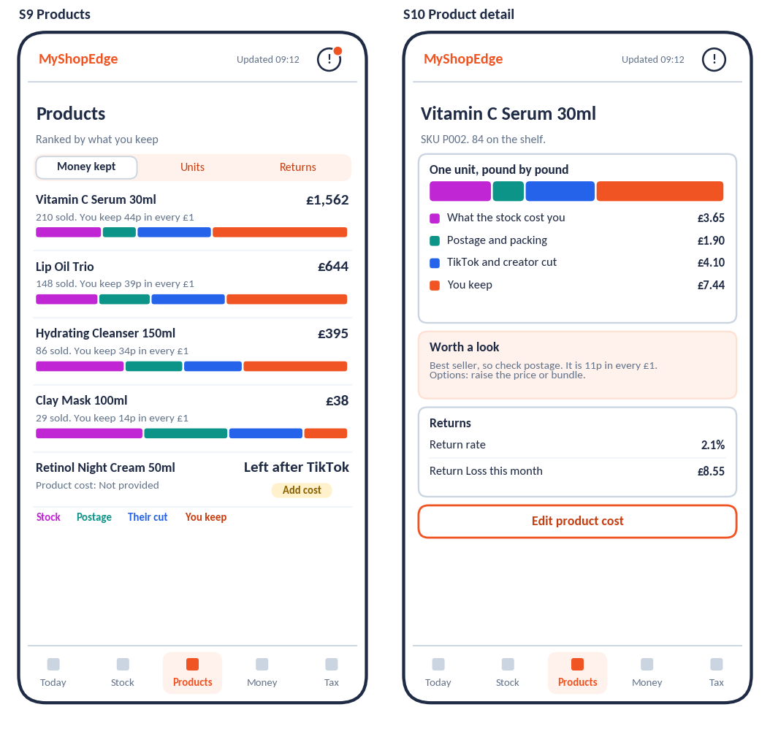
Screen | Key elements | Behaviour and states | Reqs
S9 Products | Measure switch; ranked rows with pence-in-the-£ bars; uncosted product with “Add cost” | Ranking label states the measure. Uncosted products sit below ranked ones. | DSH-4, DSH-5
S10 Product detail | One unit pound by pound; rule-based insight; returns; edit cost | Insight shows the figures behind it and options. Segments sum to the amount that reached the shop. | DSH-5, DSH-6

Figure 6: Money and Tax
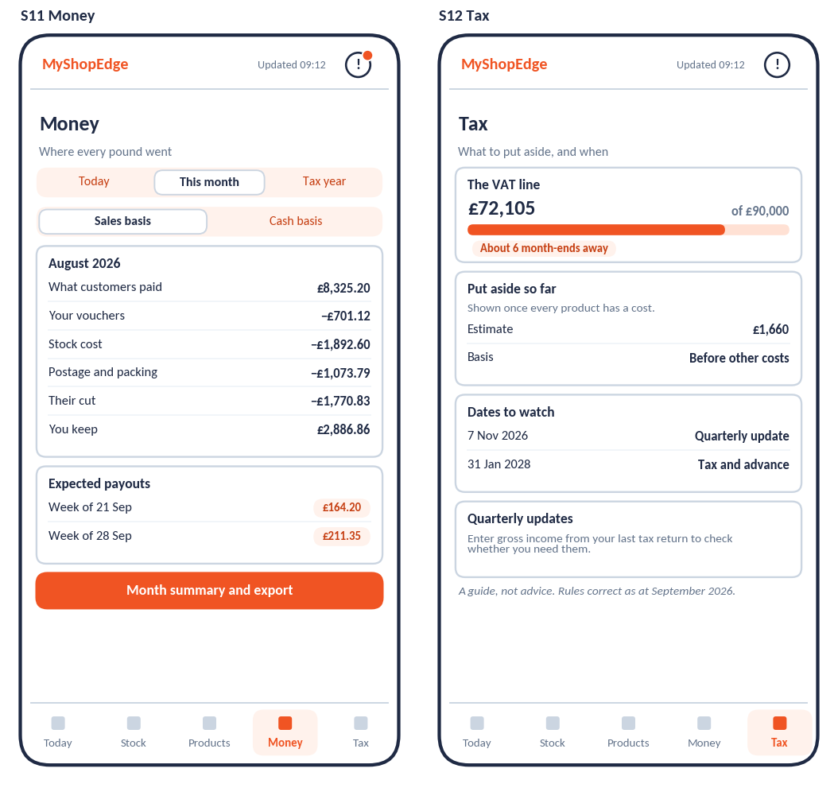
Screen | Key elements | Behaviour and states | Reqs
S11 Money | Period and basis switches; ledger lines; expected payouts by week; month summary and export | Lines sum to the figure shown. Estimated dates are labelled Estimated. | MON-1, MON-2, LED-8
S12 Tax | VAT line with method; set-aside with basis; dates; quarterly-update check | Set-aside hidden unless cost coverage is complete. Every tax screen states it is a guide and shows a correct-as-at date. | TAX-2 to TAX-7

Figure 7: Notifications and discrepancy
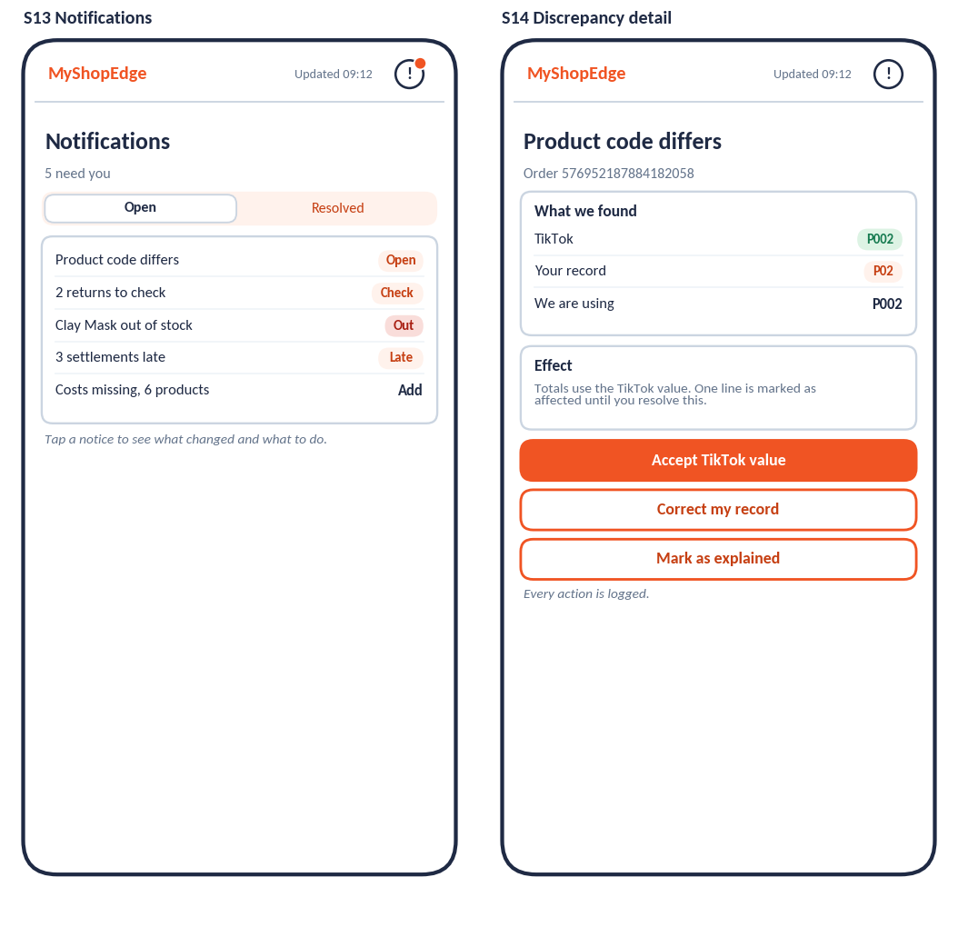
Screen | Key elements | Behaviour and states | Reqs
S13 Notifications | Open and resolved lists; one notice per condition | Tapping opens the relevant screen. | NTF-1, DSH-10
S14 Discrepancy detail | TikTok value, seller value, value in use; effect on totals; three actions | Every action is logged and clears the flag. | DSC-2 to DSC-5

Figure 8: Settings and data
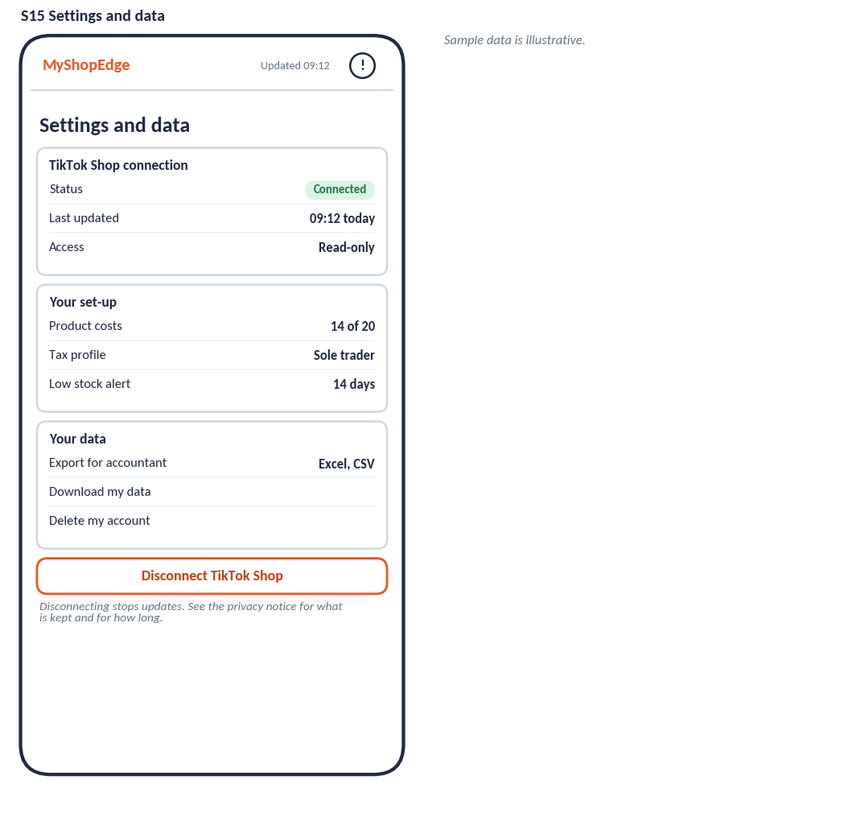
Screen | Key elements | Behaviour and states | Reqs
S15 Settings and data | Connection status and last update; set-up summary; export, download and delete; disconnect | Delete prompts an export first. Disconnect stops updates and explains what is kept and for how long. | CON-3, ACC-4, MON-2

5. Detailed workflows

5.1 Onboarding
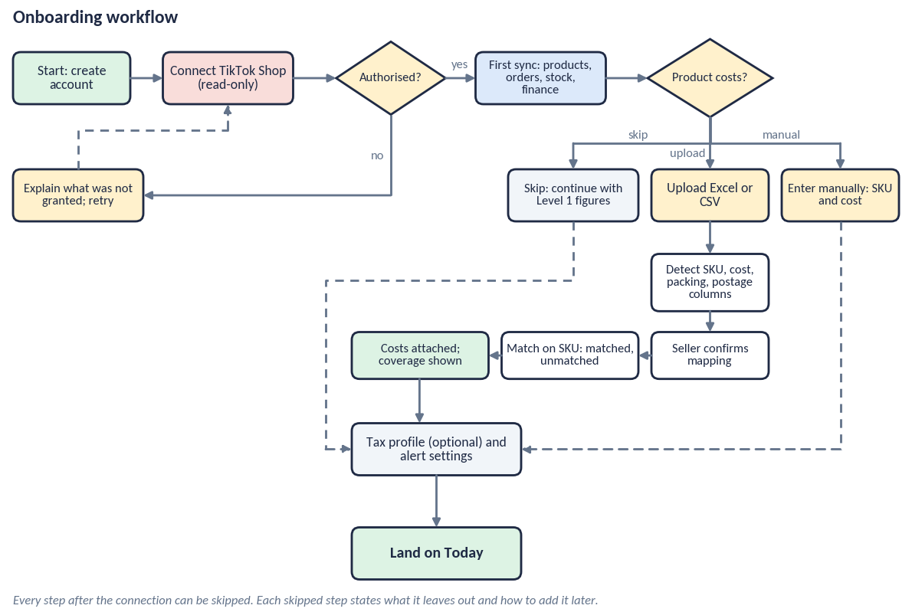
The only step that cannot be skipped is the TikTok connection. Skipped steps are listed on Today with what they leave out.

5.2 Product Costs upload and matching
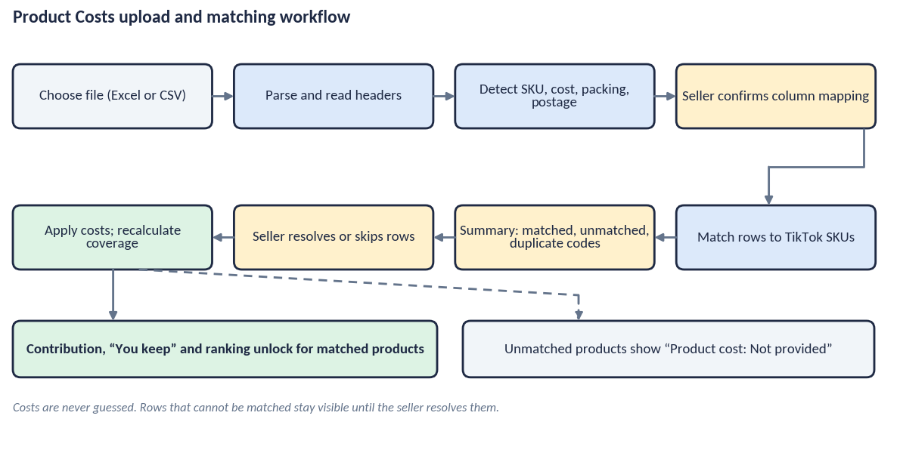
- The seller’s Product Cost sheet is the expected input. Columns are detected and always confirmed by the seller.
- Matching uses SKU or product code. A row that cannot be matched is never guessed; it stays listed.
- When costs are applied, coverage is recalculated and “You keep”, Contribution and ranking unlock for matched products only.

5.3 Return lifecycle
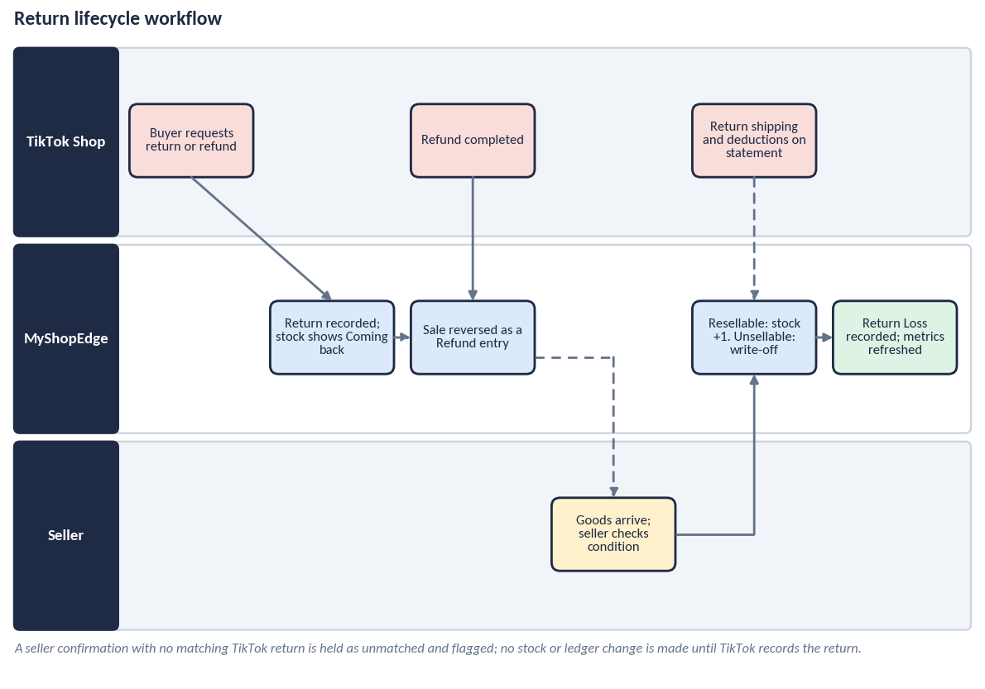
- TikTok drives the request and refund; the seller confirms the goods and their condition; MyShopEdge applies stock and ledger entries once.
- The refund is posted in the month the refund completes; the original sale month is not restated.
- Return Loss is return postage plus, for Unsellable goods, the product cost written off, using TikTok data where it provides it.

5.4 Discrepancy detection and resolution
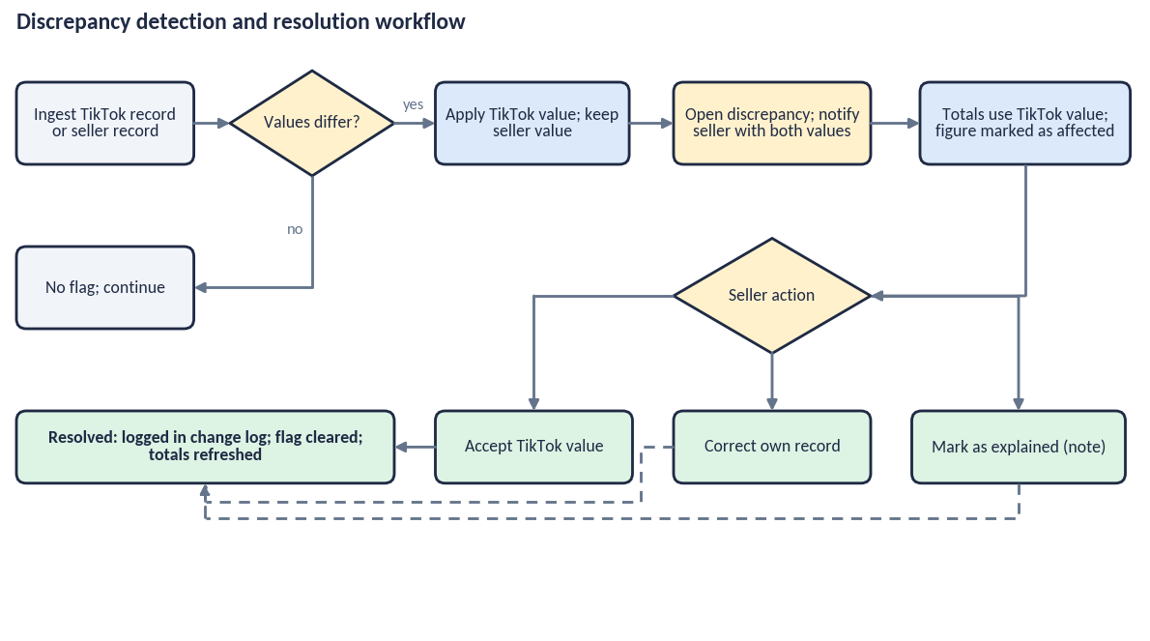
TikTok’s value is used in all totals from the moment a difference is found. The seller’s value is kept and shown alongside.

5.5 System view: sync and processing
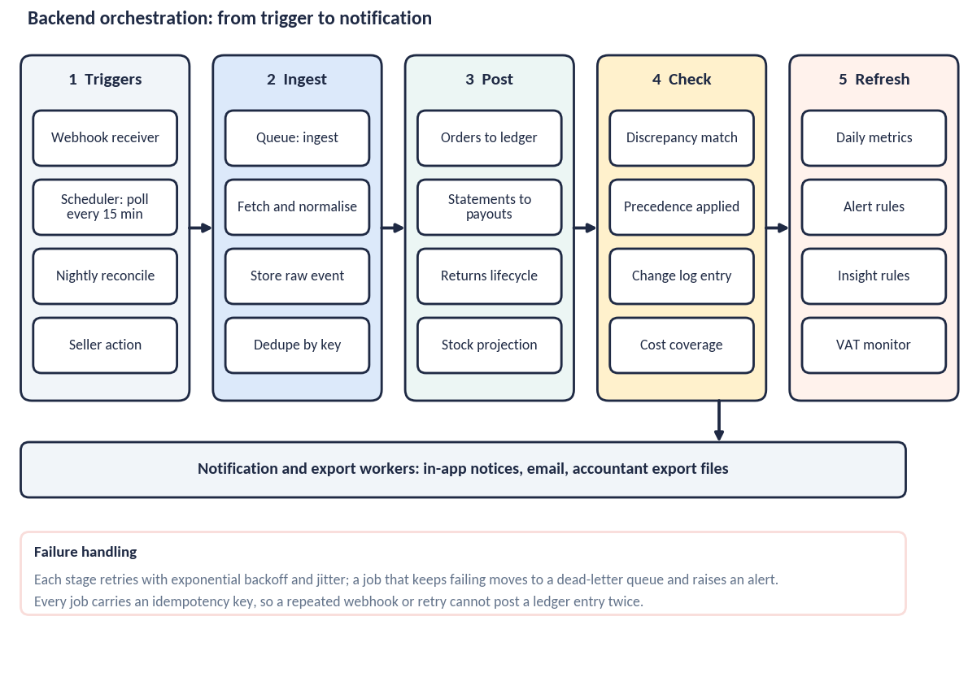
The seller never sees this flow, but it explains the “Updated” stamp: webhook events appear within minutes, a 15-minute poll catches anything missed, and a nightly reconciliation repairs gaps. Full detail is in MSE-BOS-001.

6. States and edge cases
State | What the seller sees
First sync in progress | Progress by domain; screens show what is available so far, labelled as loading; no partial totals presented as complete.
No costs | Level 1 figures; “Left after TikTok”; “Product cost: Not provided” and a single prompt to add costs; no profit-type figures.
Partial costs | Contribution for matched products; totals state “N of M products, X% of gross sales”; uncosted products labelled.
No returns yet | Coming back and return metrics show a plain empty state explaining what will appear.
Feed stale or failing | Banner from 24 hours without a successful sync; last-updated time on every screen; figures kept but marked as not current.
Connection needs attention | Notice and email; Settings shows reconnect; no data lost.
Open discrepancy | Bell count; affected figures marked; TikTok value in use.
VAT registered | Notice that figures include VAT and Contribution may be overstated (MON-4).
Estimated amounts | Estimated chip on expected payouts and any figure that awaits settlement.
Loss-making product | Negative Contribution shown in full, with an insight offering options.

7. Accessibility and responsive rules
- Meets WCAG 2.2 level AA: contrast, focus order, visible focus, keyboard operation, labels on every control, tap targets of at least 44 by 44 px.
- Every chart and bar has a text alternative stating its values and meaning.
- No meaning is carried by colour alone: chips and segments carry text and pattern or label.
- Text can scale to 200% without loss of content; reduced-motion preference respected.
- Phones: single column with bottom tabs. Larger screens: a centred column with a side detail panel; the tabs move to a left rail.
- Numbers are formatted for UK English; amounts are read out in full by screen readers.

8. Content rules for screens
- Use the labels in the terminology standard; do not introduce new terms for the same idea.
- Every card states its basis (period and basis) and, where relevant, coverage.
- Tax and VAT content shows “A guide, not advice” and a correct-as-at date.
- Insight text is generated from the data behind it and never asserts more than the figures show.

9. Open UX decisions
- Whether the tab bar or a left rail is preferred on tablets.
- Whether Returns deserves its own tab after the pilot, or stays inside Stock.
- Whether to offer a short guided tour after first sync, or rely on empty states.
- The number of insights shown on Today before it feels crowded.

