1. **Introduction:**

This document provides an overview of the data analysis process used for the music and mental health project. It outlines the project objectives, the data used, the data sources, the data cleaning process, and the methodology employed to analyze the data.

1. **Project Objectives:**

The objective of this data analysis is to answer the following questions:

* What are the most popular streaming service used from the survey?
* What is the most favorite genre listened to by the respondents?
* What age group responded in the survey?
* What is the effect of music on mental health?
* How long do they listen to music?

1. **Data Sources:**

The dataset used in this project was collected from Kaggle. The dataset was a survey Managed, collected, and uploaded by Catherinerasgaitis. This data contains information about how people listen to music, their health condition i.e., insomnia, depression, OCD, and BMP, the genre they listen to, how they stream their music, and how music affects their mental health.

1. **Methods:**

The data analysis was conducted using SQL queries and Tableau for visualization. The queries used to answer the objectives were designed to filter out missing and erroneous data and transform data types.

**PROCESS IN CLEANING THE DATA**

Using SQL to pull the needed column, removing blank cells and sorting by age

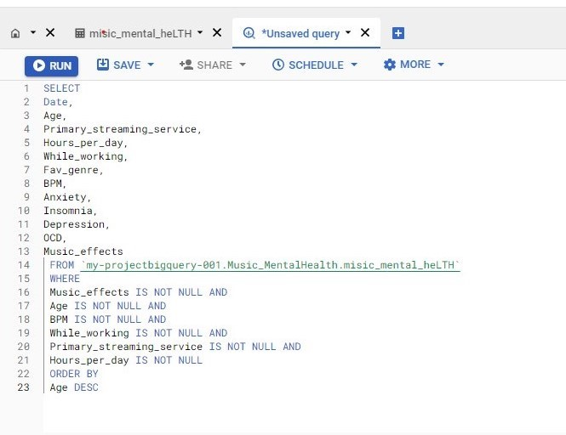 The result was downloaded and exported into an excel sheet

**Removing duplicates:** This was done to ensure that data integrity is maintained and that the results from the analysis are accurate and precise.

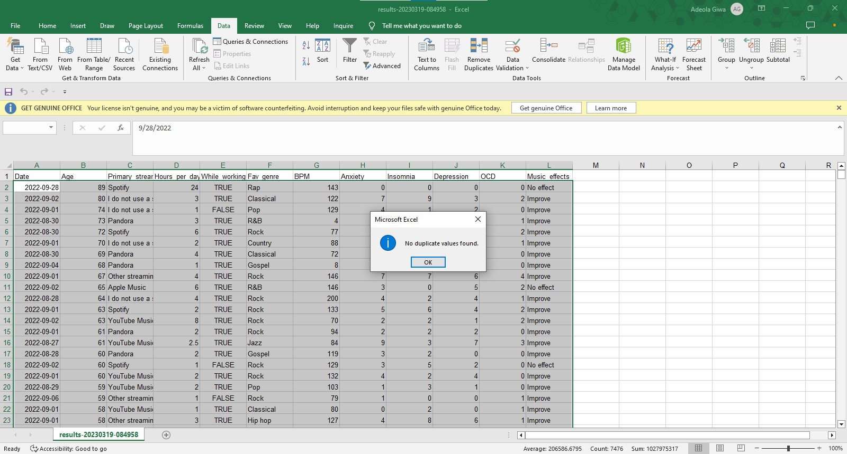

*As we can see here there are no duplicates.*

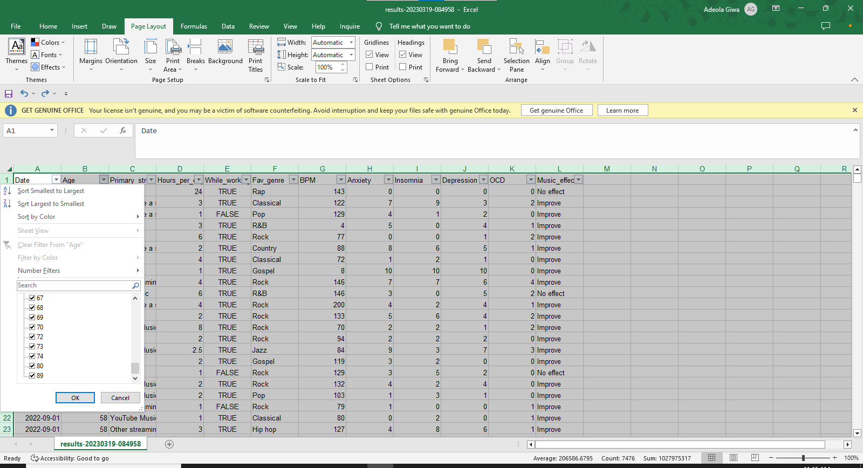**Removing Blank Cells:** This is also done to ensure data integrity is maintained and remove all forms of data inconsistency in data to avoid deriving irrelevant/useless insights.

*We can see from here that after creating a filter to check for the rows which are empty in the age column, there are no blank cells. Therefore, this is where we end the cleaning process.*

1. **Analysis:**

The data was analyzed using Tableau to create an interactive visualization and dashboard.

**ANALYSIS AND VISUALIZATION**

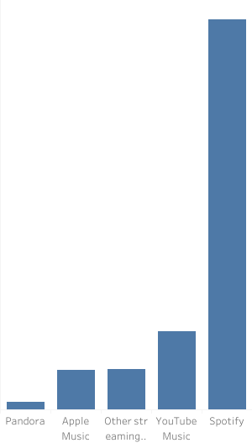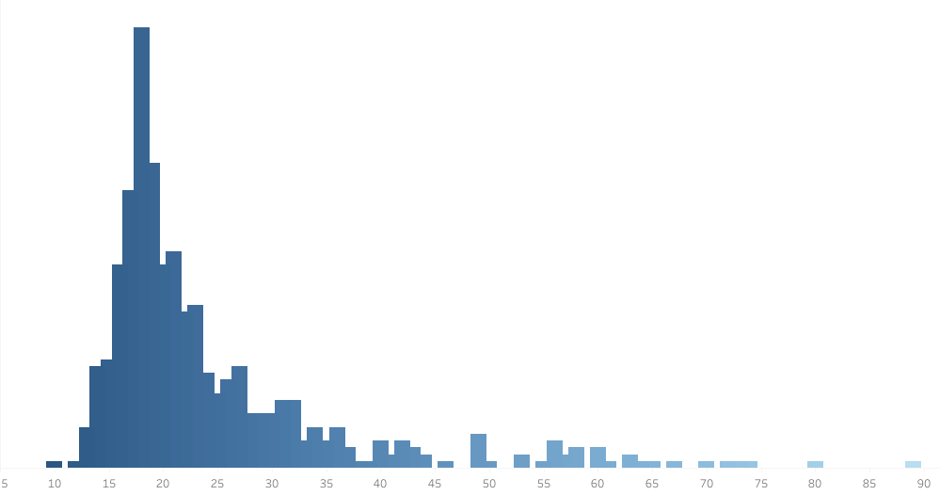 Firstly, we want to know the age of the respondents as well as the primary streaming service use.

This visualize shows most of the respondents are between the age of 15-21. The least popular streaming service is pandora while the most popular is Spotify. Unlike apple music, Spotify is a free streaming service. majority of the respondents are in their teens therefore they might not be able to pay for a streaming service which make Spotify a good choice for them.

Next, we want to know how the respondents listen to music

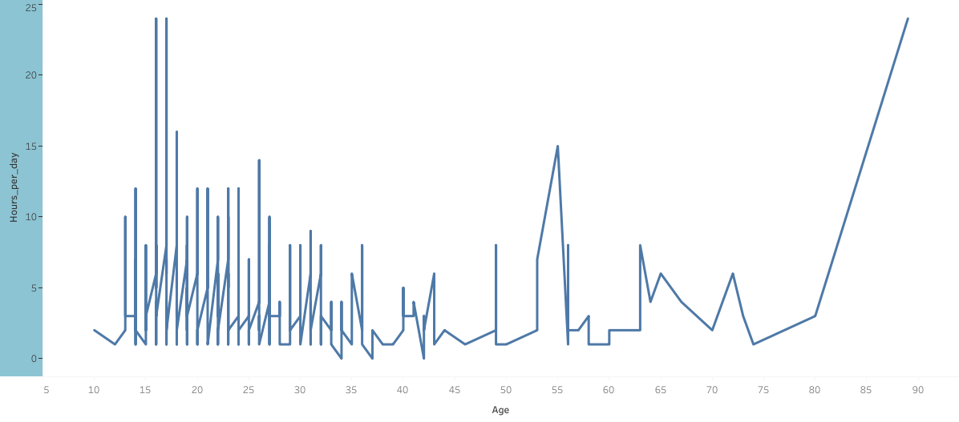

The above viz shows how respondents of different age listen to music everyday

**Results:**

The results of the analysis showed that music have a significant positive impact on human mental health and wellbeing.

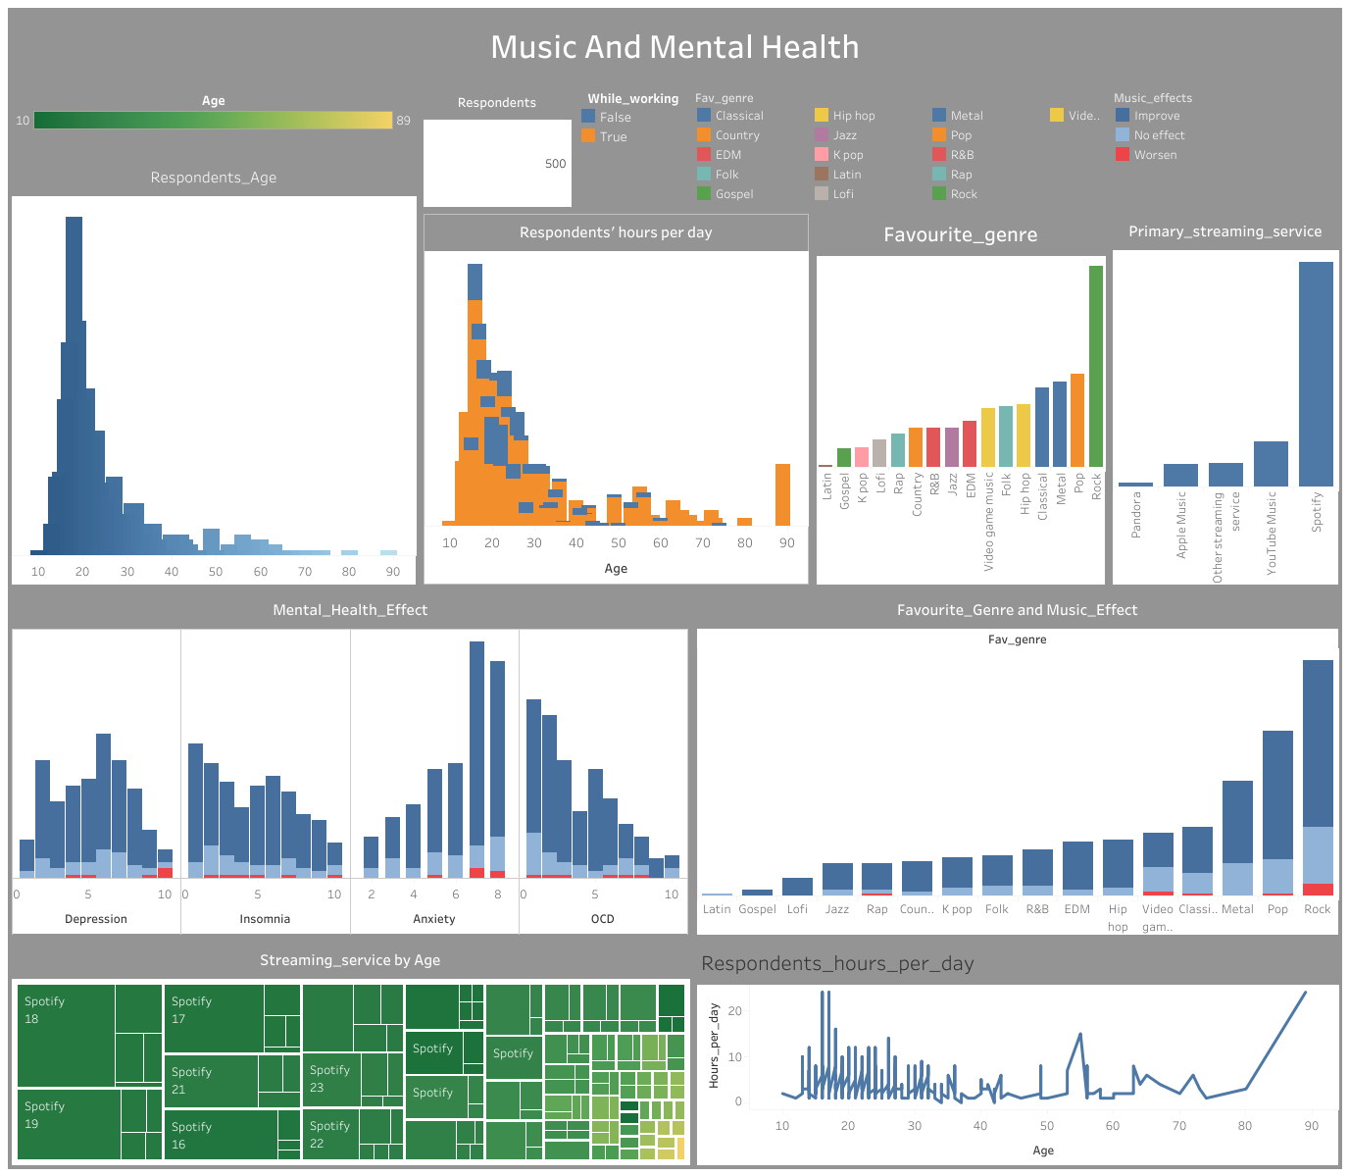

Goto <https://public.tableau.com/views/mental_health_16741601522030/Dashboard1?:language=en-US&:display_count=n&:origin=viz_share_link> to explore the dashboard

**Conclusion and Suggestion**

This document provides an overview of the data analysis process used for the music and mental health project. The data was cleaned and analyzed using SQL and Excel for further cleaning, and the results showed that music had a significant positive impact on human mental health and wellbeing. The result indicated that music therapy works and I will advise everyone to incorporate the habit of listening to music.