# AUX PROJECT 1: SHELL SCRIPTING

* I will open my git bash terminal, change directory to my downloads folder where my pem key is. Then I will run the command

--------vi onboard.sh

* I will copy and paste the script I want to use to run the creation of the user account in it

* I will copy the onboard.sh to my ubuntu using scp with the command

------- scp -I test-key.pem onboard.sh ubuntu@3.89.110.8

* I will go to my terminal to connect to my AWS EC2 instance

* I will check to ensure that the onboard.sh is in my folder using the command:

------------- ls -l

* I will make a directory, move my onboard.sh to my home folder and change into the new directory with the command

---------- mkdir Shell

-------------- mv onboard.sh /home/ubuntu/Shell

-------------- cd Shell/

* I will touch a file named “names.scv” and vim into it

--------- touch names.csv

----------- vim names.csv

* I will run the following command

------------ touch id_rsa.pub

----------------- touch id_rsa

* I will then vi into the id_rsa.pub and paste the keys into it

-------------------- vi id_rsa.pub

* I will then vi into the id_rsa and paste the keys into it

------------ vi id_rsa

* I will edit and change some parameters in my onboard.sh so I can include my home directory in it

--------- vi onboard.sh

* I will create the developers group that all the users will be added too based on the script:

----------- sudo groupadd developers

* I will give the script folder necessary permission so it can be executed

-------------- sudo chmod +x onboard.sh

* I will change to user root so I can run the script with the command

--------------------- ./onboards.sh

* I will run the command to see that the names have been created

----------- ls -l /home

* I will check if group account was created with the command

----------- getent group developers

* I will run the following command to see the details about the users

---------- cat /etc/passwd

* To test the users created I will open a new terminal, change to downloads folder. I will touch file, vi into it and paste the private key into it because the user needs to have the private key**.**

----------------- vi aux-proj.pem

* I will try to ssh into one of the sure accounts was created

-------------- ssh -I aux-proj.pem Adeola@3.89.110.8

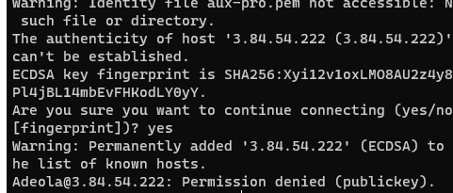

* The command above gave an error, so I need to change the permission to be able to run the command

------------ ls -l | grep aux-proj.pem

------------- sudo chmod 600 aux-proj.pem

---------- ls -l | grep aux-proj.pem

* I will run the command again and see if it will work out after changing the permissions

------------- ssh -I aux-proj.pem [Adeola@3.89.110.8](mailto:Adeola@3.89.110.8)

* To check if the user has sudo privilege will run the command

--------- sudo apt update

* I will also run the following commands

-------- ls -la

---------- ls -la .ssh/

* I will try logging in as another user

-------------- ssh -I aux-project [Samuel@3.89.110.8](mailto:Samuel@3.89.110.8)

* To check if the user has sudo privilege will run the command:

-------- sudo apt update

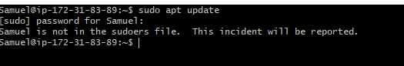

* I will also run the following commands

-------- ls -la

---------- ls -la .ssh/

