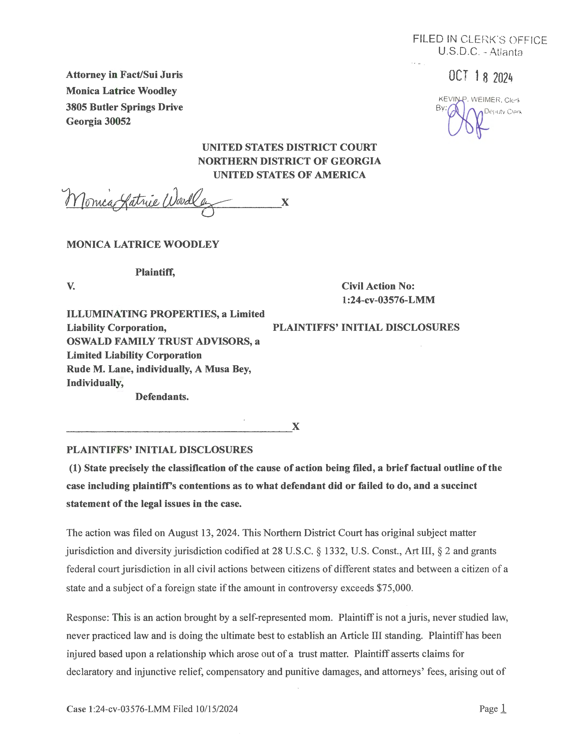

Case 1:24-cv-03576-LMM Document 19 Filed 10/18/24 Page 1 of 9

U.S.D.C. -Atlanta

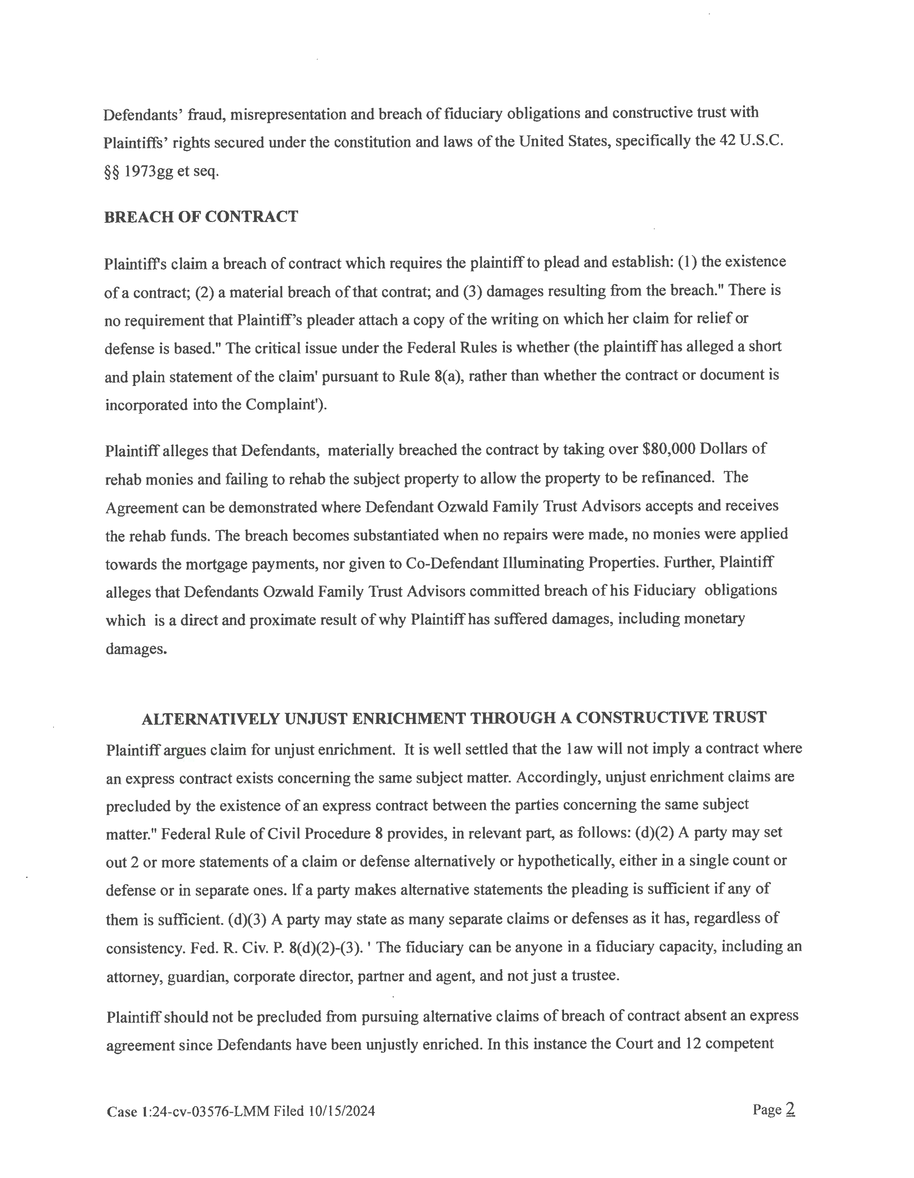

Case 1:24-cv-03576-LMM Document 19 Filed 10/18/24 Page 2 of 9

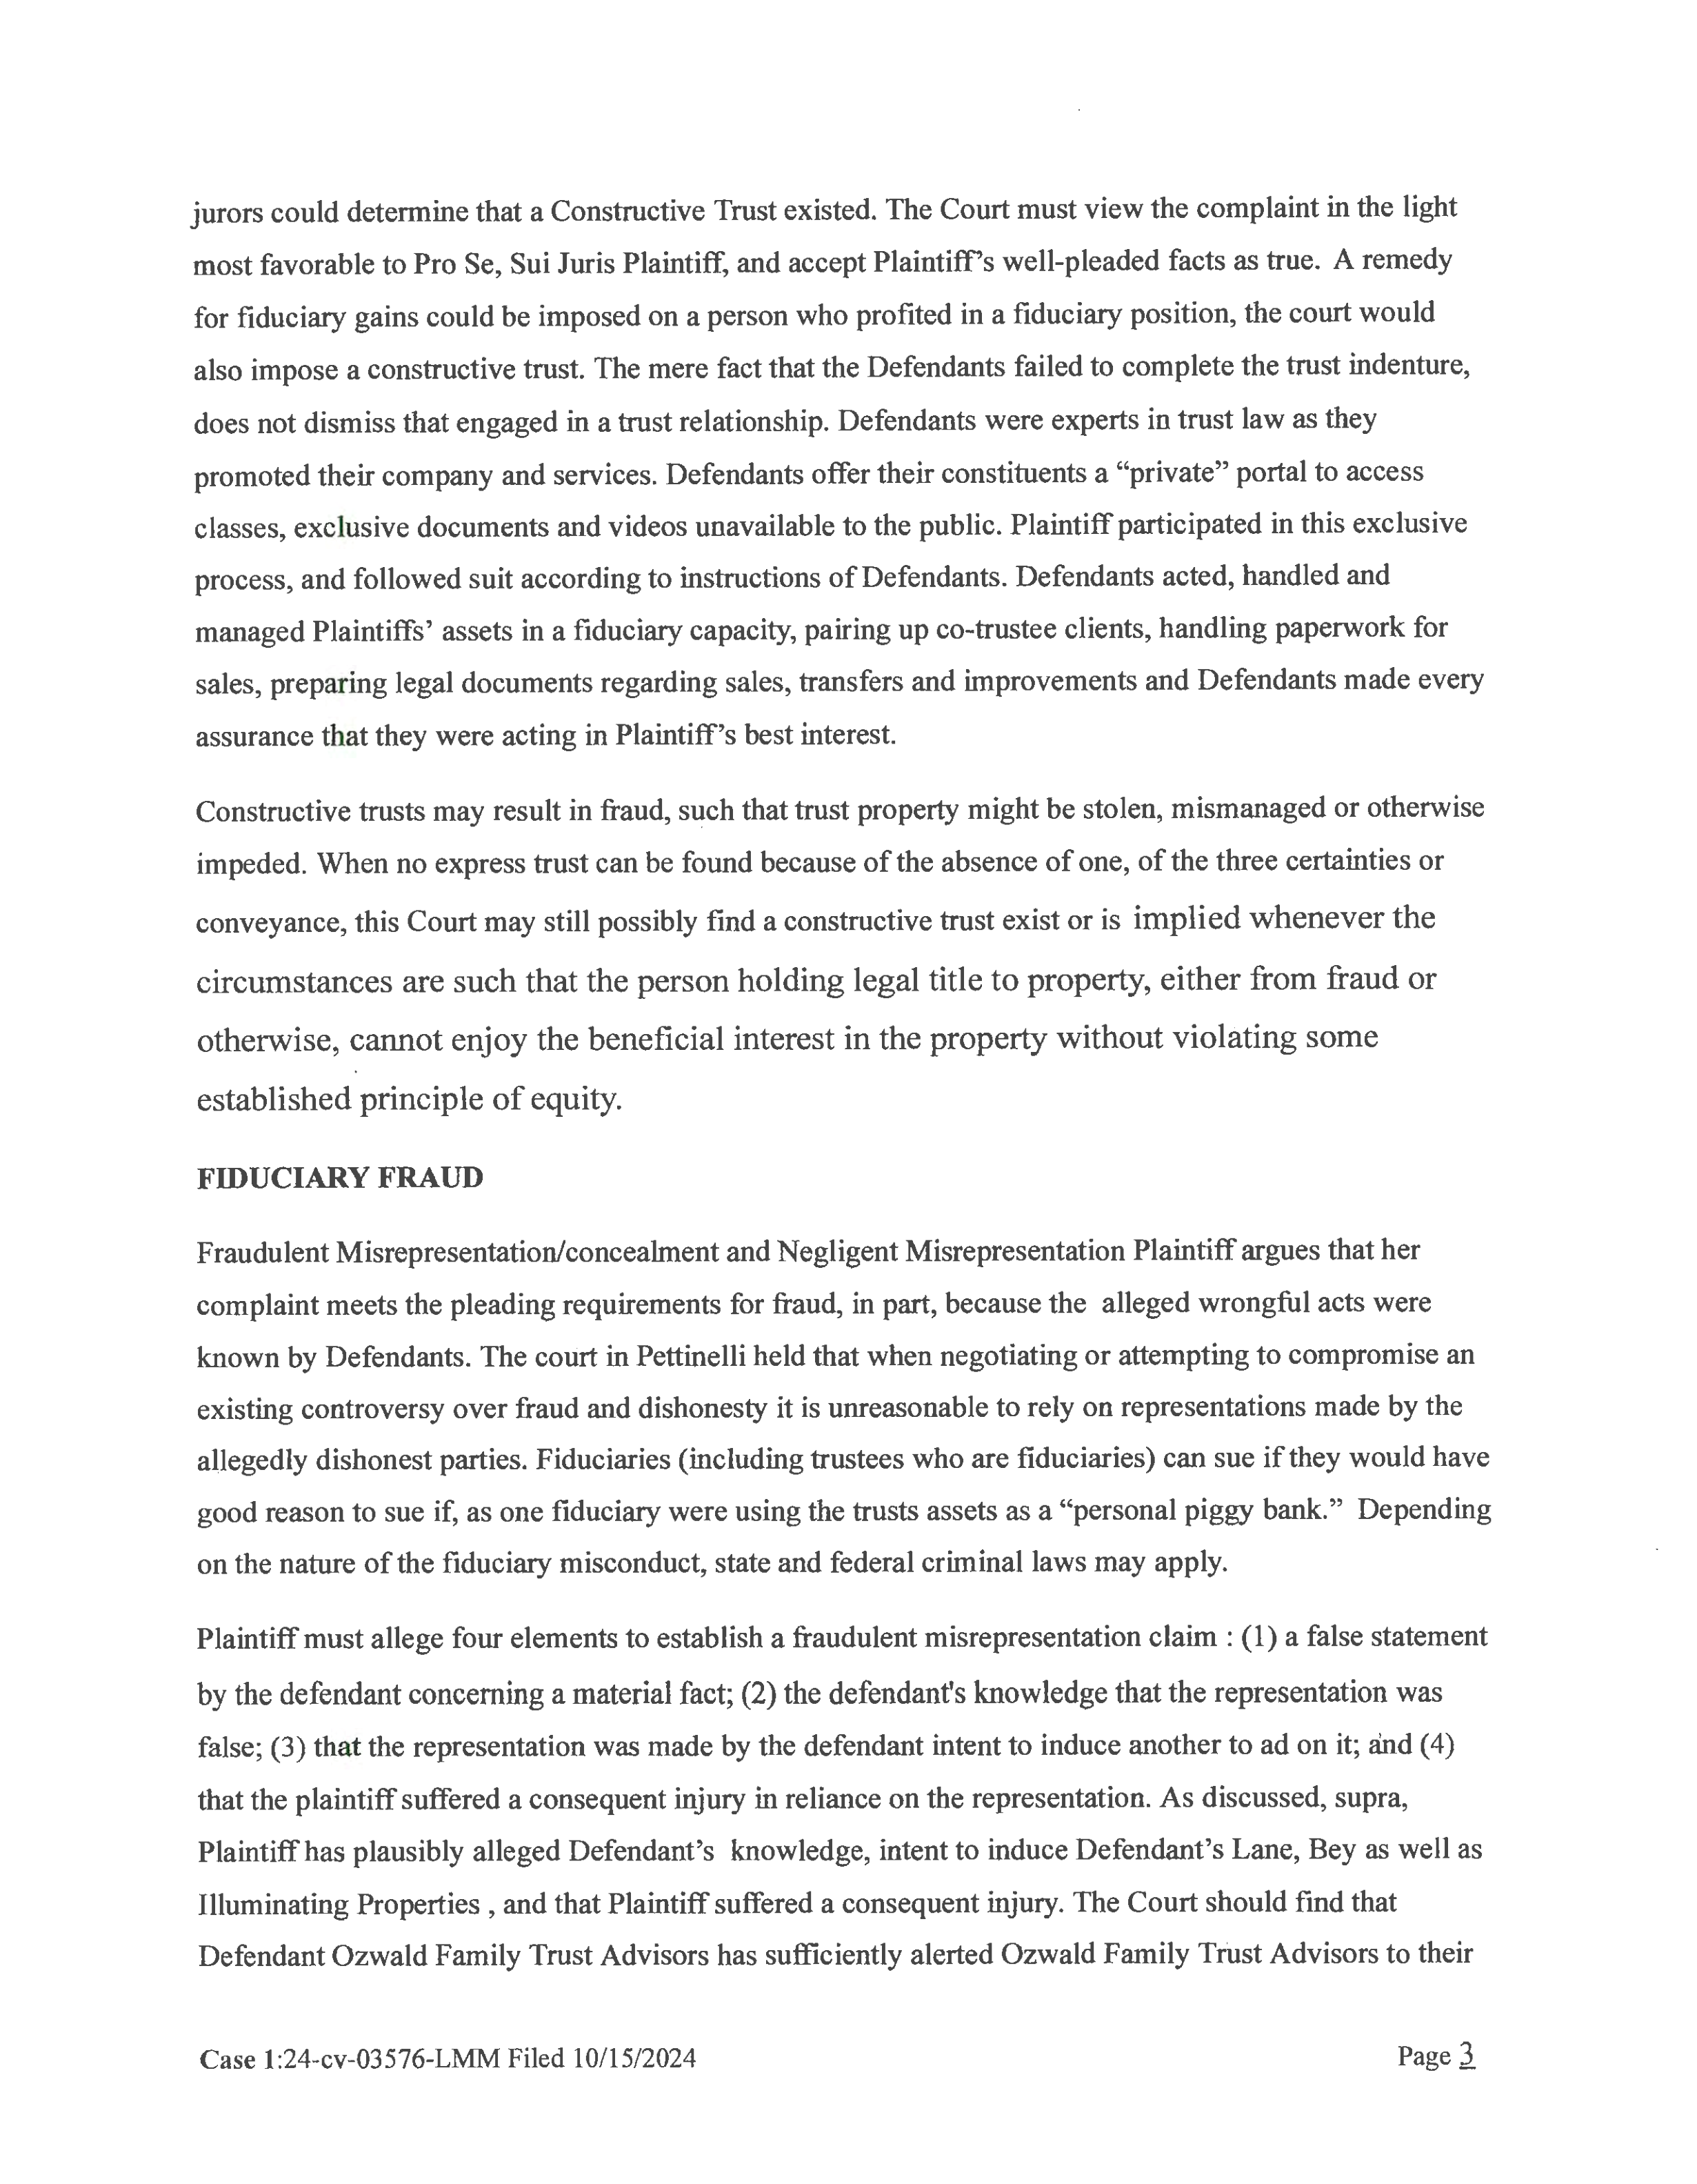

Case 1:24-cv-03576-LMM Document 19 Filed 10/18/24 Page 3 of 9

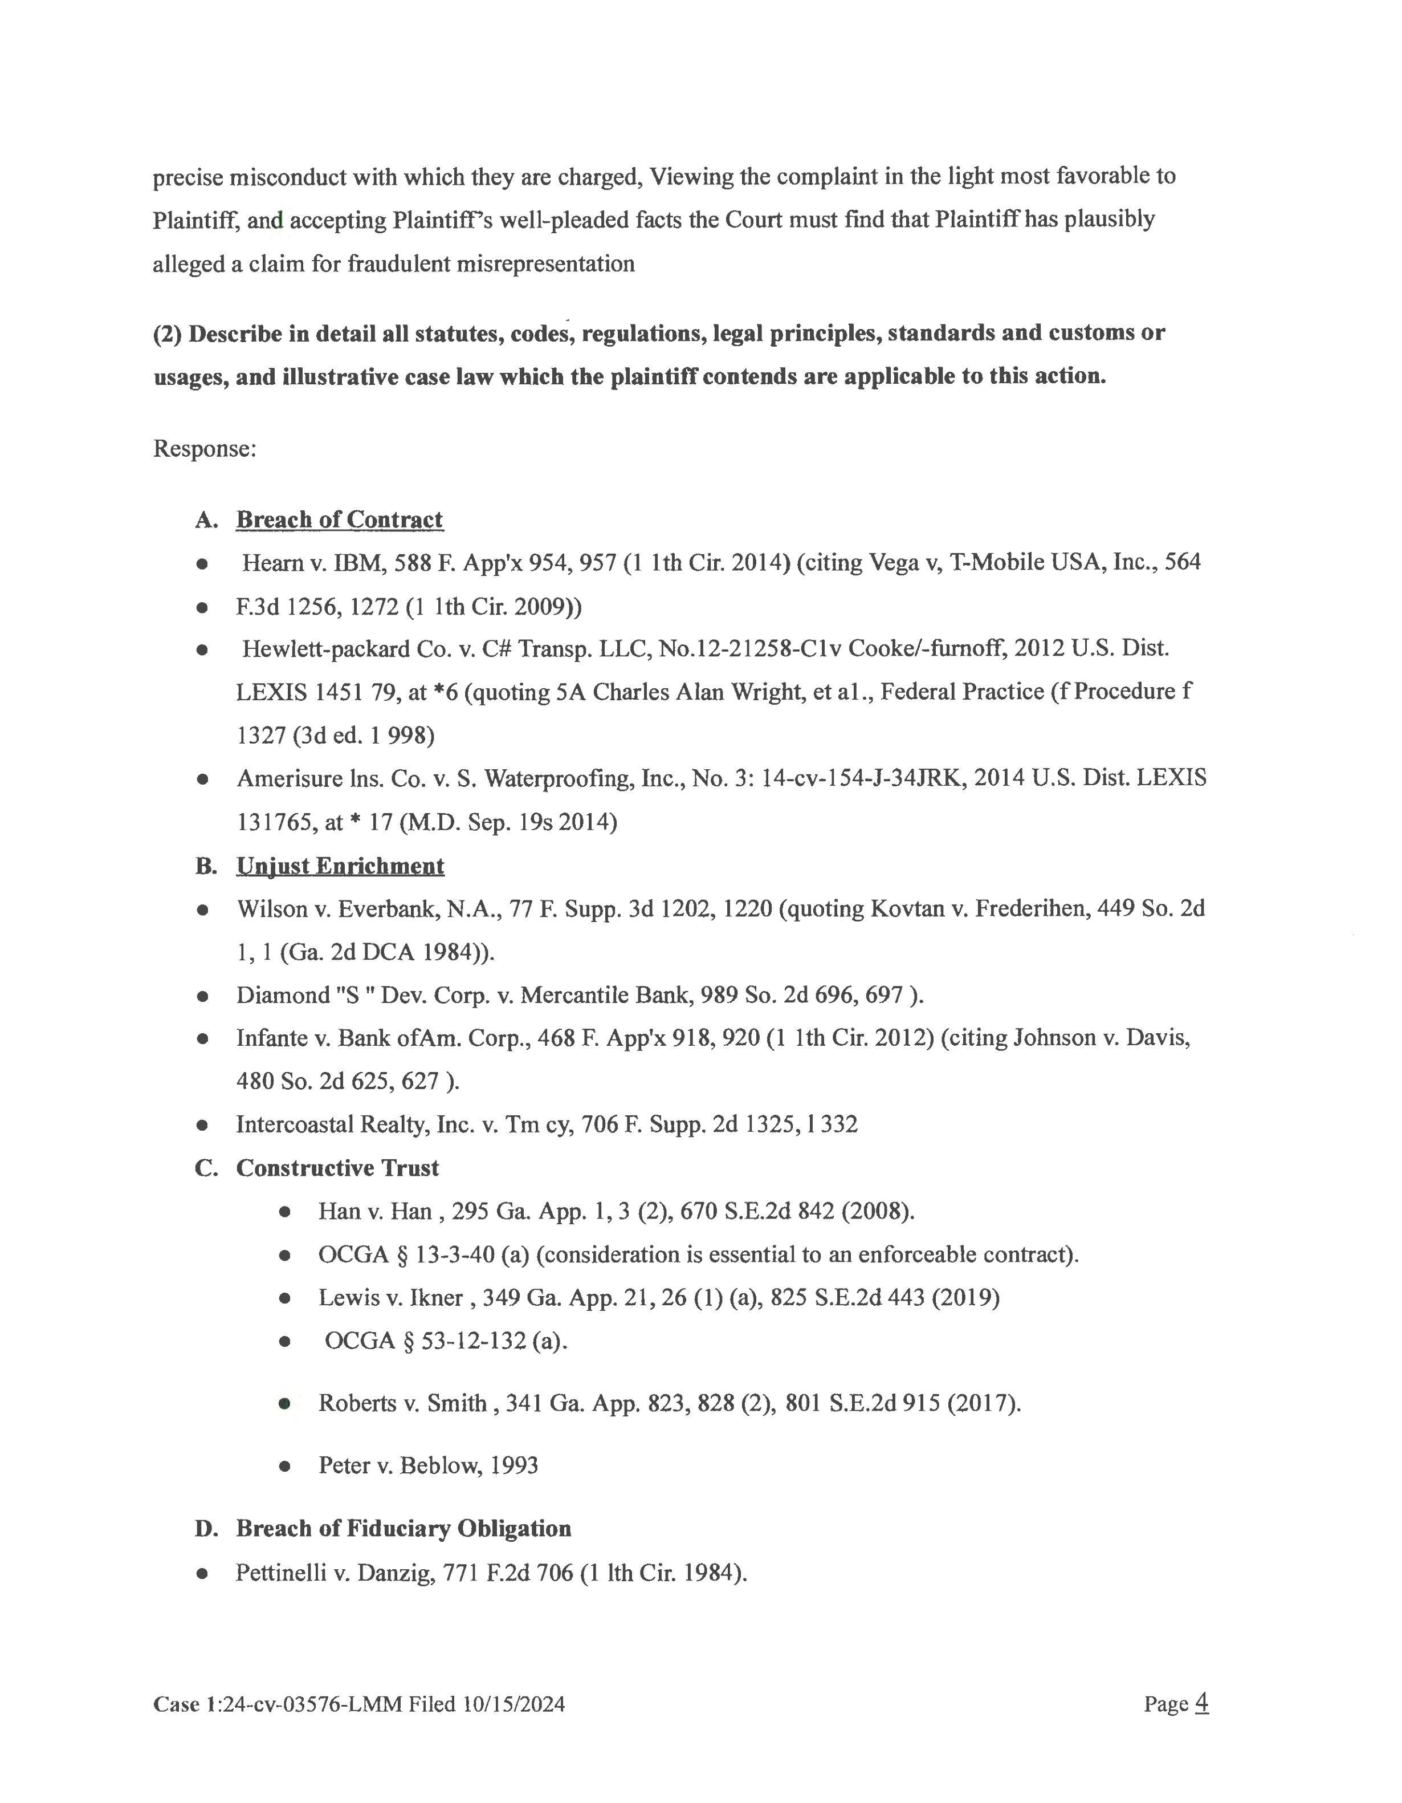

Case 1:24-cv-03576-LMM Document 19 Filed 10/18/24 Page 4 of 9

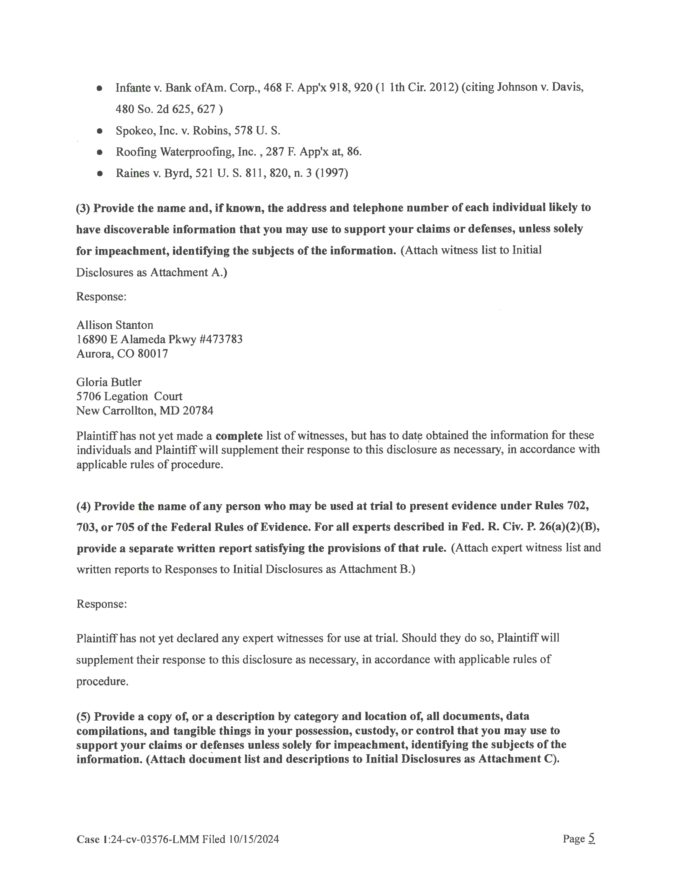

Case 1:24-cv-03576-LMM Document 19 Filed 10/18/24 Page 5 of 9

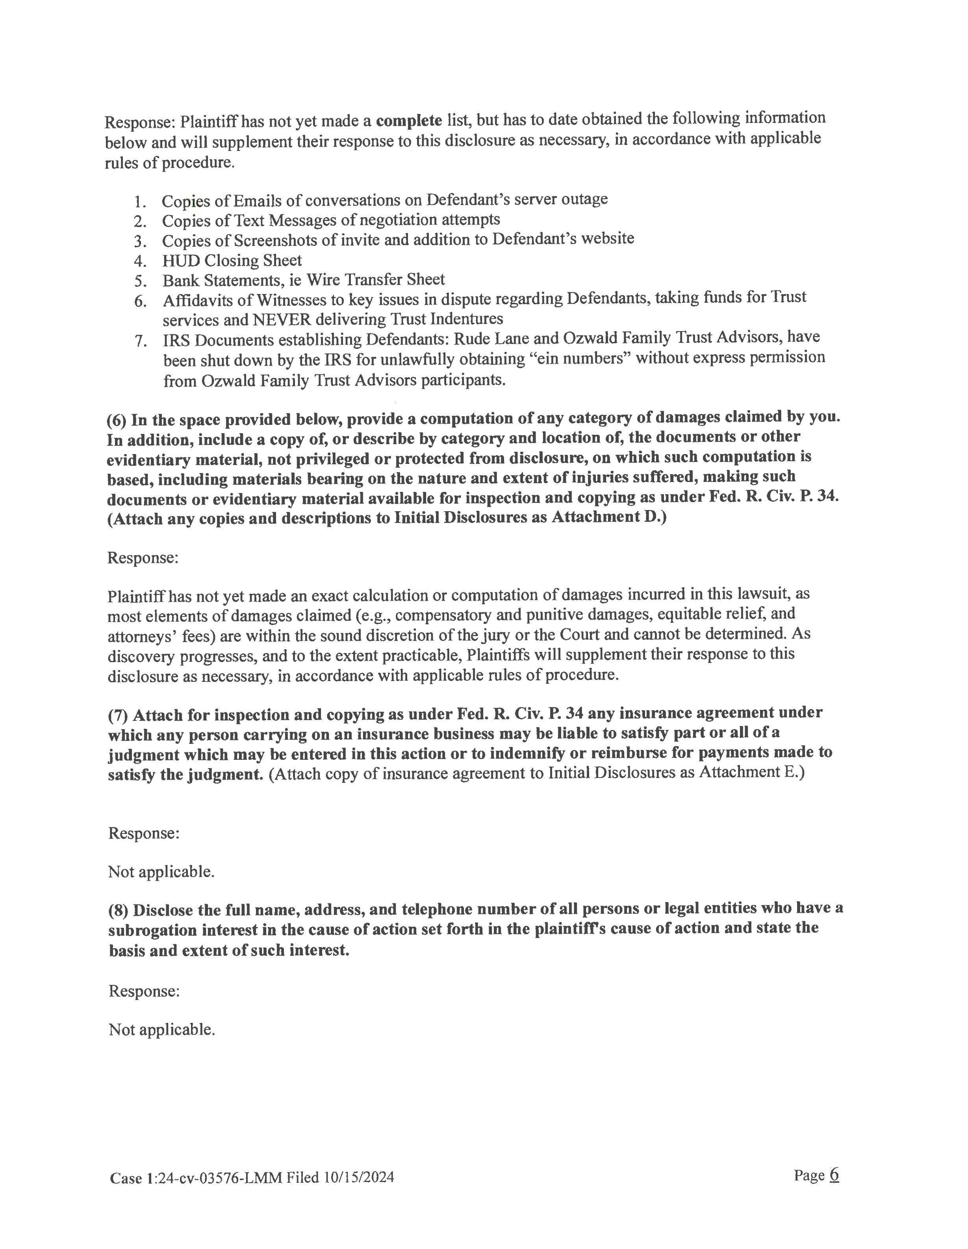

Case 1:24-cv-03576-LMM Document 19 Filed 10/18/24 Page 6 of 9

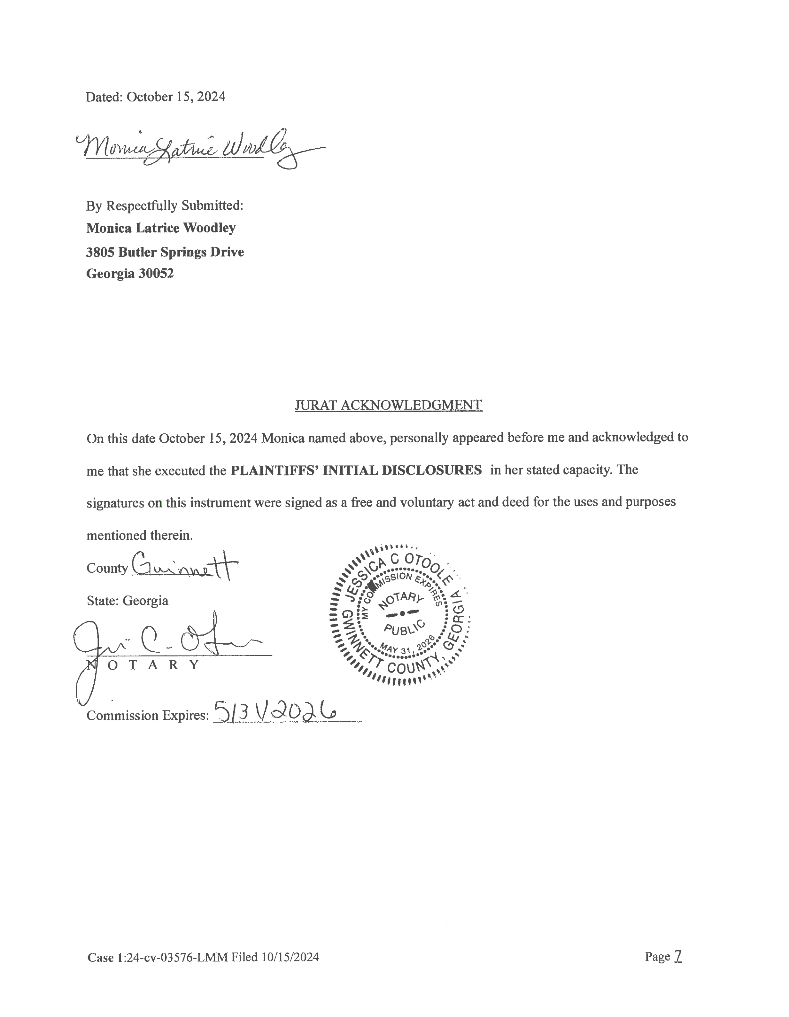

Case 1:24-cv-03576-LMM Document 19 Filed 10/18/24 Page 7 of 9

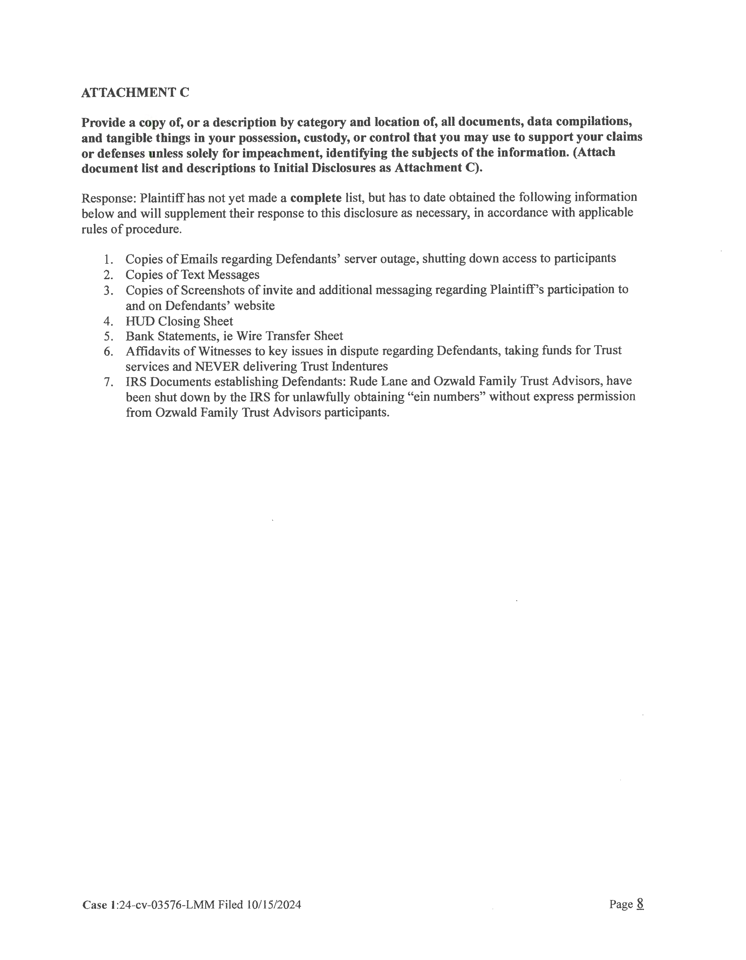

Case 1:24-cv-03576-LMM Document 19 Filed 10/18/24 Page 8 of 9

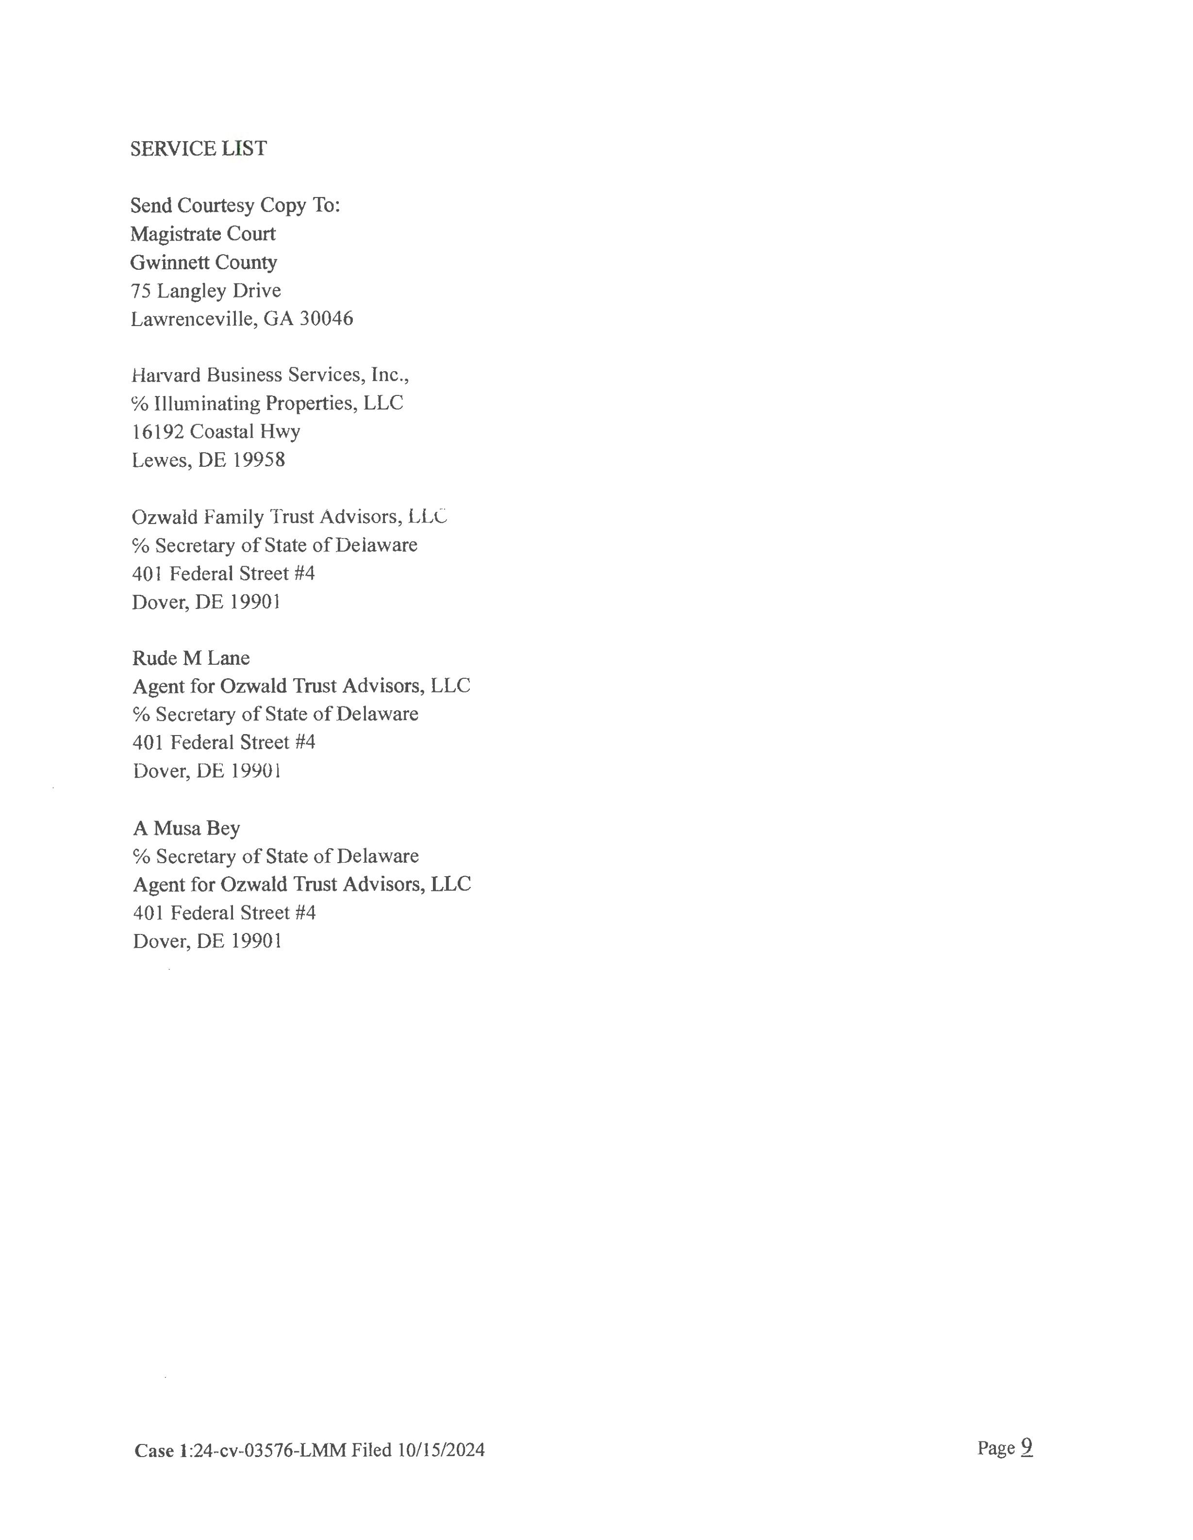

Case 1:24-cv-03576-LMM Document 19 Filed 10/18/24 Page 9 of 9