Assignment-1
Name: Adepu Tejaswini
Ht.no: 2303A51423
Batch. No: 21

1Q) Task 1: AI-Generated Logic Without Modularization (Factorial without
Functions)
Prompt used:
write a python code to calculate the factorial of a number without using any functions and input should be taken from user.
Code:
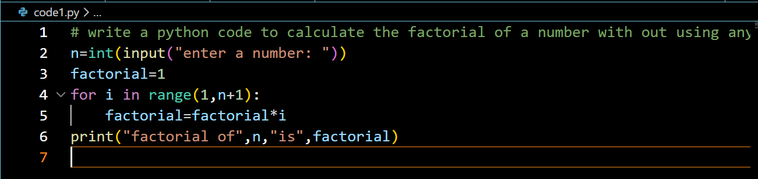
Output:
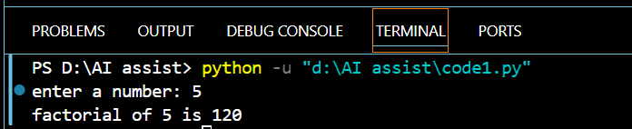
Justification:
By doing this task, the factorial of a number is calculated without using any functions.
The program takes input from the user and uses a single for loop to compute the factorial.
All steps are written directly in the main program using iterative logic.

2Q) Task 2: AI Code Optimization & Cleanup (Improving Efficiency)
Prompt used:
optimize the above code by adding comments, readability and with improved logic.
Code:
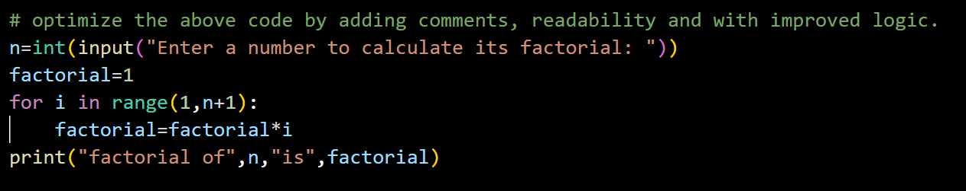
Output:
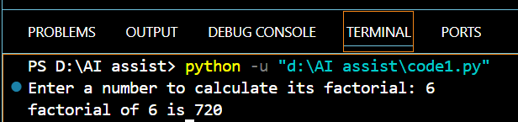
Justification:
By doing this task, the factorial program is optimized for better readability and understanding.
Meaningful comments and clear variable usage are added while keeping the logic simple and efficient.
The program still uses a single loop and user input, with all steps written in the main program.

3Q) Task 3: Modular Design Using AI Assistance (Factorial with Functions)
Prompt used:
- write a python code to calculate the factorial of a number using meaningful user defined functions and taking the input from the user.
- if user gives negative numbers then this code should handle that case as well.
Code:
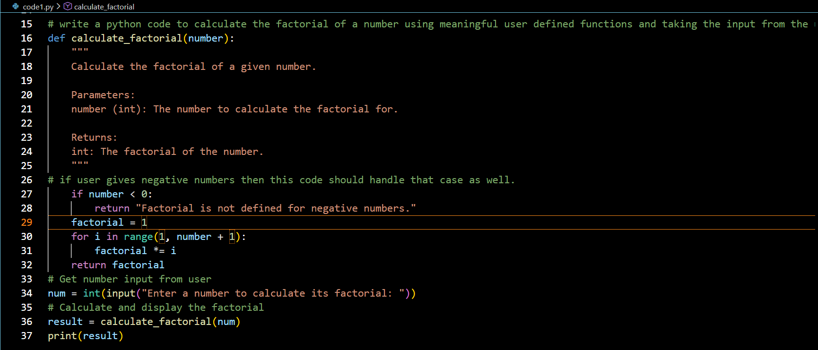
Output:
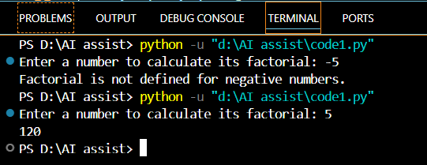
Justification:
By doing this task, the factorial logic is implemented using a meaningful user-defined function.
The program takes input from the user and handles negative numbers with proper validation.
Modular design improves code readability, reusability, and error handling.

4Q) Task 4: Comparative Analysis – Procedural vs Modular AI Code (With vs Without Functions)
Criteria | Without Functions (Procedural Code) | With Functions (Modular Code)
Logic Clarity | Logic is written linearly in one place, which is easy to follow for small programs but becomes cluttered as code grows. | Logic is clearly separated into meaningful functions, making the flow easier to understand.
Reusability | Code cannot be reused easily; the same logic must be rewritten if needed again. | Functions can be reused multiple times across the program or in other programs.
Debugging Ease | Debugging is harder because all logic is mixed in the main program. | Easier to debug since errors can be isolated within specific functions.
Suitability for Large Projects | Not suitable for large projects due to poor structure and maintainability. | Highly suitable for large projects because of clean structure and modular design.
AI Dependency Risk | Higher risk, as AI-generated logic may be copied blindly without understanding due to lack of structure. | Lower risk, as modular design encourages understanding of logic, inputs, and outputs.
Conclusion:
Procedural code is useful for small, simple tasks and beginners, while modular code using functions is better suited for scalable, maintainable, and professional software development.

5Q) Task 5: AI-Generated Iterative vs Recursive Thinking
- An iterative version of the logic
Prompt used:
write a python code to calculate the factorial of a number using iterative approach with meaningful user defined functions and taking the input from the user.
Code:
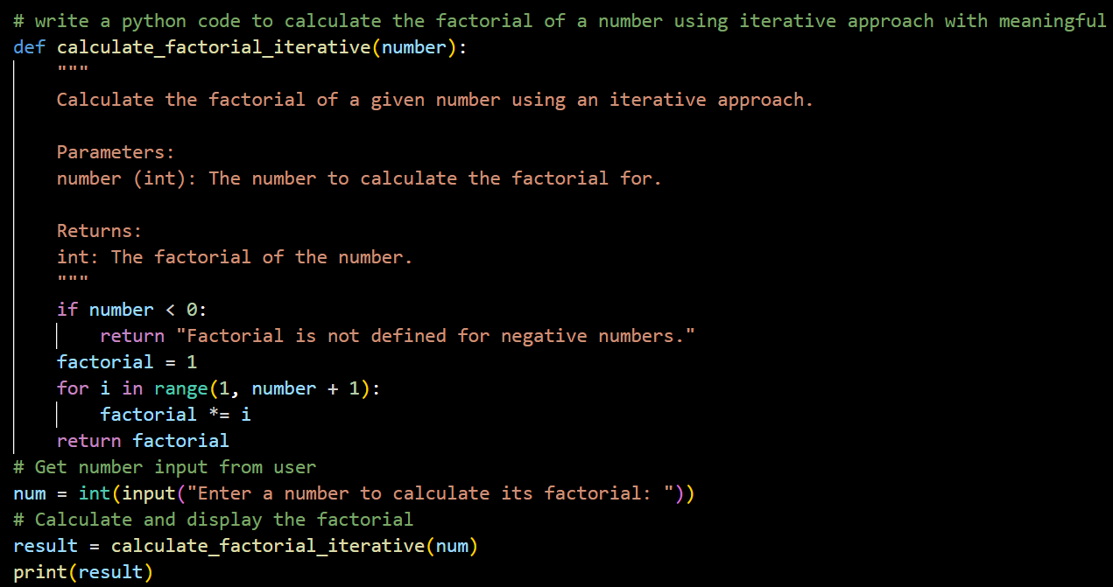
Output: 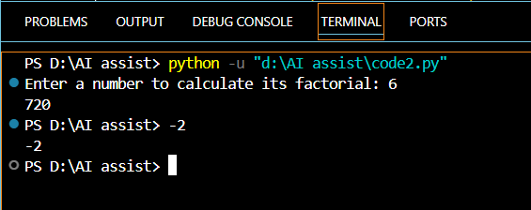
- A recursive version of the same logic
Prompt used:
write a python code to calculate the factorial of a number using recursive approach with meaningful user defined functions and taking the input from the user.

Code:
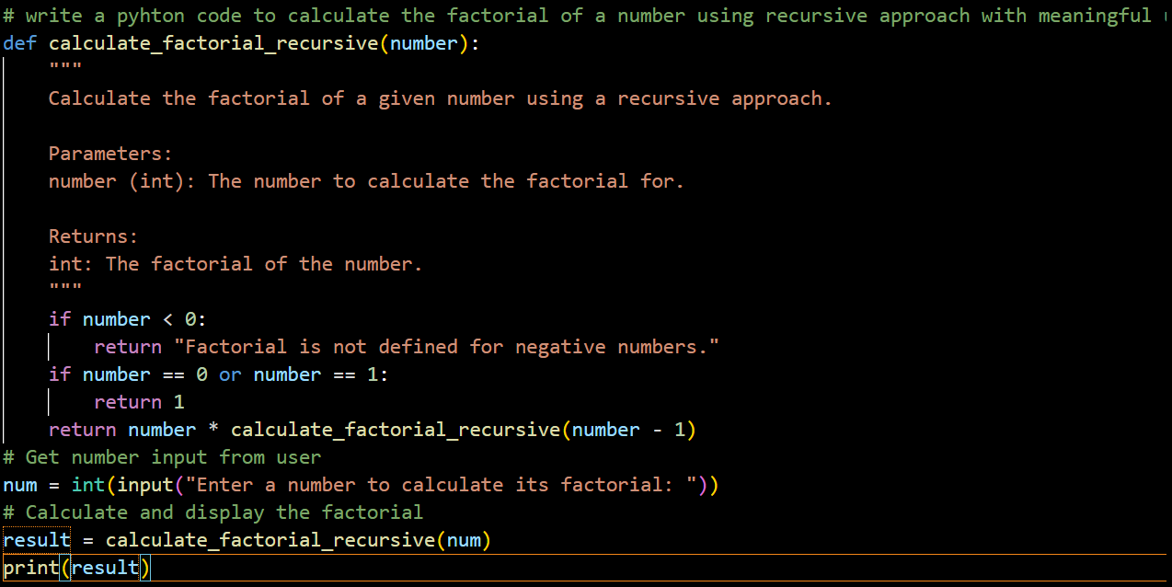
Output:
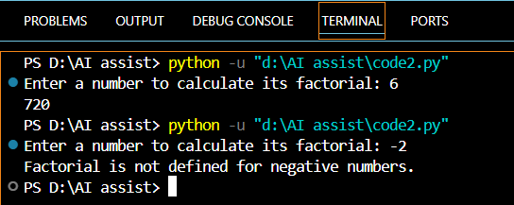
Justification:
By doing this task, factorial logic is implemented using both iterative and recursive approaches.
The iterative version uses a loop for step-by-step multiplication, while the recursive version uses function calls and base conditions.
This comparison helps understand differences in readability, stack usage, performance, and when recursion should be avoided.

