Assignment-15.5
Name: Adepu Tejaswini
Ht.no: 2303A51423
Batch. No: 21
Task 1 – Student Attendance API
Task:
Create a RESTful API for student attendance tracking.
Instructions:
• Endpoints required:
o GET /attendance → View attendance records
o POST /attendance → Mark attendance
o PUT /attendance/{id} → Update attendance record
o DELETE /attendance/{id} → Remove attendance entry
• Ensure JSON-based request and response handling.
Prompt:
  - Created REST API for student attendance using Flask
  - Implemented endpoints for POST and GET requests
  - Used PowerShell to send JSON data
  - Retrieved attendance data using browser

Code:

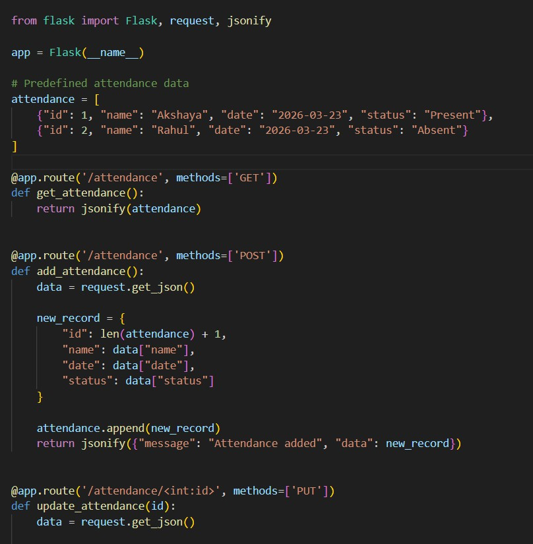

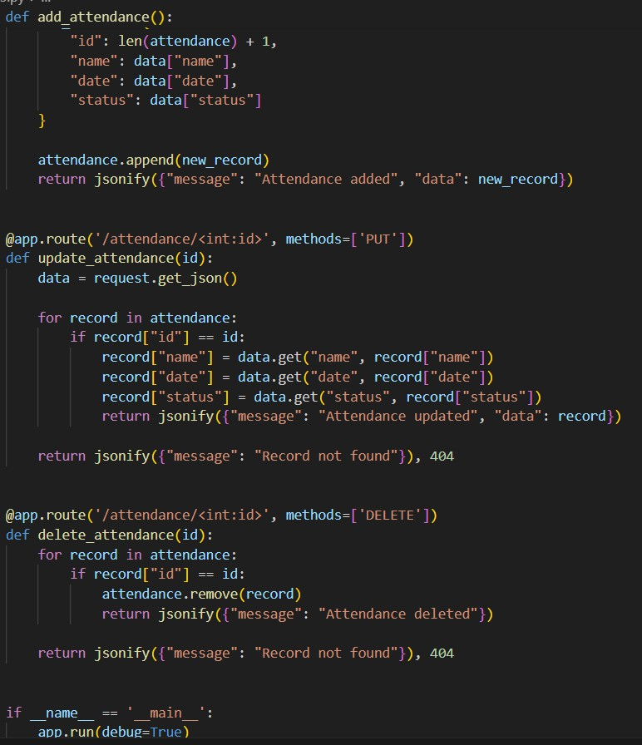

Output:

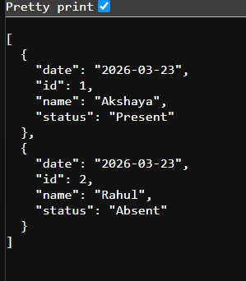

Observation:
The code creates an API to manage student attendance records.
It uses JSON format, so data can be easily sent and received.
The structure is simple, clean, and easy to understand and test.
Task 2 – Inventory Management API
Task:
Develop a REST API for warehouse inventory management.
Instructions:
• Endpoints required:
o GET /inventory → List all items
o POST /inventory → Add new item
o PUT /inventory/{id} → Update stock quantity
o DELETE /inventory/{id} → Remove an item
• Implement validation for stock values.
Prompt:
  - Developed API for inventory management
  - Implemented POST, GET, PUT, DELETE operations
  - Added item with stock value
  - Updated and deleted inventory items
Code:
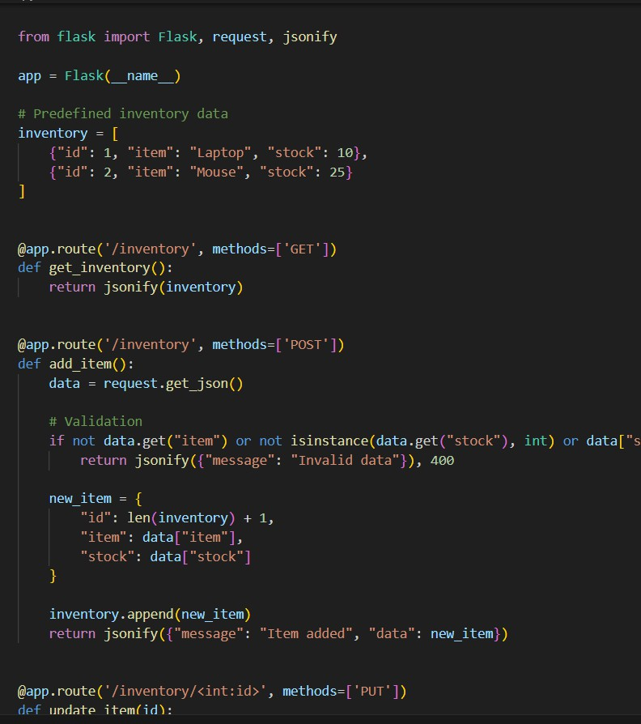

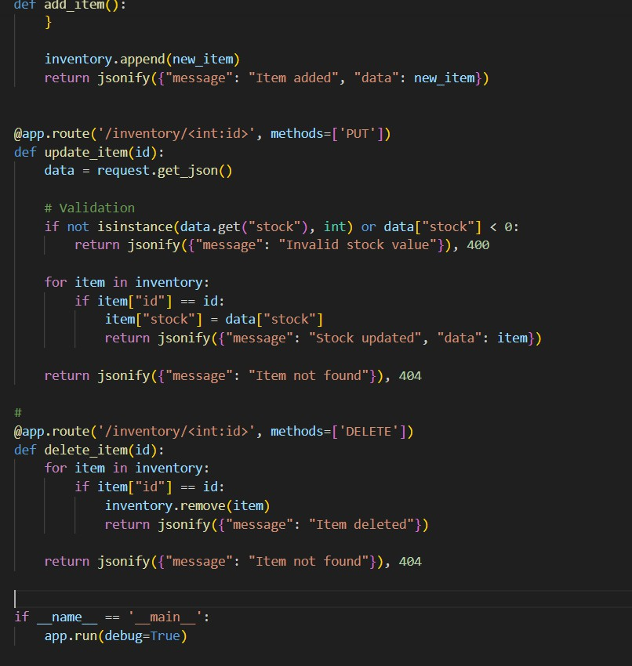

Output:

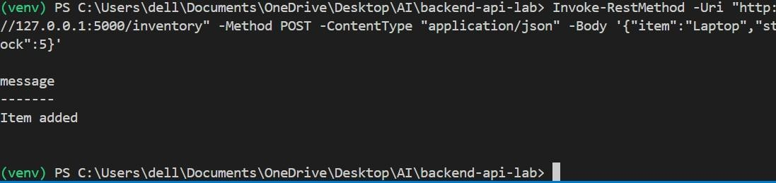

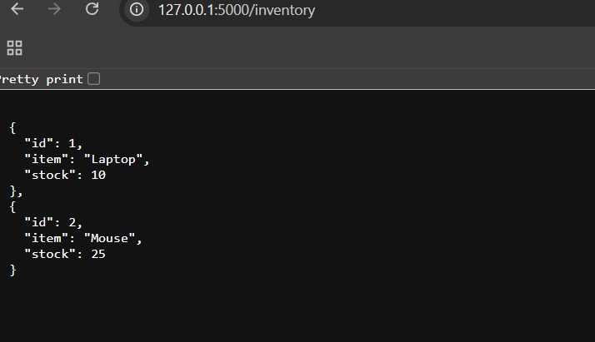

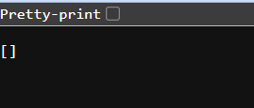
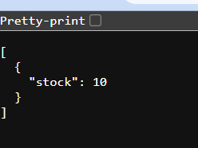

Observation:
The code creates an API to manage inventory items and stock levels.
It checks the stock value to make sure it is valid before updating.
The structure is simple and helps to easily add, view, update, and delete items.

Task 3 – Hotel Room Booking API
Task:
Develop a RESTful API for hotel room booking.

Instructions:
- Endpoints required:
- GET /rooms → View available rooms
- POST /rooms/book → Book a room
- GET /rooms/{id} → View booking details
- DELETE /rooms/{id} → Cancel booking
Implement error handling for unavailable rooms.

Prompt:
  - Created API for hotel room booking
  - Implemented endpoints for booking, viewing, and cancelling rooms
  - Used JSON input for booking details

Code:

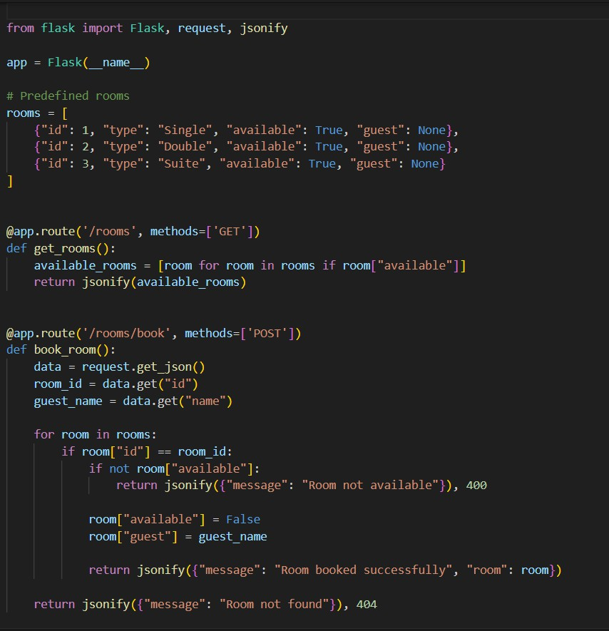

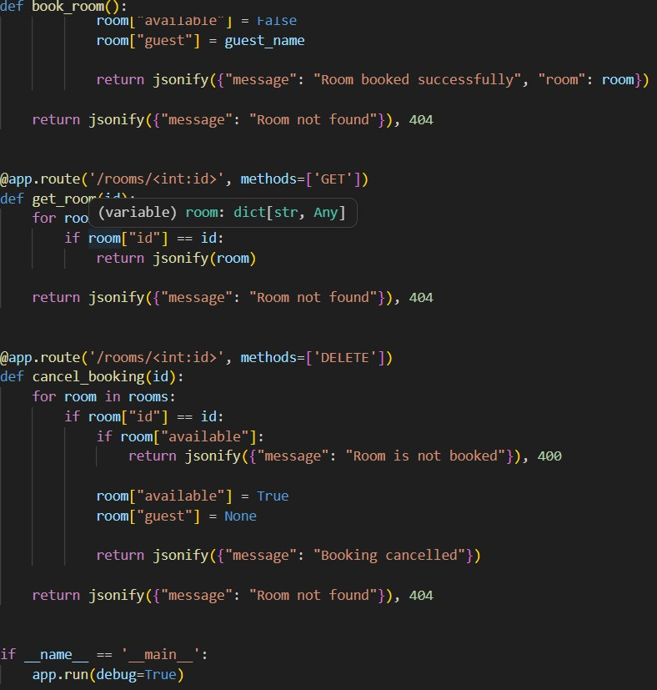
Output:

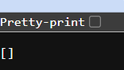

Observation:

The code creates an API to manage hotel room booking operations.
It checks if a room is available before booking and shows an error if not.
The structure is simple and makes it easy to book, view, and cancel rooms.

Task 4 – Online Voting API
Task:
Create a RESTful API for an online voting system. Instructions:
- Endpoints required:
- GET /candidates → List candidates
- POST /vote → Cast a vote
- GET /results → View voting results
- Ensure one vote per user using in-memory validation.
Prompt:
  - Developed API for online voting system
  - Implemented endpoints for candidates, voting, and results
  - Ensured one vote per user
Code:

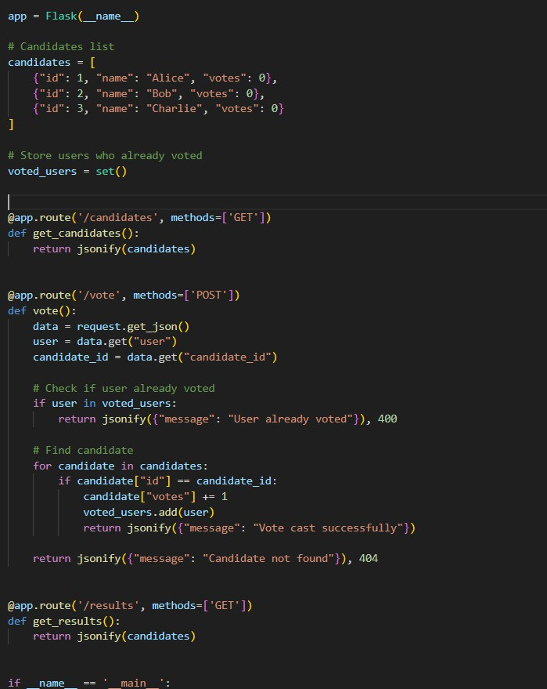

Output:

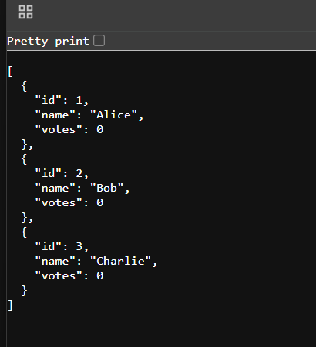



Observation:

The code creates an API to manage voting for different candidates.
It ensures that each user can vote only once using simple validation.
The structure is clean and makes it easy to view candidates and results.

Task 5 – Teacher Management API
Task:
Develop a RESTful API to manage teacher records. Instructions:
- Endpoints required:
- GET /teachers → List all teachers
- POST /teachers → Add a new teacher
- PUT /teachers/{id} → Update teacher details
- DELETE /teachers/{id} → Remove a teacher
- Ensure proper error handling and JSON responses
Prompt:
  - Created API for managing teacher records
  - Implemented CRUD operations
  - Added, updated, and deleted teacher details
Code:

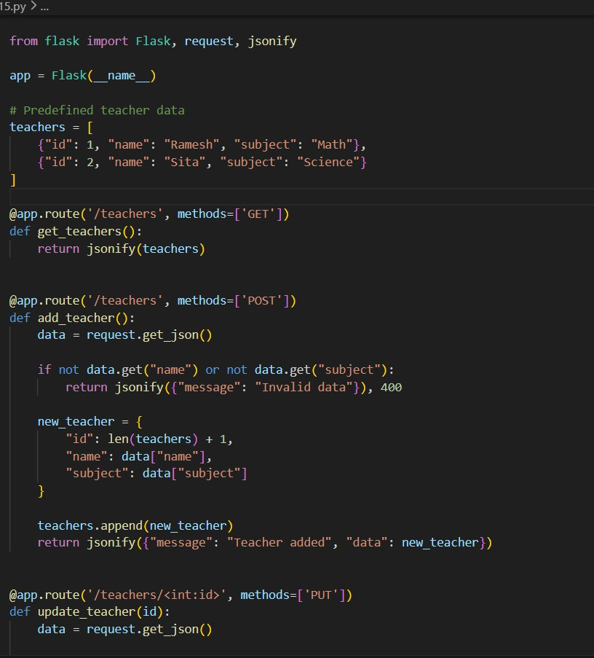

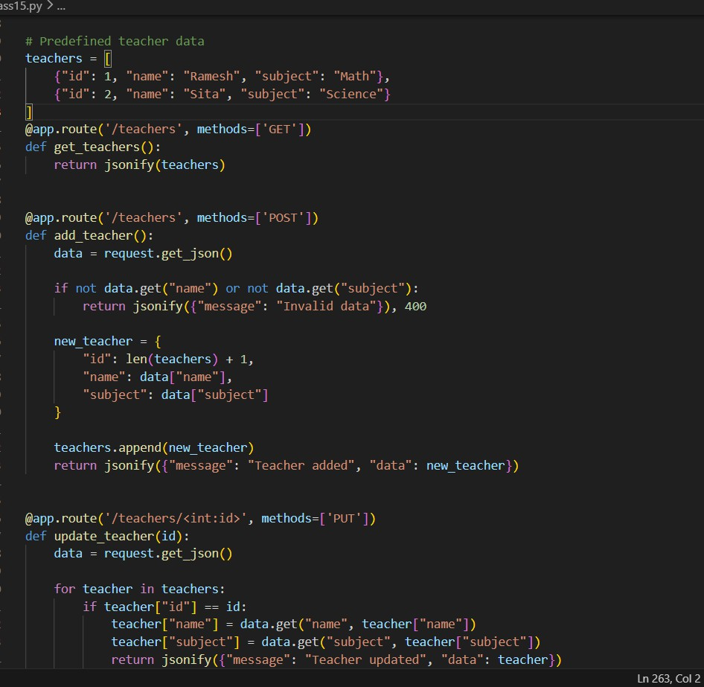

Output:
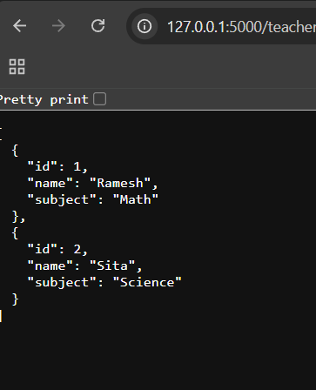

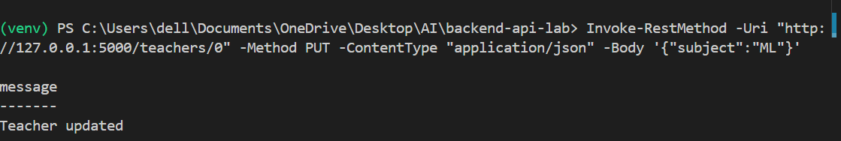
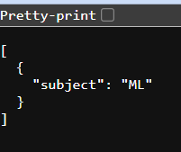
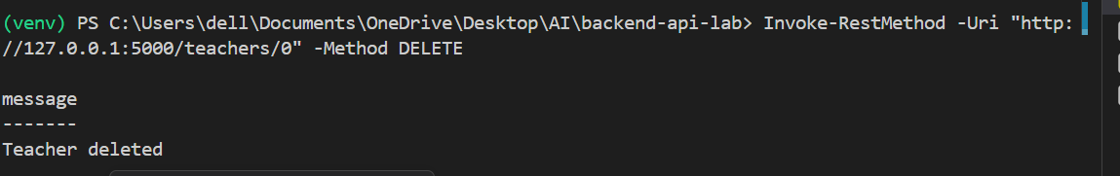
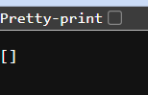

Observation:
The code creates an API to manage teacher records like add, view, update, and delete.
It uses JSON format, so data can be easily sent and received.
Error handling is added to manage invalid requests and make the API reliable.

