PROJECT-1

Title: Railway Gauges
The railway gauges are having three gauges in it, they are:
Broad Gauge: Widest track, used for high-speed and heavy trains; most common in India.
Metre Gauge: Medium width, older system now being converted to broad gauge.
Narrow Gauge: Smallest width, used in hilly or less busy routes

In this project we have to import the csv data to the pandas, we have to analyse it and also visualize the data using matplotlib.

-What are Pandas and use of matplotlib?
Pandas: A Python library used for data analysis and manipulation, especially for handling tables like CSV files.
Matplotlib: A Python library used for data visualization, helping to create graphs like bar charts.

Now, we have to import the csv file to the pandas
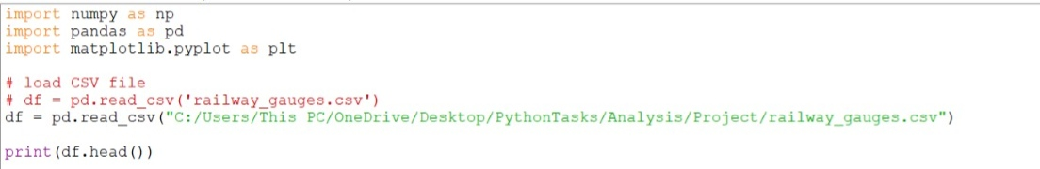
The code is a standard template for starting a data analysis project in Python.
Imports: It brings in numpy, pandas, and matplotlib.
Load: It uses Pandas to open a CSV file named railway_gauges.csv
Df.head(): The df.head() command prints the first 5 rows of that table so we can verify the data loaded correctly.

First 5 rows:
We have to understand the data here,
The three gauges data will be displayed including the year and total number of tracks.

#Example
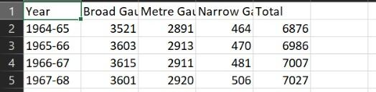

Some of the operations in pandas are:
These are used to access the data
loc[]: Used to select data by labels (names) of rows or columns.
loc → label-based
iloc[]: Used to select data by integer position
iloc → position-based

If suppose we need to find maximum installations, then here is the sample code:
It will return the data for the year that had the maximum number of installations.

Visualization of the Data:
Data visualization is the graphical representation of information and data, using visual elements like charts, graphs, maps, and dashboards.
Here is the sample code to represent the data,
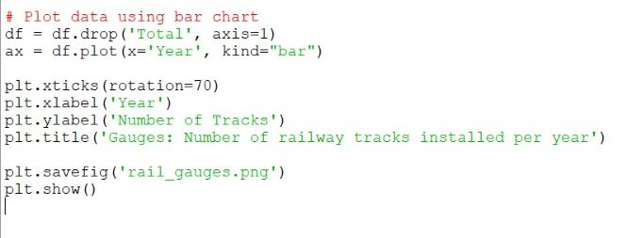
The provided code performs two main actions:
Data Preparation: It removes the "Total" column from the dataframe to isolate the specific data needed for visualization.
Data Visualization: It generates and saves a labeled bar chart that displays the number of railway tracks installed each year, with rotated x-axis labels for better readability.

What we have done?
-Imported csv to the pandas
-Identified the year with highest railway track
-Visualization of the data
-Got an idea about how pandas simplify the data.

Output of the process:
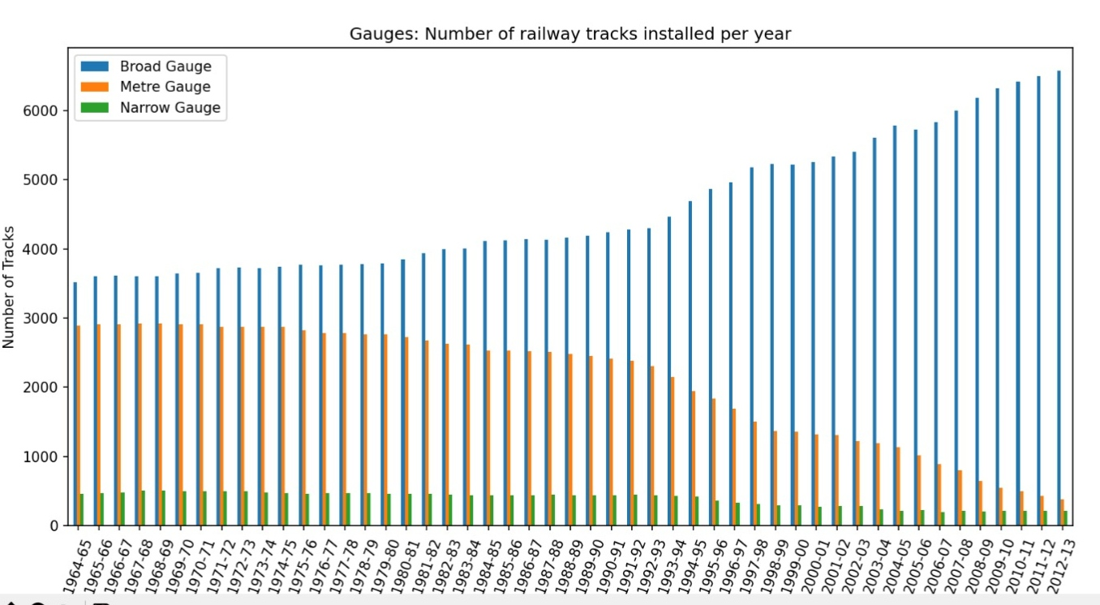

Conclusion:
Through the project we have learned about:
Import the file to pandas
Performance of data analysis
Extraction of data and visualization

