Machine Learning Pipeline
for Short-term Rental Prices in NYC

- W&B Project (public): nyc_airbnb on W&B
- GitHub Repository: Project-Build-an-ML-Pipeline-Starter

W&B Lineage View
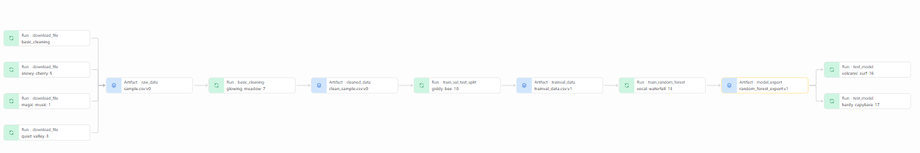

W&B Runs Table
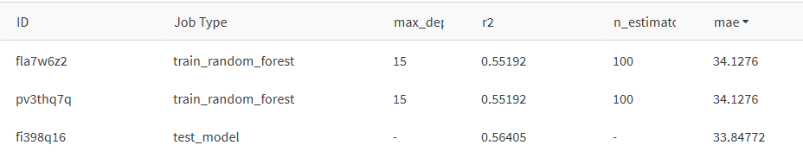

W&B Artifact Details
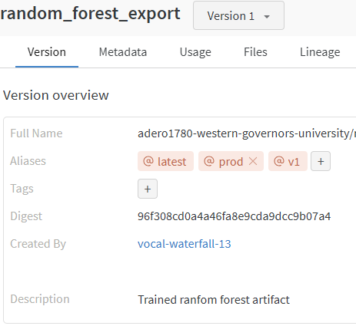
GitHub Releases
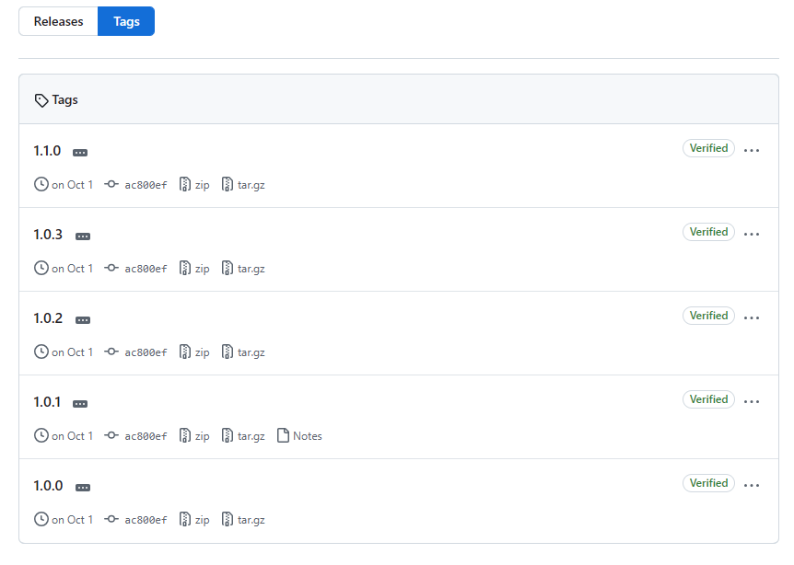

Successful Execution
2025/11/14 20:38:13 INFO mlflow.projects: === Run (ID 'd4603760dc6c439faba3bcd7693be4d4') succeeded ===
2025/11/14 20:38:13 INFO mlflow.projects: === Run (ID '152c9de193f645389f5ce49c2cf93750') succeeded ===
(eda) adero1780@LAPTOP-IA8KAI9F:~/Project-Build-an-ML-Pipeline-Starter$ https://github.com/Adero1780/Project
-Build-an-ML-Pipeline-Starter/releases

