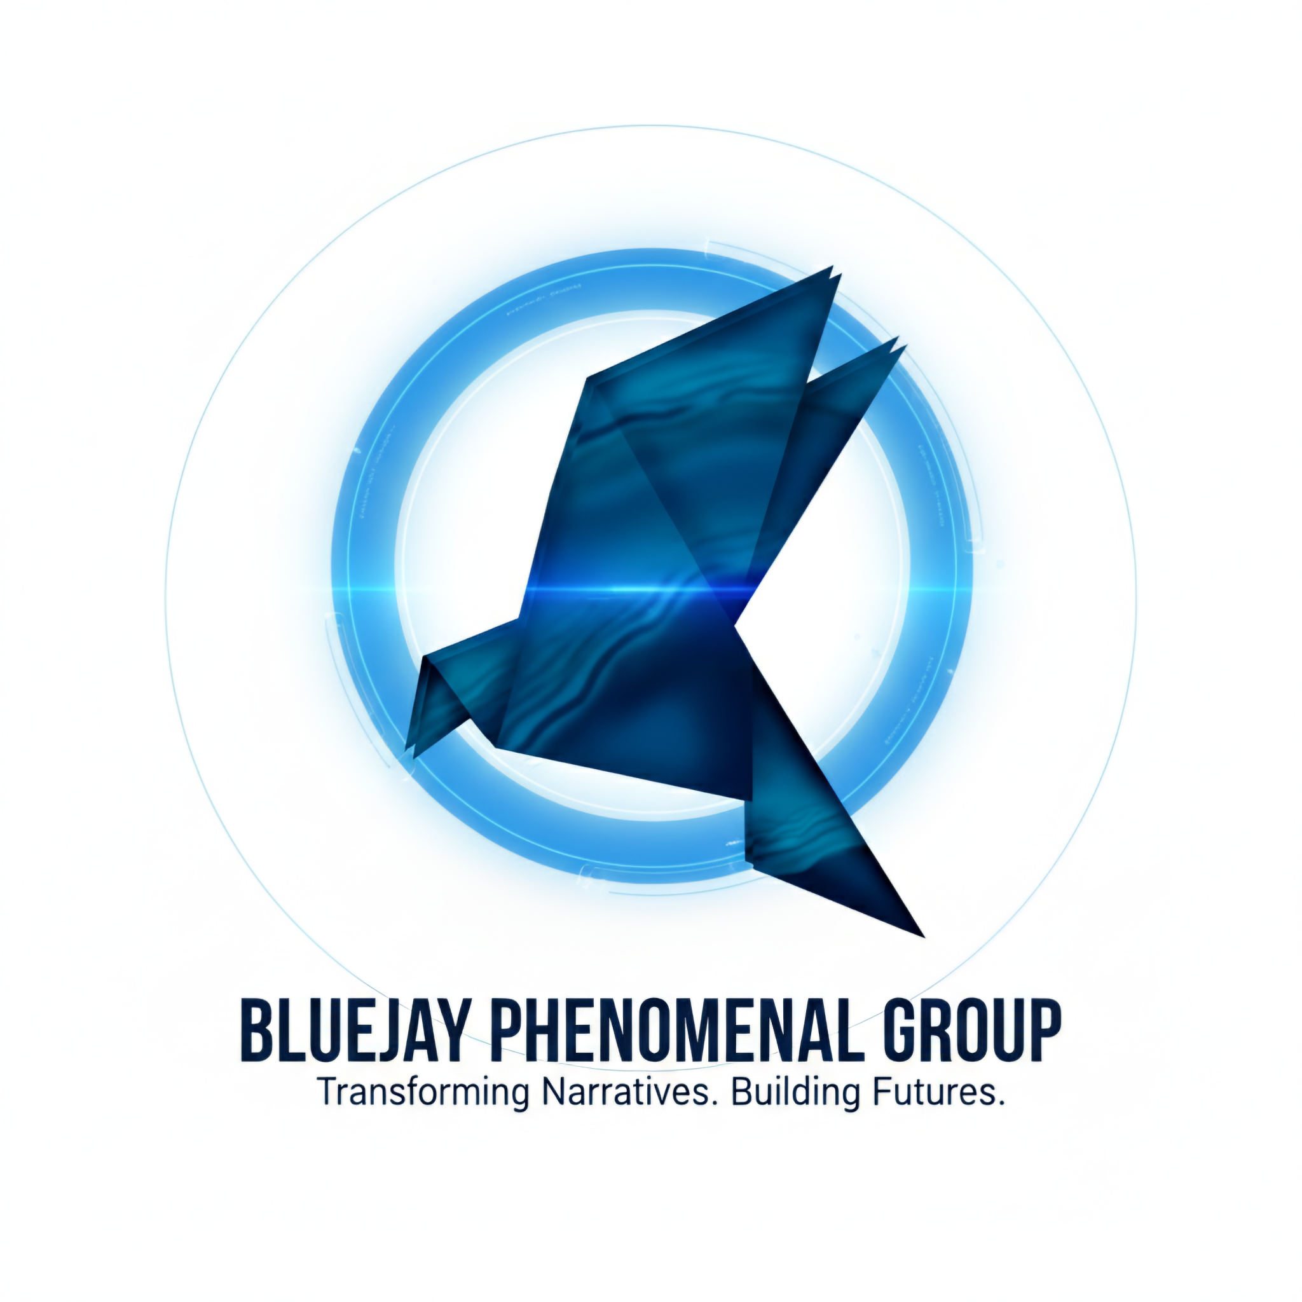

MIRROR REFLECTION & RESPONSE (MRR) SESSIONS

Institutional Program Syllabus & Methodology
Provider: BlueJay Phenomenal Group, LLC
Principal Consultant: Axel Desarden, PC, CLC
Target Populations: Justice-impacted youth and young adults; restorative justice programs and practitioners; law students and legal education programs; and professionals working across juvenile justice, reentry, diversion, and community-based settings.
Framework: Risk-Need-Responsivity (RNR) framework | Cognitive Behavioral Intervention (CBI) applications | Narrative literacy | Restorative justice and facilitated dialogue contexts.

EXECUTIVE SUMMARY
The Mirror Reflection & Response (MRR) methodology uses the cinematic narrative of Distorted Perception of Innocence as an experiential entry point for facilitated reflection and dialogue across justice-focused educational, institutional, and community-based settings.
Grounded in lived experience, the approach creates opportunities to examine identity, trauma adaptation, personal choices, accountability, and the possibility of change. The film serves as a cinematic catalyst for structured engagement, complementing existing programming and creating space for meaningful conversations about decisions, consequences, and alternative responses.
MRR is designed to be adaptable to different audiences and learning environments. Depending on the setting, the methodology can support direct participant engagement, restorative justice learning, law student education, and professional development. Its application alongside established frameworks and practices is determined by the host program's objectives, requirements, and delivery context.

TARGET POPULATIONS & APPLICATION SETTINGS

1. Justice-Impacted Youth & Young Adults
Youth and young adults, including those participating in juvenile justice, secure-facility, diversion, and Alternative-to-Incarceration (ATI) programs.
Sessions explore identity development, trauma adaptation, choices, consequences, accountability, and alternative responses to challenging situations. Facilitation is adapted to participants' developmental needs, setting, and program objectives.

2. Restorative Justice Programs & Practitioners
Restorative justice clinics, centers, facilitators, and community-based programs seeking experiential resources that can complement established restorative circles, facilitated dialogue, practitioner learning, and restorative education.
MRR offers a narrative-based entry point for exploring accountability, harm, perception, and personal responsibility. It is intended to complement—not replace—existing restorative processes or the expertise of established practitioners.

3. Law Students & Legal Education
Law school restorative justice clinics, juvenile justice programs, experiential learning courses, and other relevant legal education settings.
The film and facilitated discussion create opportunities to examine the human dimensions of justice, the influence of narrative and perception, trauma adaptation, accountability, and the relationship between lived experience and professional practice.

4. Justice Professionals & Emerging Practitioners
Attorneys, educators, youth-serving professionals, reentry practitioners, facilitators, and others working with justice-impacted populations.
Depending on program goals, sessions can encourage reflection on communication, engagement, decision-making, accountability, and the role of lived experience in justice-focused work.

CORE METHODOLOGY

1. THE CATALYST — Cinematic Immersion
Action: A screening of Distorted Perception of Innocence.
Objective: Establish an accessible entry point for engagement through narrative and lived experience, creating opportunities for participants to recognize, question, and reflect on themes relevant to their experiences and learning objectives.

2. THE MIRROR — Guided Reflection
Action: Facilitated dialogue connecting the film's themes to participants' perceptions, experiences, choices, and decision-making patterns.
Objective: Encourage examination of assumptions, survival-based adaptations, and thinking patterns that may influence behavior, relationships, responses to conflict, and perceptions of accountability.

3. THE RESPONSE — Accountability & Action
Action: Facilitated reflection, practical response planning, and, where appropriate, next-step goal setting.
Objective: Support participants in exploring accountability, emotional regulation, conflict resolution, and alternative ways of responding to challenging situations. The emphasis is on translating reflection into considered choices and practical action.

FRAMEWORK & PROGRAM APPLICATION
MRR incorporates narrative-based engagement and structured reflection in ways that may complement the Risk-Need-Responsivity (RNR) framework, cognitive behavioral interventions (CBI), restorative justice practices, and other established approaches.
Application depends on the host program, intended population, facilitator role, and institutional requirements. References to these frameworks describe areas of potential application and should not be interpreted as independent certification, formal endorsement, or validation by an external agency.

INSTITUTIONAL APPLICATION & DOCUMENTATION

Program Integration
MRR can be explored as an experiential resource within secure facilities, ATI programs, restorative justice clinics, law school courses, community-based programs, reentry settings, and professional learning environments.
Session objectives, facilitation, and discussion prompts are adapted to the audience and setting. Youth-focused intervention sessions, law student learning experiences, and practitioner development sessions may use the same cinematic catalyst while pursuing different learning objectives.

Participant Engagement & Learning
The film and facilitated sessions provide a structured opportunity to engage with identity, choices, consequences, perception, and accountability.
Participant engagement and individual outcomes depend on the setting, implementation, and participant response. Specific outcomes should be established through appropriate evaluation rather than assumed.

Documentation & Deliverables
Program materials and a syllabus can support institutional planning. Session documentation, engagement records, and Certificates of Completion may be provided where included in the agreed delivery model and consistent with institutional requirements.

EXPLORE A POTENTIAL FIT
Interested in exploring how Distorted Perception of Innocence and the MRR methodology might complement your program, clinic, course, or institutional setting?
Let's begin with a conversation about your audience, objectives, and existing practices.
Axel Desarden, PC, CLC
Principal Consultant | BlueJay Phenomenal Group, LLC
Direct: (347) 765-5676
Email: axeldesarden7@gmail.com

“See you at the intersection of story, reflection, and discussion.”

