|  |
| --- |
| **PERSONAL DETAILS** |

|  |  |
| --- | --- |
| *FULL NAME* | **Adesh Ashok Mutkule** |
| *BRANCH* | Computer Science |
| *MOB. NO* | (+91)7066179197 |
| *EMAIL* | adeshmutkule9197@gmail.com |

|  |
| --- |
| **CAREER OBJECTIVE** |

To work for an organization which provides me an opportunity to improve my skills and knowledge to grow, while fulfilling organization objectives.

|  |  |  |  |  |
| --- | --- | --- | --- | --- |
| **EDUCATION DETAILS** | | | | |
| **Class** | **University** | **Institute** | **Year** | **Percentage/SGPA** |
| B.C.S | Bamu University | Nalanda College in Computer Science, Ashti | 2024 | 71.60 |
| SSC | Maharashtra State Board | Pandit Jawaharlal Nehru Vidhyalya,Ashti | 2019 | 69.20 |

|  |  |
| --- | --- |
| **TECHNICAL QUALIFICATION** | |
| PROGRAMMING  LANGUAGES | Basics of HTML5, CSS3, JavaScript, BootStrap, Node js, React js . |
| CERTIFICATES | *Completed Full Stack Development from* ***A2Z It Hub, Ahmednagar***. |

|  |  |
| --- | --- |
| **WEB DEVELOPMENT PROJECTS** | |
|  | **Banking**  Banking is website which is for Online Visit   * *Technologies used:* ***HTML5, CSS3* and *Bootstrap.*** * *Website Link:* [**https://adesh-mutkule.github.io/Bank-Managment/**](https://adesh-mutkule.github.io/Bank-Managment/) * *Source code:* **https://github.com/Adesh-Mutkule/Bank-Managment.git** |

|  |  |
| --- | --- |
| **ACADEMIC PROJECTS** | |
| **Degree project**  *[Aug’2023 to*  *Jan’2024]* | **Appointment Of Hospital** **Management System**   1. **Streamlining Appointment Booking:** The primary goal of many patient appointment websites is to make it easy for patients to schedule appointments online. This can reduce the administrative burden on staff and provide patients with convenient access to care. 2. **Improving Patient Experience:** By offering online appointment booking, patients can avoid long wait times on the phone and have more control over when they schedule appointments. This can lead to higher patient satisfaction and loyalty. |

|  |  |
| --- | --- |
| **INTERNSHIPS** | |
| **A2z It Hub Ahmednagar**  *(Duration-6 Months)* | This course provides hands on training on setting up and maintenance of fiber Full . |
|  |  |

|  |
| --- |
| **ACHIEVEMENTS** |
| * Awarded as an ‘**IDEAL STUDENT’** in school. |

|  |
| --- |
| **EXTRA-CURRICULAR ACTIVITIES** |
| * Worked as a **co-ordinator** of cultural event. |

|  |  |
| --- | --- |
| **PERSONAL DETAILS** | |
| *Date of birth* | 2th,feb 2003 |
| *ADDRESS* | AT/Post-Kadasakhar karkhana, Tal-Ashti, Dist-Beed, Maharashtra,Pin-414203 |
| *Marital Status* | Unmarried |

|  |
| --- |
| **DECLARATION** |

All the information is true to the best of my knowledge.

PLACE: Pune.

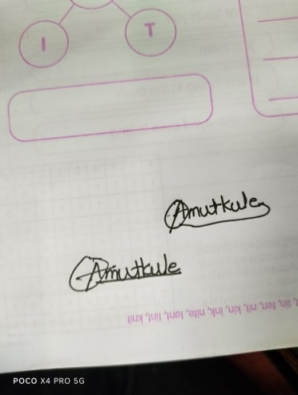

SIGNATURE

DATE: (Adesh A Mutkule)