NETWORK BANDWIDTH MONITORING
USING IFTOP AND VNSTAT
PROJECT REPORT
Submitted by:
Adesh Borhade
Department of Electronics and Computer Science
Shah & Anchor Kutchhi Engineering College, Mumbai
Academic Year: 2026–27

ABSTRACT
Network bandwidth monitoring is important for understanding network usage, traffic patterns, and data transmission on a computer system. This project implements a Linux-based network bandwidth monitoring system using iftop and vnStat on AlmaLinux. The network interface enp0s3 is monitored to observe network activity. The iftop tool is used to monitor network traffic and active connections in real time, while vnStat is used to collect and display bandwidth statistics over time. The project demonstrates the practical use of Linux command-line tools for monitoring received and transmitted network data and analyzing network bandwidth usage.
Keywords: Network Monitoring, Bandwidth Monitoring, AlmaLinux, iftop, vnStat, Network Traffic, Linux

1. INTRODUCTION
Network traffic monitoring is an important part of computer network management. It helps users understand how data is being transmitted and received by a system. Monitoring network bandwidth can help identify network usage, active connections, data transfer rates, and changes in network activity.
Linux provides several command-line tools for monitoring network activity. In this project, iftop and vnStat are used for network bandwidth monitoring. iftop provides real-time information about network connections and traffic rates, whereas vnStat records network traffic and provides bandwidth statistics for different time periods.
The project is implemented using AlmaLinux in a virtualized environment. The active network interface enp0s3 is monitored using these tools.

2. PROBLEM STATEMENT
Network activity continuously changes as applications communicate over the Internet or local network. Without proper monitoring tools, it is difficult to identify the amount of data being received and transmitted by a system. Therefore, the project aims to implement a simple Linux-based network monitoring system that can display real-time network traffic and provide bandwidth usage statistics.

3. OBJECTIVES
- To monitor network traffic in a Linux environment.
- To identify and monitor the active network interface.
- To observe real-time network connections and traffic rates.
- To measure received (RX) and transmitted (TX) data.
- To collect network bandwidth statistics over time.
- To understand the practical use of Linux network monitoring tools.
- To analyze network activity using iftop and vnStat.

4. TOOLS AND TECHNOLOGIES USED

4.1 AlmaLinux
AlmaLinux is a Linux-based operating system used as the environment for implementing the network monitoring project.

4.2 VirtualBox
Oracle VirtualBox is used to run AlmaLinux as a virtual machine on the computer.

4.3 iftop
iftop is a command-line network monitoring tool that displays network traffic and active connections in real time. It shows communication between the local system and remote hosts along with traffic rates.

4.4 vnStat
vnStat is a network traffic monitor that records bandwidth usage and provides statistics such as received data, transmitted data, total data and average rate.

4.5 Network Interface – enp0s3
The network interface enp0s3 is the active network interface used for monitoring network traffic in the AlmaLinux virtual machine.

5. SYSTEM WORKING / METHODOLOGY
The project works by monitoring the network interface of the AlmaLinux virtual machine. The basic working process is:
AlmaLinux → Identify Network Interface → enp0s3 → vnStat / iftop → Network Traffic Monitoring → Bandwidth Statistics
- Start the AlmaLinux virtual machine.
- Identify the available network interfaces.
- Identify the active interface as enp0s3.
- Install the required network monitoring tools.
- Start and enable the vnStat service.
- Verify that vnStat is running.
- Display bandwidth statistics using vnStat.
- Start iftop to observe real-time network traffic.
- Observe received and transmitted traffic.
- Record the results using screenshots.

6. IMPLEMENTATION

6.1 Identifying the Network Interface
ip -br link
This command displays the available network interfaces and their status. The output showed that enp0s3 was in the UP state.
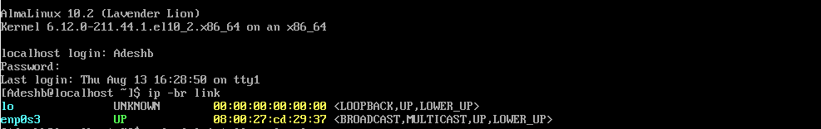
Figure 1. Active network interface identified as enp0s3.

6.2 Installing EPEL Repository
sudo dnf install epel-release -y
This command installs and enables the Extra Packages for Enterprise Linux (EPEL) repository, which provides additional software packages for Enterprise Linux-based systems.

6.3 Installing iftop and vnStat
sudo dnf install iftop vnstat -y
This command installs the two network monitoring tools used in the project: iftop for real-time traffic monitoring and vnStat for bandwidth statistics.

6.4 Starting and Enabling vnStat
sudo systemctl enable --now vnstat
This command enables the vnStat service to start automatically and starts the service immediately.

6.5 Checking vnStat Service Status
systemctl status vnstat
The command was used to verify whether the vnStat service was running successfully. The service status showed Active: active (running).
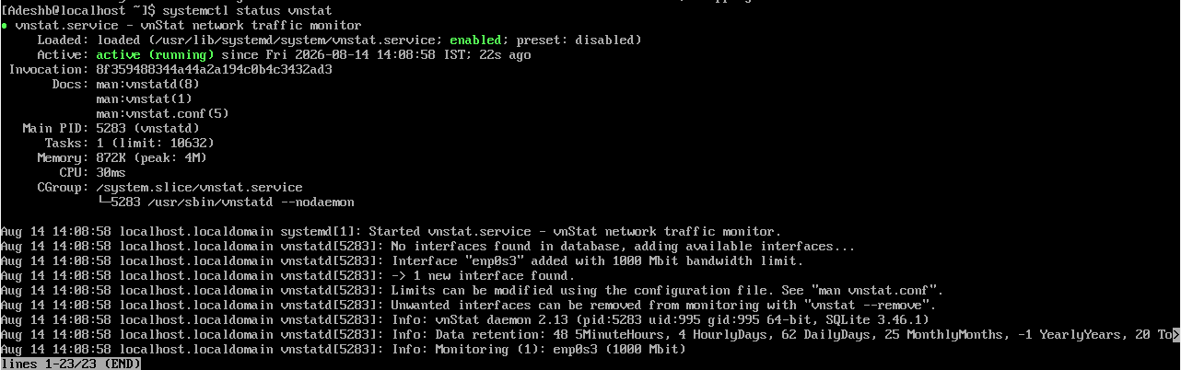
Figure 2. vnStat service status showing active and running.

6.6 Viewing Bandwidth Statistics Using vnStat
vnstat -i enp0s3
This command displays bandwidth statistics for the enp0s3 interface. The output includes received (RX), transmitted (TX), total data, average rate, daily statistics, and monthly statistics.
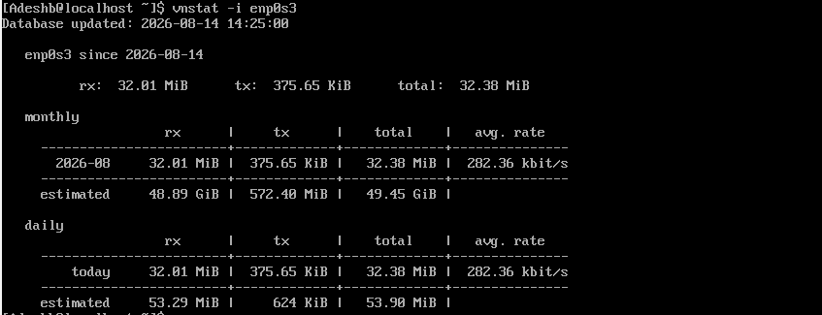
Figure 3. vnStat bandwidth statistics for enp0s3.

6.7 Real-Time Network Traffic Monitoring Using iftop
sudo iftop -i enp0s3
This command starts iftop on the enp0s3 network interface. iftop displays active network connections between the local system and remote hosts. The traffic rates change continuously depending on network activity. The symbol => represents outgoing/transmitted traffic, while <= represents incoming/received traffic.
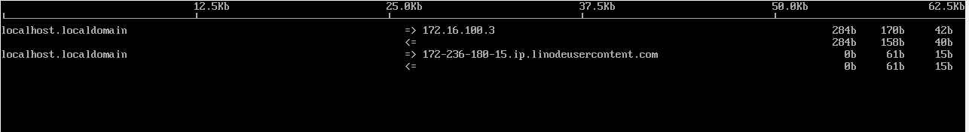
Figure 4. iftop real-time network traffic monitoring.

7. RESULTS AND DISCUSSION
The network bandwidth monitoring system was successfully implemented on AlmaLinux. The ip command was used to identify the active network interface, and enp0s3 was found to be active.
The vnStat service was successfully started and verified as active. vnStat recorded network traffic and displayed received and transmitted data along with daily and monthly statistics.
The iftop tool displayed real-time network connections and traffic rates. When network activity occurred, different remote hosts and corresponding traffic values were displayed.
Tool | Observation
ip -br link | Identified the active network interface
systemctl status vnstat | Confirmed that vnStat was running
vnstat -i enp0s3 | Displayed bandwidth statistics
iftop -i enp0s3 | Displayed real-time network traffic
The project demonstrates that iftop and vnStat provide complementary monitoring capabilities. iftop is useful for observing real-time traffic, while vnStat is useful for viewing bandwidth usage statistics over time.

8. ADVANTAGES
- Simple command-line based implementation.
- Uses lightweight Linux monitoring tools.
- Provides real-time network traffic monitoring.
- Provides historical bandwidth statistics.
- Helps understand network data usage.
- Can be used without developing a separate monitoring application.

9. LIMITATIONS
- iftop mainly provides real-time information and does not provide long-term historical statistics.
- vnStat requires time to collect meaningful historical data.
- The monitoring is limited to the selected network interface.
- The accuracy of observed traffic depends on the network activity of the system.

10. FUTURE SCOPE
- Graphical visualization of bandwidth usage.
- Automatic generation of network usage reports.
- Network usage alerts when a specified bandwidth limit is exceeded.
- Monitoring multiple network interfaces.
- Storing and analyzing long-term network usage data.
- Developing a web-based dashboard for remote monitoring.

11. CONCLUSION
The project successfully demonstrated network bandwidth monitoring using iftop and vnStat on AlmaLinux. The active network interface enp0s3 was identified and monitored. vnStat was successfully configured to collect bandwidth statistics, while iftop was used to observe real-time network traffic and active connections.
The project provided practical knowledge of Linux networking commands, network interfaces, received and transmitted traffic, real-time monitoring, and bandwidth statistics. The combination of iftop and vnStat provides a simple and effective approach to understanding network activity in a Linux environment.

12. REFERENCES
1. AlmaLinux OS Documentation, AlmaLinux Project.
2. iftop – Network Bandwidth Monitoring Tool.
3. vnStat – Network Traffic Monitor.
4. Linux ip command documentation.
5. Linux systemctl command documentation.

