Smart Lab Management using Cloud and ML

***Abstract*—In the field of laboratory computer management, the transition from manual installations to an efficient and effective approach is a long-term challenge. This system represents a new system designed to revolutionize the management of laboratory computers by replacing the cumbersome manual installation process with a sophisticated automated solution. Motivated by the limitations and time- consuming nature of the legacy system, this approach uses remote server orchestration and PC configuration. This allows administrators to easily remotely manage software installations, updates and system configurations across multiple computers in the lab, ensuring consistency and reducing operational overhead. The system provides an environment to the user or any organization to efficiently manage tasks in a lab without any issues.**

**The system not only increases efficiency, but also addresses the need for predictive maintenance and problem identification. Incorporating performance prediction mechanisms and proactive problem detection, the system offers a comprehensive solution to maintain optimal computer performance, enhancing the overall lab experience. With this system administrators gain the ability to deploy software packages and configurations across a network of lab PCs, eliminating the need for manual intervention. This system demonstrates the potential to significantly enhance the efficiency, reliability, and user experience of lab PC management, marking a significant step forward from the limitations of manual installation processes.**

***Keywords*— Laboratory computer management, Remote server orchestration, PC configuration, Performance prediction**

1. INTRODUCTION

In the context of today's rapidly changing landscape of scientific research, laboratories are continuously exploring avenues to enhance their operations. Among the persistent obstacles encountered by research institutions is the intricate process of transitioning from manual to efficient laboratory PC management. Historically, lab management heavily relied on labour-intensive and error-prone manual installations and configurations. Researchers and administrators painstakingly dedicated extensive hours to individually install and update software, set up configurations, and manage security patches for each laboratory PC. This approach not only consumed significant amounts of valuable research time but also posed challenges in maintaining consistency across multiple machines, often resulting in compatibility issues and productivity setbacks. As technology progresses, there is a growing awareness among researchers and administrators regarding the necessity for efficient, automated solutions to maintain the currency, security, and dependability of their laboratory computers. This system, therefore, aims to confront this challenge head-on by introducing a groundbreaking system poised to revolutionize the management of laboratory PCs. Rather than relying on these cumbersome manual installations and configurations, this novel approach harnesses the potential of automation, offering a streamlined, error-free, and time-efficient solution for laboratory PC management.

The proposed system makes use of remote server orchestration and incorporates Ansible playbooks, establishing a seamless and efficient environment for PC configuration. Through the adoption of this innovative system, laboratory administrators can access a range of benefits. Remote management becomes a viable option, simplifying the process of software installations, updates, and configurations across all laboratory PCs. This not only conserves valuable time and resources but also guarantees a notable level of uniformity throughout the entirety of the laboratory infrastructure. This system addresses the ongoing challenge of shifting from manual to efficient laboratory PC management. It presents an innovative system that replaces labour-intensive manual installations with an automated approach, utilizing remote server orchestration and Ansible playbooks to streamline PC configuration.

Furthermore, this innovative laboratory PC management system goes beyond mere automation by integrating advanced machine learning techniques. Leveraging the power of machine learning, it introduces predictive maintenance and issue identification capabilities. Through continuous analysis of data from laboratory PCs, the system employs sophisticated algorithms to detect subtle anomalies and patterns that may go unnoticed by traditional monitoring methods. This proactive methodology enables the system to identify potential problems well in advance, allowing researchers and administrators to take preventive measures before they escalate into significant disruptions.

1. LITERATURE SURVEY

This paper has examined the feasibility of forecasting benchmark outcomes for hardware setups that have not been previously tested. The primary emphasis has been on exploring the potential of employing Deep Learning techniques to model the intricate, non-linear connections within the data. The investigation has revolved around the SPEC CPU 2017 dataset, where three types of deep neural networks have been explored: Multi-Layer Perceptrons (MLPs), Convolutional Neural Networks (CNNs), and a variant of CNNs known as ResNet. This research serves as an initial indication and foundation, suggesting that deep neural networks can be effectively trained on established benchmark datasets to make performance predictions.[1]

This paper furnishes a comprehensive understanding of the inception of cloud computing, elucidating its fundamental principles, models, and service paradigms. Furthermore, it delves into a meticulous comparative analysis of all cloud computing deployment models, thoughtfully presented in tabular format. This comparison encompasses critical facets such as platform compatibility, supported programming languages, storage capacity provisions, an array of services, and an array of products within the cloud ecosystem. This paper culminates by underscoring the profound transformative influence that cloud computing wields over enterprises, accentuating the pivotal significance of selecting the most fitting deployment model. It draws attention to the

remarkable versatility inherent in cloud computing, exhibited through its diverse deployment alternatives and the widespread adoption of multi-cloud strategies within contemporary organizations.[2]

This paper underscores the advantages of employing Ansible, a powerful tool that empowers system administrators to automate their organization's infrastructure management. In many instances, system administrators find themselves repeatedly performing identical tasks to configure numerous systems, a process that is not only time- consuming but also prone to human error. Ansible, however, offers a solution by automating the configuration of an organization's infrastructure, ultimately enhancing the efficiency of the system administrator's work. By crafting well-structured playbooks containing precise instructions, Ansible ensures that tasks are executed consistently and error-free across multiple iterations. Consequently, the time required to configure a single system is mirrored when configuring multiple systems simultaneously. This streamlined and error-resistant approach to infrastructure management significantly optimizes the system administrator's workflow, leading to more efficient operations.[3]

This paper investigates the increasing integration of cloud technology within the field of information technology, driven by the rising demands of customers. There is a growing necessity for acquiring cloud services, and a majority of clients are now directly engaging with cloud service providers. The DevOps team is deeply committed to this evolution, as they bear the responsibility for automating processes and ensuring the continuous delivery of systems. The primary objective of this document is to attain automation in client application management through the utilization of Ansible, spanning from the initial provisioning phase to the ultimate system delivery.[4]

This paper discusses the impact of cloud computing, which has led to a surge in the quantity of servers and workstations requiring management. System administrators are tasked with overseeing numerous servers within both physical and virtual environments, many of which share identical configurations and run similar applications. In this study, the developed Ansible framework for remote administration was evaluated across more than ten laboratories at the Brno University of Technology (BUT). To enhance accessibility for system administrators, a versatile web application was designed and tested, enabling configuration adjustments to be made via smart devices.[5]

This paper illustrates new methods of configuring network devices with the help of automation, which in turn reduces the time required to configure devices and is much easier to maintain. It also discusses limiting manual errors in the configuration syntax and different ways to configure devices. There are many fast-growing tools available in the market such as Ansible and Terraform that can be used to provision and configure system infrastructure. This article demonstrates the use of Ansible due to its simplicity.[6]

This paper presents innovative approaches to automate the configuration of network devices, resulting in reduced configuration time and simplified maintenance. It also explores methods to minimize human errors in configuration

syntax and various techniques for device configuration. There is a plethora of rapidly advancing tools in the market, including Ansible and Terraform, designed for provisioning and configuring system infrastructure. This article specifically showcases the use of Ansible, emphasizing its user-friendly nature.[7]

1. EXISTING SYSTEM

In the current laboratory management system, the process of managing laboratory computers is largely manual and time-consuming. This outdated approach often means that IT administrators physically visit each lab computer to perform installations, updates, and configurations. For example, when new software or an application needs to be installed, an IT technician must physically access each computer, install the software, and configure it individually. Similarly, when system updates or security patches become available, they must be manually applied to each computer, one at a time. This manual approach not only consumes considerable manpower, but also introduces the potential for inconsistencies and errors in the laboratory's computer network. Additionally, troubleshooting and troubleshooting often require on-site visits, resulting in extended downtime and hindrances to research productivity. At a time when technology is rapidly evolving, these traditional practices for managing lab computers are becoming increasingly inefficient, limiting the lab's ability to quickly adapt to changing research needs.

In the traditional system, when a new version of this critical software is released or a security update becomes available, the IT administrator must physically visit each of the 50 lab PCs distributed throughout the facility. This involves manually inserting installation CDs or USB drives into each computer, initiating the installation process, and configuring settings individually. This tedious process can take several hours to complete and is prone to human error, potentially resulting in inconsistencies in the software configurations across different PCs.

1. PROPOSED SYSTEM

The primary purpose of this system is transitioning from manual to efficient laboratory PC management. The proposed system will serve as the antidote to the inefficiencies and inconsistencies that have plagued laboratories for years. reposed system will introduce a centralized software repository, where administrators can select and deploy applications effortlessly to multiple lab PCs simultaneously. Leveraging Ansible playbooks and remote orchestration, the system will ensure that all software installations and updates are carried out seamlessly and consistently across the laboratory network. This not only eliminates the need for IT personnel to physically visit each PC but also significantly reduces the risk of human errors in the installation process.

Additionally, the purpose of the system is to perform predictive maintenance to test the performance of the pcs in the lab. For predictive maintenance of PCs, a range of critical parameters are considered to ensure optimal performance and minimize downtime. These parameters

include CPU Usage, Memory Usage, Disk Space, Network Activity, CPU Temperature, Fan Speed, and Software Updates. By continuously monitoring these metrics, organizations can proactively identify performance bottlenecks, potential hardware failures, or overheating issues. The Random Forest algorithm is a valuable tool for predictive maintenance, specifically designed to forecast when maintenance is required on PCs or equipment based on historical maintenance records. In this context, the algorithm exclusively relies on data derived from the PCs themselves. Historical maintenance records serve as the primary dataset, offering essential insights into past maintenance activities. These records typically encompass details about the types of maintenance performed, timestamps, and components involved. By training on this historical dataset, the Random Forest algorithm identifies patterns and relationships within the PC maintenance data. Its ensemble of decision trees, each constructed using a random subset of training data and features, ensures model robustness and minimizes overfitting. This predictive maintenance model empowers organizations to proactively schedule maintenance tasks, thereby minimizing downtime, preventing unexpected failures, and optimizing resource allocation.

The security of computer lab servers in the cloud-based environment is maintained through a comprehensive approach that encompasses several key practices and technologies. Data encryption protocols, including encryption in transit and at rest, ensure the confidentiality of data. Identity and Access Management (IAM) solutions, alongside strong authentication methods like multi-factor authentication (MFA), control user access to cloud resources. Network security measures such as firewalls, intrusion detection systems (IDS), and network segmentation safeguard network traffic.

Additionally, the system will feature intelligent compatibility checks, ensuring that software updates are applied without disrupting existing configurations or research workflows. By overcoming the limitations of traditional manual installations, this proposed system guarantees a smooth transition to an era of streamlined, efficient, and error-free laboratory PC management. Researchers can be confident that their computing resources are always up-to-date and in optimal working condition, allowing them to dedicate more time to groundbreaking research endeavors.

Secure cloud servers are essential for maintaining a safe and reliable environment. By establishing strict identity and access management (IAM) practices to ensure effective authentication and minimal access. Network security is important. Supported by strong encryption of data in transit and at rest with cloud-native encryption services and core solutions. Continuous site management is essential to minimize security vulnerability, and regular weather monitoring and decision-making is required to detect and respond to security incidents. Consider detection and intrusion prevention systems (IDS/IPS) and manage backup and disaster recovery systems. Compliance with specific business standards and security policies is non-negotiable. Ensure that server hardening practices are in place and that vulnerability assessments, audits, and penetration tests are performed regularly.

The proposed system uses the following technology as shown below:

**Ansible Technology:** Ansible is an open-source platform that is widely used for configuring, managing, and orchestrating IT infrastructure and software deployments. It simplifies complex tasks like software installation, configuration management, and application deployment by automating them through easy-to-understand, human- readable scripts known as "playbooks."

**Key features and concepts of Ansible include:**

* Agentless: Ansible is agentless, meaning it doesn't require any software or agents to be installed on the target systems you want to manage. Instead, it uses SSH (Secure Shell) for Unix-based systems and WinRM (Windows Remote Management) for Windows-based systems to establish connections and execute tasks.
* Roles: Roles are a way to organize and package Ansible playbooks and related files into reusable components. Roles encapsulate sets of tasks, variables, and templates, making it easier to manage complex automation workflows and share them across projects.
* Idempotent: Ansible tasks are designed to be idempotent, meaning they can be run multiple times without causing harm or unintended changes if the desired state is already achieved. This helps maintain consistency in system configurations.
* Inventory: Ansible uses an inventory file to define the list of target hosts or systems it will manage. This inventory can be a simple text file or dynamically generated from various sources, including cloud providers or other tools.
* Tags: Playbooks can be tagged with labels that allow you to selectively run specific tasks or groups of tasks. This is useful when you want to execute only a subset of tasks in a playbook.

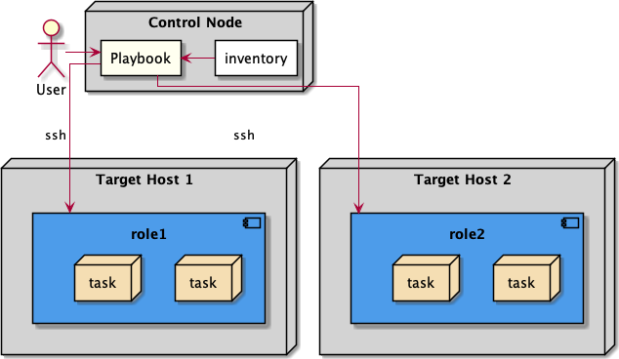

Fig. 1 Ansible local deployment [8]

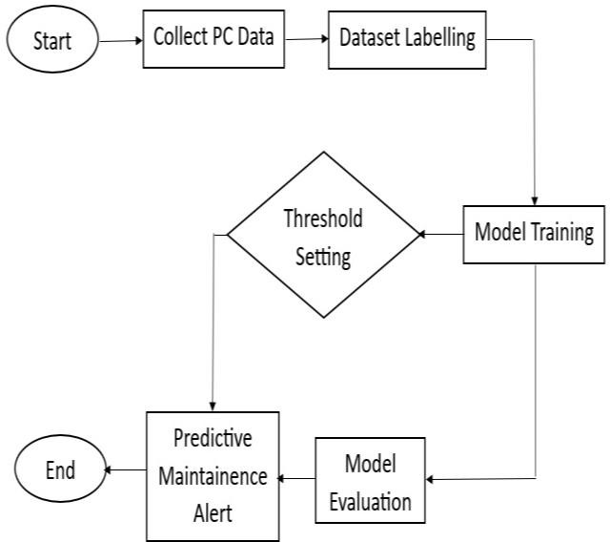

Fig. 2 Architectural block diagram

In Fig. 1 flow of remote installation with Ansible begins with the user who initiates the process by executing an Ansible playbook. The playbook, which contains a series of defined tasks and configurations, references an inventory file specifying the target hosts or servers. Ansible then establishes SSH connections to these target hosts using the provided credentials and executes the tasks sequentially, ensuring that the specified software installations, configurations, or other automation tasks are applied consistently across the remote servers. This orchestrated process enables users to remotely manage and secure multiple servers in a streamlined and efficient manner, making server administration more manageable and reliable.

Fig. 2 is a block diagram that depicts the architectural diagram and the interaction between the user interface and the ansible playbook, the user interface contains the details about the admin pcs and the host pcs and the ansible inventory contains several roles and modules to perform installation s and remote updates.

Fig. 3 is a flowchart that illustrates the fundamental steps involved in utilizing Ansible to automate tasks on remote systems. It commences with inventory setup, then define the hosts they wish to manage. This is followed by the creation of a playbook that delineates the tasks to be carried out. Subsequently, Ansible undertakes the execution of these tasks on the designated target hosts, all the while maintaining a vigilant check for errors. Upon the successful completion of all tasks, the automation process concludes. This workflow embodies a core concept within Ansible for the efficient management and configuration of multiple remote systems.

Fig. 3 Flow chart for Remote Execution Using Ansible Playbooks

1. 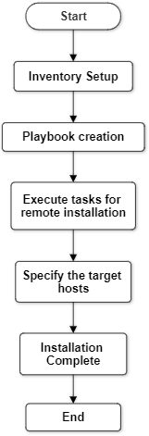CONCLUSION

This proposed system marks a significant leap forward in the realm of laboratory PC management. By harnessing the power of Ansible playbooks, it not only simplifies the laborious processes of installations and configurations but also paves the way for unprecedented efficiency and consistency in managing lab PCs. The predictive maintenance modules further elevate the system's capabilities, enabling proactive issue identification and resolution before they disrupt critical research activities. However, the innovation does not stop there. The seamless integration of cloud services and the utilization of Simple Notification Service (SNS) provide a robust foundation for disaster readiness and also providing security to the data. This aspect of the system ensures that laboratories are not only equipped to manage routine operations with ease but are also well-prepared to handle unexpected challenges and emergencies, safeguarding valuable research data and minimizing disruptions.

1. ACKNOWLEDGEMENT

The development of "Smart Lab Management Using Cloud and ML" saw the invaluable contributions of numerous individuals. Sincere thanks are extended to Dr.

S.M. Khot, Principal of Fr. C Rodrigues Institute of Technology, Vashi, for granting the opportunity to showcase skills and providing essential resources. Heartfelt gratitude is also conveyed to Prof. Shubhangi Vaikole, Head of Department of Information Technology, for her unwavering

support and motivation. Deep appreciation is expressed to the project guide and mentor, Prof. Rupali Deshmukh, for constant encouragement to think innovatively and significant contributions in this proposed system.

REFERENCES

1. Mehmet Cengiz, Matthew Forshaw, Amir Atapour-Abarghouei, and Andrew Stephen McGough. 2023. Predicting the Performance of a Computing System with Deep Networks. In Proceedings of the 2023 ACM/SPEC International Conference on Performance Engineering (ICPE ’23), April 15–19, 2023, Coimbra, Portugal. ACM, New York, NY, USA, 9 pages.
2. Patel, Hiral B., and Nirali Kansara. "Cloud Computing Deployment Models: A Comparative Study." International Journal of Innovative Research in Computer Science & Technology (IJIRCST) (2021)
3. Kaushik K R, and Dr. Divya T L. "Survey on Ansible." International Journal Of Advance Research And Innovative Ideas In Education 6.3(2020) : 714-718.
4. Pranav T P, Charan S, Darshan M R. (2021). Devops Methods for Automation of Server Management using Ansible . International Journal of Advanced Scientific Innovation, 1(2), 7-13.
5. P. Masek, M. Stusek, J. Krejci, K. Zeman, J. Pokorny and M. Kudlacek, "Unleashing Full Potential of Ansible Framework: University Labs Administration," 2018 22nd Conference of Open Innovations Association (FRUCT), Jyvaskyla, Finland, 2018, pp. 144-150, doi: 10.23919/FRUCT.2018.8468270.
6. Islami, Muhammad & Musa, Purnawarman & Lamsani, Missa. (2020). Implementation of Network Automation Using Ansible to Congure Routing Protocol in Cisco and Mikrotik Router with Raspberry PI. 19. 10.32409/jikstik.19.2.80
7. S. Kokuryo, M. Kondo and O. Mizuno, "An Empirical Study of Utilization of Imperative Modules in Ansible," 2020 IEEE 20th International Conference on Software Quality, Reliability and Security (QRS), Macau, China, 2020, pp. 442-449, doi: 10.1109/QRS51102.2020.00063
8. https://docs.alfresco.com/content-services/7.1/install/ansible/
9. https://docs.ansible.com/ansible/latest/playbook_guide/playbooks_int ro.html
10. https://docs.ansible.com/ansible/2.9/user