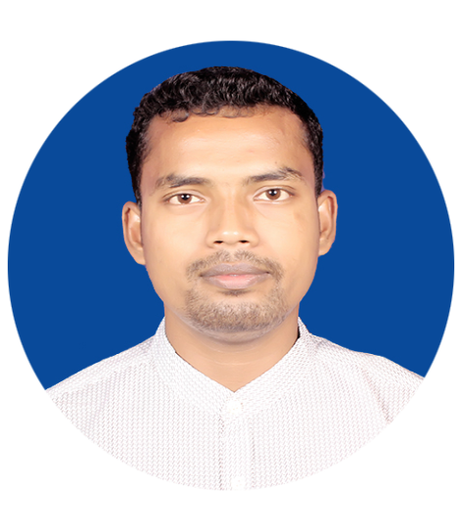

**ADESH CHANDRO**

**SARKER.**

**WEB DESIGNER.**

CAREER OBJECTIVE

I am a skilled Web Designer. I have been involved in this profession for the last three years and I have received training as a web designer from a number of quality organizations.

CONTACT

Saidpur, Nilphamari, Bangladesh.

+880161-012-1441

SKILL

adeshchandrosarker.sdp@gmail.com

95%

90%

http://adeshsarker.com

https://www.fiverr.com/adeshchandro

90%

TRAINING

EDUCATION

BOOTSTRAP

CSS

HTML

80%

Git

jQuery

95%

80%

JAVASCRIPT

Honours, Nilphamari Govt College, Nilphamari.

HSC, Saidpur College, Saidpur, Nilphamari.

SSC, Botlagari High School, Saidpur, Nilphamari.

Topic: Web Design.

Institution: WEB TRAINING INSTITUTE, DHAKA.

EXPERIENCE

Topic: Web Design.

Institution: FAWKUN IT, SAIDPUR.

**FAWKUN IT**

Senior Web Designer(2018-20)

Responsibility:

Topic: Web Design & Development.

Institution: FREEDOM IT INSTITUTION, CHADPUR, DHAKA.

* Translated customer requirements into technical site concepts for bidding and initial planning purposes.
* Crafted website content and graphics by coordinating copywriting, and designing images, icons, banners and enhancements.

Topic: Office Application Graphics Designer.

Institution: SHIFA COMPUTER, SAIDPUR.

Topic: Mobile Game & Application.

Institution: SKILL DEVELOPMENT FOR MOBILE GAME & APPLICATION, ISPIN OF STUDIO.

Responsibility:

**FREEDOM IT INSTITUTION**

Senior Web Designer(2020-TO)

* My responsibility was to design as the customer wished. I always put their wishes first and always tried to help them.
* Crafted website content and graphics by coordinating copywriting, and designing images, icons, banners and enhancements.
* Crafted website content and graphics by coordinating copywriting, and designing images, icons, banners and enhancements.

**Thanks and Regards**

**Adesh Chandro Sarker**