**Practical - 5**

**Program Definition:**

Write a python program to create a simple 3-layer neural network for implementation of binary function.

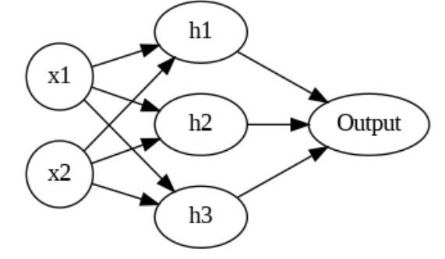

**Output:**

