**Practical - 6**

**Program Definition:**

Write a python program to implement Bayesian Network to model probabilistic reasoning for a burglary alarm system.

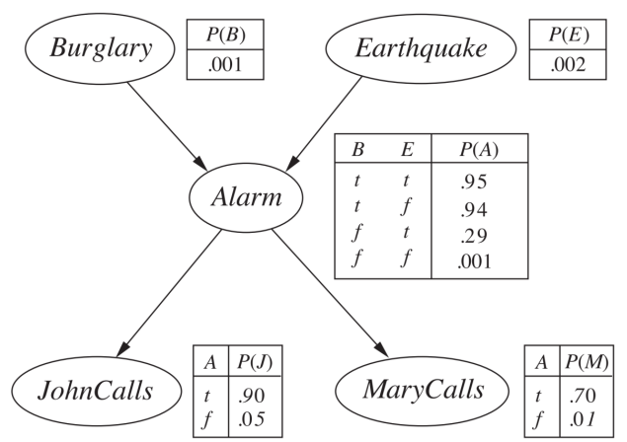

**Output:**

