**Practical - 7**

**Program Definition:**

Write a python program to implement Q-value iteration algorithm for solving the Markov Decision Process (MDP) problem in the farmer example.

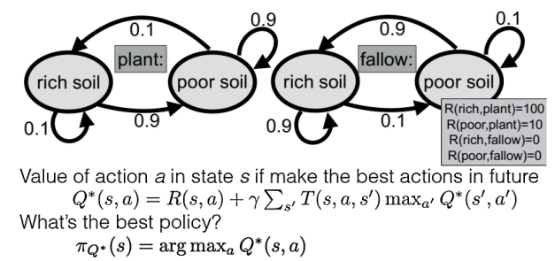

**Output:**

