**[2CEIT603: CLOUD COMPUTING]**

**Practical : 1**



**AIM-** Web Service Implementation.



**Department of**

**Information Technology**

1. **Create Web application in NetBeans.**

File > New Project > Java Web > Web Application

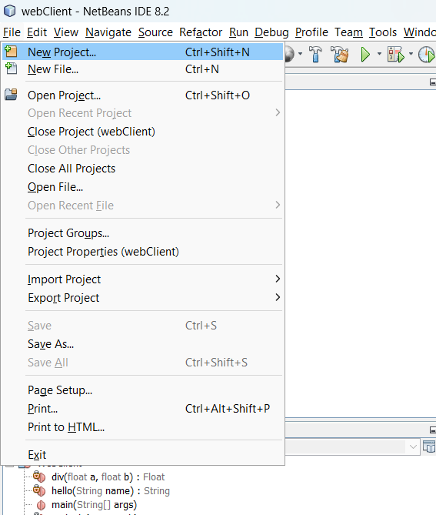

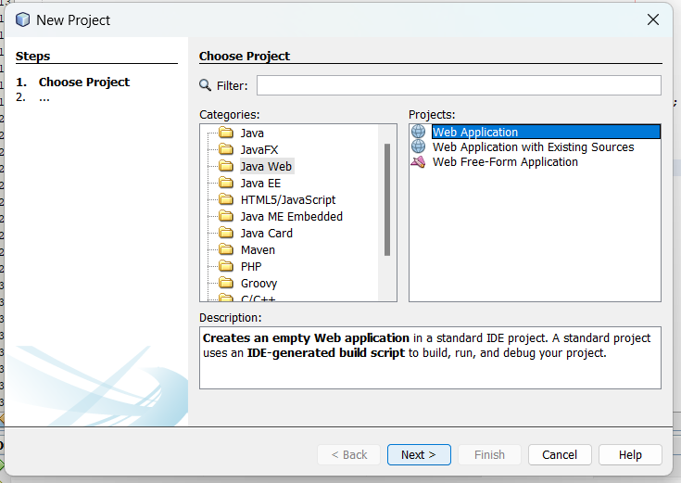

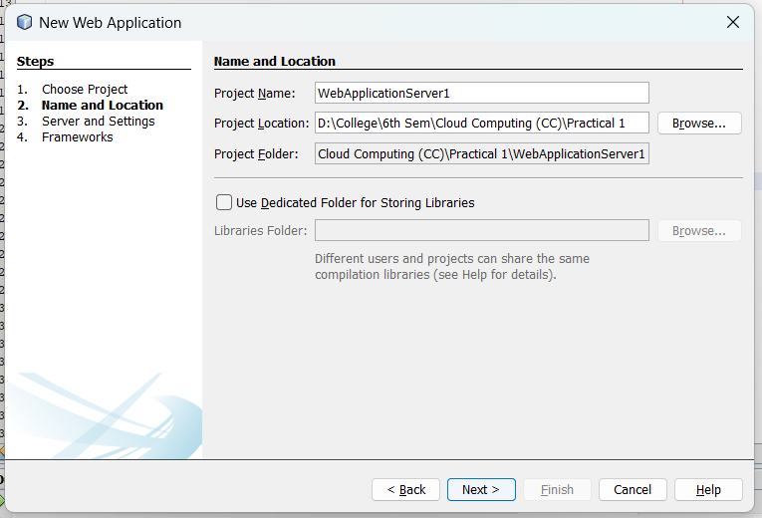

Click Next and Finish.

1. **Create Java Packages from**

Web Application > Source Packages > New > Java Package

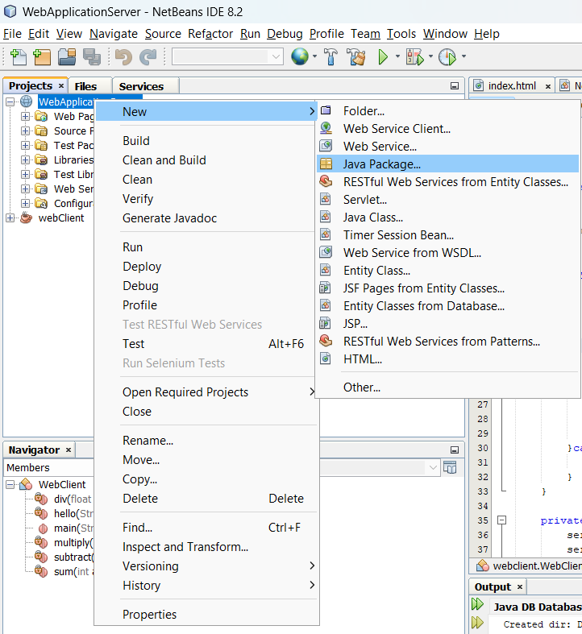

1. **Specify Name of Java Package and click on Finish Button.**

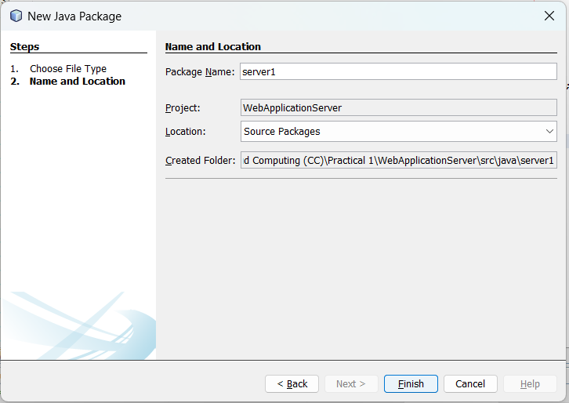

1. **Right click on Package and create web service**

New > Web Service

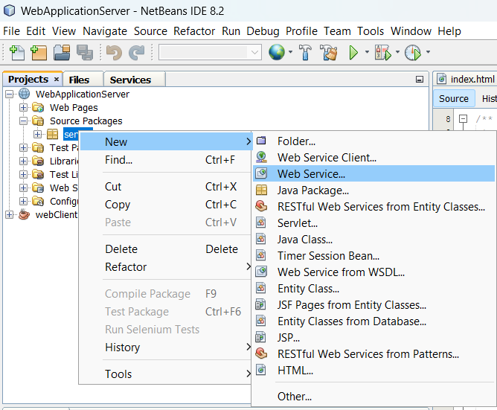

1. **Specify Name of Web service and select Java Package**

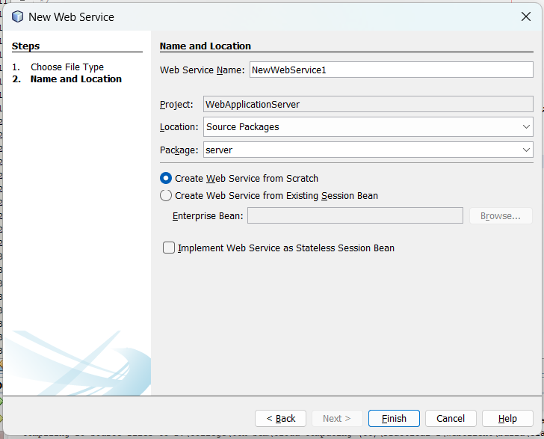

Web service folder created.

1. **Under web services folder select web service and Right click > Add Operation**

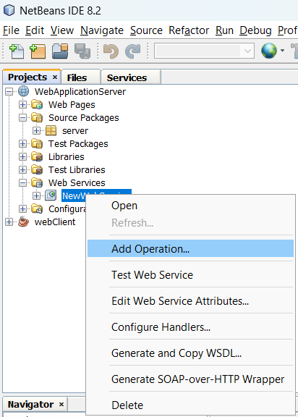

1. **Add Operation**

Specify Name of Operation and click on OK

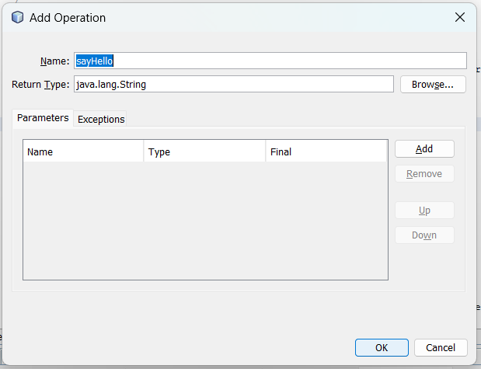

1. **You may also add operation with parameters**

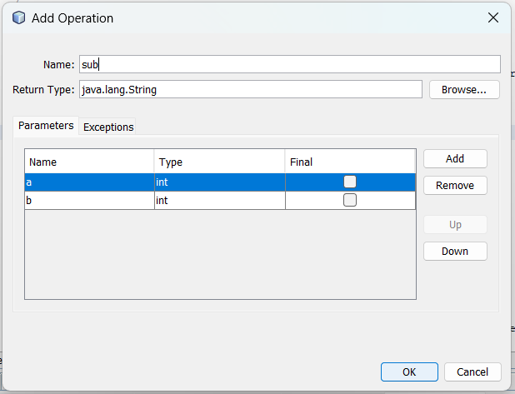

1. **Modify method according to requirement.. like I want to return String is My Name is.. and perform arithmetic operations then code**

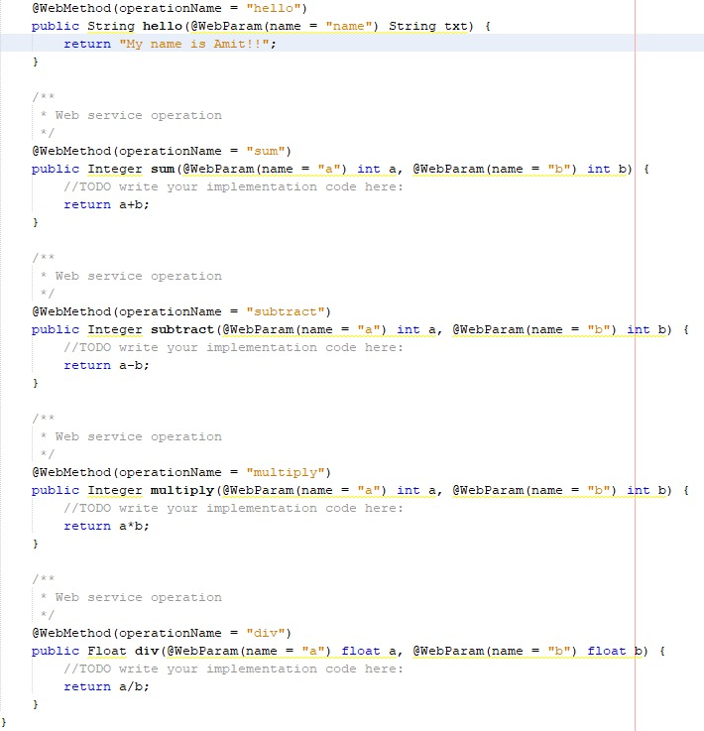

**10) Deploy Project**

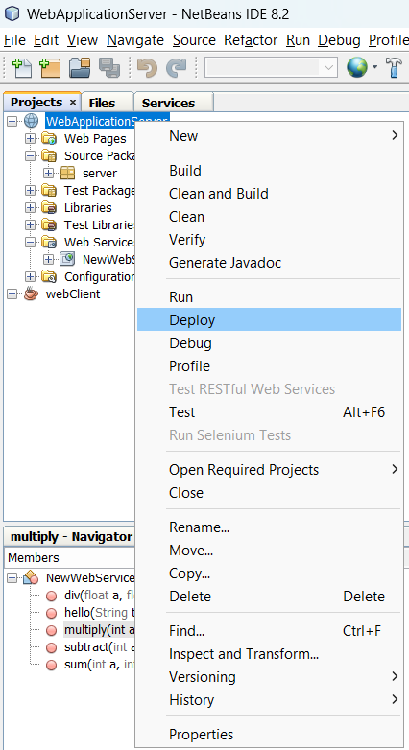

For successful deployment

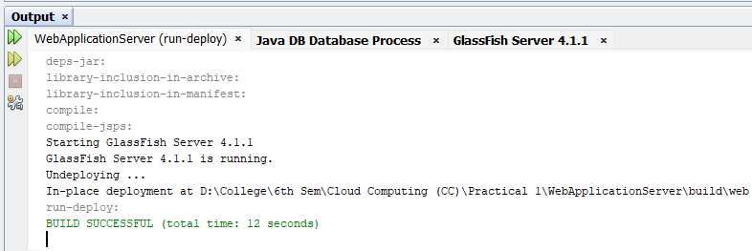

**11) Test Web Service**

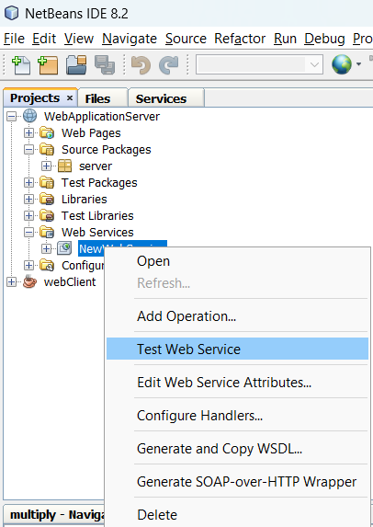

Output of Test web service in web browser

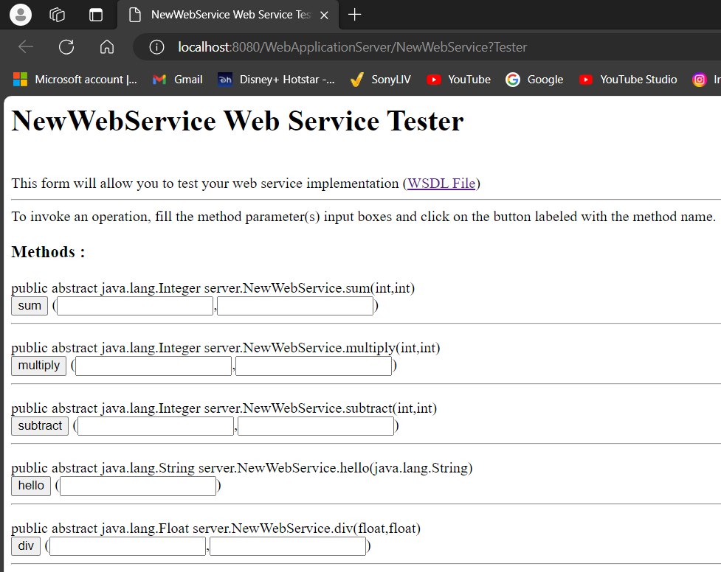

**12) Click on WSDL file Link and copy newly open window URL**

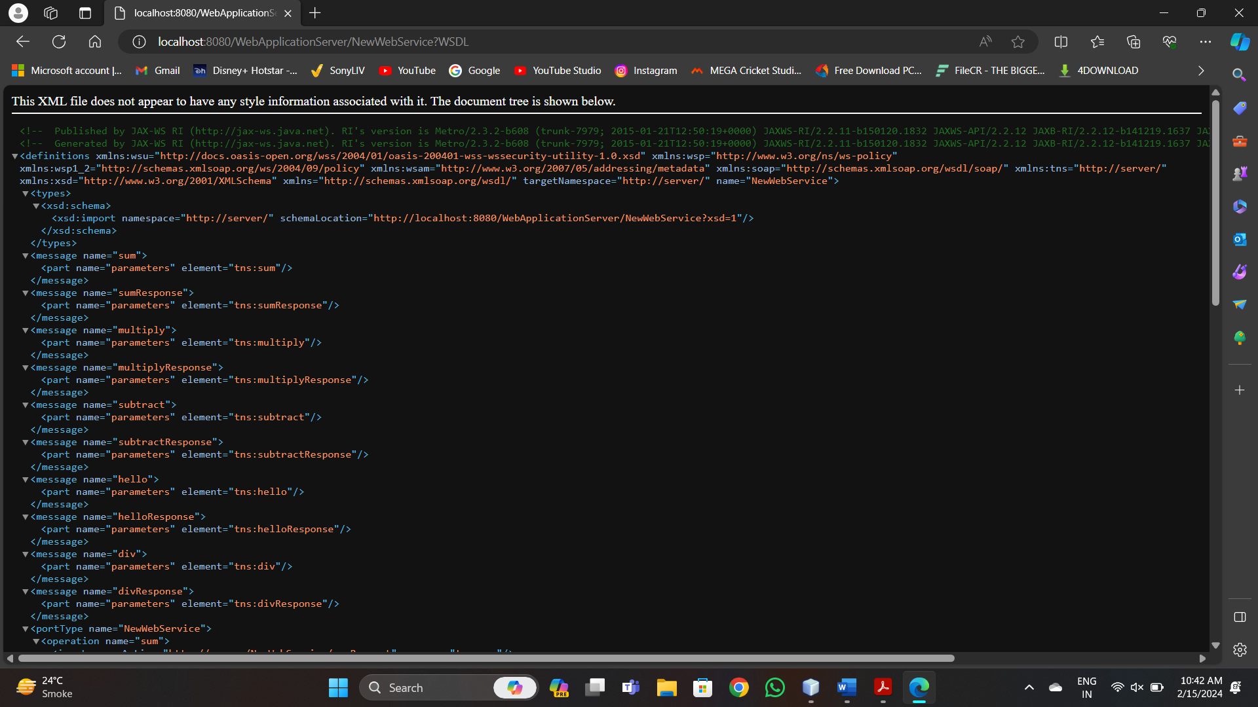

**13) Create simple Java application from File > New > Java > Java Application**

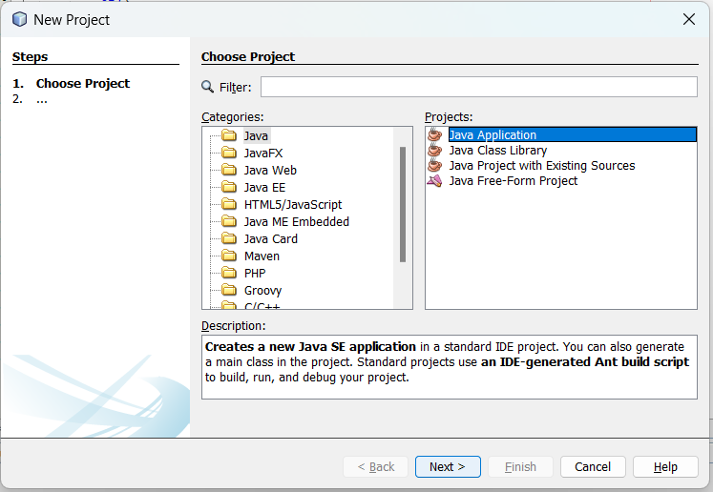

**14) Specify Name and Finish**

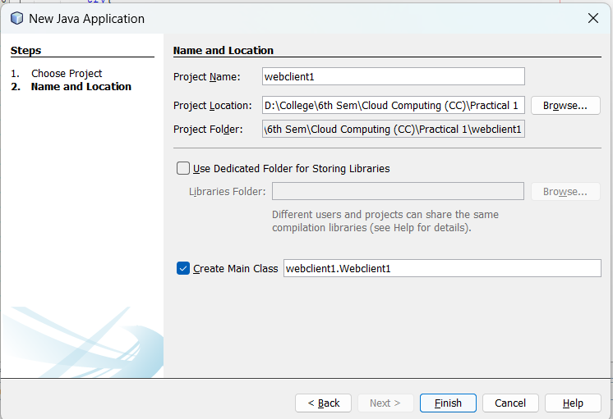

**15) Add web service client from**

Client Project > Source Package > New > Web Service Client

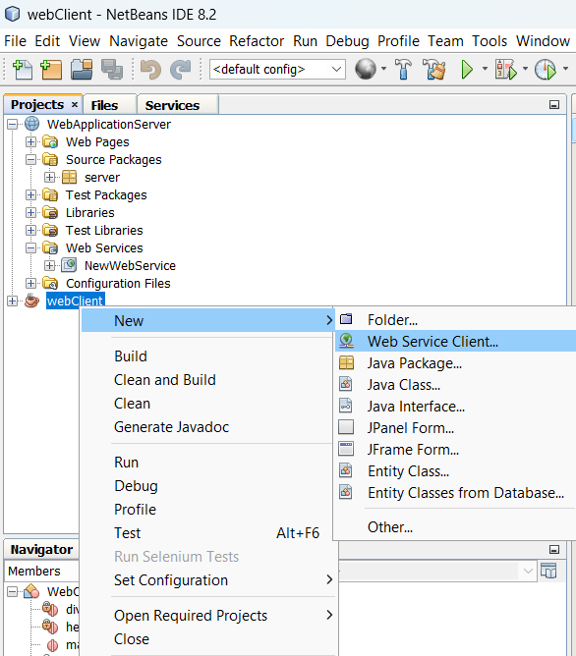

**16) Add WSDL and click on Finish**

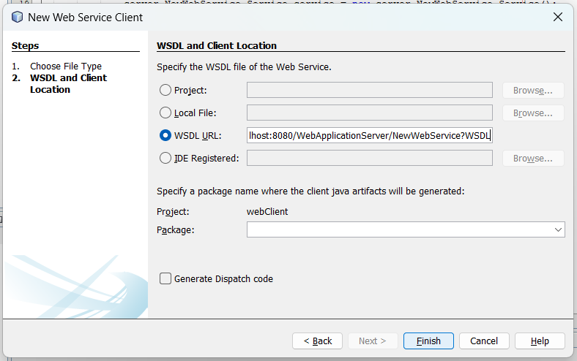

**17) Open Code of java file and Right click > Insert code**

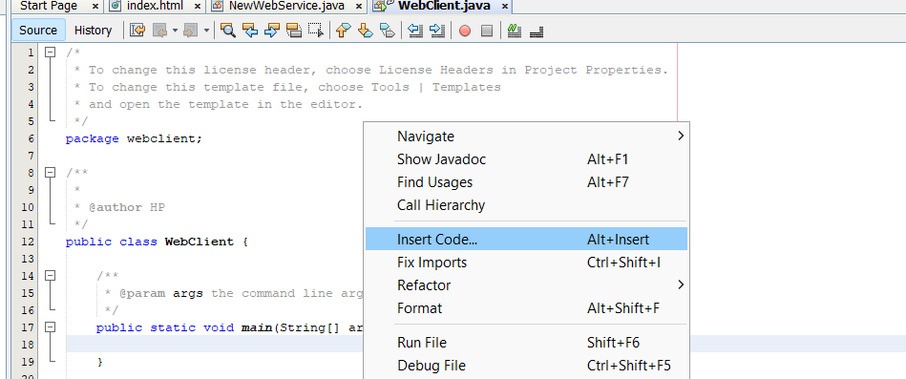

Then select Call Web Service Operation

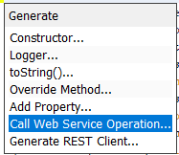

**18) Select Operation from Web Service**

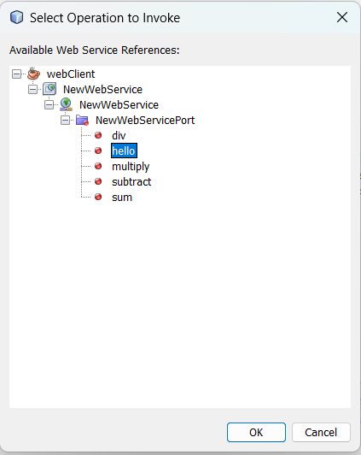

**19) You may Invoke multiple operation one by one**

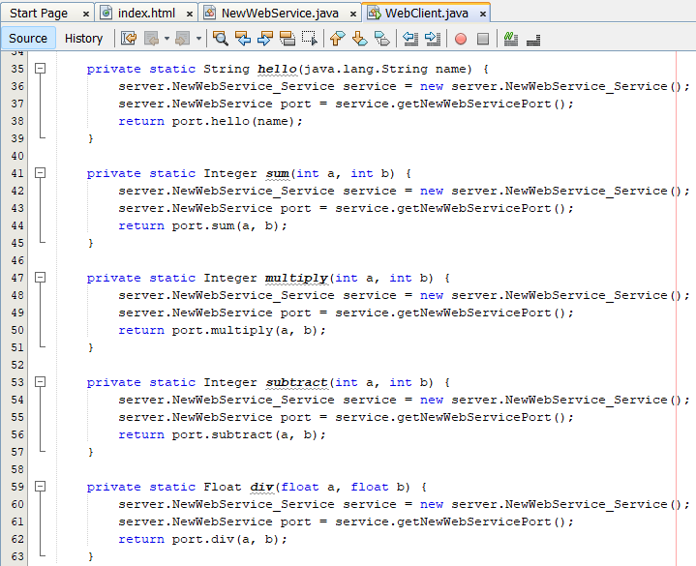

**20) Modify code of main method in webClient.java**

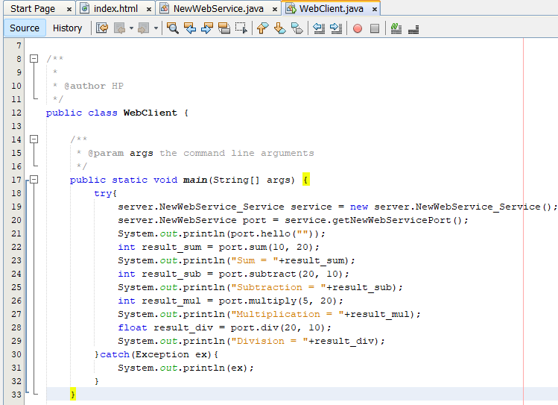

OR You may modify in this way (optimal)

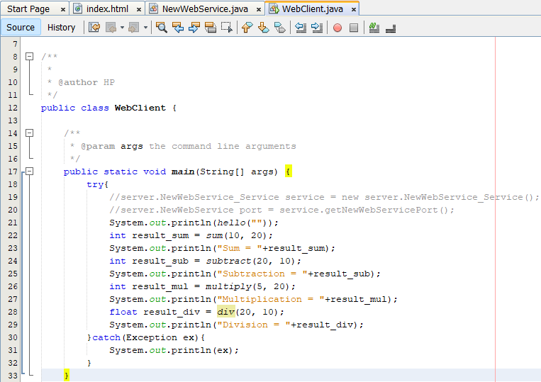

**21) Run Webclient.java file**

