**[ 2CEIT603: CLOUD COMPUTING]**

Practical: 5



**AIM- Hosting Websites on Amazon EC2 Instances.**

Submitted By: ADESHARA BRIJESH G.

Enrollment number: 21012021001



**Department of**

**Information Technology**

**Title:** **Hosting Websites on Amazon EC2 Instances.**

**Introduction:**

* Cloud computing has transformed web hosting, providing scalable and reliable infrastructure solutions.
* This report explores the deployment of websites on Amazon EC2 instances, highlighting procedures and benefits.

**Purpose:**

* Gain practical experience in deploying websites on Amazon EC2 instances.
* Understand components, architecture, and procedures involved in cloud-based web hosting.

**Components:**

* **Amazon EC2**:
  + Virtual computing environments (instances) configurable with various operating systems.
  + Key component of Amazon Web Services (AWS) for scalable and customizable computing resources.
* **Web Hosting**:
  + Deployment of website files on a server accessible via the internet.
  + Components include web server software, website files, domain names, and optional databases.

**Architecture:**

* **Amazon EC2 Architecture**:
  + Instances provisioned with selected configurations (OS, instance type).
  + Network configurations (VPC, subnets, security groups) for accessibility.
  + Storage volumes (EBS) for data persistence and file storage.
* **Web Hosting on EC2**:
  + Configuration of web server software (e.g., Apache, Nginx) on EC2 instances.
  + Deployment of website files to the server.
  + DNS settings adjustment to point to the instance's IP address or domain name.

**Pros/Cons:**

* **Pros**:
  + Scalability: Resources can be scaled up or down based on demand.
  + Flexibility: Choose from a variety of instance types and configurations.
  + Reliability: Benefit from AWS's robust infrastructure and redundancy.
* **Cons**:
  + Cost: Pay-per-use model may become expensive for high-traffic websites.
  + Complexity: Requires knowledge of AWS services and configurations.
  + Maintenance: Regular updates and monitoring are necessary.

**Implementation Steps:**

1. **Sign Up for AWS Account**:
   * Create an AWS account if not already registered.

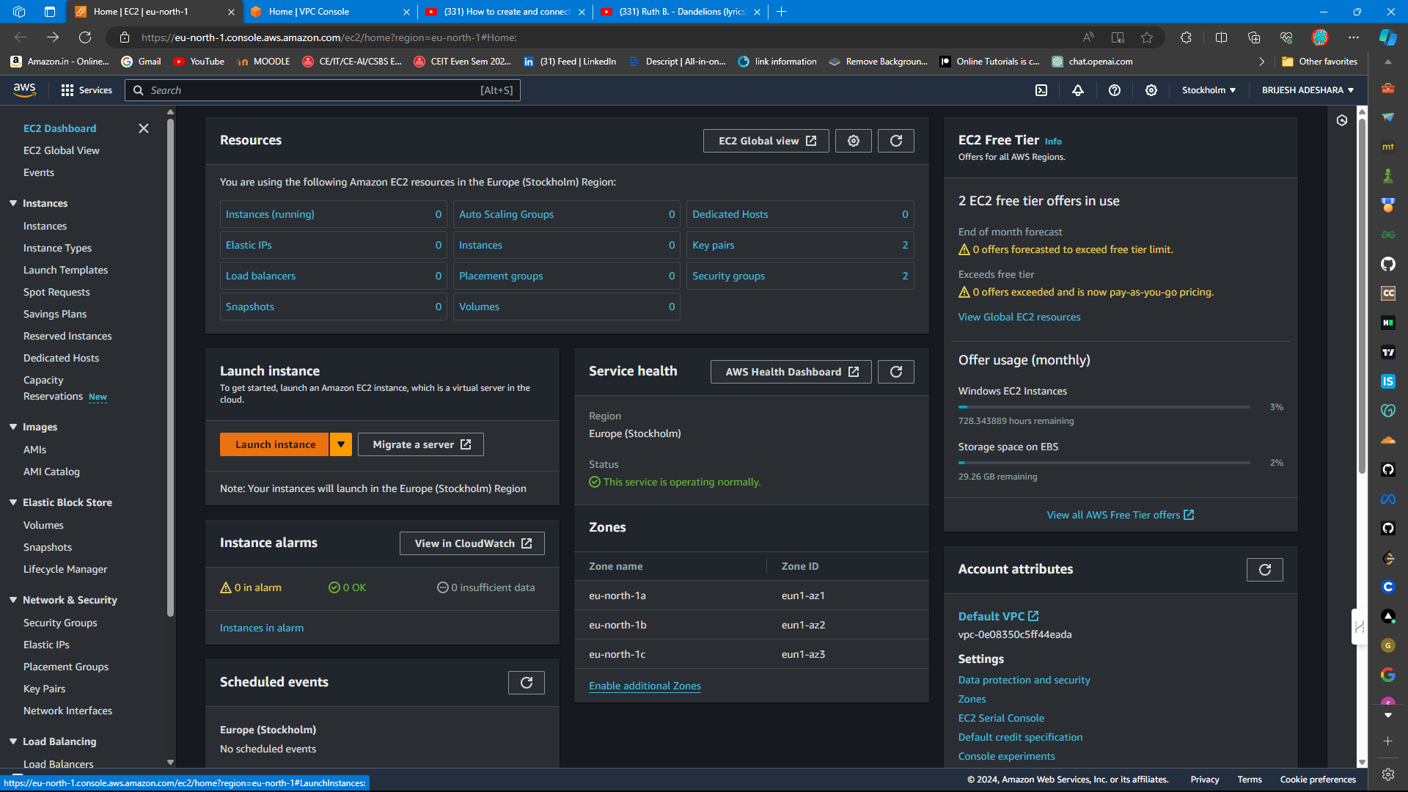

1. **Launch EC2 Instance**:
   * Choose an appropriate AMI (Amazon Machine Image) based on your operating system preference (Windows/Linux).

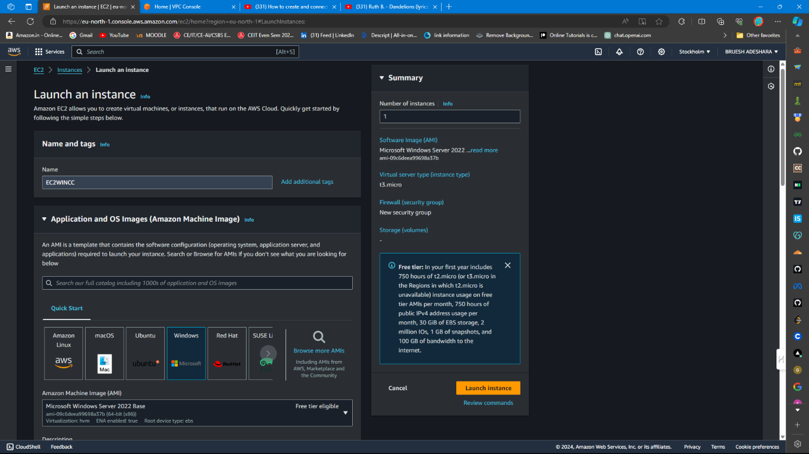

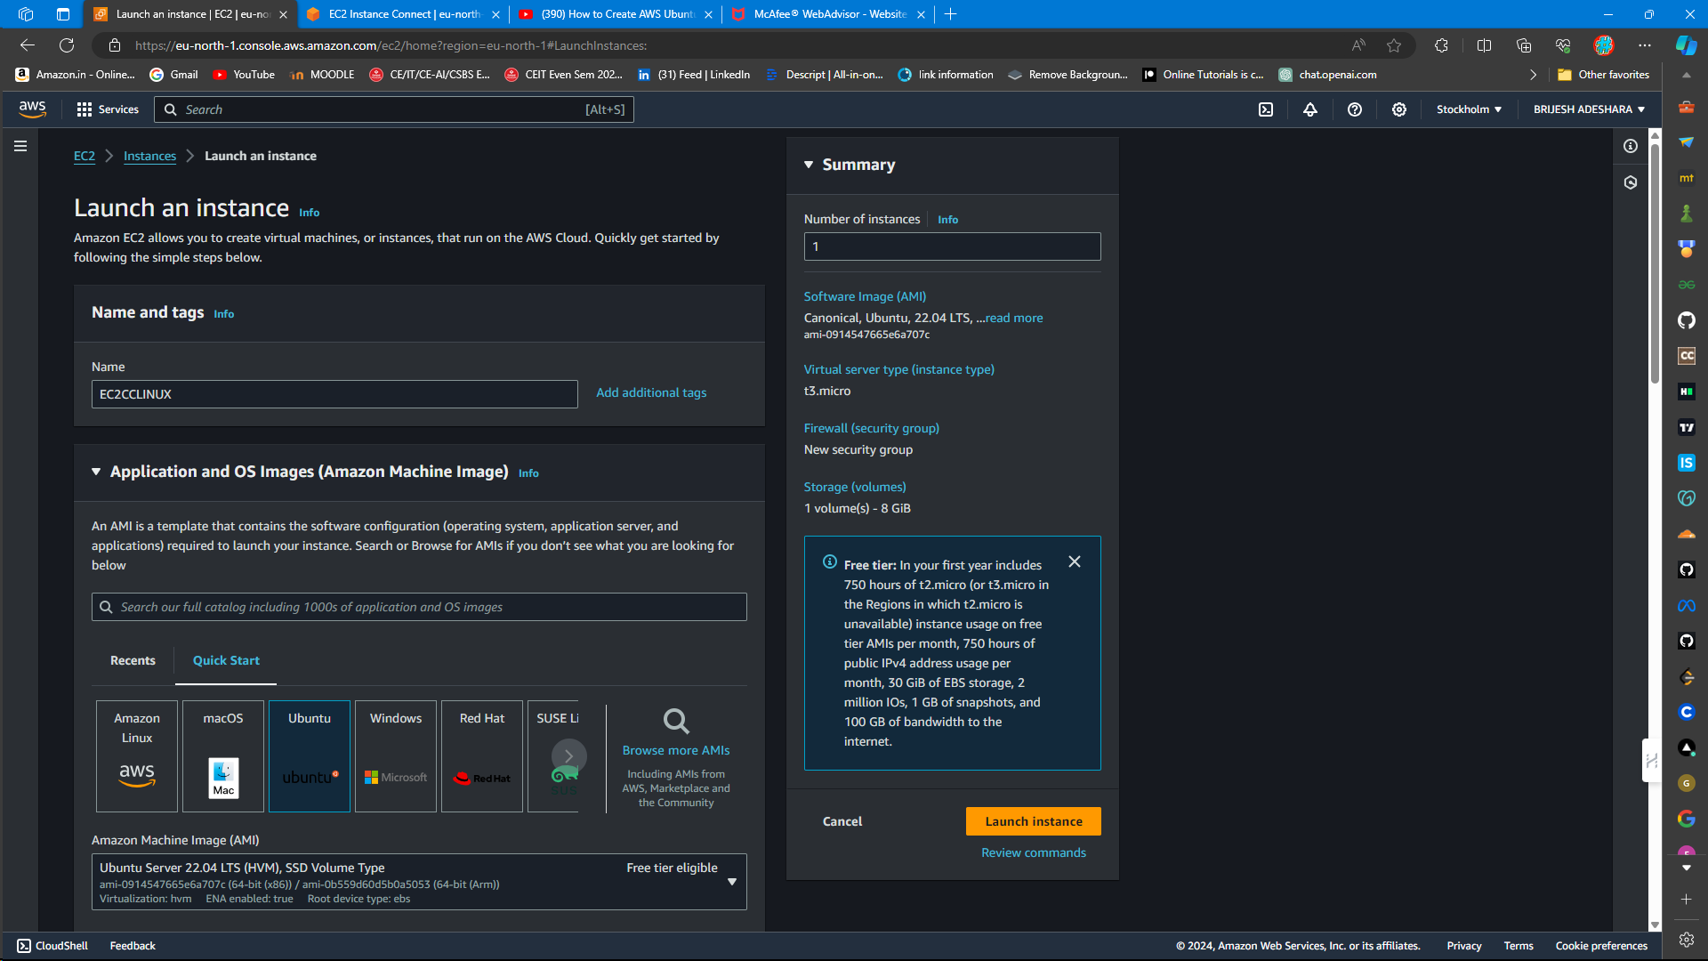

* + Configure instance type, networking settings (VPC, subnet), and storage (EBS volume).

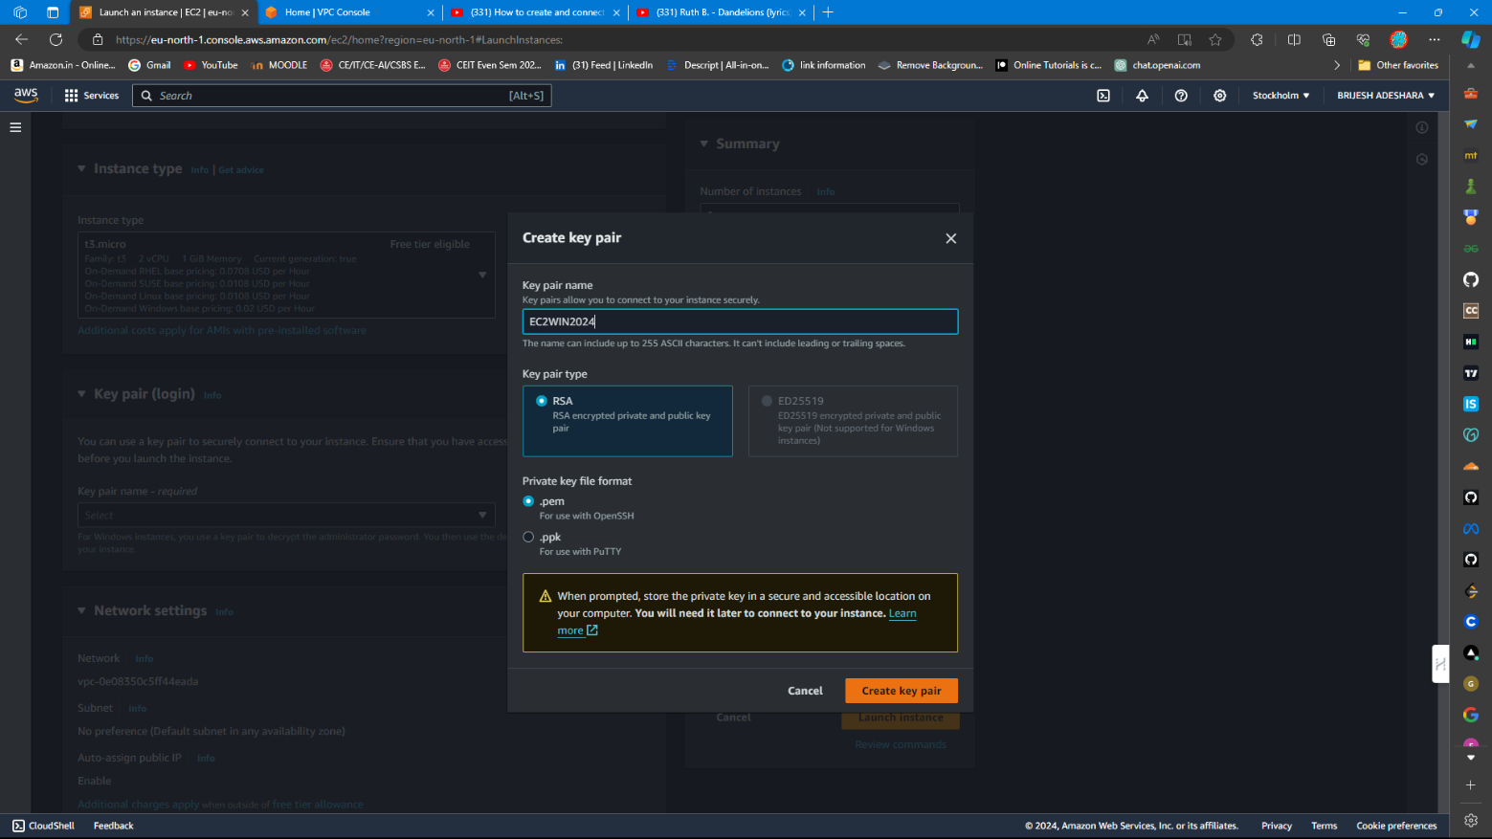

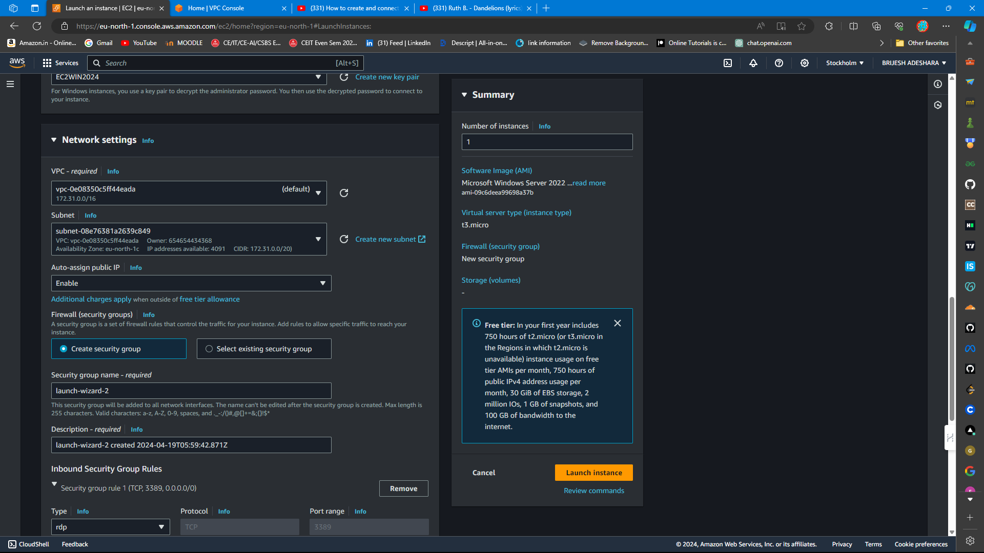

1. **Configure Security Groups**:
   * Define inbound rules to allow HTTP (port 80) and/or HTTPS (port 443) traffic.

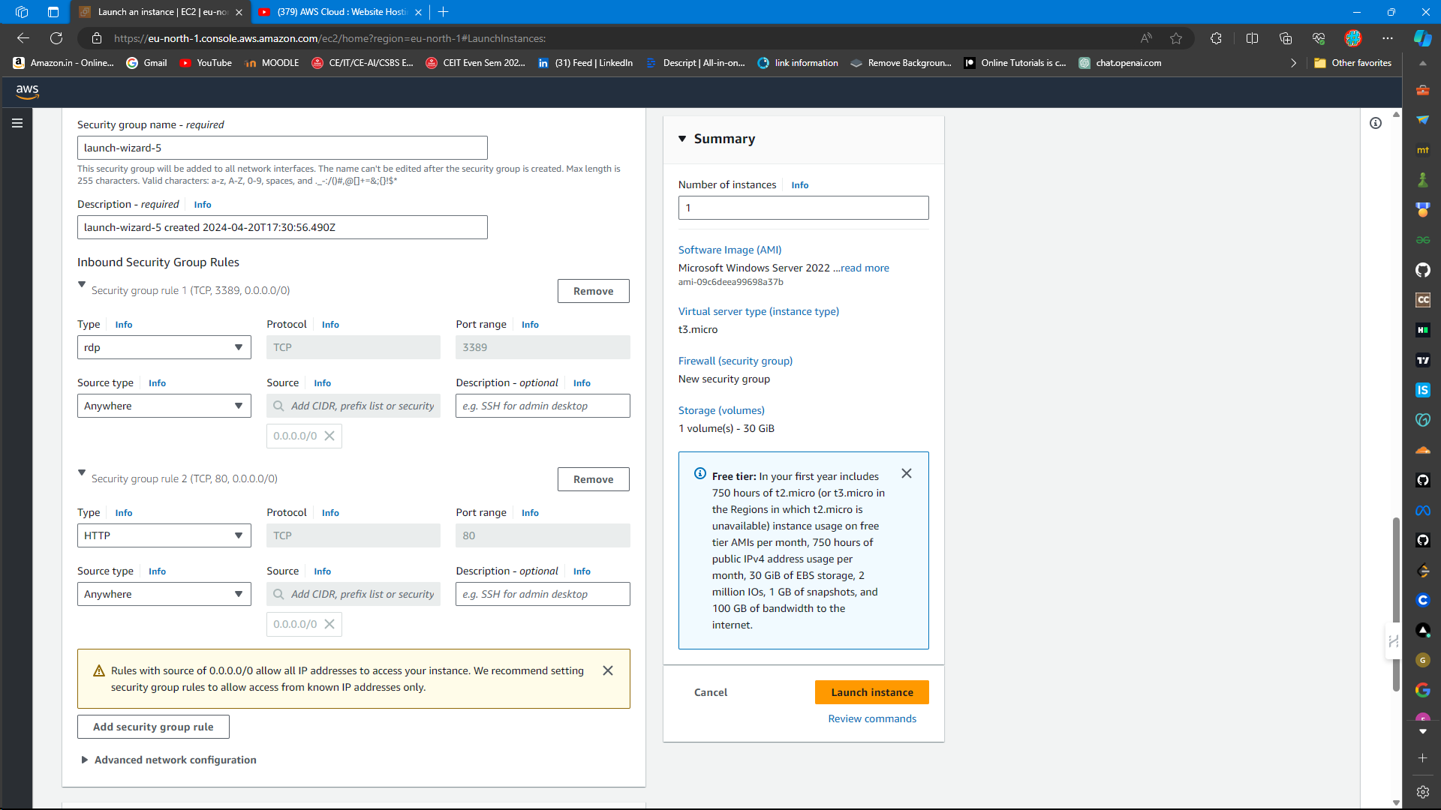

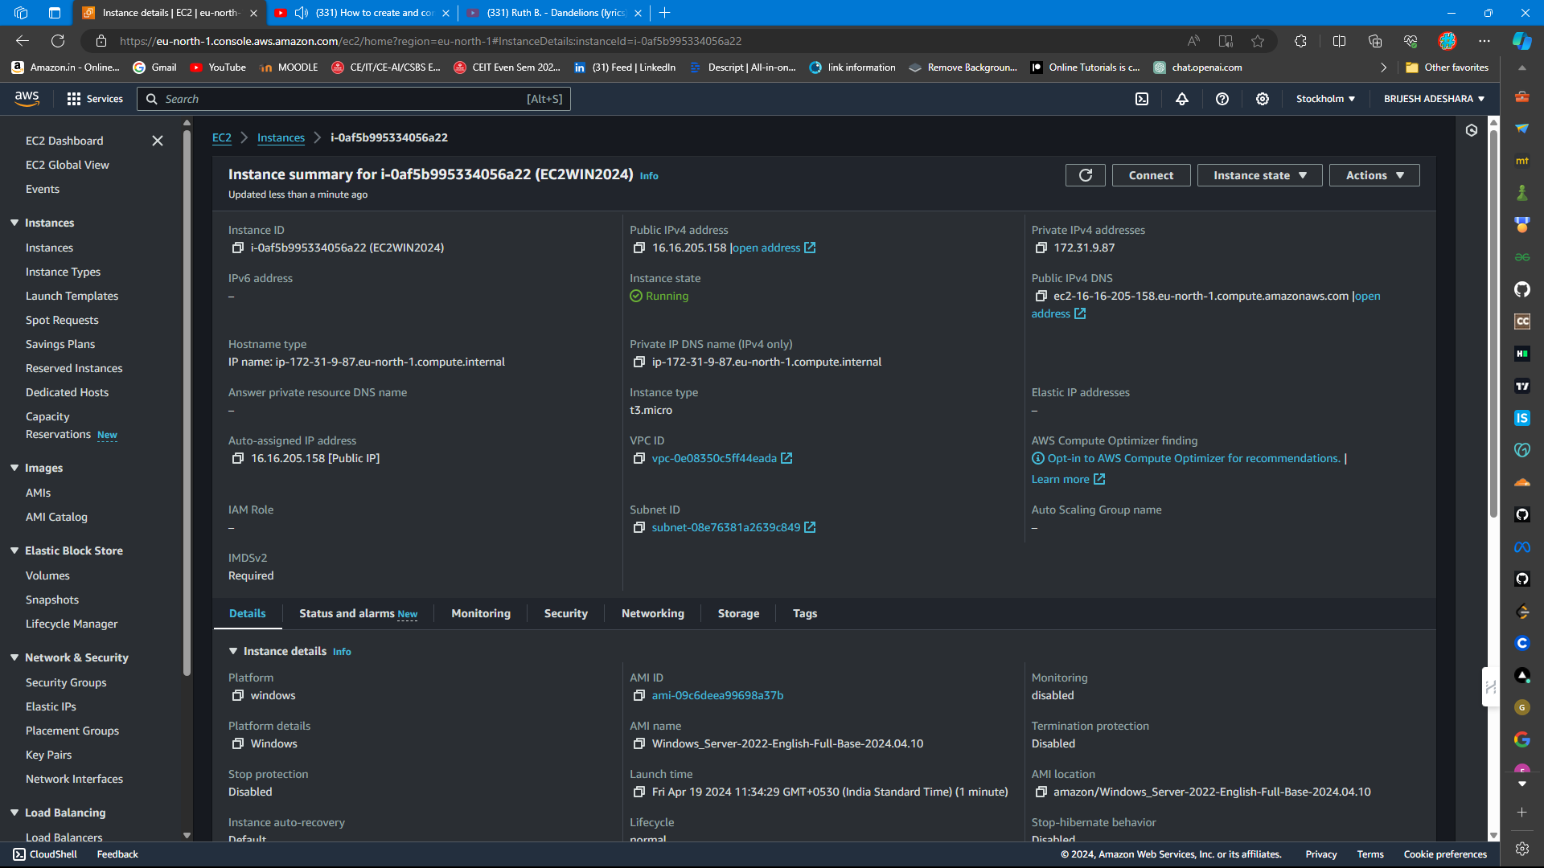

1. **Connect to EC2 Instance**:
   * Use Remote Desktop Protocol (RDP) for Windows instances or Secure Shell (SSH) for Linux instances to connect to your EC2 instance.

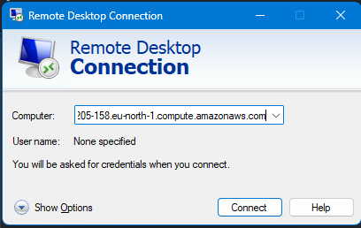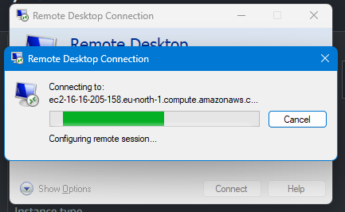

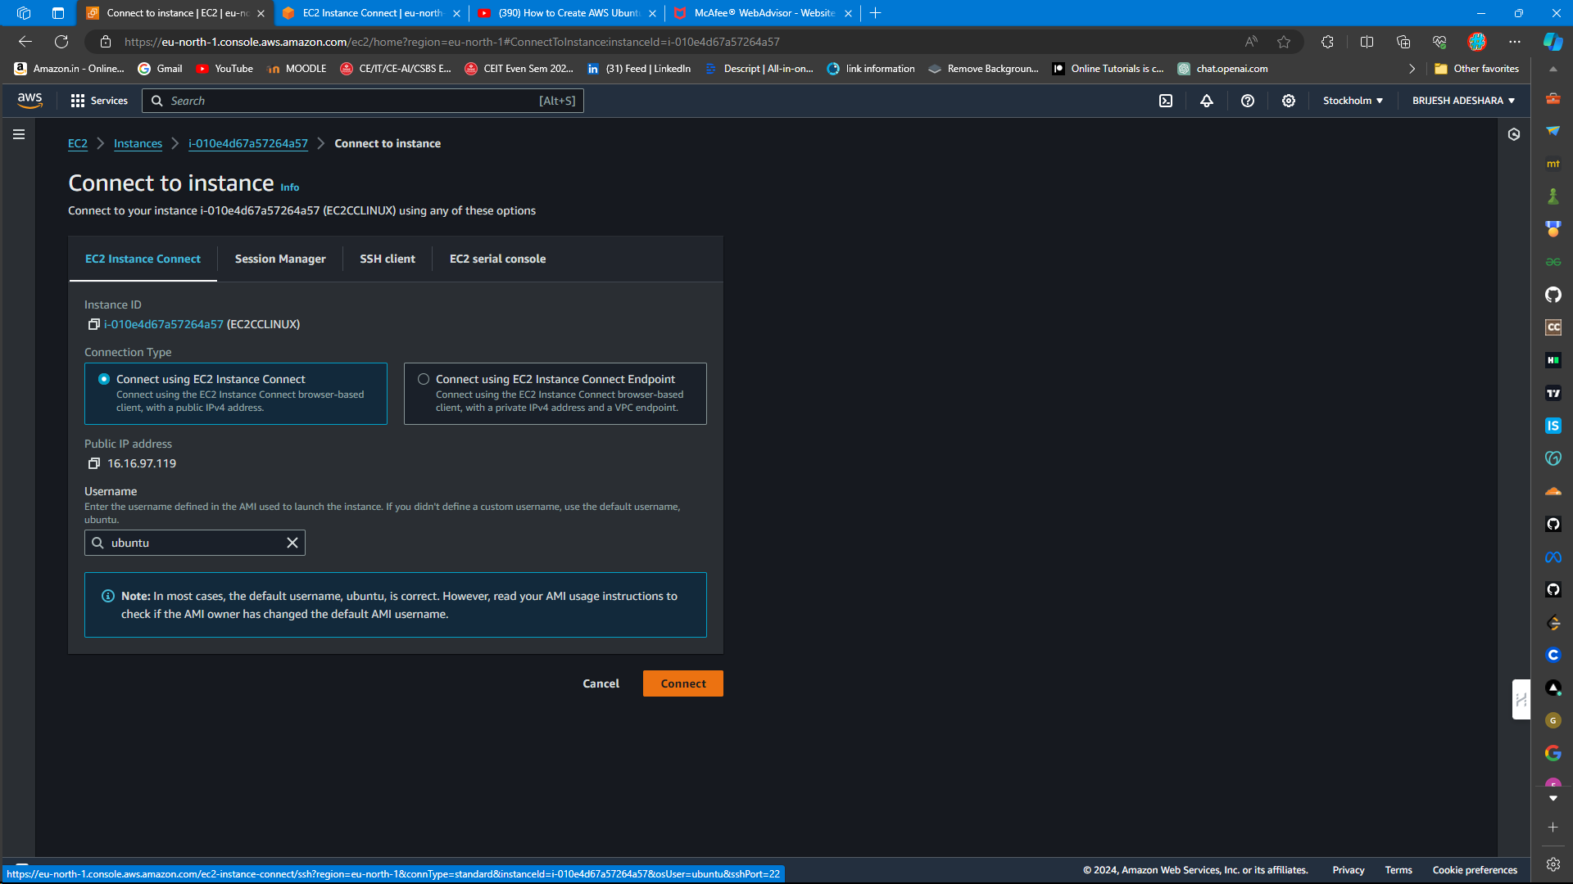

1. **Install Web Server Software**:
   * For Windows: Install IIS (Internet Information Services) or another web server.

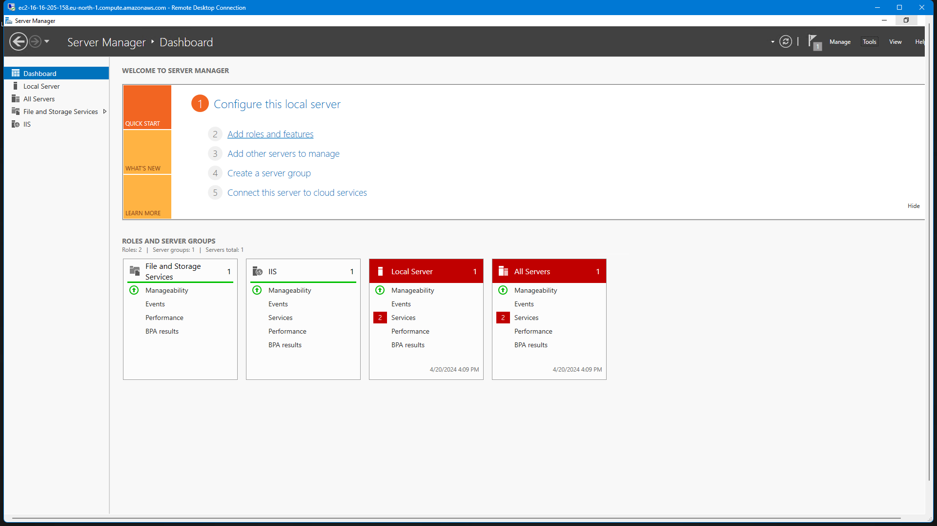

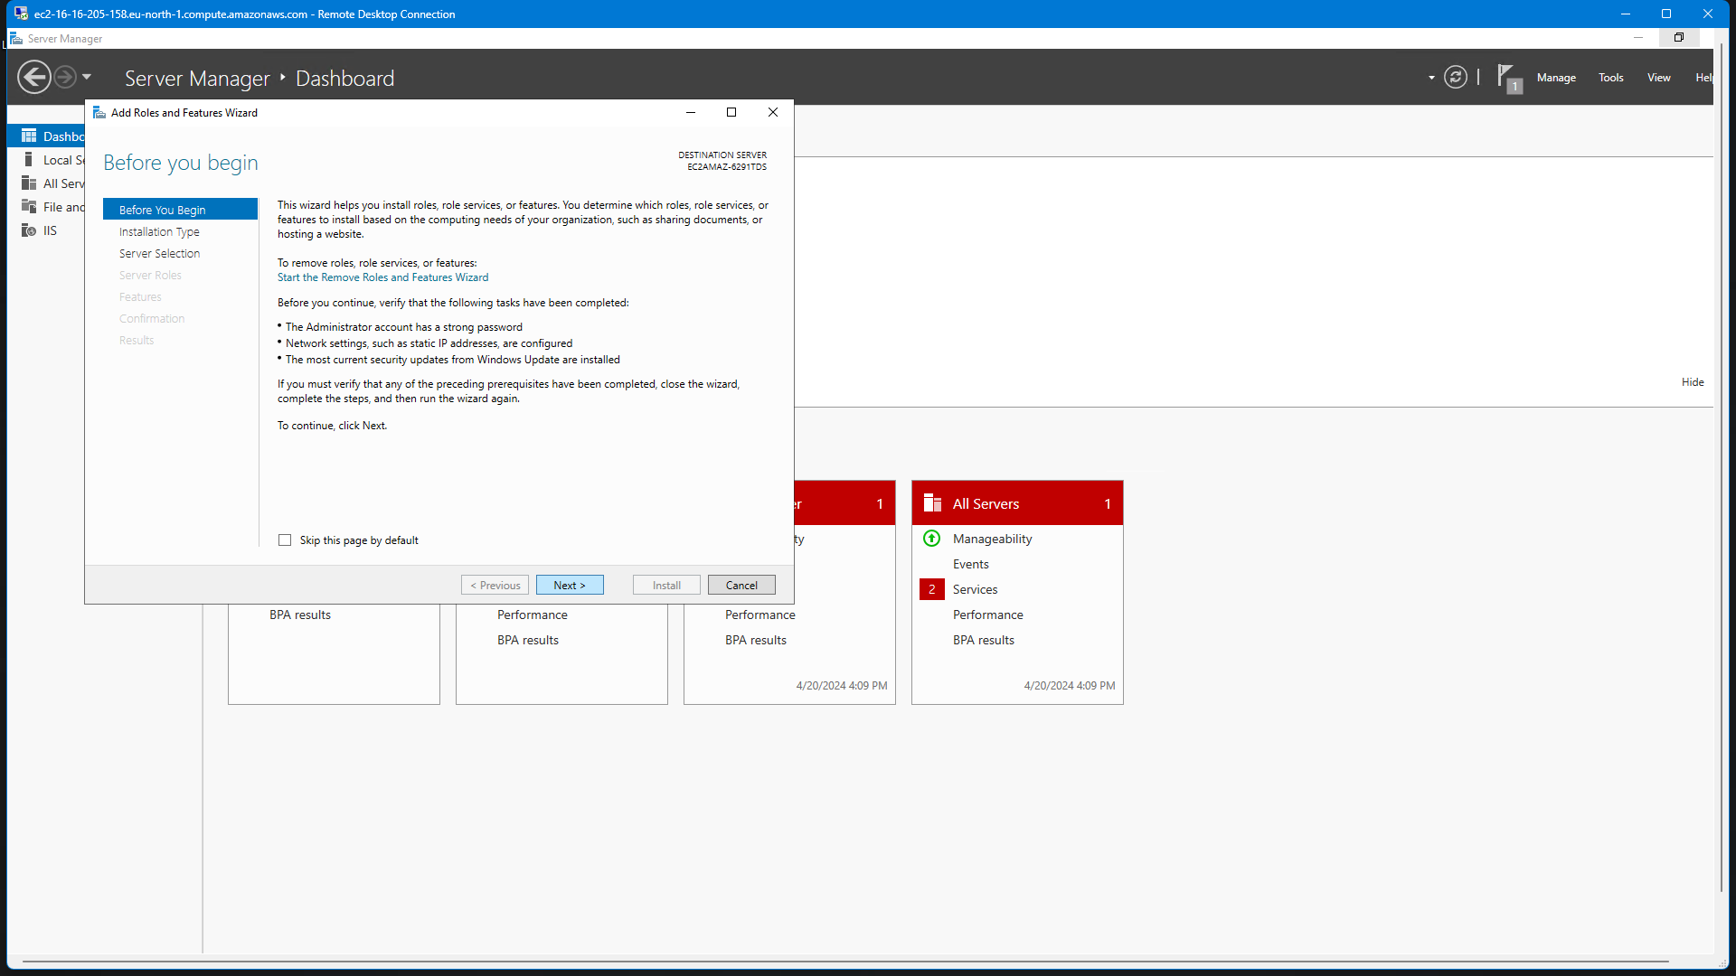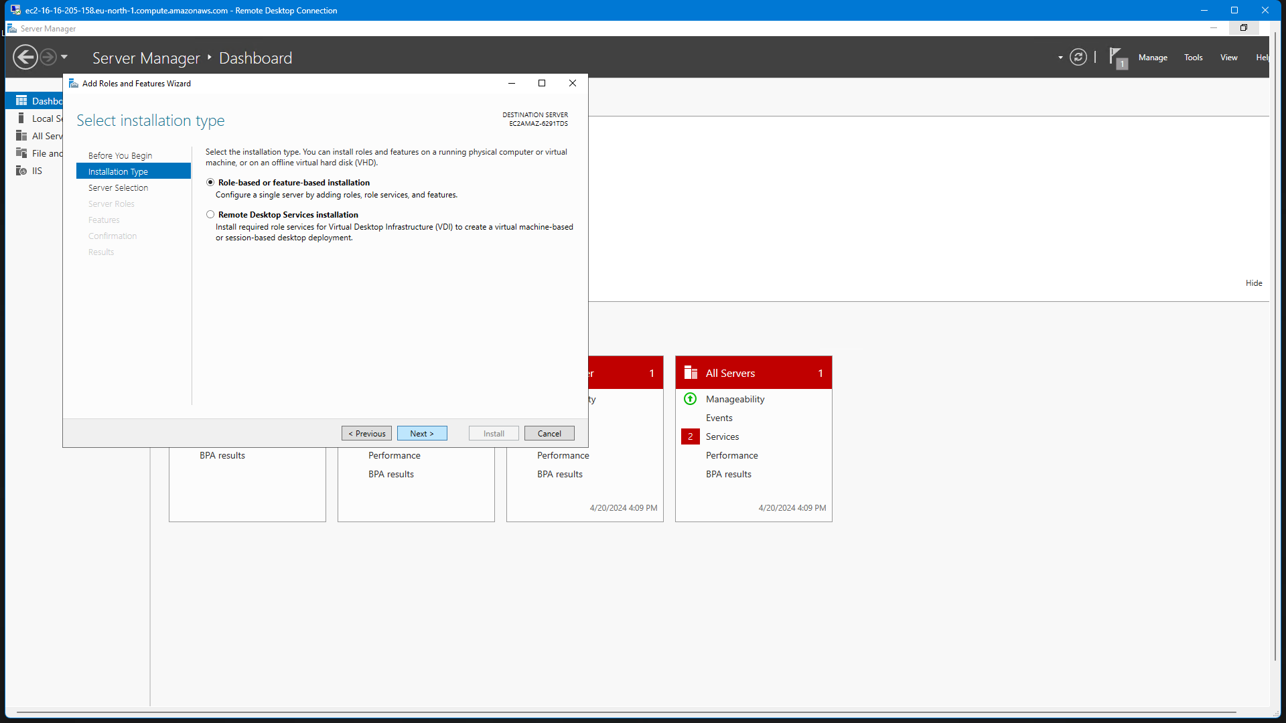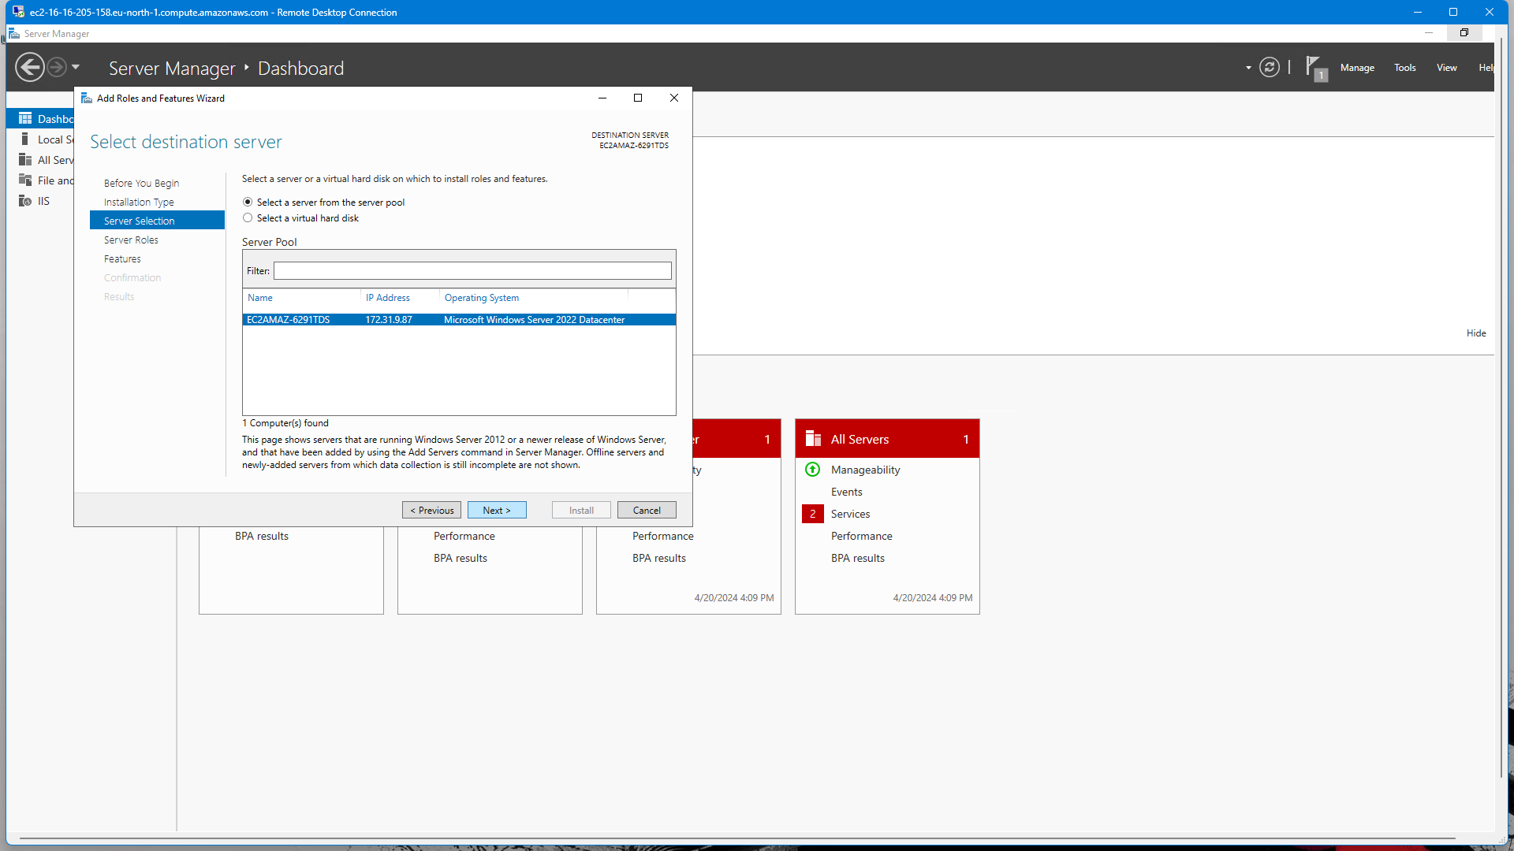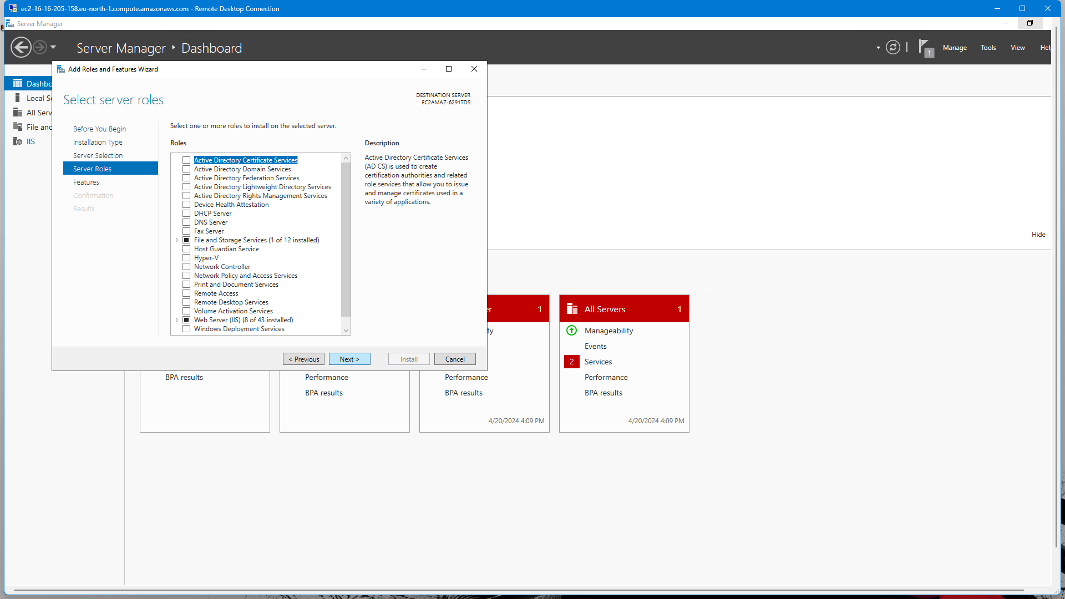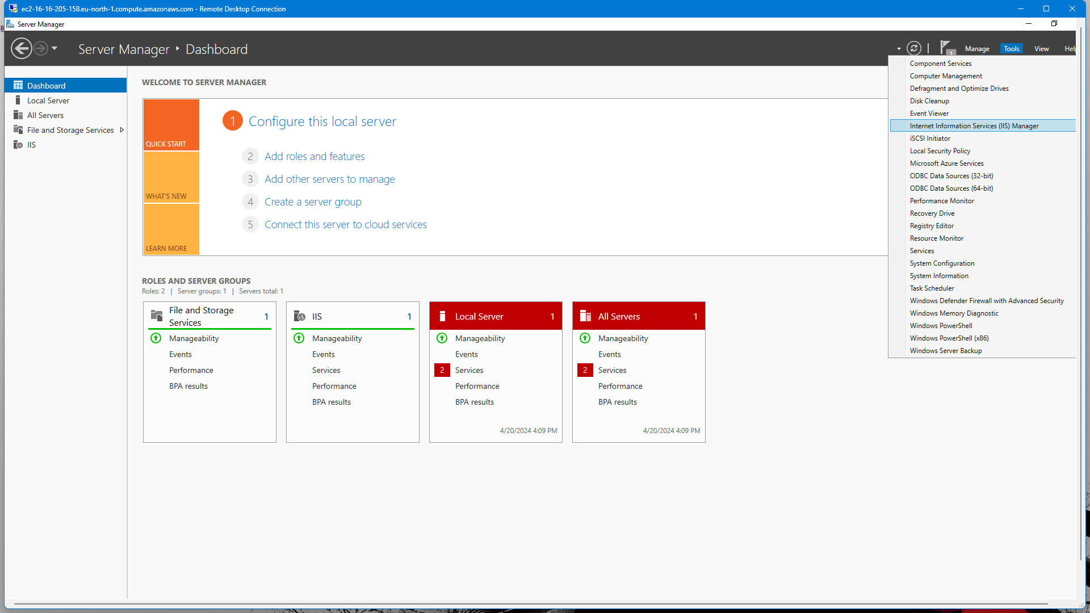

* + For Linux: Install Apache, Nginx, or another preferred web server.

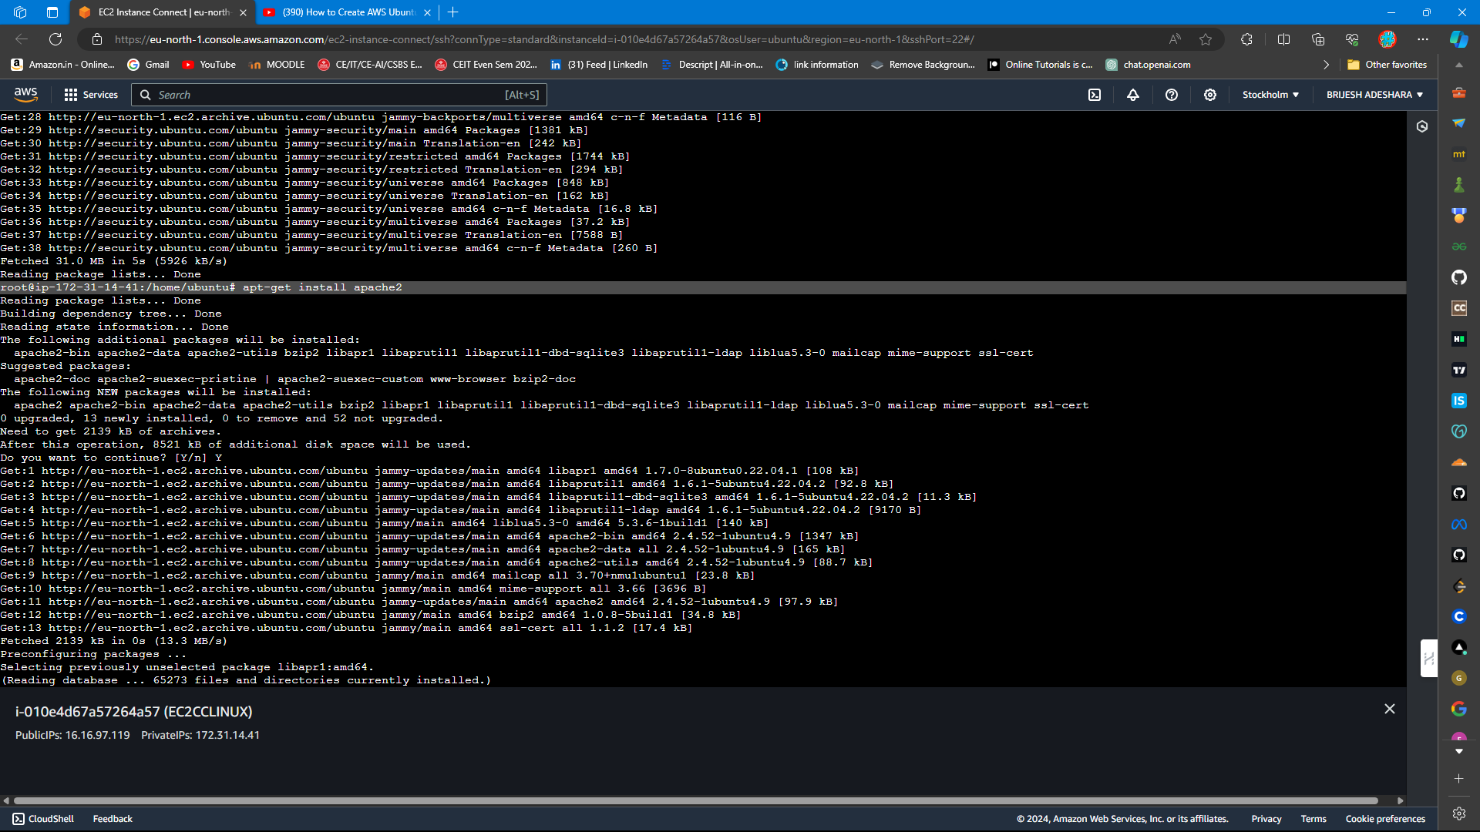

1. **Deploy Website Files**:
   * Transfer website files (HTML, CSS, JavaScript, etc.) to the appropriate directory on the EC2 instance.

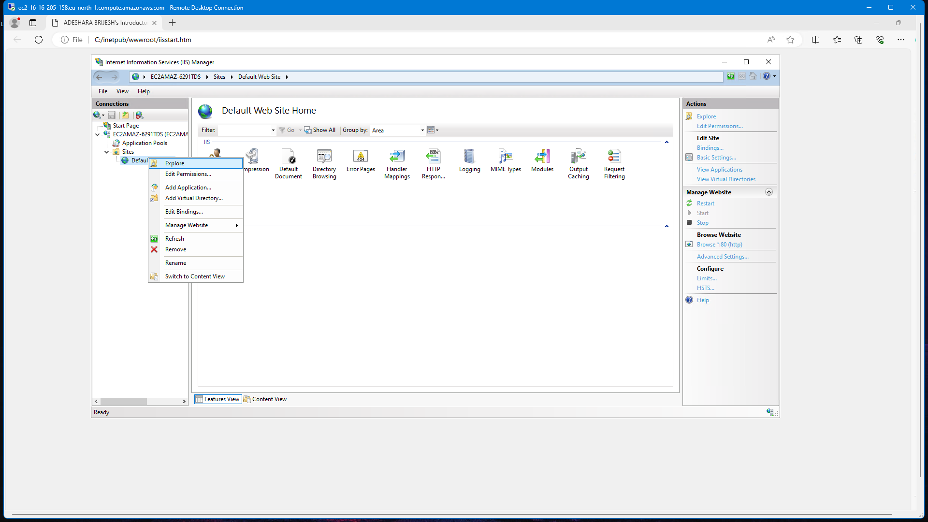

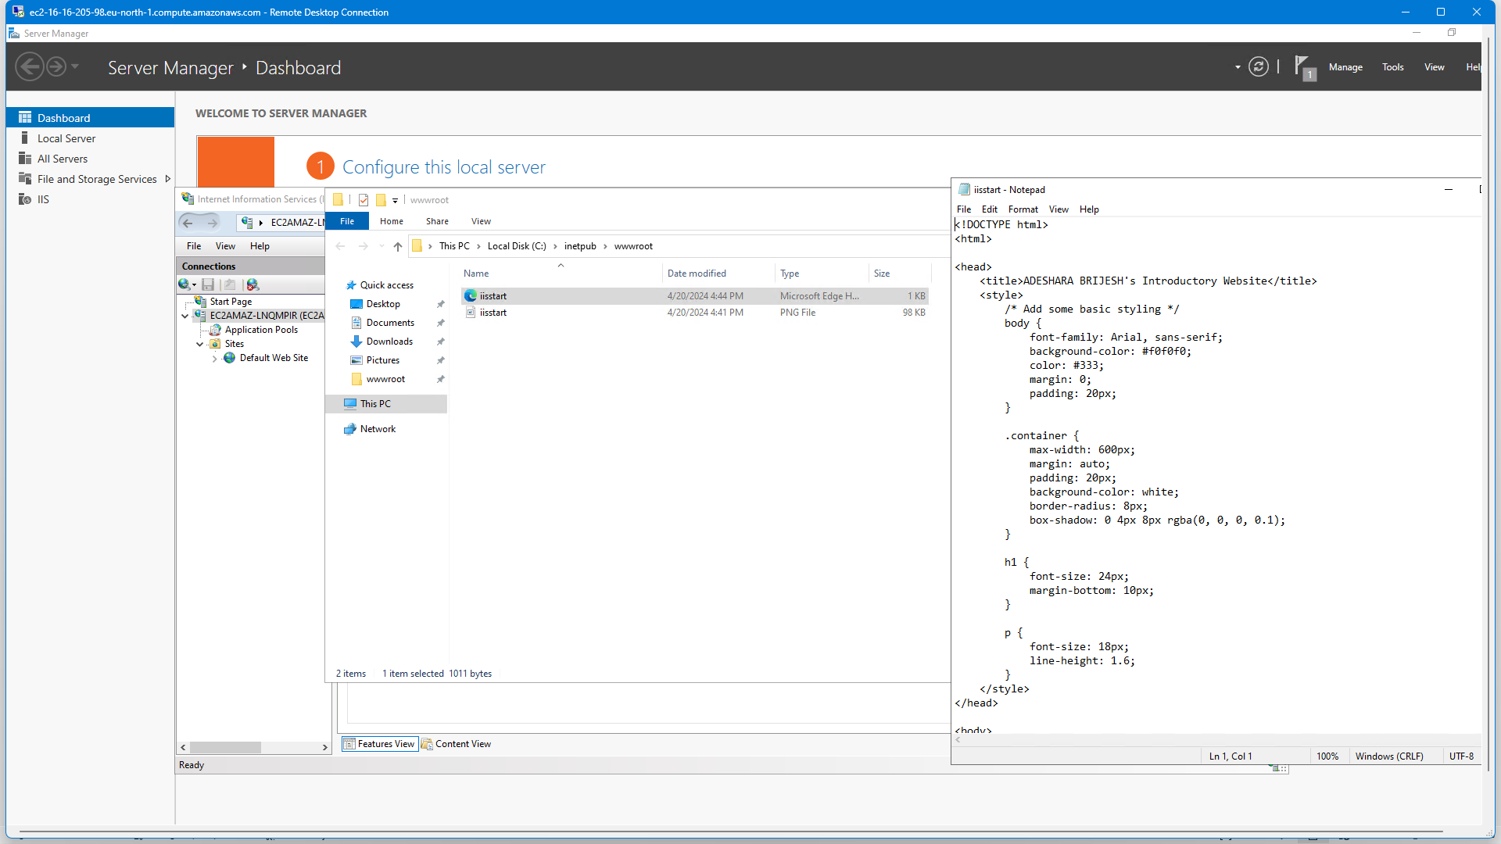

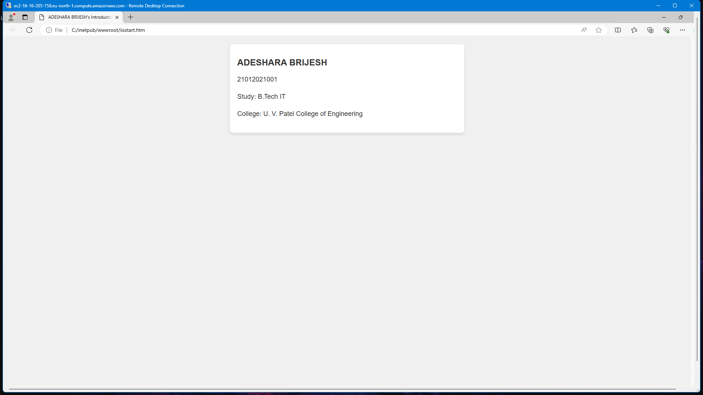

* **LINUX**

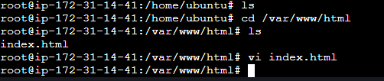

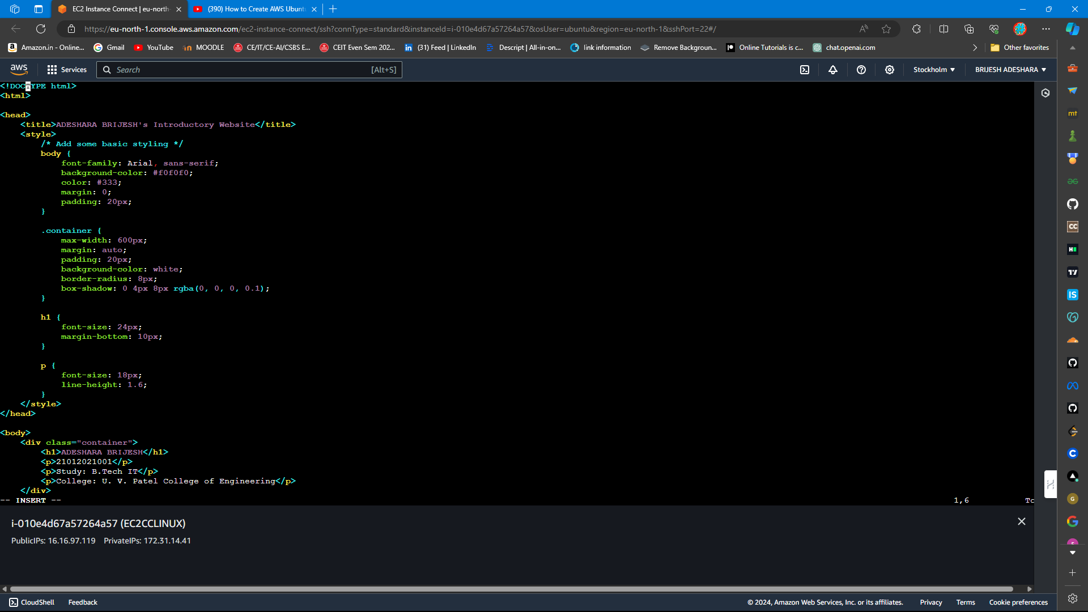

1. **Configure DNS Settings**:
   * Update DNS records (A records or CNAME) to point to the public IP address or domain name associated with your EC2 instance.

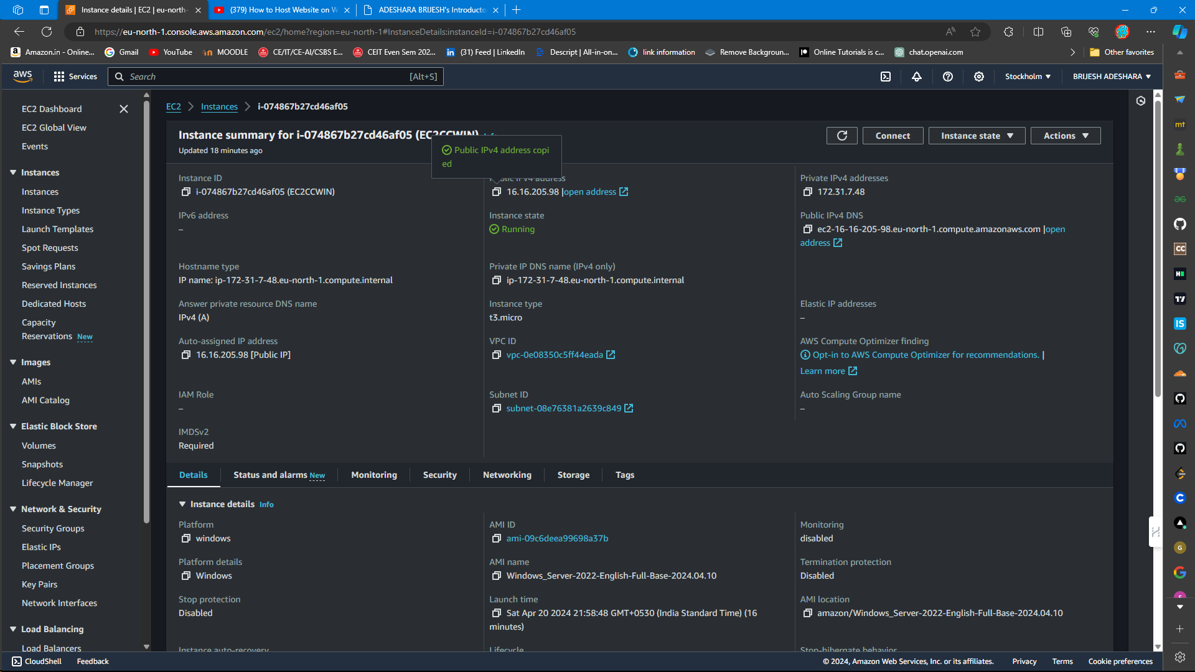

1. **Test Website Accessibility**:
   * Access the website using the public IP/domain name to ensure successful deployment.

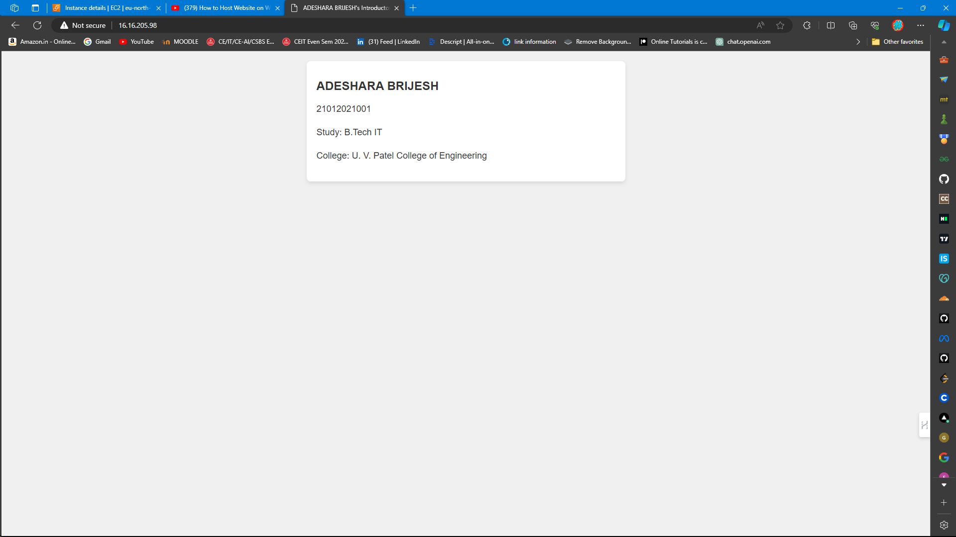

**Comparison:**

|  |  |  |  |
| --- | --- | --- | --- |
| **Aspect** | **Amazon EC2** | **Traditional Hosting** | **Other Cloud Providers** |
| **Scalability** | Highly scalable, allowing resources to be scaled up or down based on demand. | Limited scalability, typically offering fixed hosting plans with limited resources. | Varies among providers, with some offering scalability similar to EC2 and others with limitations. |
| **Flexibility** | Offers a wide range of instance types, configurations, and additional services for customization. | Limited flexibility, with predefined hosting plans and configurations. | Flexibility varies among providers, with some offering customizable solutions comparable to EC2 and others with more restricted offerings. |
| **Cost** | Pay-per-use model, allowing users to pay only for the resources they consume, potentially cost-effective for varying workloads. | Often fixed monthly fees, which may become costly for unused resources or sudden spikes in traffic. | Pricing structures vary among providers, with some offering competitive pricing comparable to EC2 and others with different pricing models. |
| **Ease of Use** | Requires knowledge of AWS services and configurations but provides extensive documentation and management tools for ease of use. | Typically easier to set up and manage, with user-friendly control panels and customer support. | Ease of use varies among providers, with some offering intuitive interfaces and support comparable to EC2 and others with different levels of usability. |

**Conclusion:**

* Hosting websites on Amazon EC2 instances provides scalable and reliable solutions leveraging cloud infrastructure.
* This project enhances understanding of cloud computing principles and practices in web hosting.

**Future Considerations:**

* Explore advanced features of Amazon EC2 (e.g., auto-scaling, load balancing).
* Integrate additional AWS services (e.g., Amazon RDS for database hosting) for enhanced website functionality.
* Stay updated on evolving cloud technologies to optimize website hosting solutions.