|  |
| --- |
| **[ cLOUD COMPUTING ]** |
|  |

Practical: 1

**-:AIM:-**

**Implementation of web service**

Submitted By: Dharmay Sureja

Enrollment No:17012011056



**GANPAT UNIVERSITY**

**U. V. Patel College of Engineering**

**Computer Engineering Department**

**AIM:- Implementation of web service**

**NewWebService.java:-**

package server;

import javax.jws.WebService;

import javax.jws.WebMethod;

import javax.jws.WebParam;

/**

*

* @author dharm

*/

@WebService(serviceName = "NewWebService")

public class NewWebService {

/**

* This is a sample web service operation

*/

@WebMethod(operationName = "hello")

public String hello(@WebParam(name = "name") String txt) {

return "Hello " + txt + " !";

}

/**

* Web service operation

*/

@WebMethod(operationName = "sum")

public Integer sum(@WebParam(name = "a") int a, @WebParam(name = "b") int b) {

//TODO write your implementation code here:

return (a+b);

}

/**

* Web service operation

*/

@WebMethod(operationName = "sub")

public Integer sub(@WebParam(name = "a") int a, @WebParam(name = "b") int b) {

//TODO write your implementation code here:

return (a-b);

}

/**

* Web service operation

*/

@WebMethod(operationName = "mul")

public Integer mul(@WebParam(name = "a") int a, @WebParam(name = "b") int b) {

//TODO write your implementation code here:

return (a*b);

}

/**

* Web service operation

*/

@WebMethod(operationName = "div")

public Integer div(@WebParam(name = "a") int a, @WebParam(name = "b") int b) {

//TODO write your implementation code here:

return (a/b);

}

/**

* Web service operation

*/

@WebMethod(operationName = "mod")

public Integer mod(@WebParam(name = "a") int a, @WebParam(name = "b") int b) {

//TODO write your implementation code here:

return (a%b);

}

}

**Practical1.java:-**

package practical1;

import java.util.Scanner;

/**

*

* @author dharm

*/

public class Practical1 {

/**

* @param args the command line arguments

*/

public static void main(String[] args) {

// TODO code application logic here

Scanner sc=new Scanner(System.in);

System.out.println("Enter value of a");

int a= sc.nextInt();

System.out.println("Enter value of b");

int b= sc.nextInt();

System.out.println("Enter 1.Addition 2.Subtraction 3.Multiplicatio 4.Division 5.Modulo/n");

int ch=sc.nextInt();

try

{

server.NewWebService_Service service = new server.NewWebService_Service();

server.NewWebService port = service.getNewWebServicePort();

if(ch==1)

{System.out.println("addition is="+port.sum(a, b));}

else if(ch==2)

{System.out.println("subtraction is="+port.sub(a, b));}

else if (ch==3)

{System.out.println("Multiplication is="+port.mul(a, b));}

else if (ch==4)

{System.out.println("Division is="+port.div(a, b));}

else if (ch==5)

{System.out.println("Modulo is="+port.mod(a, b));}

}

catch(Exception e)

{

System.out.println("Error");

}

}

}

**OUTPUT:-**

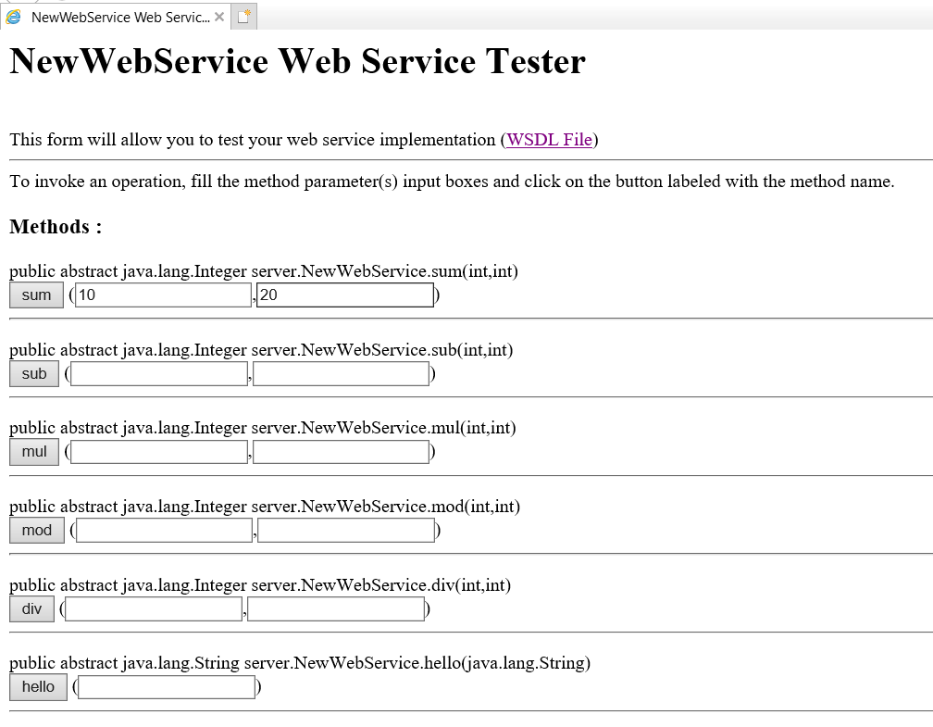

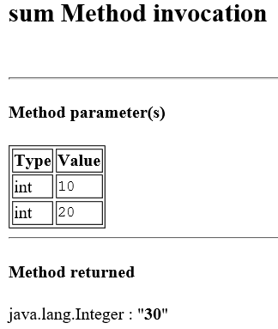

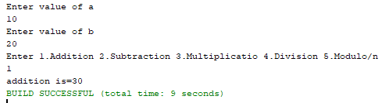

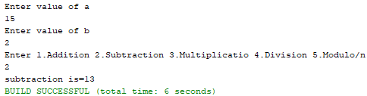

**STEPS:**

