|  |
| --- |
| **[ CLOUD COMPUTING ]** |
|  |

Practical: 11



Submitted By: Dharmay Sureja

Enrollment No:17012011056





**AIM:- To Configure Openstack.**

* **Pre-requisites / Configuration Environment :**

**Operating System :** Ubuntu (64-bit)

**Version :** ubuntu-18.04.3-desktop

**Base Memory :** 8194 MB (6GB)

**Storage :** 50 GB

The following are the steps to configure Openstack and to create instance in Openstack :

**Installation of Ubuntu 18.04**

* Firstly, we need to install the ubuntu in the Oracle VM Box Manager of our PC.
* So, let’s just install the ubuntu 18.04 LTS in our Oracle VM Box Manager
* First download the ISO file of ubuntu 18.04 from the website called [www.ubuntu.com](http://www.ubuntu.com)
* Then go to your VM Box manager and click “NEW” to add the ISO file of ubuntu 18.04.

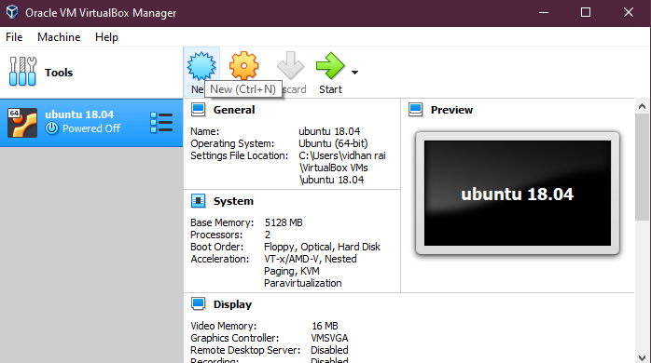

* After clicking “NEW” you’re asked to name your PC and username for your ubuntu account.

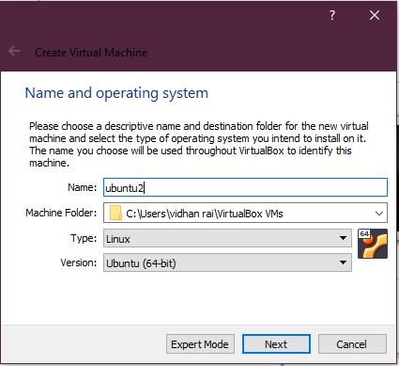

* Now in the next step you will be asked to adjust the Memory size (RAM) of your OS. And we know that open stack consumes more RAM so we need to adjust our Memory size(RAM) at around 5/6 GB.

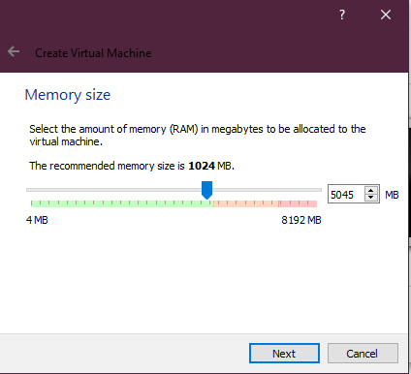

* After fixing the RAM size , you would be asked about the Hard disk of your OS. So just keep it as default. (Virtual Hard Disk) and keep as default in the next step also.

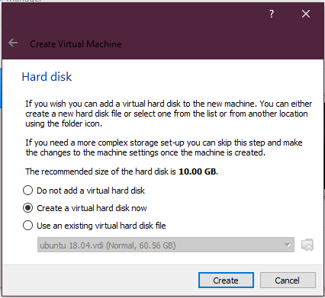 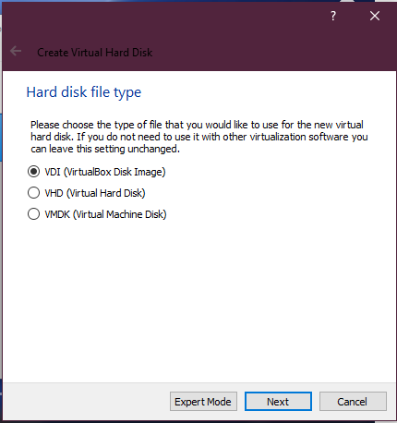

* Now in the next option we are asked to select storage type where we will again keep as default (i.e Dynamically allocated)

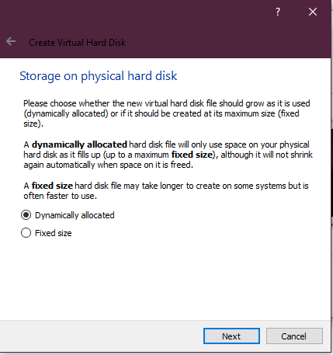

* And now finally in the next step we are asked to select the file Location and size where you can change the size as per your need. Basically around 50-60 GB should be allotted.

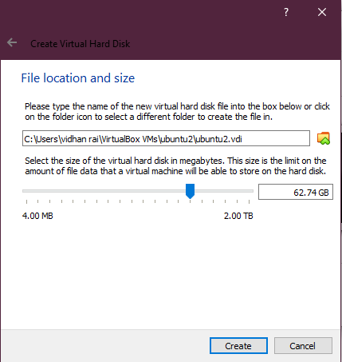

* After Clicking the “Create” button as shown above your ubuntu OS will be created in your VM Box Manager.

Hence, now you are able to see the ubuntu 18.04 on left hand side top corner of the VM Box Manager as shown below : 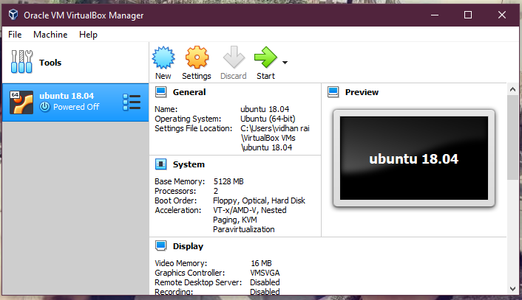

Now , before clicking the “start” icon just go to the “settings” for the configuaration of ubuntu 18.04.

* In settings , go to “Advanced” > select the “Bi-directional” for both “shared Clipboard” as well as “Drag and Drop” as choosing “Bi-directional” option allow you to copy/move your file from your OS to your VM-OS.
* After this , go to “system” where you can configure the components as per your requirements.
* After the configuring “system”, go into the “Storage” where you need to choose the “Empty” option in the “Controller Id” after which just move your cursor to the disk icon which is placed right after the “optical drive” option.
* Just click disk icon>choose virtual optical disk file>give the path of your ISO File of ubuntu 18.04 and then click OK.

Hence , now we are done with the configuration of settings and so we are ready to run our Virtual Machine.

* Now just click on the “start” icon of VM Box Manager to Run the OS. After Clicking you will get the below screen.
* So let’s just follow the step by step as shown below :-

Step -1 :- select Language

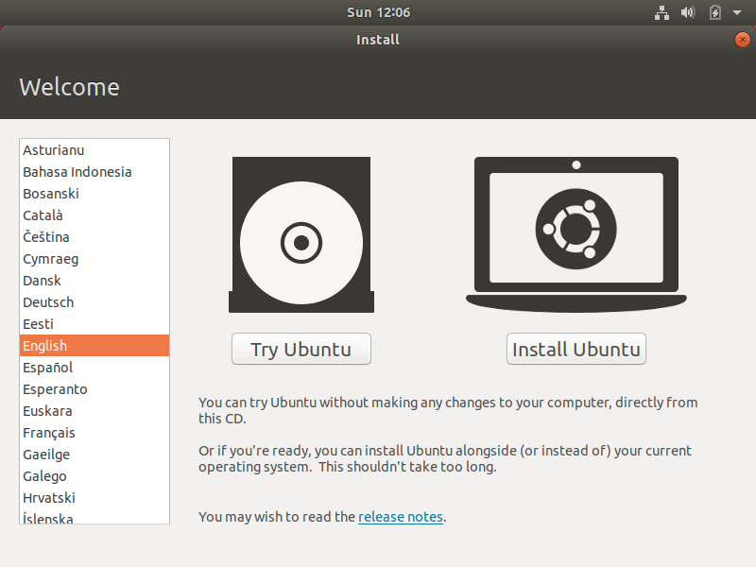

Step – 2:-

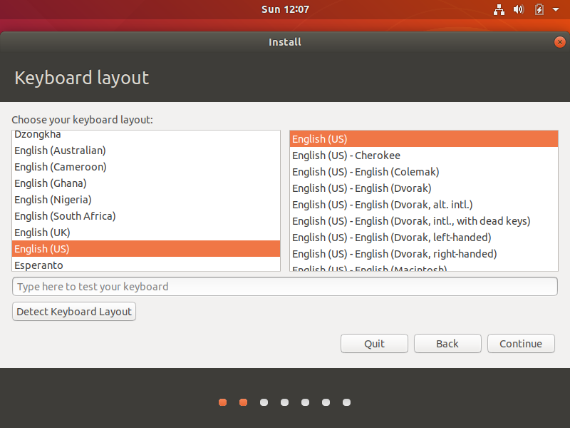

Step -3:-

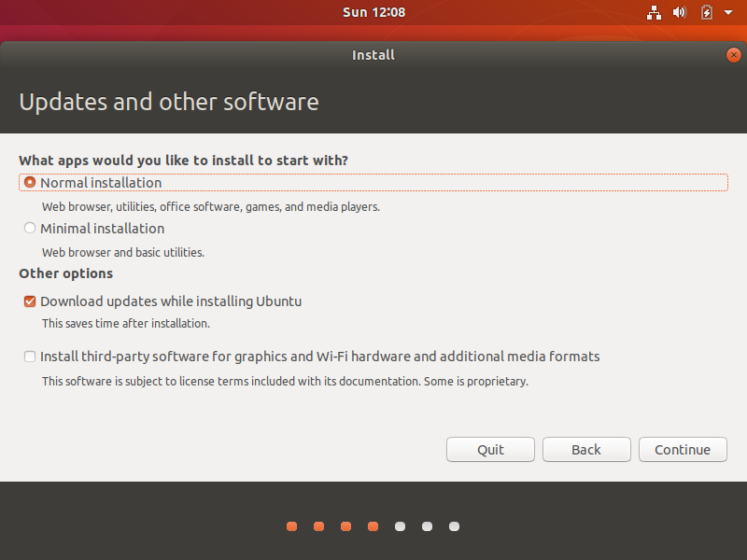

Step-4:-

Step-5:-

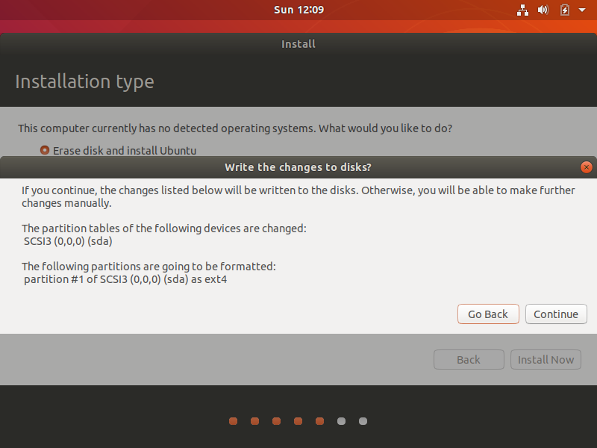

Step-6:-

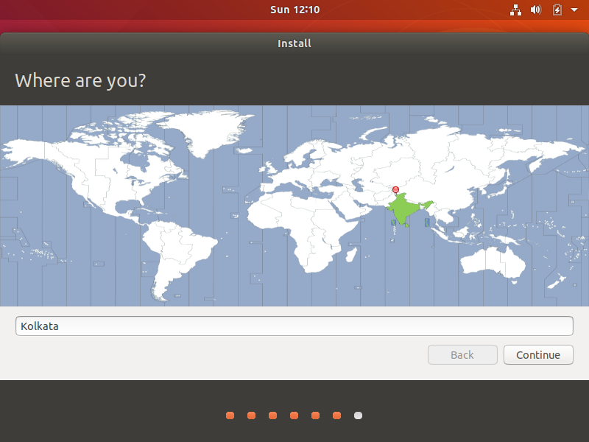

Step-7:-

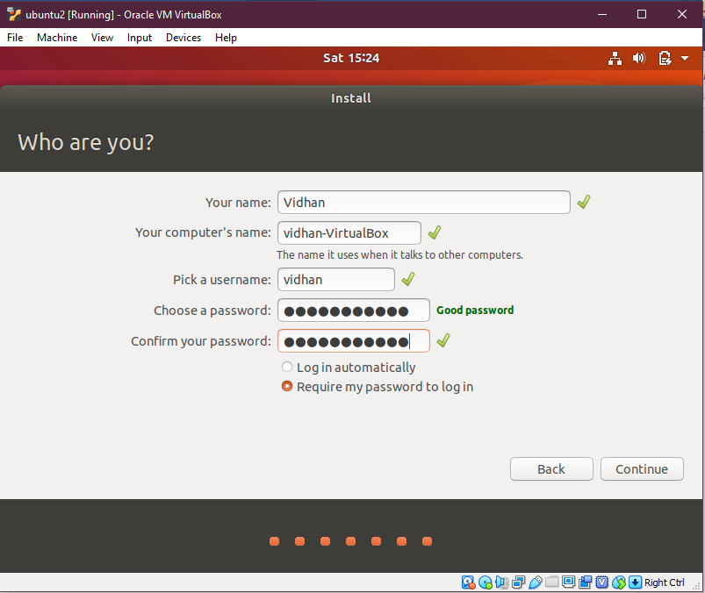

Step -8:-

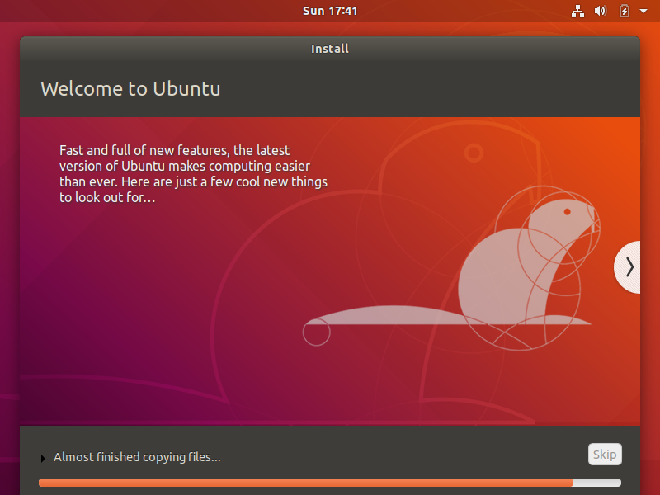

Step -9:-

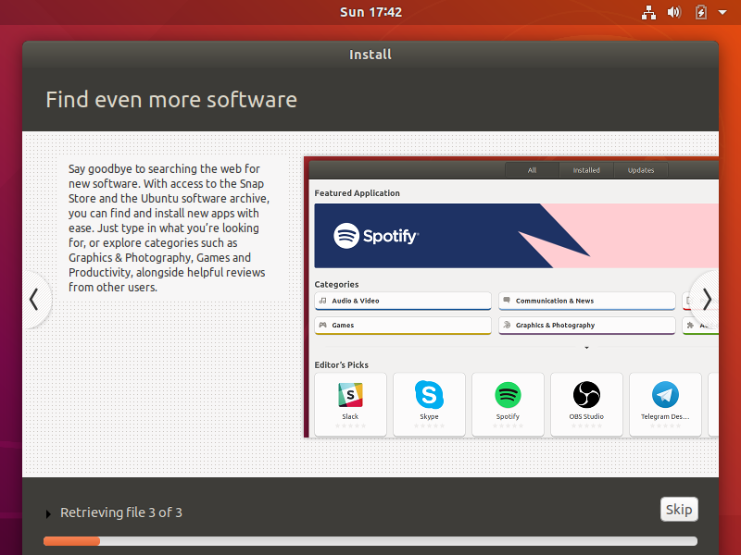

Step-10:-

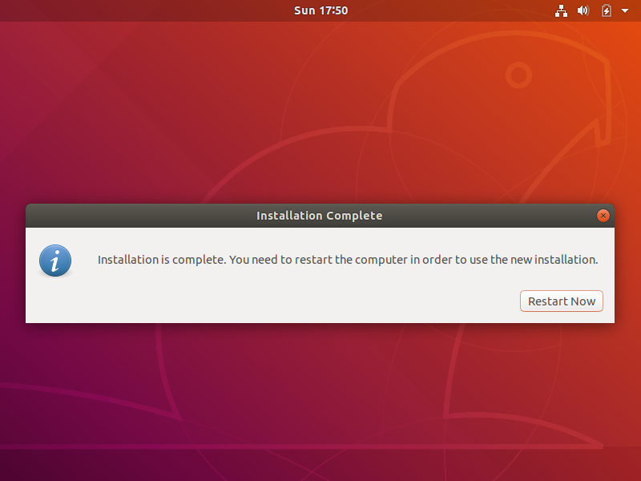

Step-11:-

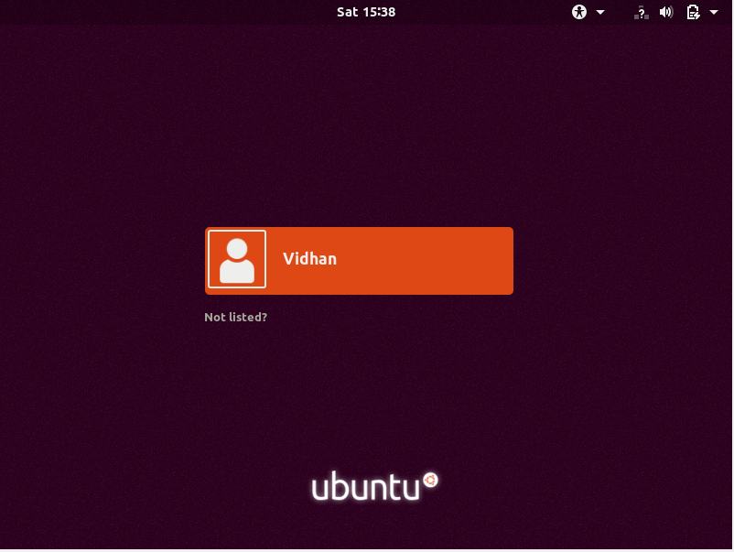

Step-12:-

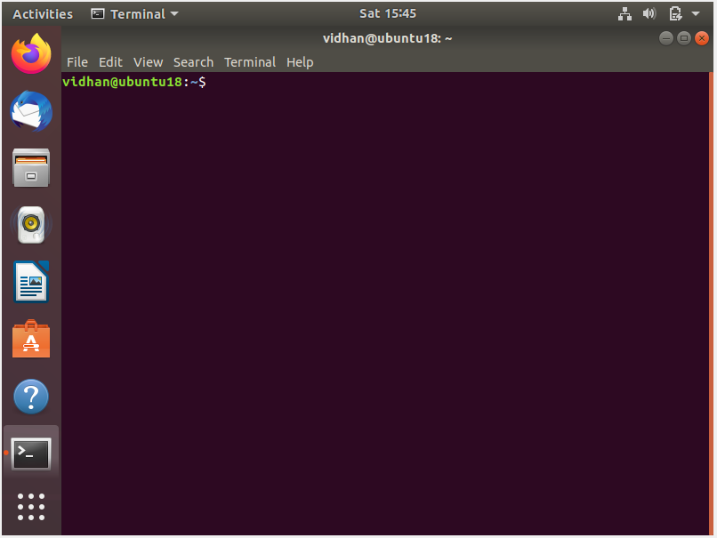

Step-13:- sudo apt-get update

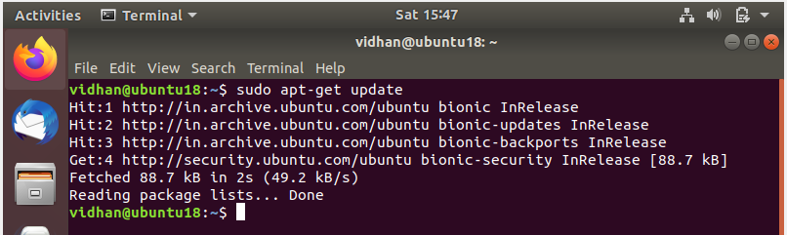

Step-14:- sudo apt-get upgrade

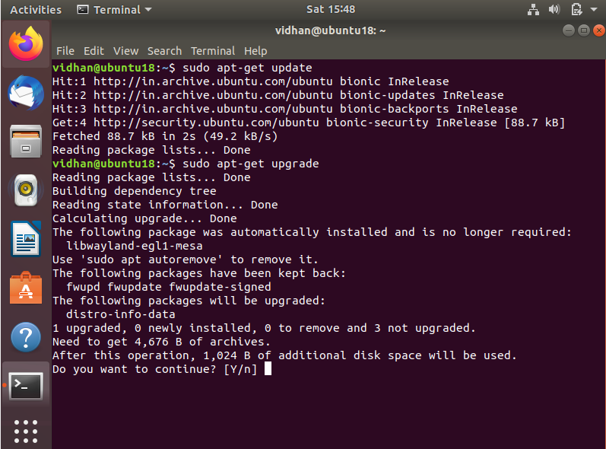

Step-15:- After clicking ‘y’ :-

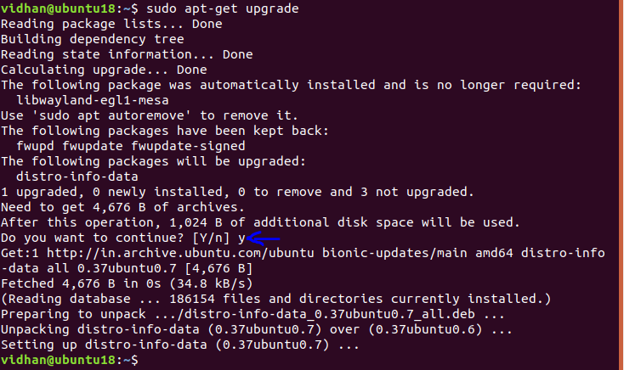

Step-16 :- sudo apt-get install git

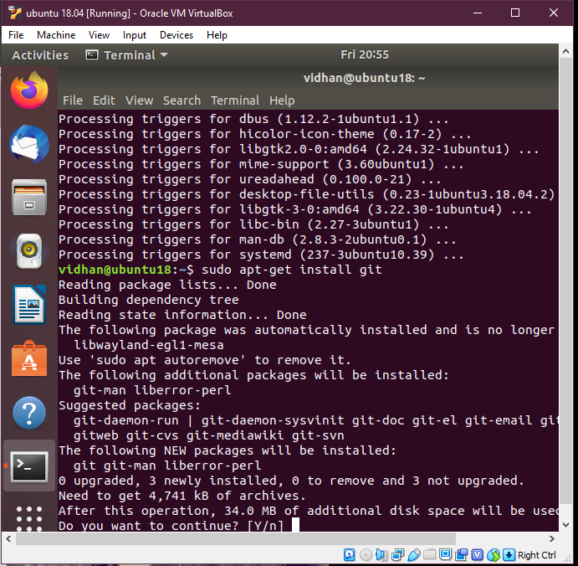

Click yes (y) :-

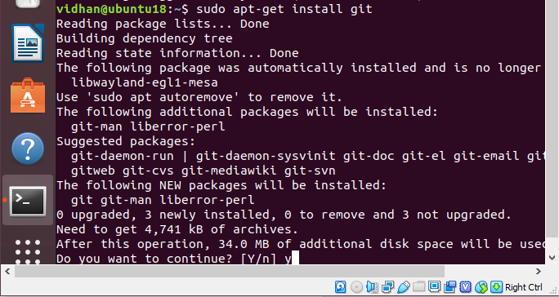

Step-17 :- Asks for password :

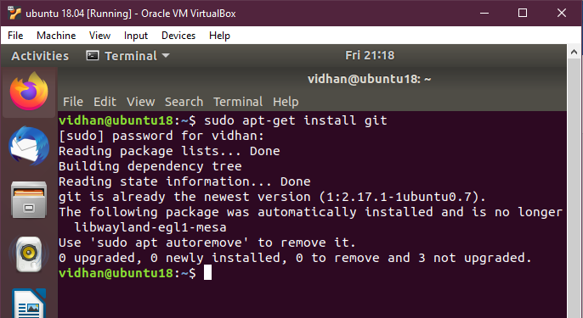

**(git - open source distributed version control system that is used to support the development of Linux)**

**(Git clone command is used to copy the existing git repository)**

Step-18:- type “git clone <https://opendev.org/openstack/devstack>”

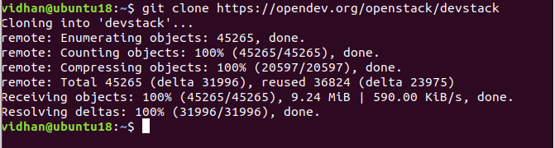

(**Note**: - devstack repository contains the script that install open stack)

Step-19:- Type “ls” and “cd devstack/” to go into the devstack folder and in that we’re going to change the inc python file because for most of the time we found that if we do not make changing into the INC python file we normally get an error while installing the open stack specially on ubuntu 18.04.

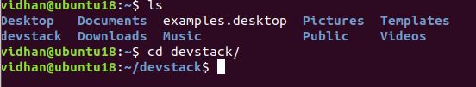

Step-20:- Editing inc python file :

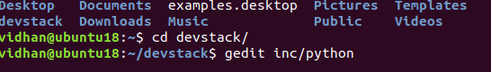

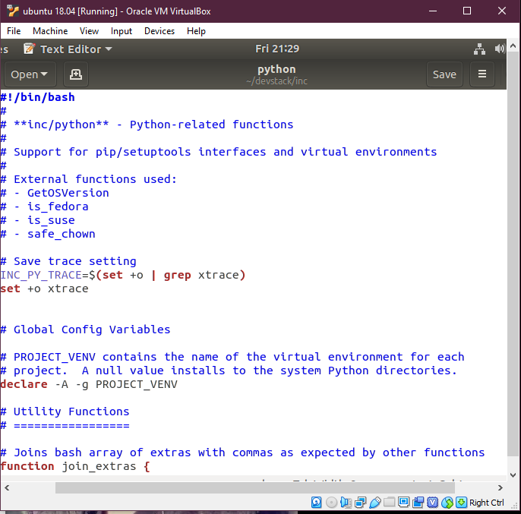

Step-21:- Now search for $cmd pip in this file

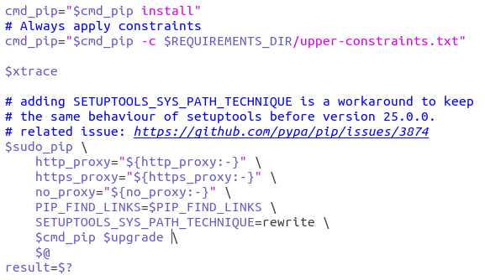

Step-22:- Adding “$install_test_reqs –ignore-installed” command after $support to ignore pip error.

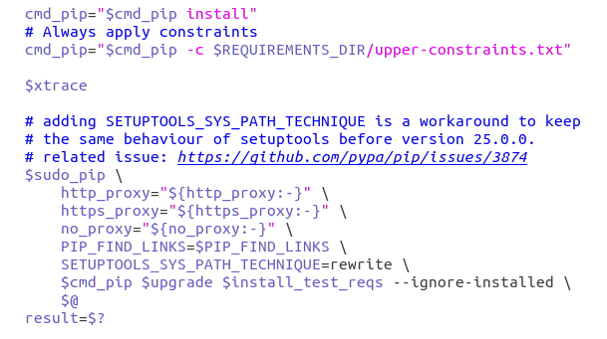

Step-23:- Now next step is that we need to go into the “**samples**” folder.

Command: - (enter)cd samples

And then, (enter) cp local.conf ../

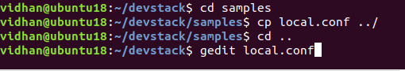

Steps-24:- Now let’s make changes into the local.conf file

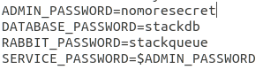

Changing the password for easy to remember:-

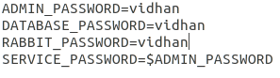

Hence, we have changed the admin password, database password and Rabbit password.

Now, after that we need to change the Host IP in the local.conf file.



Now to check your Ip > go to the Terminal (CTRL+ALT+T) and type “ip addr show” or “ip addr” then you would be able to see your Ip after “inet” (here :- 10.0.2.15) as shown below:

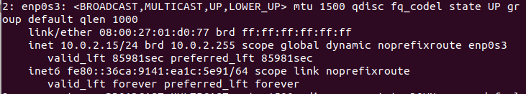

Step-25:- Now we write this Ip at Host Ip to change it and we also add Floating Range after it:-

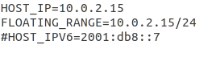

Hence, now we’re ready to install openstack cloud :-

Step-26: - Go to terminal again and type: **./stack.sh** (to start the Cloud installation)

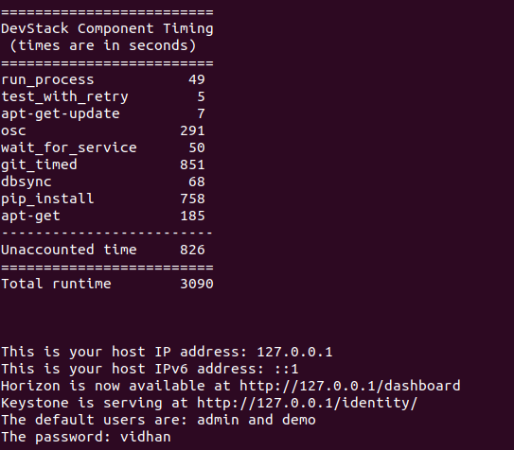

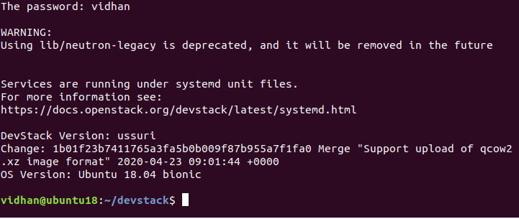

You can see your Host address and Horizon after a successful installation of open stack cloud.

Note that this horizon address (i.e 127.0.0.1/dashboard) will be used to log into the open stack cloud.

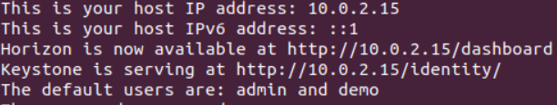

**Hence, we finally installed open stack cloud in ubuntu 18.04.**

Step-27: - Now we just open Firefox > type our horizon address> 127.0.0.1/dashboard (Press Enter) > We’ll be on Login Page as shown below: -

Step-28:- After Successfully Logged into the Open Stack :-

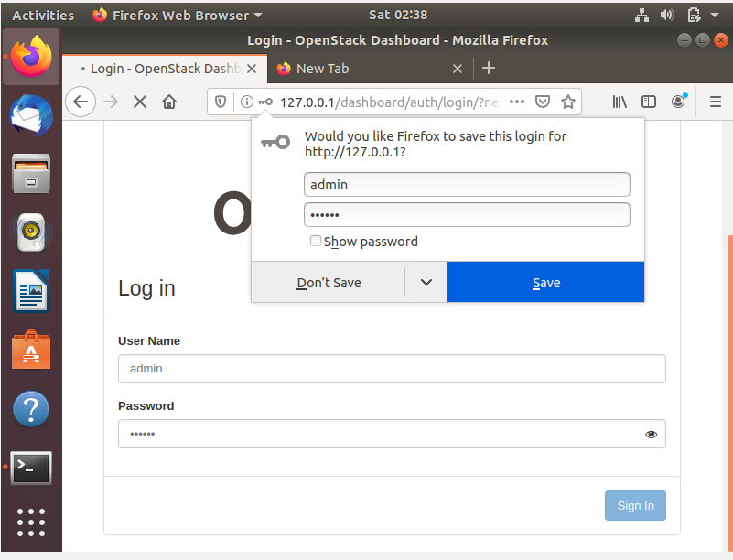

**Let’s make an Instance now by following given steps below:-**

**Step-29:-** Login With Your Username & Password That You Have Created. By Default There Are Two Usernames **admin** and **demo**. After Login You Will See Following Dashboard.

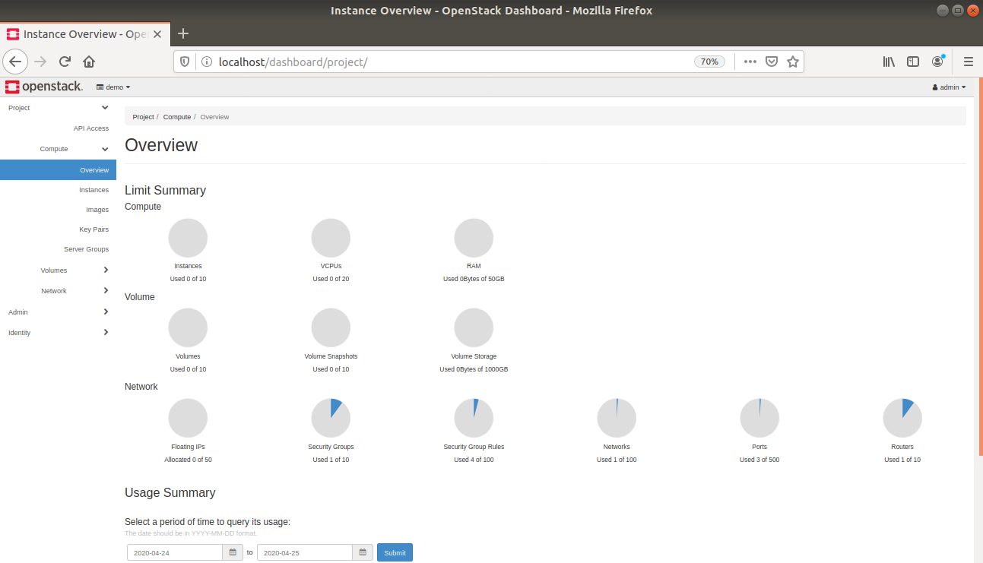

1. **Step 30:-** Now Click On “**Compute**” Then Click On “**Instances**” You Will See The Following Screen.
2. **Step-31:-** Now Click On The “**Launch Instance**” Button. The Following Pop-up Will Be Appeared.

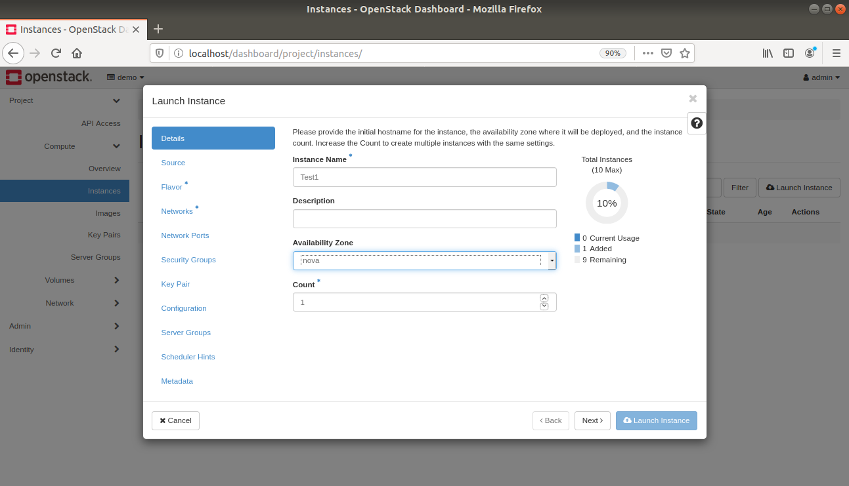

1. **Step-32:-** Then Select Source For Instance , Instance Image Etc. Click Next Button.

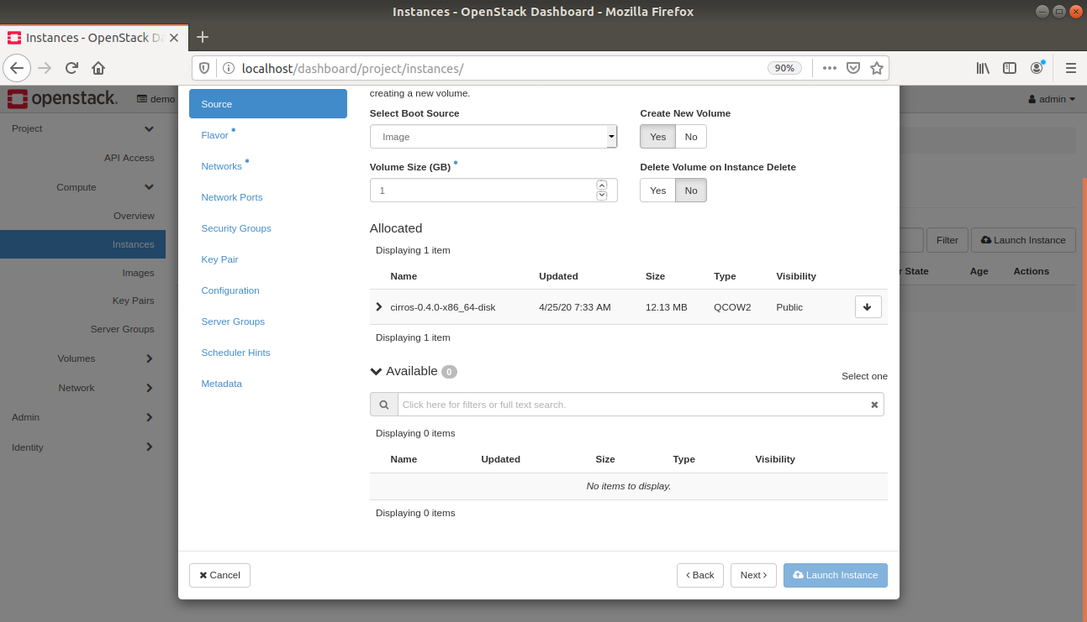

1. **Step-33:-** Select The Flavor Of The Instance. Click On Next.

**Step-33:-** Now Click on Launch Instance.

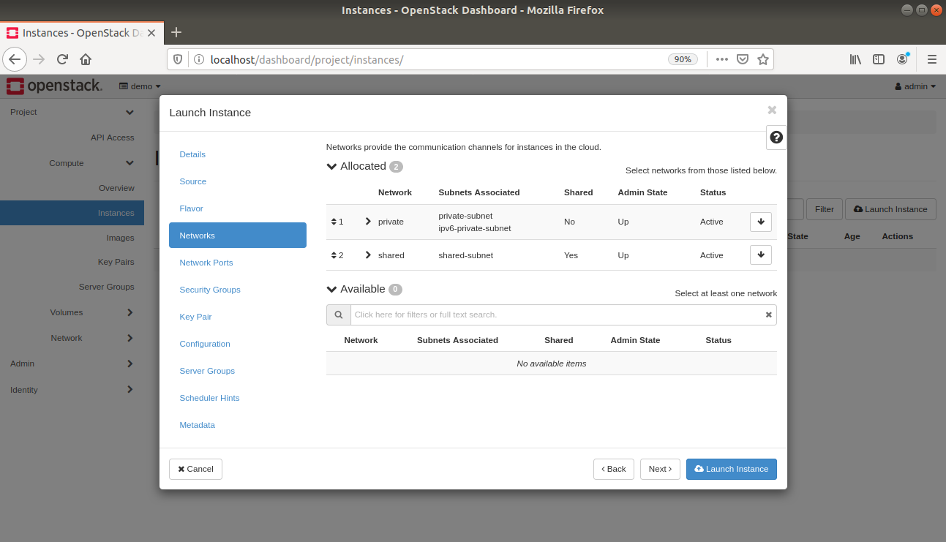

**Step-34:-** It Will Take 2-3 Minutes To Make Instance Working. After That Your Instance Is In Running State.

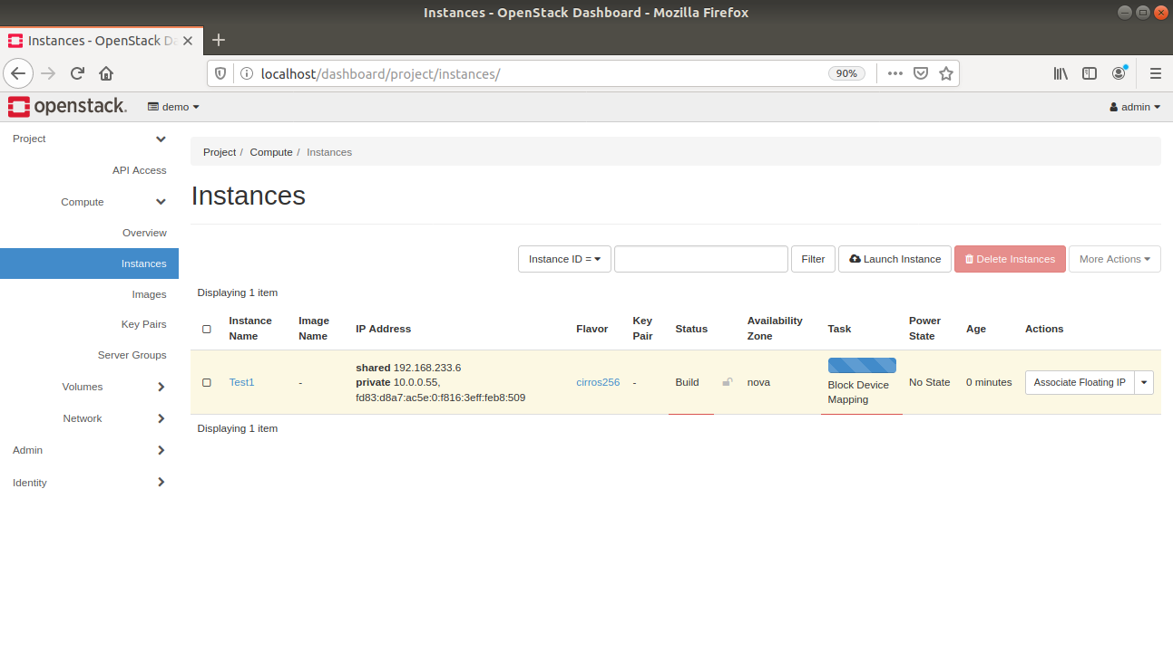

**Step-35:-** Now Click On Dropdown Arrow Right To Create Snapshot Button. Then Select “**View Log**”.

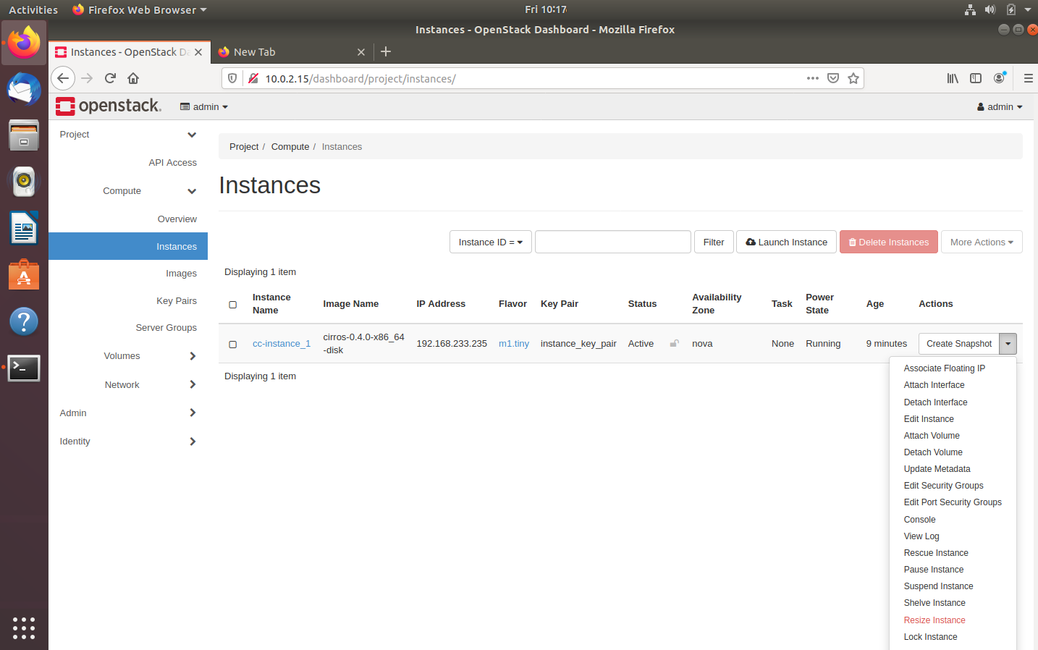

**Step-36:-** After That You Will See Following Screen. At The End Of That Make A Note Of user & password mentioned in the log. By Default User is **cirros** & password is **gocubsgo.** (In Case Of Cirros As Instance Image)

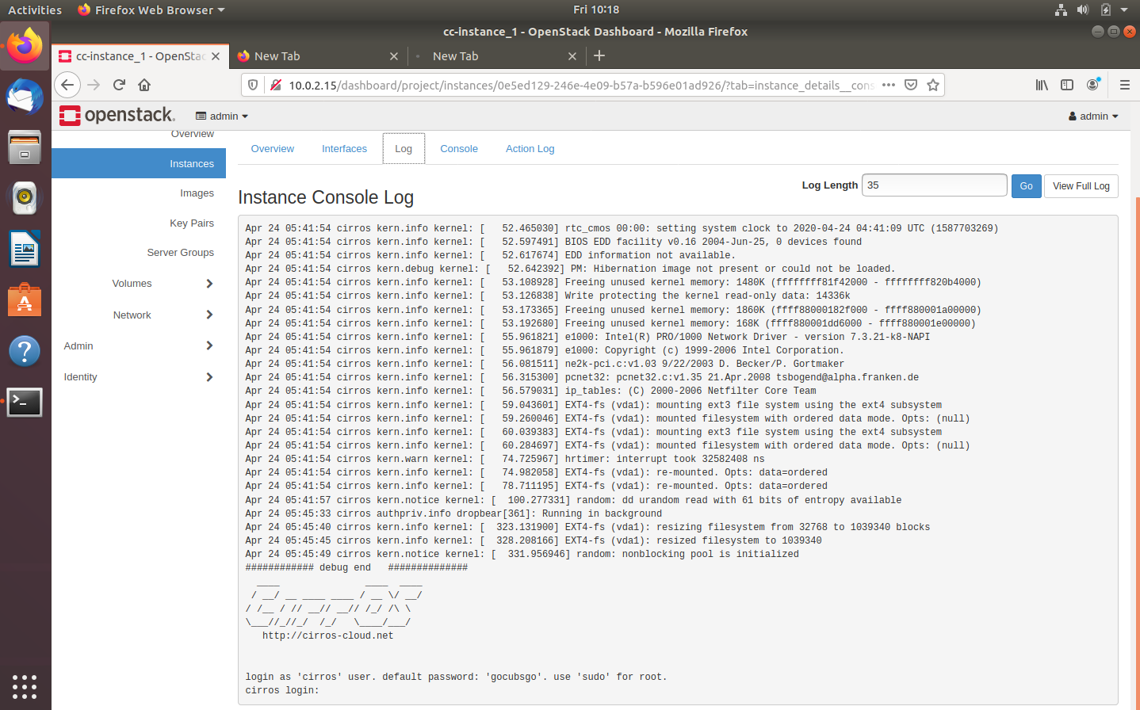

**Step 37:-** Now Click On Console in Top Navigation Bar To Access The Instance.



**Step 38:-** The Following Screen Will Appear.

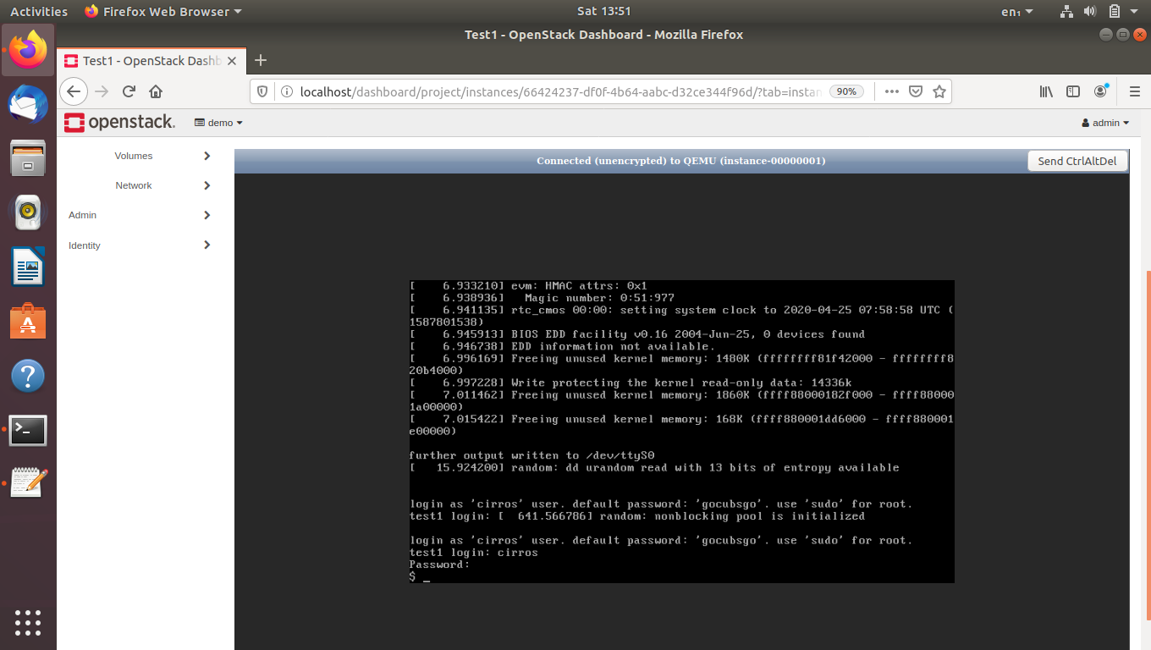

1. **Step-39:-** Write The Following Content:

echo “17012011029---- Dev”

echo “17012011049-----Hardavi ”

echo “17012011046----Vidhan”

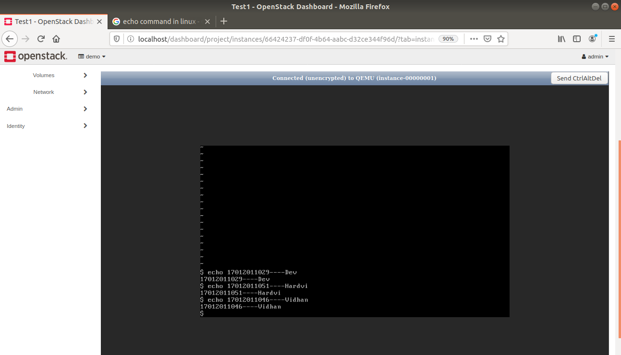

**Step-40:-** Now You Can See That Instance Is Working Completely Fine.

