|  |
| --- |
| **[ cLOUD COMPUTING ]** |
|  |

Practical: 2

**-:AIM:-**

**Java RMI Programming**

Submitted By: Dharmay Sureja

Enrollment No:17012011056



**GANPAT UNIVERSITY**

**U. V. Patel College of Engineering**

**Computer Engineering Department**

**AIM:- Java RMI Programming**

**Implementation of “Hello World” Service using Java RMI.**

**SampleClient.java:**

import java.rmi.*;

import java.rmi.server.*;

public class SampleClient

{

public static void main(String[] args)

{

// set the security manager for the client

// System.setSecurityManager(new RMISecurityManager());

//get the remote object from the registry

try

{

System.out.println("Security Manager loaded");

String url = "//localhost/SAMPLE-SERVER";

SampleServer remoteObject = (SampleServer)Naming.lookup(url);

System.out.println("Got remote object");

System.out.println(" 10 + 20 = " + remoteObject.sum(10,20) );

}

catch (RemoteException exc) {

System.out.println("Error in lookup: " + exc.toString()); }

catch (java.net.MalformedURLException exc) {

System.out.println("Malformed URL: " + exc.toString()); }

catch (java.rmi.NotBoundException exc) {

System.out.println("NotBound: " + exc.toString());

}

}

}

**SampleServer.java**

import java.rmi.*;

public interface SampleServer extends Remote

{

public int sum(int a,int b) throws RemoteException;

}

**SampleServerImpl.java**

import java.rmi.*;

import java.rmi.server.*;

import java.rmi.registry.*;

public class SampleServerImpl extends UnicastRemoteObject

implements SampleServer

{

SampleServerImpl() throws RemoteException

{

super();

}

public static void main(String args[])

{

try

{

// System.setSecurityManager(new RMISecurityManager());

//set the security manager

//create a local instance of the object

SampleServerImpl Server = new SampleServerImpl();

//put the local instance in the registry

Naming.rebind("SAMPLE-SERVER" , Server);

System.out.println("Server waiting.....");

}

catch (java.net.MalformedURLException me) {

System.out.println("Malformed URL: " + me.toString()); }

catch (RemoteException re) {

System.out.println("Remote exception: " + re.toString()); }

}

public int sum(int a,int b) throws RemoteException

{

return a + b;

}

}

**Step1:Compile all java Files**

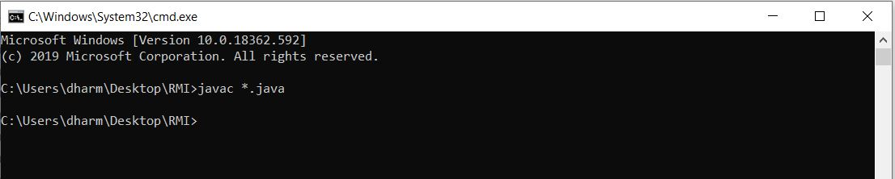

**Step2: Create stub file Using RMIC**

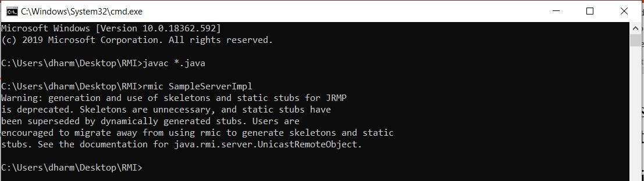

**Step3: Start the RMI Registry**

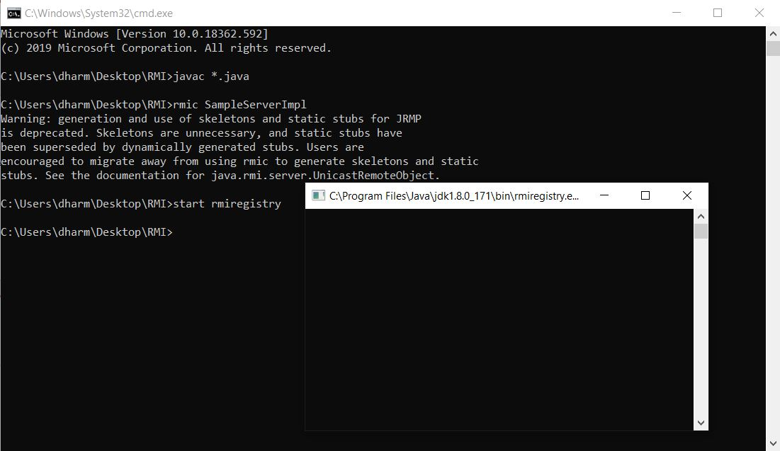

**Step 4: Start Server by executing SampleServerImpl file**

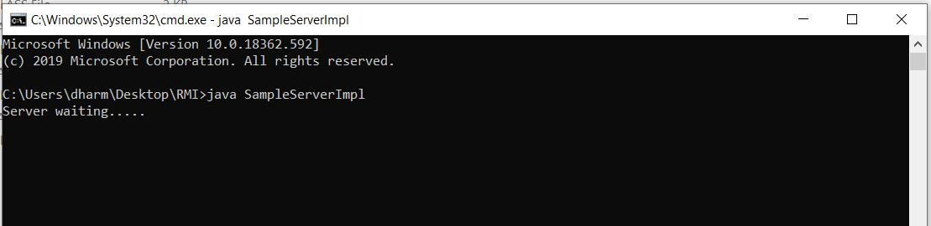

**Step 5:Execute Client file**

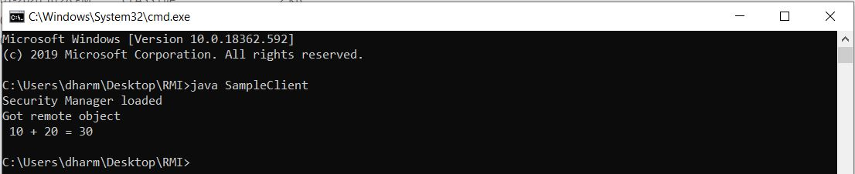

**Implementation of “GCD & LCM” Service using Java RMI.**

**SampleClient.java**

import java.rmi.*;

import java.rmi.server.*;

public class SampleClient

{

public static void main(String[] args)

{

// set the security manager for the client

// System.setSecurityManager(new RMISecurityManager());

int a=Integer.parseInt(args[0]);

int b=Integer.parseInt(args[1]);

//get the remote object from the registry

try

{

System.out.println("Security Manager loaded");

String url = "//localhost/SAMPLE-SERVER";

SampleServer remoteObject = (SampleServer)Naming.lookup(url);

System.out.println("Got remote object");

System.out.println(" GCD IS = " + remoteObject.gcd(a,b) );

System.out.println(" LCM IS = " + remoteObject.lcm(a,b) );

}

catch (RemoteException exc) {

System.out.println("Error in lookup: " + exc.toString()); }

catch (java.net.MalformedURLException exc) {

System.out.println("Malformed URL: " + exc.toString()); }

catch (java.rmi.NotBoundException exc) {

System.out.println("NotBound: " + exc.toString());

}

}

}

**SampleServer.java**

import java.rmi.*;

public interface SampleServer extends Remote

{

public int gcd(int a,int b) throws RemoteException;

public int lcm(int a,int b) throws RemoteException;

}

**SampleServerImpl.java**

import java.rmi.*;

import java.rmi.server.*;

import java.rmi.registry.*;

public class SampleServerImpl extends UnicastRemoteObject

implements SampleServer

{

SampleServerImpl() throws RemoteException

{

super();

}

public static void main(String args[])

{

try

{

// System.setSecurityManager(new RMISecurityManager());

//set the security manager

//create a local instance of the object

SampleServerImpl Server = new SampleServerImpl();

//put the local instance in the registry

Naming.rebind("SAMPLE-SERVER" , Server);

System.out.println("Server waiting.....");

}

catch (java.net.MalformedURLException me) {

System.out.println("Malformed URL: " + me.toString()); }

catch (RemoteException re) {

System.out.println("Remote exception: " + re.toString()); }

}

public int gcd(int a,int b) throws RemoteException

{

int gcd=1;

for(int i = 1; i <= a && i <= b; i++)

{

if(a%i==0 && b%i==0)

gcd = i;

}

return gcd;

}

public int lcm(int a,int b) throws RemoteException

{

int gcd=1;

for(int i = 1; i <= a && i <= b; i++)

{

if(a%i==0 && b%i==0)

gcd = i;

}

int lcm= (a*b)/gcd;

return lcm;

}

}

**Output:**

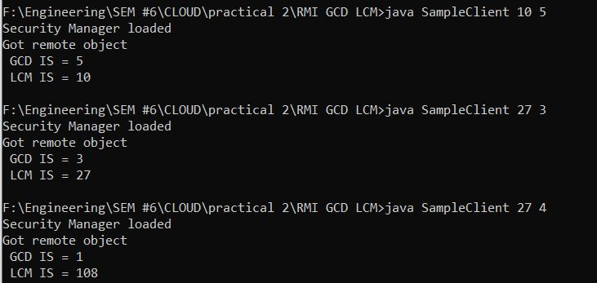

**Implementation of “Calculator” Service (Add, Sub, Mul, Div) using Java RMI.**

**SampleClient.java**

import java.rmi.*;

import java.rmi.server.*;

public class SampleClient

{

public static void main(String[] args)

{

// set the security manager for the client

// System.setSecurityManager(new RMISecurityManager());

int a=Integer.parseInt(args[0]);

int b=Integer.parseInt(args[1]);

//get the remote object from the registry

try

{

System.out.println("Security Manager loaded");

String url = "//localhost/SAMPLE-SERVER";

SampleServer remoteObject = (SampleServer)Naming.lookup(url);

System.out.println("Got remote object");

System.out.println(" a + b = " + remoteObject.sum(a,b) );

System.out.println(" a - b = " + remoteObject.sub(a,b) );

System.out.println(" a * b = " + remoteObject.mul(a,b) );

System.out.println(" a / b = " + remoteObject.div(a,b) );

System.out.println(" a % b = " + remoteObject.mod(a,b) );

}

catch (RemoteException exc) {

System.out.println("Error in lookup: " + exc.toString()); }

catch (java.net.MalformedURLException exc) {

System.out.println("Malformed URL: " + exc.toString()); }

catch (java.rmi.NotBoundException exc) {

System.out.println("NotBound: " + exc.toString());

}

}

}

**SampleServer.java**

import java.rmi.*;

public interface SampleServer extends Remote

{

public int sum(int a,int b) throws RemoteException;

public int sub(int a,int b) throws RemoteException;

public int mul(int a,int b) throws RemoteException;

public int div(int a,int b) throws RemoteException;

public int mod(int a,int b) throws RemoteException;

}

**SampleServerImpl.java**

import java.rmi.*;

import java.rmi.server.*;

import java.rmi.registry.*;

public class SampleServerImpl extends UnicastRemoteObject

implements SampleServer

{

SampleServerImpl() throws RemoteException

{

super();

}

public static void main(String args[])

{

try

{

// System.setSecurityManager(new RMISecurityManager());

//set the security manager

//create a local instance of the object

SampleServerImpl Server = new SampleServerImpl();

//put the local instance in the registry

Naming.rebind("SAMPLE-SERVER" , Server);

System.out.println("Server waiting.....");

}

catch (java.net.MalformedURLException me) {

System.out.println("Malformed URL: " + me.toString()); }

catch (RemoteException re) {

System.out.println("Remote exception: " + re.toString()); }

}

public int sum(int a,int b) throws RemoteException

{

return a + b;

}

public int sub(int a,int b) throws RemoteException

{

return a - b;

}

public int mul(int a,int b) throws RemoteException

{

return a * b;

}

public int div(int a,int b) throws RemoteException

{

return a / b;

}

public int mod(int a,int b) throws RemoteException

{

return a % b;

}

}

