|  |
| --- |
| **[ cLOUD COMPUTING ]** |
|  |

Practical: 7

**-:AIM:-**

**Configuration of OpenNebula Cloud**

Submitted By: Dharmay Sureja

Enrollment No:17012011056



**GANPAT UNIVERSITY**

**U. V. Patel College of Engineering**

**Computer Engineering Department**

**AIM:- Configuration of OpenNebula Cloud**

**Requirements:-**

CentOS 8 or Ubuntu 18.04

**Steps:-**

If you are performing this on Virtual Box First Enable Nested Virtualization by performing this code to cmd

Open CMD to VirtualBox’s install path:

VBoxManage modifyvm **“YourVirtualBoxName”** --nested-hw-virt on

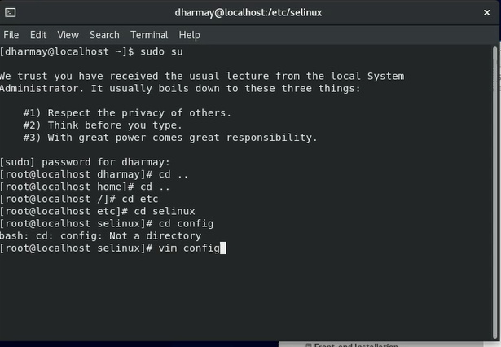

Disable SELINUX

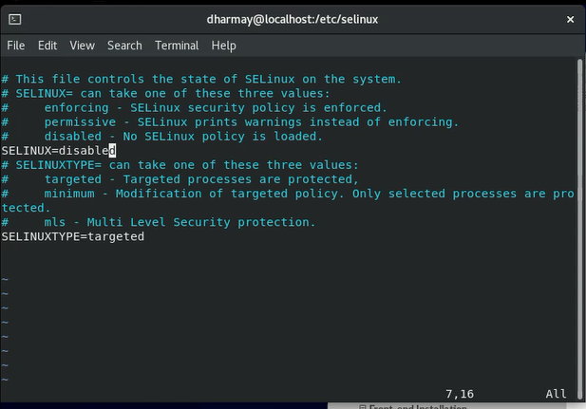

Add Opennebula Repository:

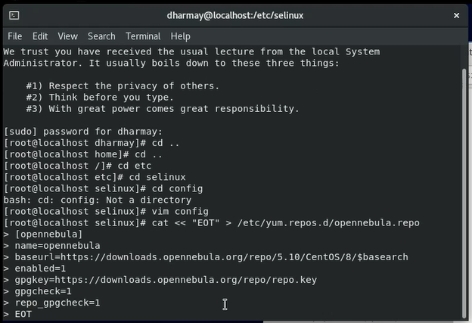

Install Opennebula

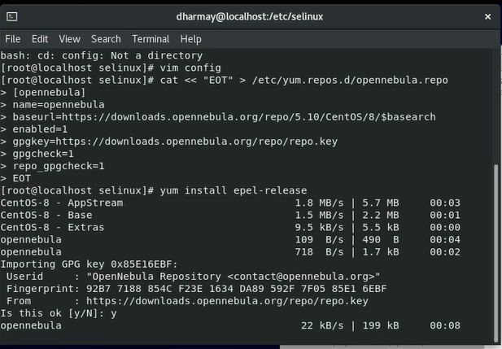

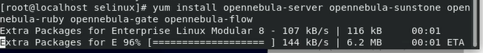

Install gems:



Set user oneadmin’s UNIX password:



Set Opennebula’s Oneadmin login password: (here “123456” is password)



NOW LOGIN TO ONEADMIN USER and proceed further.

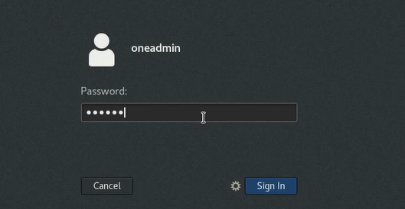

Start Opennebula and opennebula suntone:



Check oneuser status:

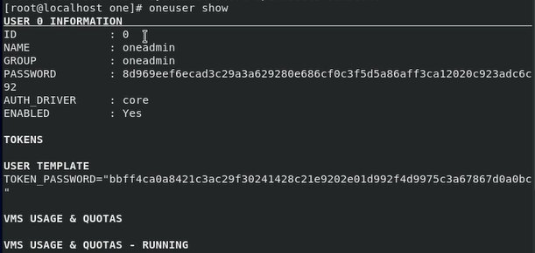

Open Browser and open url <https://localhost:9869>

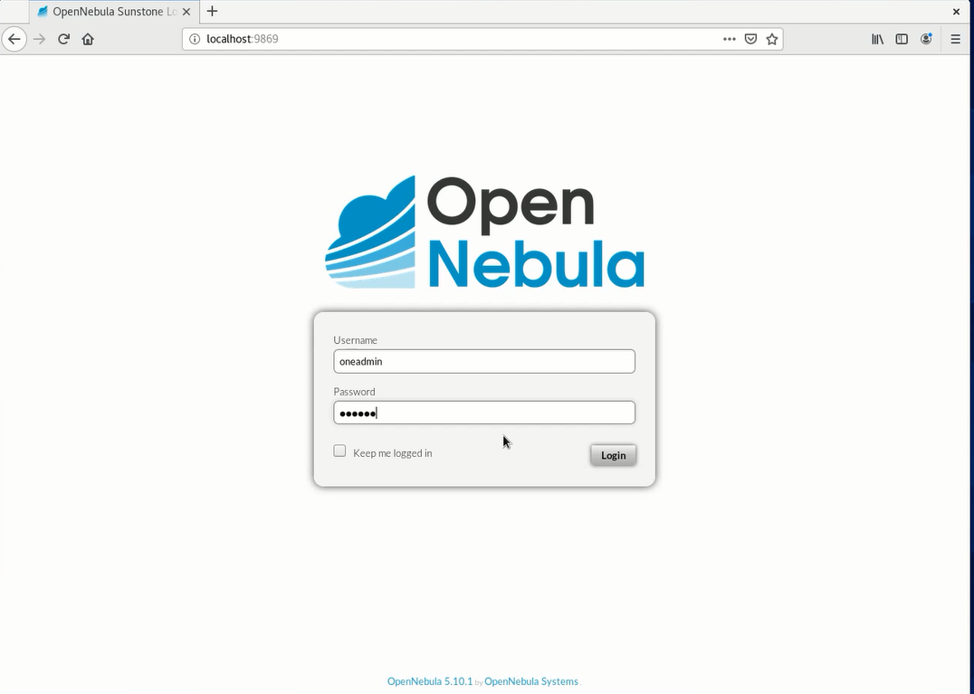

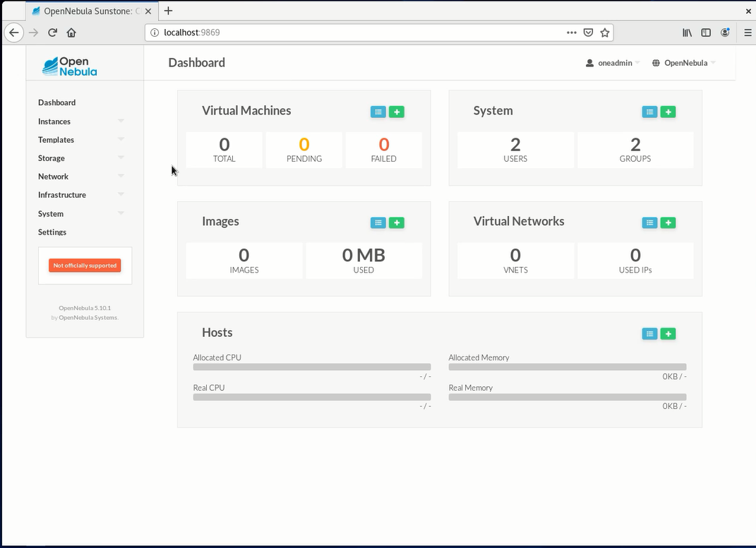

Now Login back to default user and install KVM node by adding it to repository :

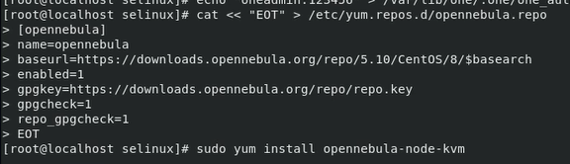

After successful installation of KVM restart it :

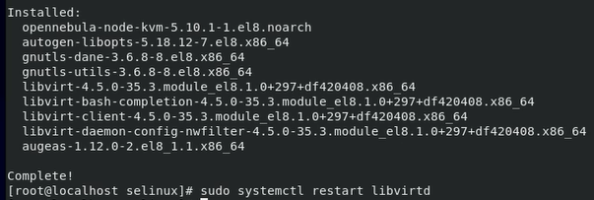

NOW, we have to configure passwordless ssh for that note the ip address of ONEADMIN user:

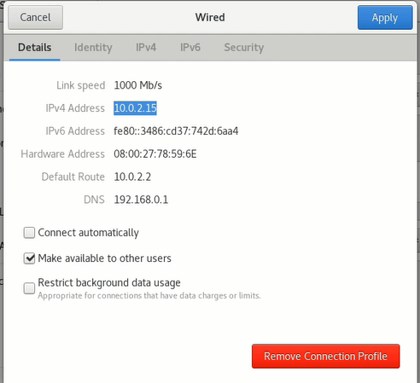

Make changes to this file:



Add ip of ONEADMIN user:

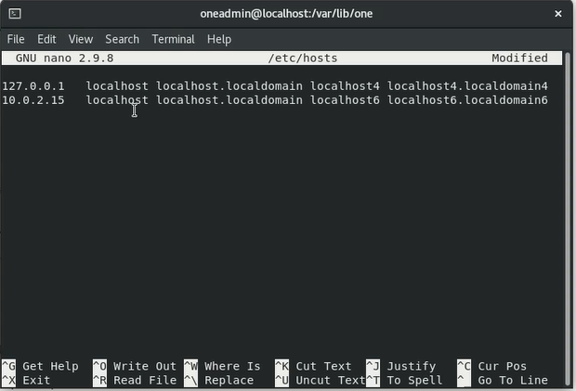

Now we have to copy ssh files:

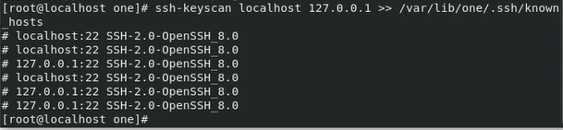

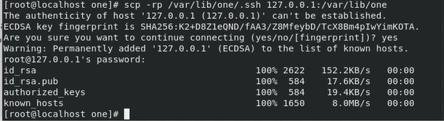

Now create host :

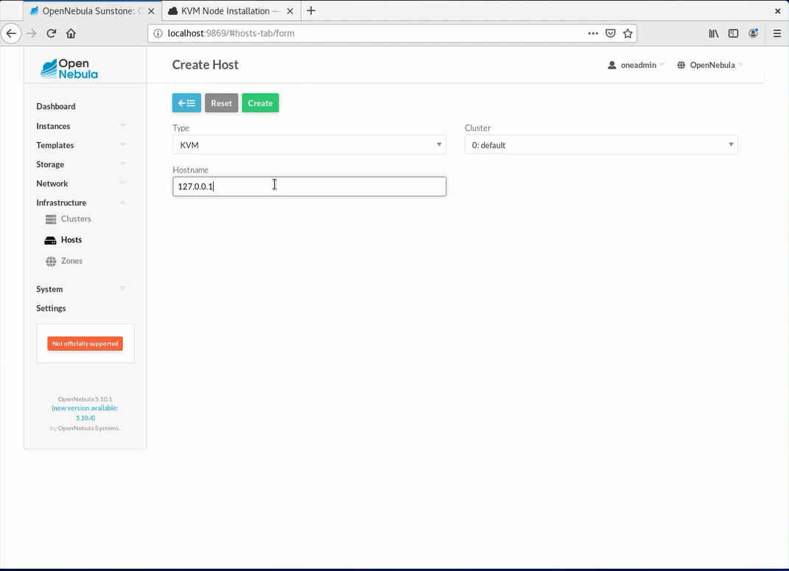

Wait until status is “ON”

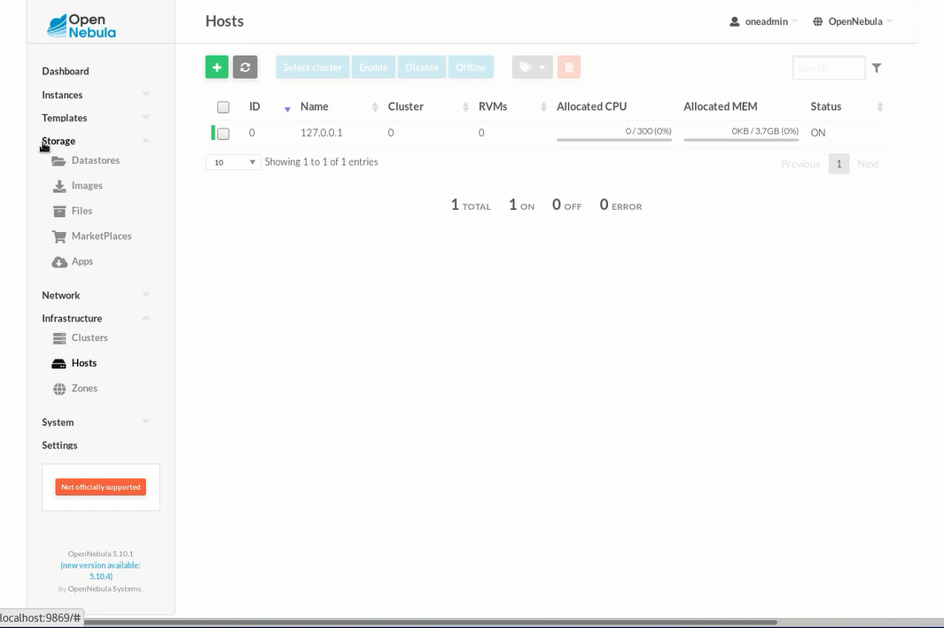

NOW goto apps and find tty-linux image:

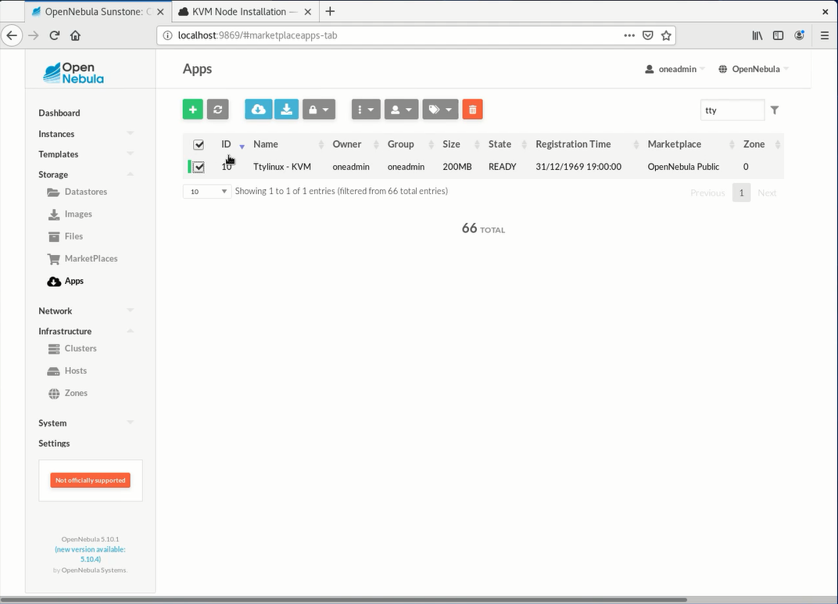

Download it

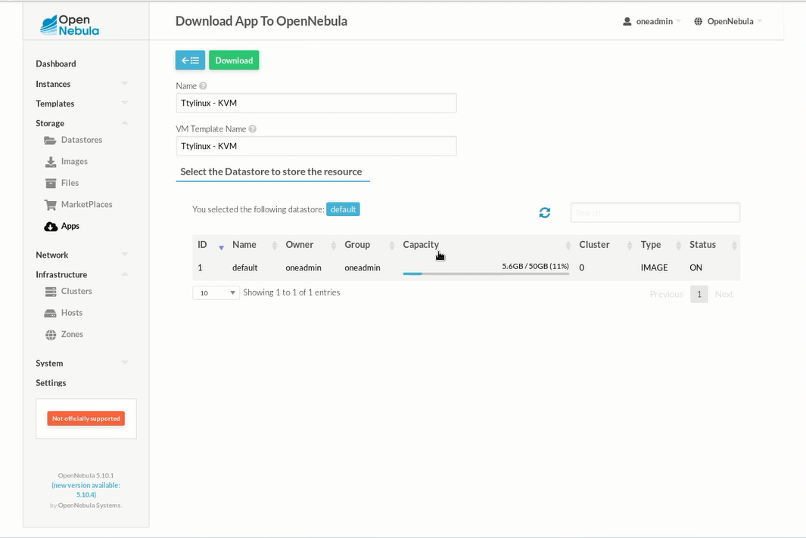

After successfully downloading goto TEMPLATES > VMs.

A VM template should be created automatically

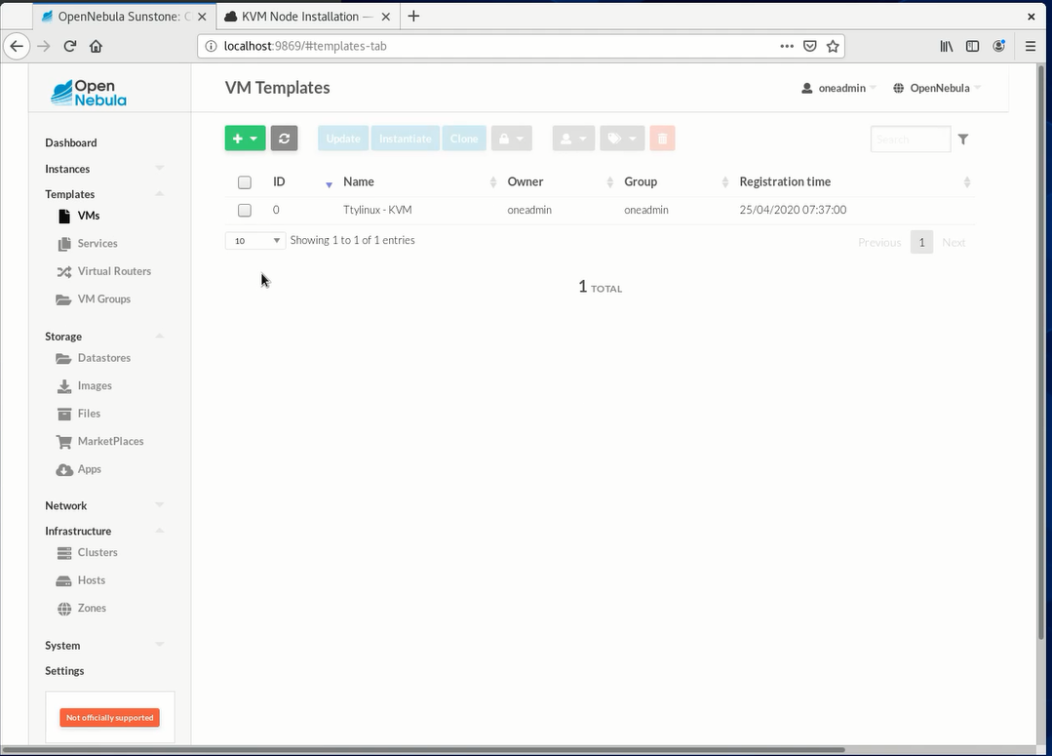

Now Goto instances and create virtual machine instance:

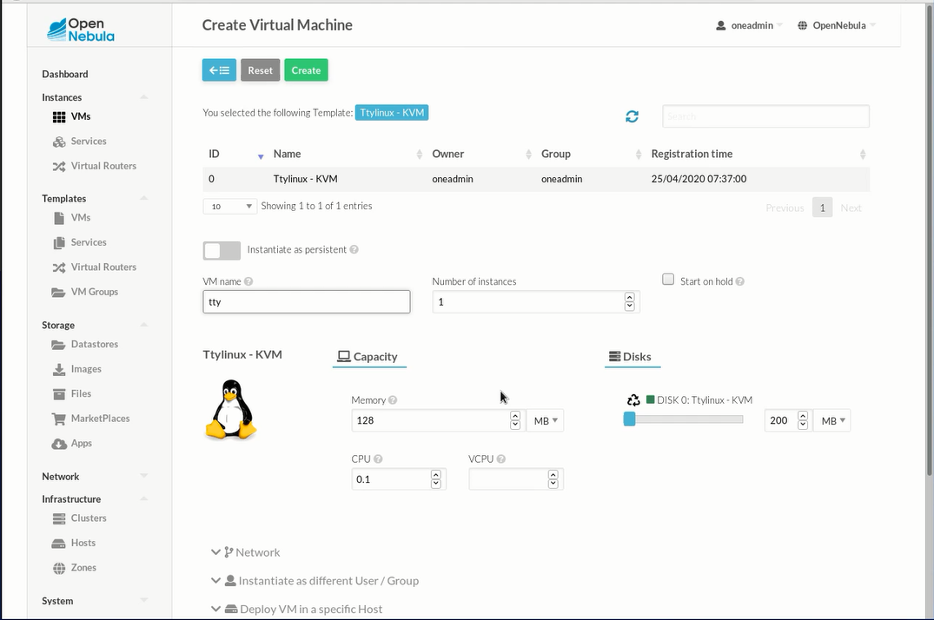

After a while status will be running:

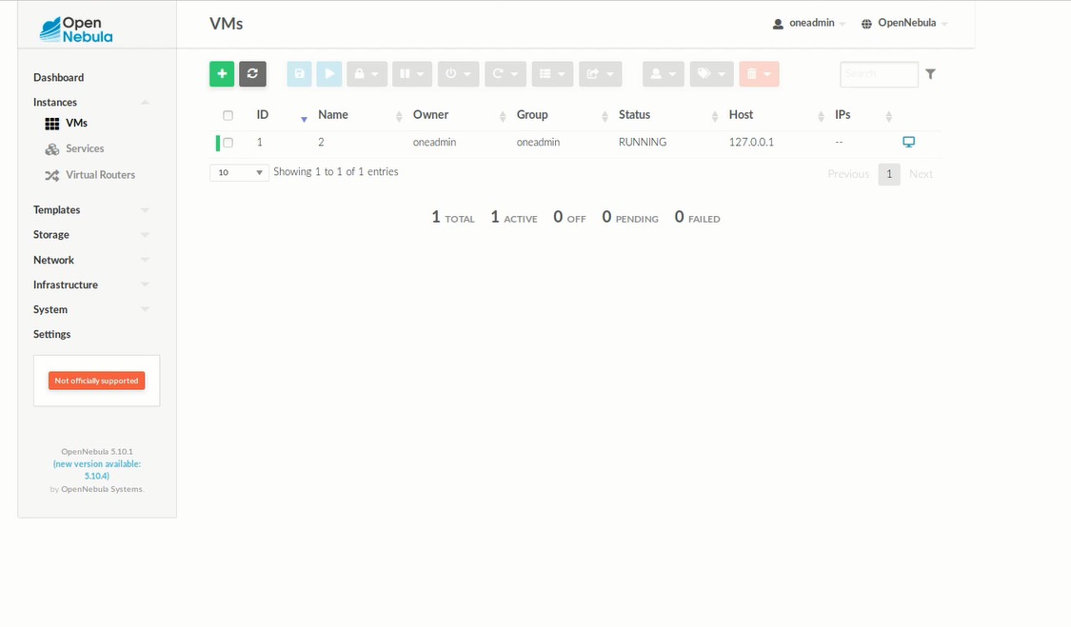

Click on this button To open VNC:

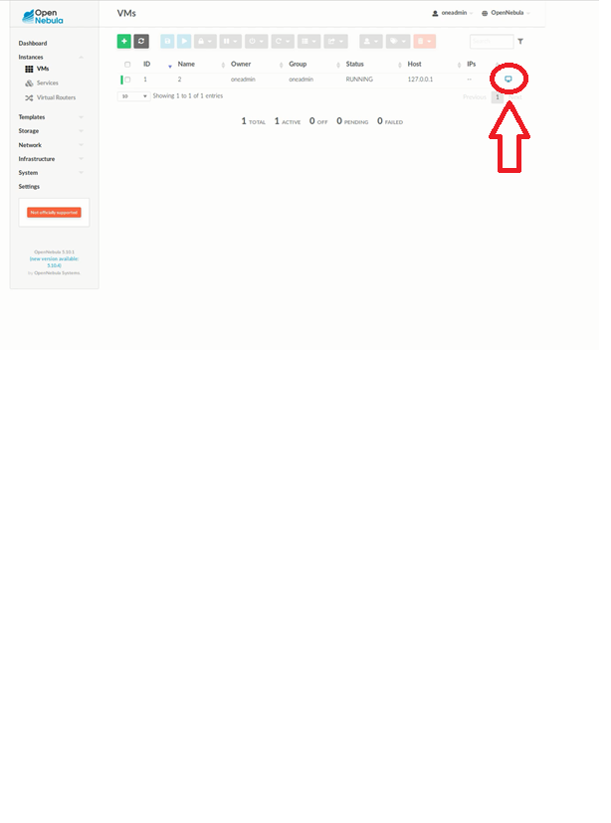

TTY linux will be booted and this will be output:

