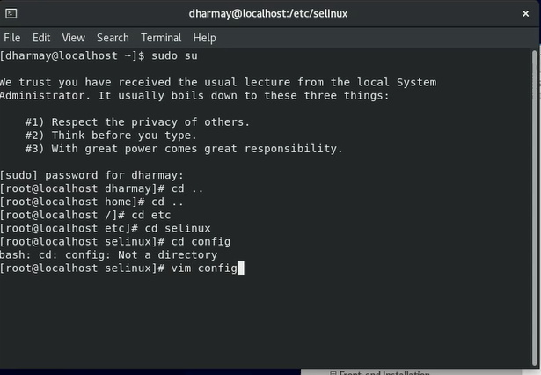

Disable SELINUX

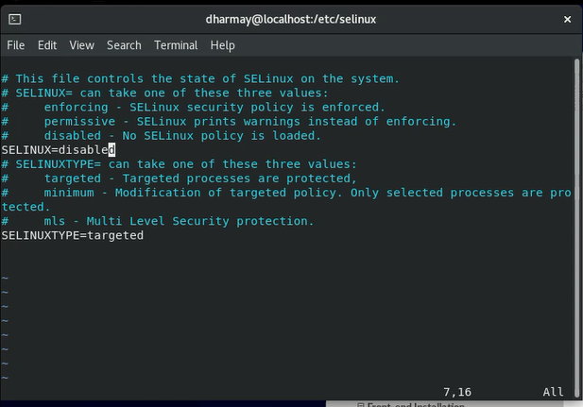

Add Opennebula Repository:

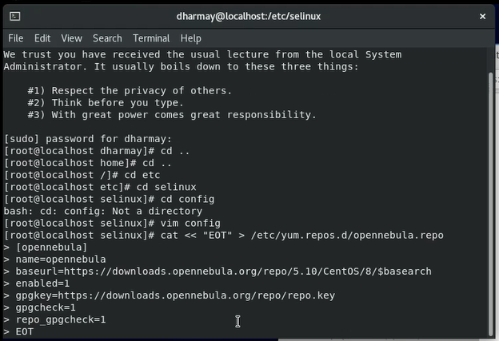

Install Opennebula

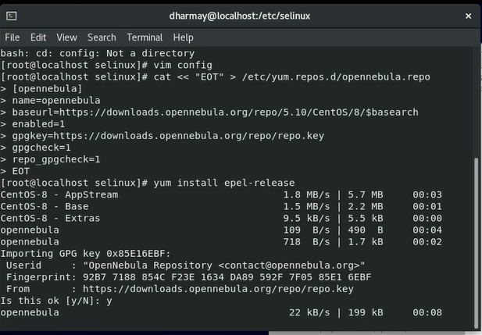

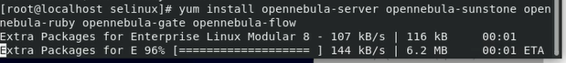

Install gems:



Set user oneadmin’s UNIX password:



Set Opennebula’s Oneadmin login password: (here “123456” is password)



NOW LOGIN TO ONEADMIN USER and proceed further.

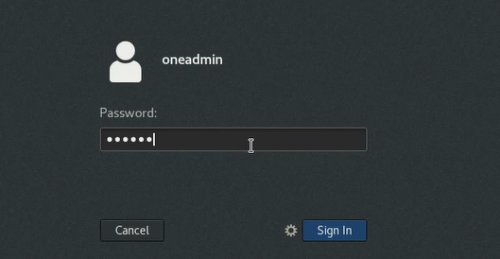

Start Opennebula and opennebula suntone:



Check oneuser status:

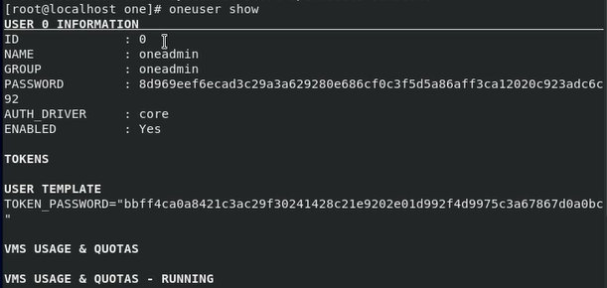

Open Browser and open url <https://localhost:9869>

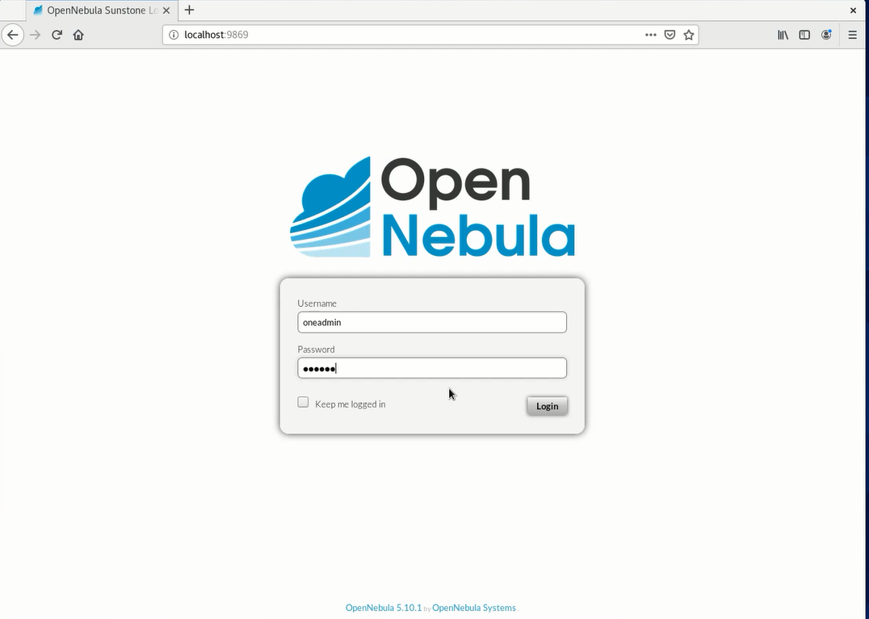

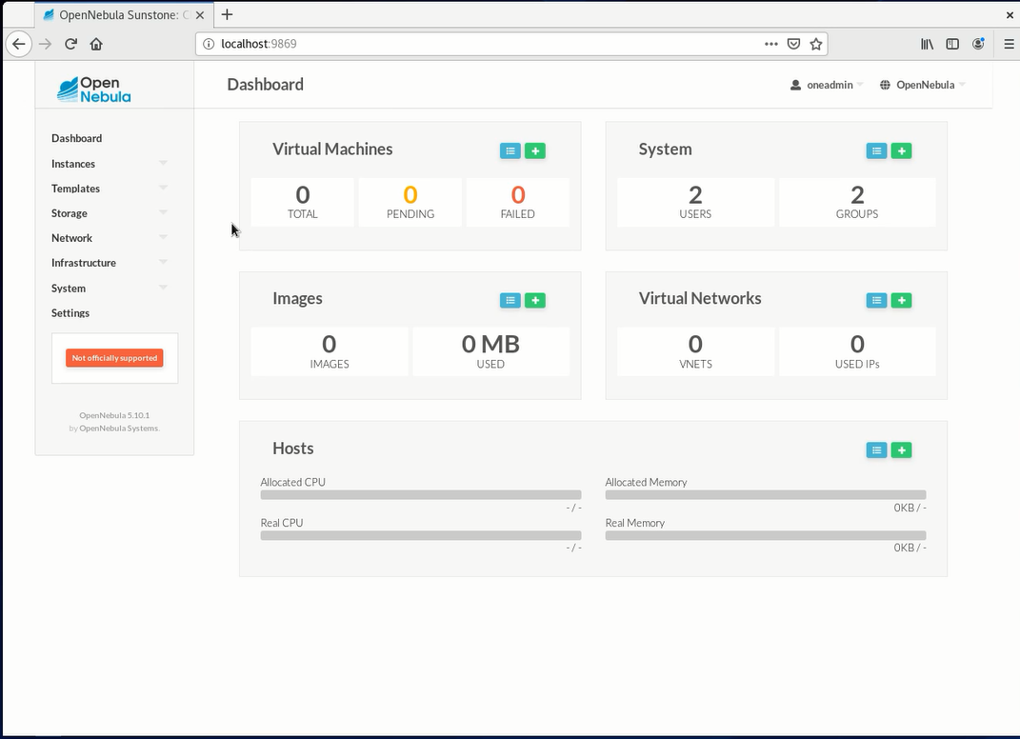

Now Login back to default user and install KVM node by adding it to repository :

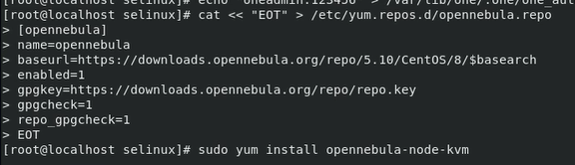

After successful installation of KVM restart it :

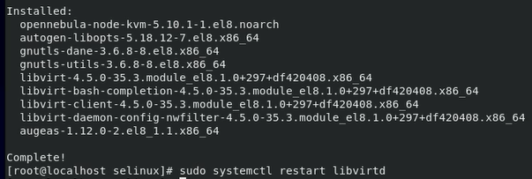

NOW, we have to configure passwordless ssh for that note the ip address of ONEADMIN user:

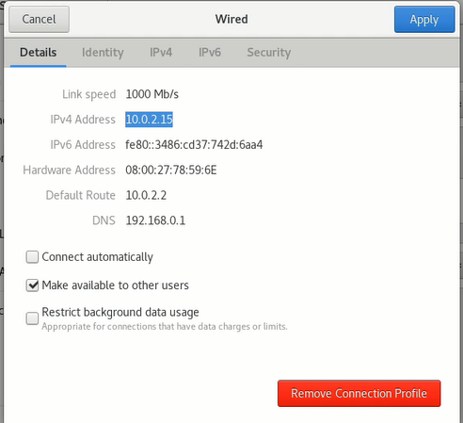

Make changes to this file:



Add ip of ONEADMIN user:

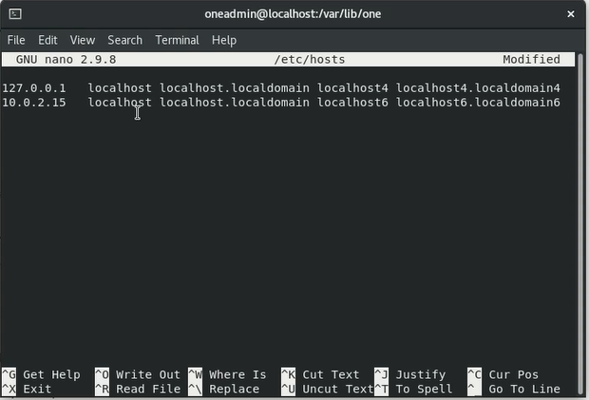

Now we have to copy ssh files:

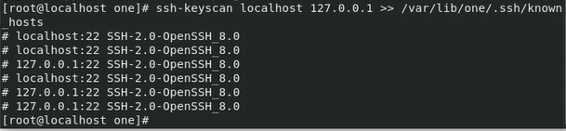

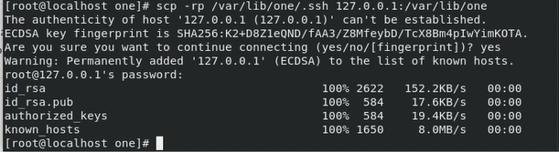

Now create host :

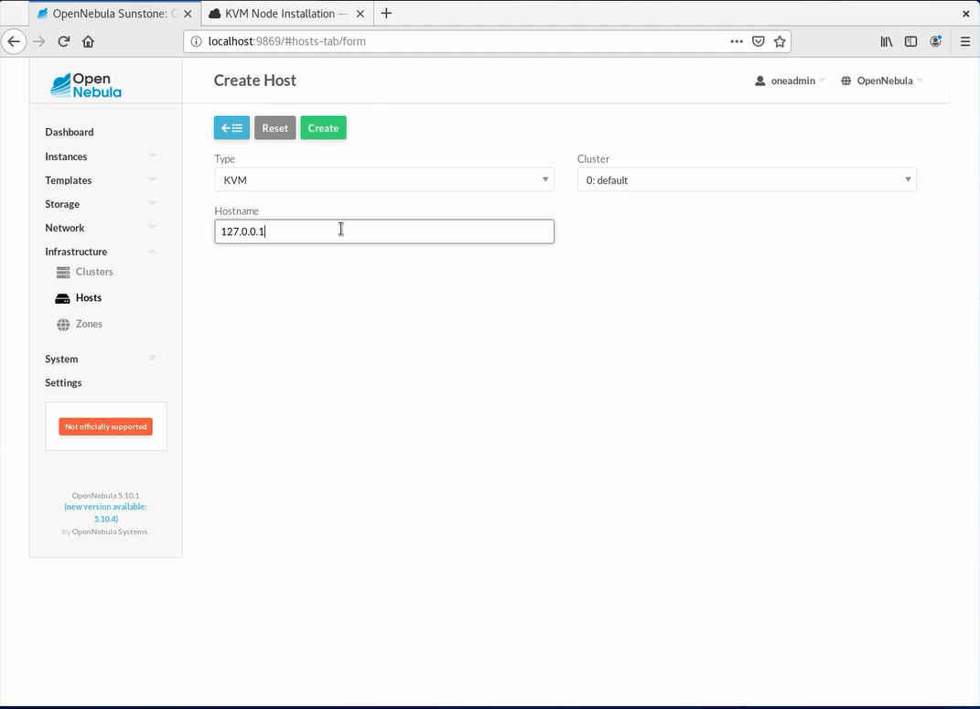

Wait until status is “ON”

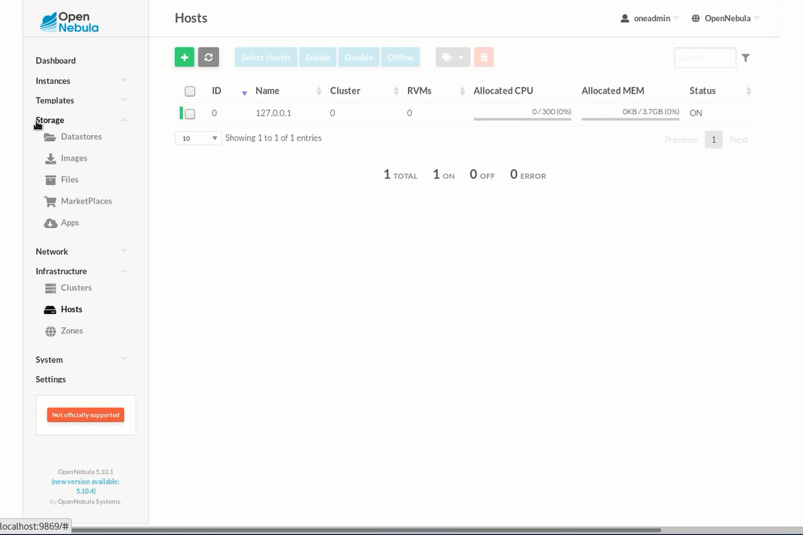

NOW goto apps and find tty-linux image:

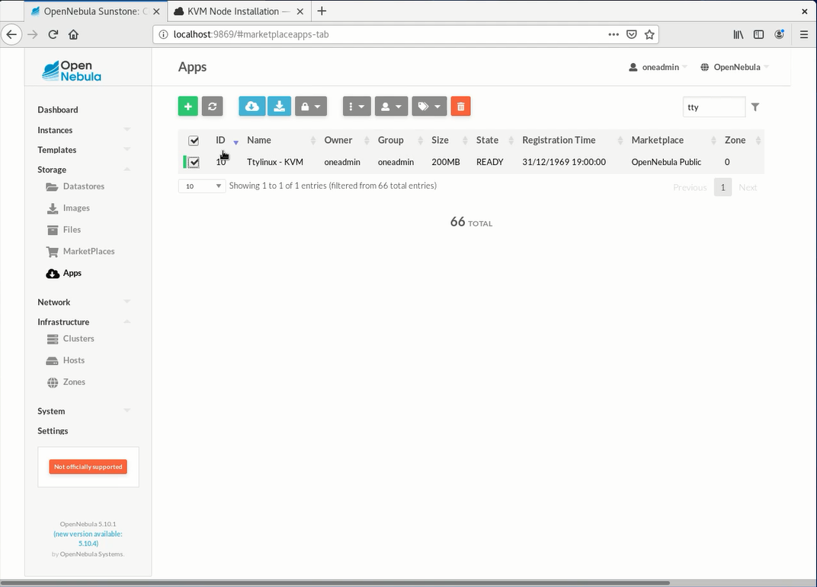

Download it

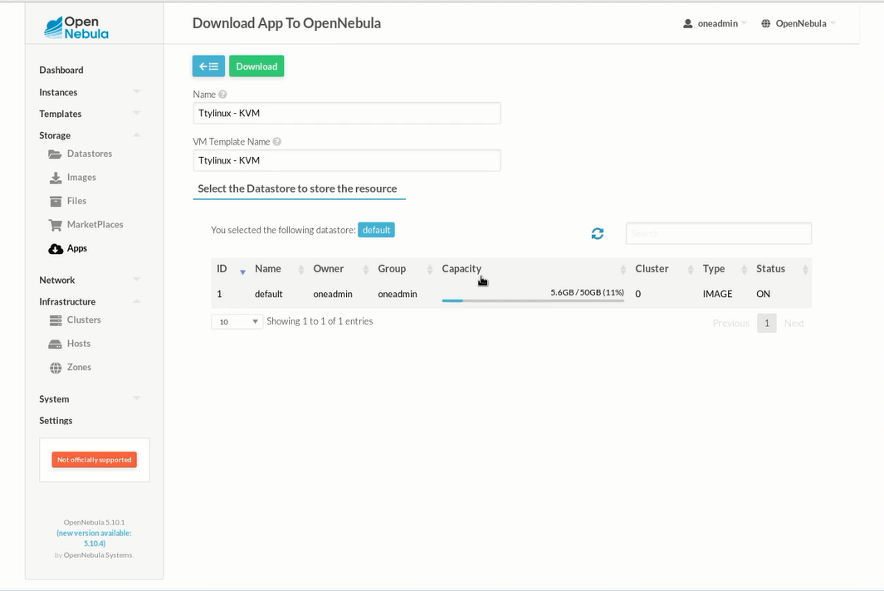

After successfully downloading goto TEMPLATES > VMs.

A VM template should be created automatically

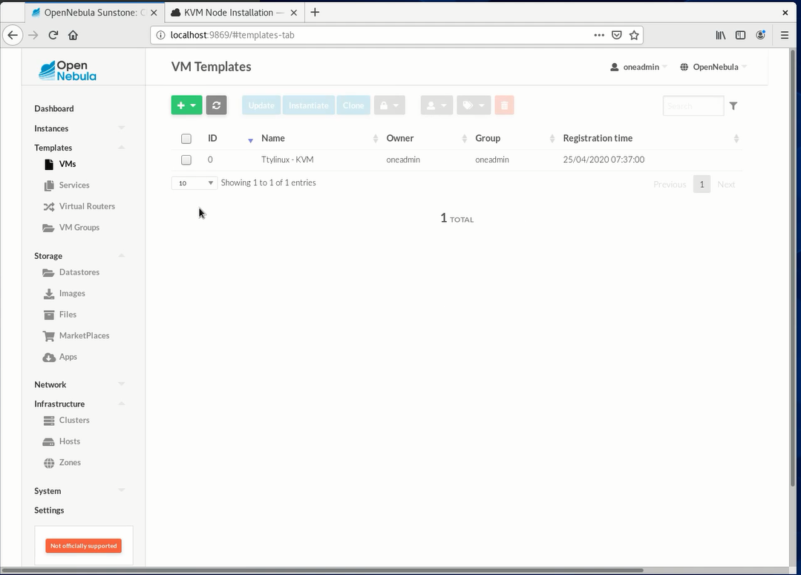

Now Goto instances and create virtual machine instance:

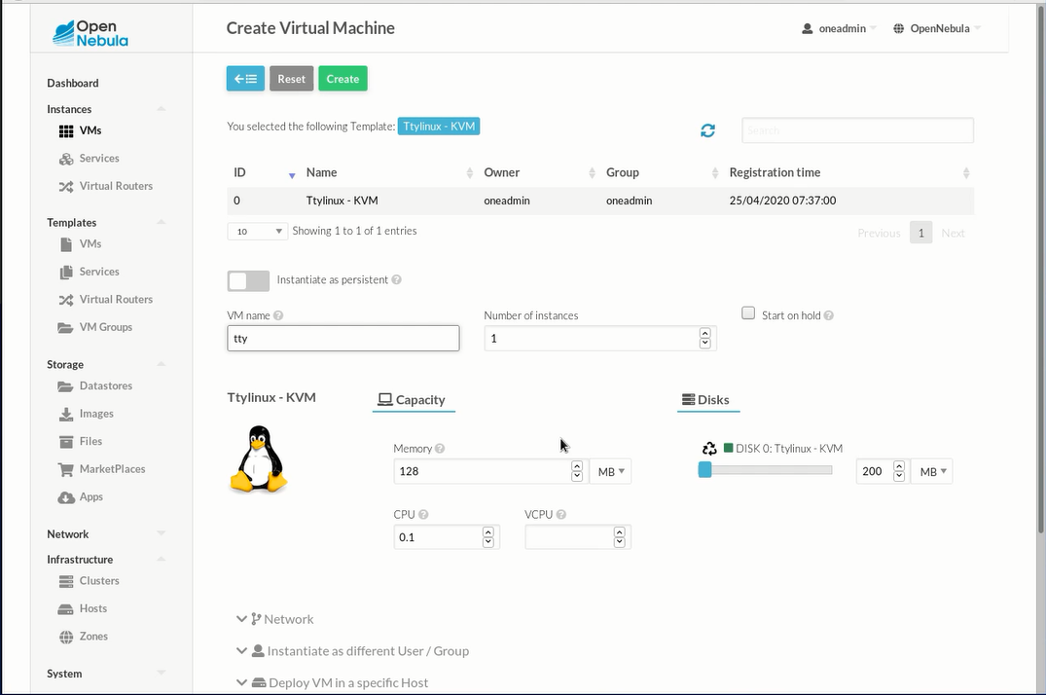

After a while status will be running:

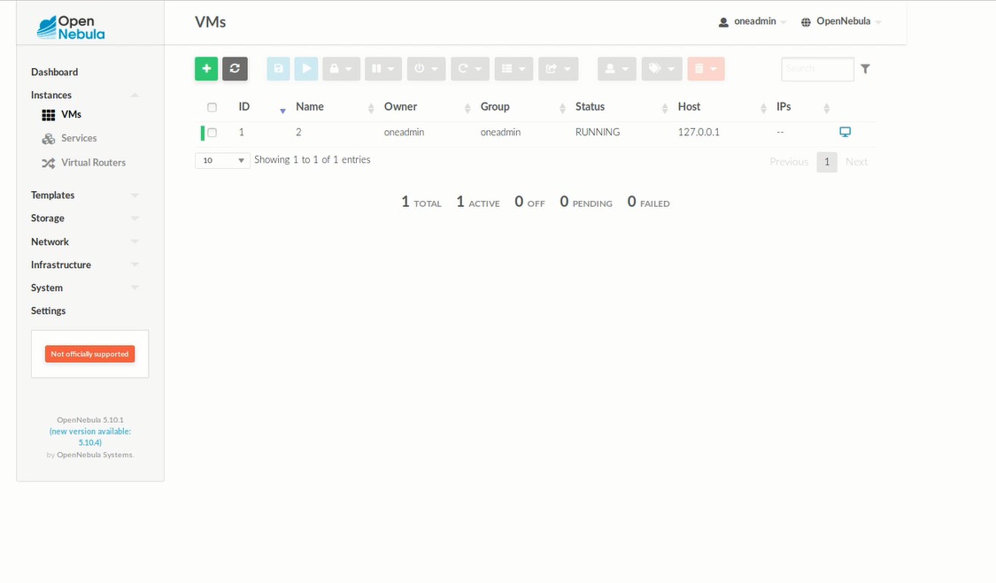

Click on this button To open VNC:

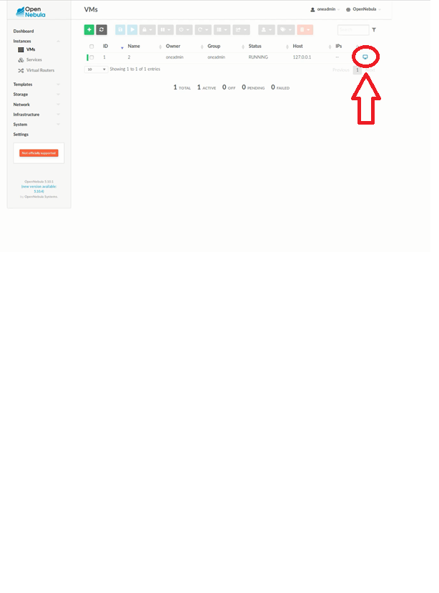

TTY linux will be booted and this will be output:

