**ASSIGNMENT -1**

1. **What is a service level agreement? How does it help the service level management process?**

A Service Level Agreement (SLA) is a formal contract between a service provider and a client that specifies the expected level of service, performance metrics, and responsibilities. It includes metrics such as uptime, response time, and resolution time, and outlines the remedies or penalties for not meeting these standards.

**How SLAs Help in Service Level Management:**

* **Set Clear Expectations:** SLAs define service standards, helping clients know what to expect and providers know what to deliver.
* **Performance Measurement:** They provide measurable criteria to evaluate the performance of the service.
* **Accountability:** SLAs hold service providers accountable for their performance, fostering trust and reliability.
* **Dispute Resolution:** They offer a framework for resolving disputes regarding service levels.

**Diagram: SLA Components**

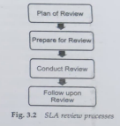

1. **Discuss the difference between service level and operational level agreements.**

**Service Level Agreement (SLA):**

* **Purpose:** Agreement between a service provider and an external customer.
* **Focus:** Defines the expected level of service.
* **Scope:** Covers external services provided to customers.
* **Metrics:** Includes service performance metrics like uptime, response time.

**Operational Level Agreement (OLA):**

* **Purpose:** Agreement between internal departments within an organization.
* **Focus:** Supports the SLA by defining internal service support.
* **Scope:** Covers internal processes and support required to meet the SLA.
* **Metrics:** Includes internal performance metrics relevant to service support.

**Diagram: Relationship Between SLA and OLA**

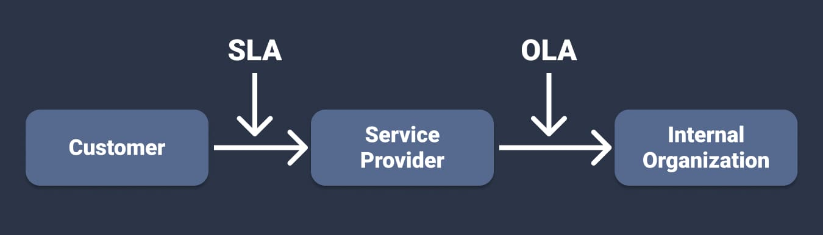

1. **What are the important steps involved in the implementation of service level management?**

**Steps in Implementing Service Level Management:**

1. **Define Services:** Identify and document the services to be managed.
2. **Identify Stakeholders:** Determine who will be impacted by the service and who will contribute.
3. **Draft SLAs and OLAs:** Develop agreements that specify service levels and internal support.
4. **Monitor Performance:** Set up tools and processes to measure service performance.
5. **Review Performance:** Regularly review performance data against SLA metrics.
6. **Report Performance:** Communicate performance data to stakeholders.
7. **Service Review Meetings:** Conduct regular meetings to discuss performance and improvements.
8. **Continuous Improvement:** Use feedback and performance data to enhance service quality.

**Diagram: Service Level Management Process**

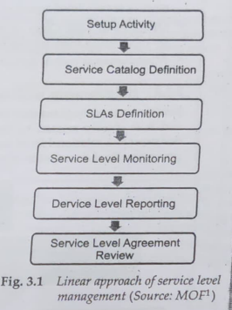

1. **What are the important cost factors involved in the implementation of service level management in an organization?**

**Cost Factors in Implementing Service Level Management:**

* **Initial Setup Costs:** Investment in tools and technology for monitoring and reporting.
* **Training Costs:** Expenses for training staff on SLA management and tools.
* **Ongoing Monitoring Costs:** Costs associated with continuous service performance monitoring.
* **Review and Audit Costs:** Regular costs for conducting service reviews and audits.
* **Infrastructure Improvement Costs:** Investments needed to meet SLA standards.
* **Penalty Costs:** Potential costs incurred from failing to meet SLA targets.

**Diagram: Cost Factors in SLM Implementation**

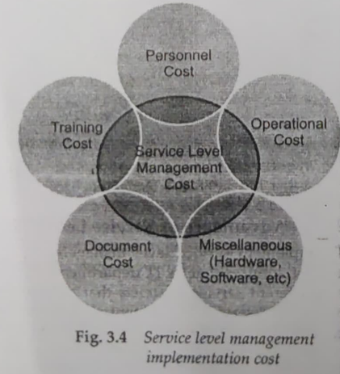

1. **Discuss two popular methods used for budget preparation.**

**Incremental Budgeting:**

* **Method:** Adjusts the previous year’s budget by a set increment.
* **Advantages:** Simple, easy to implement, stable.
* **Disadvantages:** May not encourage cost efficiency, can perpetuate inefficiencies.

**Zero-Based Budgeting:**

* **Method:** Starts from a zero base; every expense must be justified.
* **Advantages:** Promotes efficient resource allocation, encourages cost reduction.
* **Disadvantages:** Time-consuming, requires detailed analysis.

1. **How does financial management benefit an organization? What are the cost factors included in its implementation?**

**Benefits of Financial Management:**

* **Efficient Resource Allocation:** Ensures resources are used effectively.
* **Profitability Improvement:** Helps in maximizing profits through cost control.
* **Risk Management:** Identifies and mitigates financial risks.
* **Strategic Decision Making:** Provides financial insights for informed decisions.
* **Transparency and Accountability:** Enhances financial transparency and accountability.

**Cost Factors in Implementation:**

* **Financial Management Software:** Costs for purchasing and maintaining software.
* **Training Costs:** Training staff in financial management practices.
* **Audit and Compliance Costs:** Regular financial audits and compliance with regulations.
* **Consultancy Fees:** Costs for financial planning and analysis consulting.

1. **What are the advantages of financial management?**

**Advantages:**

* **Resource Optimization:** Ensures optimal use of financial resources.
* **Cost Control:** Helps in monitoring and controlling costs.
* **Profit Maximization:** Aims at improving the profitability of the organization.
* **Risk Mitigation:** Identifies and manages financial risks effectively.
* **Informed Decision Making:** Provides accurate financial data for strategic decisions.

1. **Discuss the relationship of financial management to other processes.**

**Relationships:**

* **Operational Management:** Provides financial data for operational planning and control.
* **Human Resource Management:** Involves budgeting for employee salaries, training, and benefits.
* **Strategic Management:** Aligns financial resources with strategic goals and initiatives.
* **Risk Management:** Works to identify, assess, and mitigate financial risks.

**Diagram: Financial Management Interrelationships**

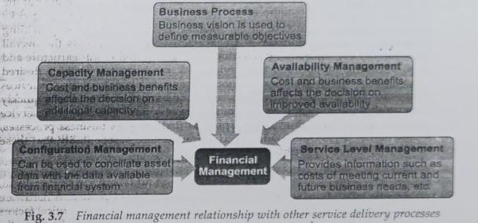

1. **Explain failover and restoration processes of IT service continuity management with suitable examples.**

IT service continuity management ensures that services are available in case of a service interruption, regardless of the cause of the disruption. It involves two main processes: failover and restoration.

**Failover Process:**

* **Definition:** Failover is the act of automatically or manually moving the operations of a component from its primary location to a secondary location. This ensures continuous service availability despite the failure of the primary component.
* **Example 1 (Automatic Failover):** Assume a computer has dual redundant power supplies. During normal operation, each supply provides half of the power required by the system. If one of the supplies fails or goes offline, the other automatically takes over and supplies all the power needed by the system. This is an example of automatic failover.
* **Example 2 (Manual Failover):** Consider a data center site that gets destroyed by a natural calamity. In this situation, the entire IT infrastructure must be recreated at a new location, requiring manual intervention. This comes under manual failover.

**Restoration Process:**

* **Definition:** Restoration involves bringing the operation of a component back from the secondary location to the primary location. This process is crucial and must be handled carefully when creating a contingency plan.
* **Example:** After a failover to a backup server, the primary server is repaired and restored. Once the primary server is fully operational again, operations are switched back to the primary server.

Organizations often have detailed plans for moving services to a backup location in case of an emergency, but they rarely have plans to restore the service back to the original location when the time comes. Proper planning for both failover and restoration is essential for effective IT service continuity management.

**Diagram: Failover and Restoration Processes**

|  |  |  |
| --- | --- | --- |
| **Process** | **Description** | **Example** |
| **Failover** | The act of automatically or manually moving the operations of a component from its primary location to a secondary location to ensure continuous service availability. | - Automatic Failover: A computer with dual redundant power supplies automatically switches to a single power supply if one fails, ensuring continuous power to the system.<br>- Manual Failover: A data center destroyed by a natural calamity requires the IT infrastructure to be manually recreated at a new location. |
| **Restoration** | Bringing the operation of a component back from the secondary location to the primary location, ensuring that the service is restored to its original state. | - After failover to a backup server, the primary server is repaired and restored. Operations are then switched back to the primary server once it is fully operational. |

1. **What are the advantages of IT service continuity management?**

**Advantages:**

* **Minimized Downtime:** Reduces the duration and impact of service disruptions.
* **Enhanced Reliability:** Ensures consistent and reliable service delivery.
* **Protection of Reputation:** Maintains customer trust and organizational reputation.
* **Regulatory Compliance:** Helps meet legal and regulatory requirements for service continuity.
* **Cost Savings:** Reduces the financial impact of service disruptions.

1. **Discuss the relationship of IT service continuity management to other processes.**

**Relationships:**

* **Incident Management:** ITSCM plans help manage and resolve incidents quickly.
* **Change Management:** Ensures changes do not compromise service continuity.
* **Capacity Management:** Ensures adequate resources for failover and recovery.

**Diagram: IT Service Continuity Management Relationships**

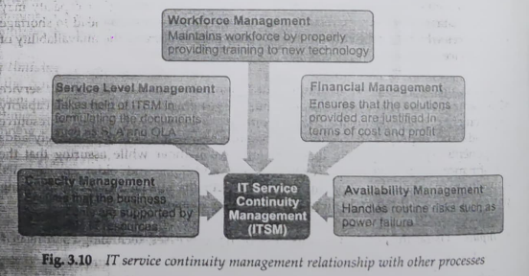

1. **Explain various management tasks involved in capacity management.**

* **Monitoring:** Continuously tracking resource usage and performance.
* **Analysis:** Evaluating current capacity and predicting future needs.
* **Planning:** Developing strategies to meet future capacity requirements.
* **Optimization:** Enhancing resource usage efficiency.
* **Reporting:** Communicating capacity status and forecasts to stakeholders.

**Diagram: Capacity Management Tasks**

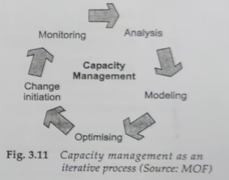

1. **What are the advantages of capacity management?**

**Advantages:**

* **Ensures Adequate Resources:** Meets current and future business demands.
* **Prevents Over/Under Provisioning:** Optimizes resource allocation.
* **Enhances Performance:** Improves system efficiency and user satisfaction.
* **Supports Cost Management:** Avoids unnecessary expenses through efficient planning.
* **Facilitates Planning:** Provides data for informed decision-making.

1. **What are the advantages of availability management?**

**Advantages:**

* **Maximizes Service Uptime:** Ensures services are available when needed.
* **Improves User Satisfaction:** Reliable services lead to higher user satisfaction.
* **Reduces Downtime Costs:** Minimizes the financial impact of service outages.
* **Enhances Reliability:** Improves the overall reliability of IT services.
* **Supports SLAs:** Helps meet service level agreements with customers.

1. **What is an availability plan? What are the management processes that need to be considered while designing an availability plan?**

**Availability Plan:** An availability plan outlines strategies and actions to ensure IT services meet agreed-upon availability targets. It includes forecasting, capacity planning, and redundancy strategies.

**Management Processes:**

* **Service Level Management:** Aligning availability targets with SLA requirements.
* **Capacity Management:** Ensuring sufficient resources to meet availability needs.
* **IT Service Continuity Management:** Planning for disaster recovery and failover.
* **Incident Management:** Handling and resolving incidents to maintain availability.
* **Change Management:** Managing changes to prevent disruption to service availability.

**Diagram: Availability Plan Components**

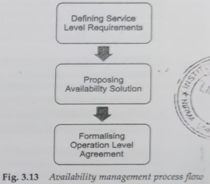

1. **Discuss the relationship of availability management to other processes.**

**Relationships:**

* **Service Level Management:** Ensures service availability meets SLA standards.
* **Capacity Management:** Provides necessary resources to maintain service availability.
* **Incident Management:** Manages and resolves incidents affecting availability.
* **IT Service Continuity Management:** Prepares for and mitigates service disruptions.

**Diagram: Availability Management Interrelationships**

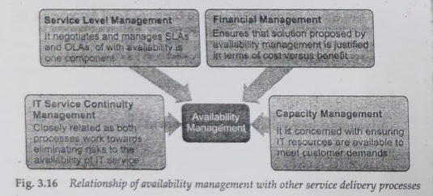

1. **How do performance and tuning processes differ from other processes?**

**Performance and Tuning:**

* **Focus:** Optimizes system performance and efficiency.
* **Continuous Improvement:** Involves ongoing adjustments to system parameters.
* **Specialized Skills:** Requires expertise in performance analysis and optimization tools.

**Other Processes:**

* **Incident Management:** Resolves service disruptions.
* **Change Management:** Manages changes to IT systems.
* **Problem Management:** Identifies and resolves root causes of incidents.

**Diagram: Performance and Tuning vs. Other Processes**

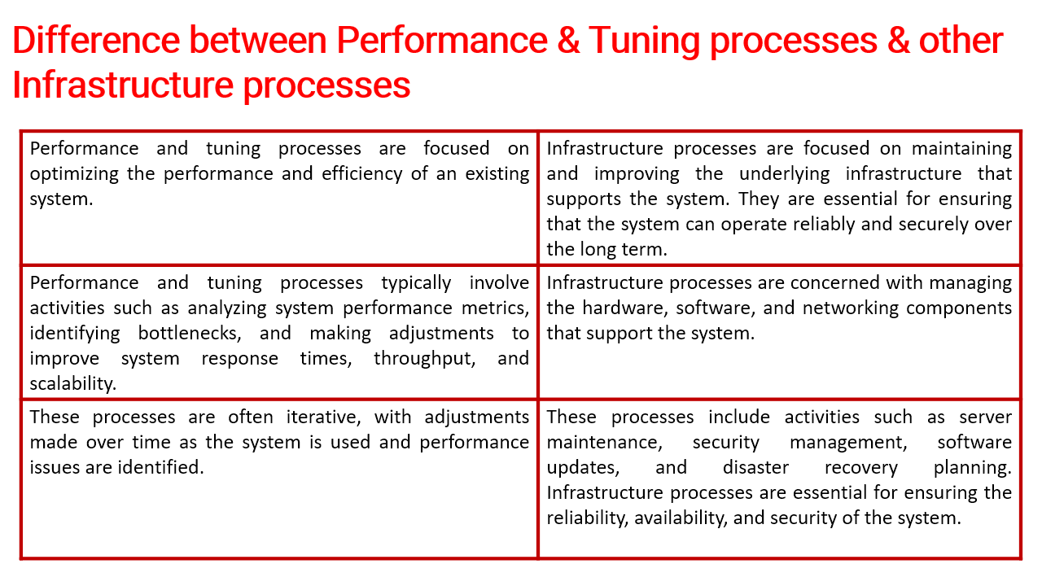

1. **Differentiate incident management and problem management.**

It is important to differentiate incident management from problem management due to their distinct focus areas and objectives. Here are some prominent differences:

**Restoration vs. Root Cause:**

* **Incident Management:** Solely concerned with returning the service to an operational state as quickly as possible. It does not focus on analyzing the root cause, as this could slow down the restoration process.
* **Problem Management:** Focuses on analyzing and identifying the root causes behind incidents to prevent future occurrences.

**Combat vs. Remedy:**

* **Incident Management:** Deals with combating the symptoms of incidents. The primary goal is to quickly address and resolve immediate disruptions.
* **Problem Management:** Aims to permanently remove the causes of incidents from the IT infrastructure, providing a long-term remedy.

**Reactive vs. Proactive:**

* **Incident Management:** Typically reactive, focusing on finding a workaround or temporary solution to restore normal services for the customer as quickly as possible.
* **Problem Management:** More proactive, with IT support staff deploying resources to identify and resolve the underlying causes of incidents to prevent recurrence.

**Customer Interaction:**

* **Incident Management:** Involves direct interaction with the customer. The Service Desk or support team engages with customers to resolve issues swiftly.
* **Problem Management:** Usually involves little to no direct interaction with customers, as the focus is on behind-the-scenes analysis and resolution. Customer communication is typically managed by the Service Desk.

1. **Explain proactive and reactive problem management.**

**Proactive Problem Management:**

* **Focus:** Identifies potential problems before they cause incidents.
* **Methods:** Trend analysis, risk assessment, preventive measures.

**Reactive Problem Management:**

* **Focus:** Addresses the root cause of incidents after they occur.
* **Methods:** Incident investigation, root cause analysis, corrective actions.

**Diagram: Proactive vs. Reactive Problem Management**

1. **Explain in detail the relationship among problem management, change management, and incident management.**

**Incident Management:**

* **Role:** Manages and resolves incidents to restore normal service.
* **Relationship:** Incidents often lead to the identification of problems.

**Problem Management:**

* **Role:** Identifies and resolves root causes of incidents.
* **Relationship:** Problems may require changes to be implemented to resolve root causes.

**Change Management:**

* **Role:** Manages changes to IT systems to ensure minimal disruption.
* **Relationship:** Changes are often initiated by problem management to fix root causes or prevent incidents.

**Diagram: Relationship Among Incident, Problem, and Change Management**

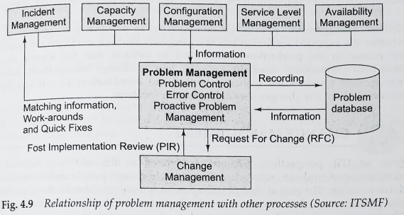

1. **Define the following terms:**

**a. Configuration Item (CI):** Any component that needs to be managed to deliver an IT service, such as hardware, software, documentation, or personnel.

**b. Attributes of Configuration Item:** Characteristics of a CI, such as type, owner, version, status, and relationships with other CIs.

**c. Configuration Manager:** Responsible for maintaining information about configuration items required to deliver an IT service, including their relationships.

**d. Configuration Management Database (CMDB):** A database that stores information about configuration items and their relationships, supporting configuration management processes.

**e. Compact Failure Impact Analysis (CFIA):** A method used to assess the impact of failures on the business, identifying critical components and potential failure points.

**Diagram: Configuration Management Terms**

1. **Discuss change management and various steps involved in its implementation.**

**Change Management:** Ensures that changes to IT systems are managed systematically to minimize disruption and maintain service quality.

**Steps in Implementation:**

1. **Request for Change (RFC):** Submission of a formal request for a change.
2. **Assessment and Approval:** Evaluation of the change request for feasibility, impact, and risk, followed by approval or rejection.
3. **Planning:** Detailed planning of the change, including resources, timeline, and rollback procedures.
4. **Testing:** Testing the change in a controlled environment to ensure it works as expected.
5. **Implementation:** Deploying the change to the live environment.
6. **Review and Closure:** Post-implementation review to assess the success of the change and formally close the change request.

**Diagram: Change Management Process**

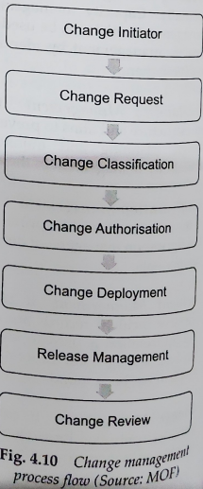

1. **What is the implementation cost of incident management?**

**Implementation Costs:**

* **Incident Management Tools:** Costs for purchasing and maintaining incident management software.
* **Training Costs:** Training staff on incident management procedures and tools.
* **Resource Costs:** Staffing for 24/7 incident monitoring and response.
* **Resolution Costs:** Expenses associated with incident resolution and recovery.
* **Review and Audit Costs:** Regular costs for reviewing and auditing incident management processes.

1. **Discuss various processes involved in release management.**

**Processes in Release Management:**

1. **Release Planning:** Defining the scope, schedule, and resources for releases.
2. **Build and Test:** Developing and testing the release components in a controlled environment.
3. **Deployment:** Rolling out the release to the live environment following a planned deployment strategy.
4. **Review and Closure:** Assessing the release performance, gathering feedback, and closing the release process.

**Diagram: Release Management Processes**

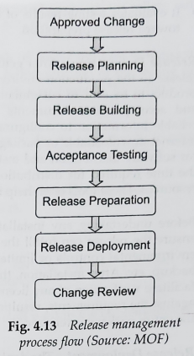

1. **Explain Storage Area Network (SAN) and NAS.**

**Storage Area Network (SAN):**

* **Definition:** A high-speed network that provides access to consolidated block-level storage, typically used for large-scale, high-performance storage needs.
* **Advantages:** High performance, scalability, centralized storage management.

**Diagram: SAN**

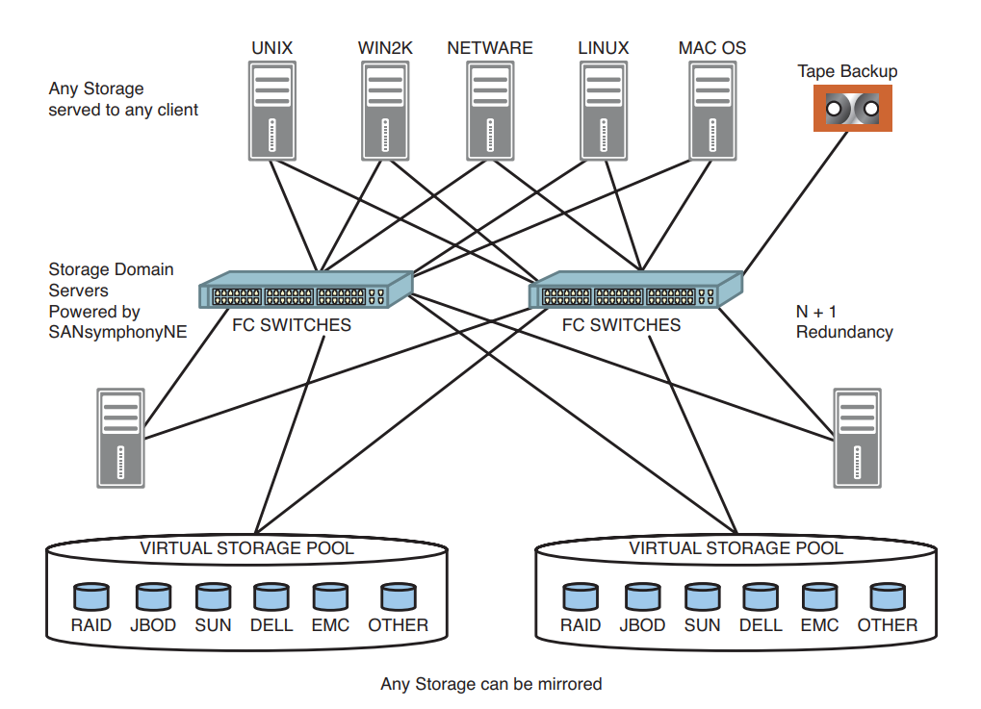

**Network Attached Storage (NAS):**

* **Definition:** A file-level storage architecture connected to a network, allowing multiple users to access shared data. Ideal for file sharing and backup solutions.
* **Advantages:** Easy to set up and manage, cost-effective, supports file sharing.