**Tutorial - 5**

1. **Asset Network Corporation Case.**

**Case Background:**

* **Company Profile:** Asset Network Corporation (ANC) is a mid-sized enterprise providing asset management solutions to various industries, including manufacturing, healthcare, and logistics. The company operates globally and handles a vast array of physical and digital assets.
* **Current Infrastructure:** ANC's current IT infrastructure includes legacy systems that are disparate and often incompatible. The databases are siloed, leading to fragmented data and inefficiencies in asset tracking and management. The asset management process is largely manual, which is prone to errors and time-consuming.
* **Challenges:** Key challenges include inefficiencies in asset tracking, high operational and maintenance costs, data inaccuracies, lack of real-time visibility into asset status, and poor integration between different IT systems.

**Analysis:**

* **Problem Identification:** The primary issues include outdated hardware, software compatibility problems, data silos, and manual asset tracking processes. These lead to operational inefficiencies, increased costs, and poor decision-making due to unreliable data.
* **Requirements Gathering:** Through stakeholder meetings and workshops, ANC gathered requirements that highlighted the need for a modern, integrated asset management system that supports real-time tracking, predictive maintenance, and seamless data integration.

**Solution Proposal:**

* **Infrastructure Upgrade:** ANC decided to implement a new, integrated asset management system. This solution involves migrating to a cloud-based platform, which offers scalability, accessibility, and cost-efficiency.
* **Technology Stack:** The proposed technology stack includes:
  + **IoT Devices:** For real-time asset tracking.
  + **AI and Machine Learning:** For predictive maintenance and analytics.
  + **Blockchain Technology:** For secure and transparent transaction recording.
  + **Cloud Computing:** For scalable and accessible data storage and processing.
* **Implementation Plan:** The implementation plan includes:
  + **Phase 1: Pilot Testing:** Deploy the new system in a small, controlled environment to identify any issues and gather feedback.
  + **Phase 2: Training:** Provide comprehensive training for employees to ensure they can effectively use the new system.
  + **Phase 3: Full Deployment:** Roll out the system across the entire organization in stages to minimize disruption.

**Expected Outcomes:**

* **Efficiency Gains:** Improved asset tracking and management, leading to reduced downtime and better resource utilization.
* **Cost Savings:** Lower maintenance and operational costs due to predictive maintenance and more efficient processes.
* **Enhanced Data Visibility:** Real-time insights into asset performance and lifecycle, enabling better decision-making.

1. **Business Process Outsourcing (BPO) Infrastructure Planning and Management.**

**Introduction:**

* **Definition:** Business Process Outsourcing (BPO) involves contracting specific business processes, such as customer service, payroll, or IT services, to third-party providers.
* **Importance:** BPO is crucial for reducing operational costs, improving service quality, and allowing companies to focus on their core business functions.

**Planning and Management Steps:**

**Step 1: Assessment**

* **Needs Analysis:** Identify which business processes are candidates for outsourcing. For example, customer service operations that require 24/7 availability can be efficiently handled by BPO providers.
* **Risk Analysis:** Evaluate potential risks associated with outsourcing, including data security, compliance with regulations, and maintaining service quality.

**Step 2: Vendor Selection**

* **Criteria Development:** Define selection criteria such as the vendor’s experience, technological capabilities, cost, and reliability.
* **RFP Process:** Issue a Request for Proposal (RFP) to potential BPO providers, outlining your requirements and expectations. Evaluate the proposals based on predefined criteria.

**Step 3: Infrastructure Planning**

* **Technology Requirements:** Determine the necessary technological infrastructure. This includes CRM systems for customer service BPO, secure data centers for data processing, and robust telephony systems for call centers.
* **Integration Plan:** Develop a plan to integrate the BPO provider’s systems with your existing IT infrastructure to ensure seamless data flow and operational continuity.

**Step 4: Implementation**

* **Pilot Phase:** Start with a pilot project to test the BPO provider’s capabilities and make necessary adjustments.
* **Full Deployment:** Based on the pilot results, gradually roll out the BPO services to minimize disruption and ensure a smooth transition.

**Step 5: Management and Monitoring**

* **Service Level Agreements (SLAs):** Establish SLAs that define performance metrics and standards for the BPO provider to ensure service quality.
* **Performance Metrics:** Regularly monitor performance using metrics such as response times, resolution rates, customer satisfaction scores, and compliance with regulatory requirements.

**Diagram:**

* **BPO Lifecycle Diagram:** A diagram showing the lifecycle of BPO implementation from assessment to management and monitoring.

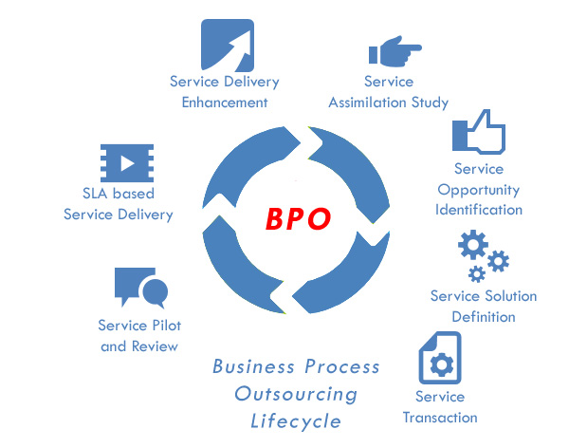

1. **e-Commerce Business Infrastructure Planning and Management.**

**Introduction:**

* **Definition:** e-Commerce involves the buying and selling of goods and services over the internet.
* **Importance:** Effective e-commerce infrastructure is crucial for reaching a global market, enhancing customer experience, and driving sales growth.

**Planning and Management Steps:**

**Step 1: Market Analysis**

* **Target Audience:** Identify the demographic and psychographic characteristics of your target customers. Conduct surveys and market research to understand their preferences and shopping behavior.
* **Competitor Analysis:** Analyze your competitors to identify their strengths and weaknesses, market positioning, and customer engagement strategies.

**Step 2: Infrastructure Requirements**

* **Web Platform:** Choose a reliable and scalable e-commerce platform (e.g., Shopify, Magento, WooCommerce) that fits your business needs.
* **Hosting Solutions:** Select a hosting provider that offers high availability, scalability, and security. Consider cloud-based hosting solutions like AWS or Google Cloud for flexibility and reliability.
* **Security Measures:** Implement robust security protocols, including SSL certificates for secure transactions, firewalls to protect against cyber threats, and secure payment gateways to ensure customer data safety.

**Step 3: Development and Design**

* **Website Design:** Focus on creating a user-friendly design that offers easy navigation, mobile responsiveness, and an intuitive shopping experience.
* **Backend Development:** Ensure efficient inventory management, order processing, customer relationship management (CRM), and integration with third-party applications.

**Step 4: Testing**

* **Functional Testing:** Test all website functionalities, including search features, product listings, shopping cart, checkout process, and payment systems.
* **Performance Testing:** Conduct load testing to ensure the website can handle high traffic volumes, especially during peak shopping seasons.

**Step 5: Launch and Marketing**

* **Soft Launch:** Begin with a soft launch to a limited audience to gather initial feedback and make necessary adjustments.
* **Full Launch:** Officially launch the e-commerce platform with a comprehensive marketing campaign, including SEO, social media marketing, email marketing, and online advertising.

**Step 6: Maintenance and Improvement**

* **Regular Updates:** Continuously update the platform with new features, security patches, and improvements based on user feedback.
* **Customer Feedback:** Implement a system for gathering and analyzing customer feedback to identify areas for improvement and enhance the overall shopping experience.

**Diagram:**

* **Gantt Chart:** A detailed Gantt chart showing the timeline for each phase of the e-commerce infrastructure setup, from market analysis to maintenance and improvement.

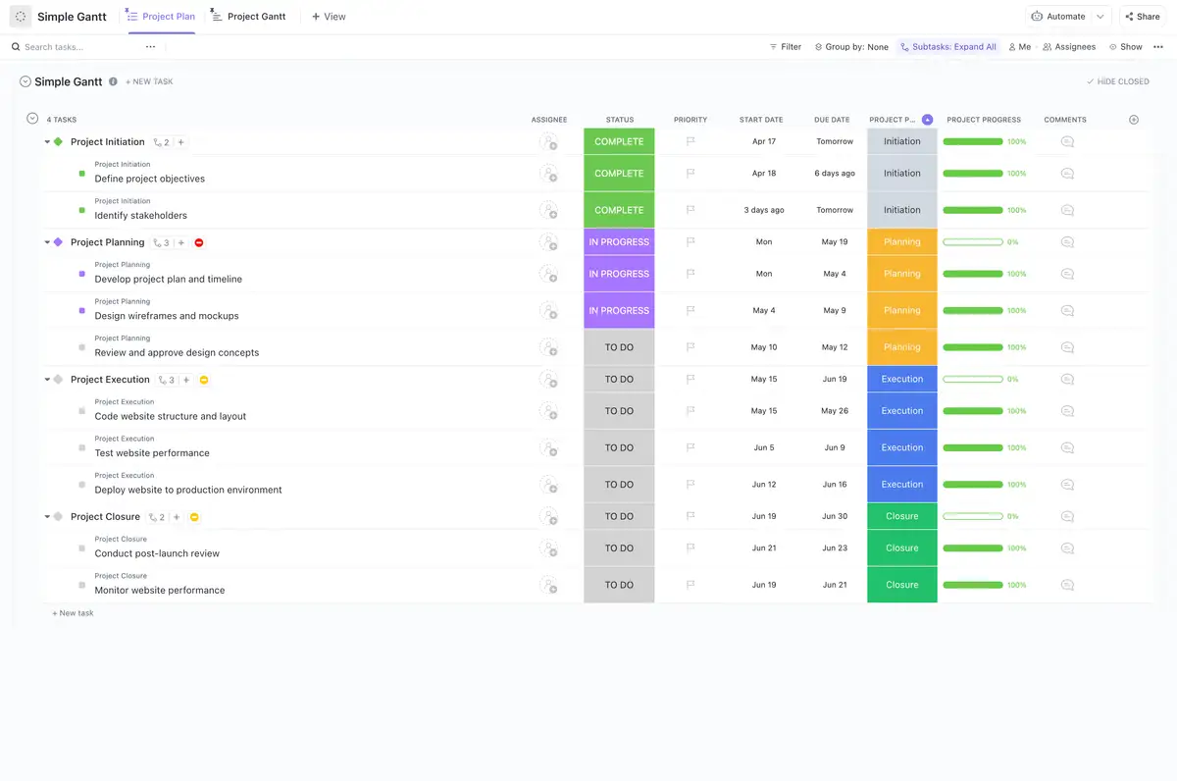

**Tutorial - 6**

1. **Enron Case Study.**

**Background:**

* **Company Profile:** Enron was an American energy, commodities, and services company founded in 1985. It was one of the world's major electricity, natural gas, communications, and pulp and paper companies.
* **Scandal Summary:** Enron's collapse in December 2001 was one of the largest corporate scandals in history. It was primarily due to widespread accounting fraud and corporate corruption.

**Key Events:**

* **Accounting Practices:** Enron used complex financial instruments, such as Special Purpose Entities (SPEs), to hide debt and inflate profits. They employed mark-to-market accounting, which allowed them to book potential future profits as current income.
* **Whistleblowing:** Sherron Watkins, an Enron executive, alerted the CEO about accounting irregularities, but her warnings were ignored.
* **Bankruptcy:** Enron filed for bankruptcy on December 2, 2001, resulting in the loss of billions of dollars in shareholder value and the elimination of thousands of jobs.

**Impact:**

* **Legislation:** The Enron scandal led to the creation of the Sarbanes-Oxley Act in 2002. This legislation introduced significant changes to financial practice and corporate governance regulation, aiming to increase transparency and reduce the incidence of corporate fraud.
* **Corporate Governance:** The scandal highlighted the importance of ethical behavior, transparent financial reporting, and the need for effective internal controls and independent auditing.

**Diagram:**

* **Timeline Diagram:** A timeline showing major events in the Enron scandal, from the company's founding to its bankruptcy, highlighting key moments such as the use of SPEs, the whistleblower incident, and the bankruptcy filing.

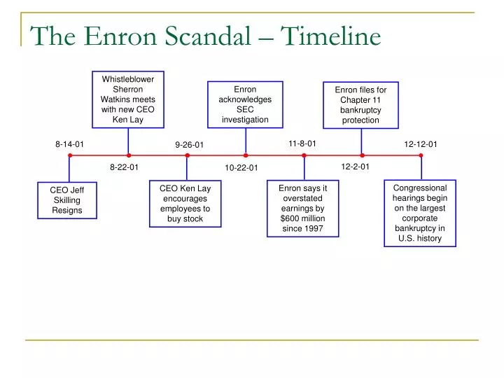

1. **Tyco Case Study.**

**Background:**

* **Company Profile:** Tyco International was a global manufacturing conglomerate, operating in security systems, electronics, healthcare, and fire protection services.
* **Scandal Summary:** Tyco's scandal involved top executives, including CEO Dennis Kozlowski and CFO Mark Swartz, who engaged in massive fraud and theft from the company.

**Key Events:**

* **Misuse of Funds:** Kozlowski and Swartz misappropriated company funds for personal expenses, including extravagant parties, luxury apartments, and art purchases.
* **Investigations:** The SEC launched investigations after suspicious activities were reported. The misuse of funds and fraudulent accounting practices were uncovered.
* **Convictions:** Kozlowski and Swartz were tried and convicted of grand larceny, falsifying business records, and other crimes. They were sentenced to substantial prison terms.

**Impact:**

* **Reforms:** The scandal led to changes in corporate governance practices, emphasizing the need for stricter controls, transparent financial reporting, and accountable executive management.
* **Investor Confidence:** The case underscored the necessity for investors to be vigilant and for regulatory bodies to enforce compliance with ethical standards.

**Diagram:**

* **Flowchart:** A chart showing the flow of funds misappropriated by Tyco executives, detailing the methods used to divert company assets for personal use.

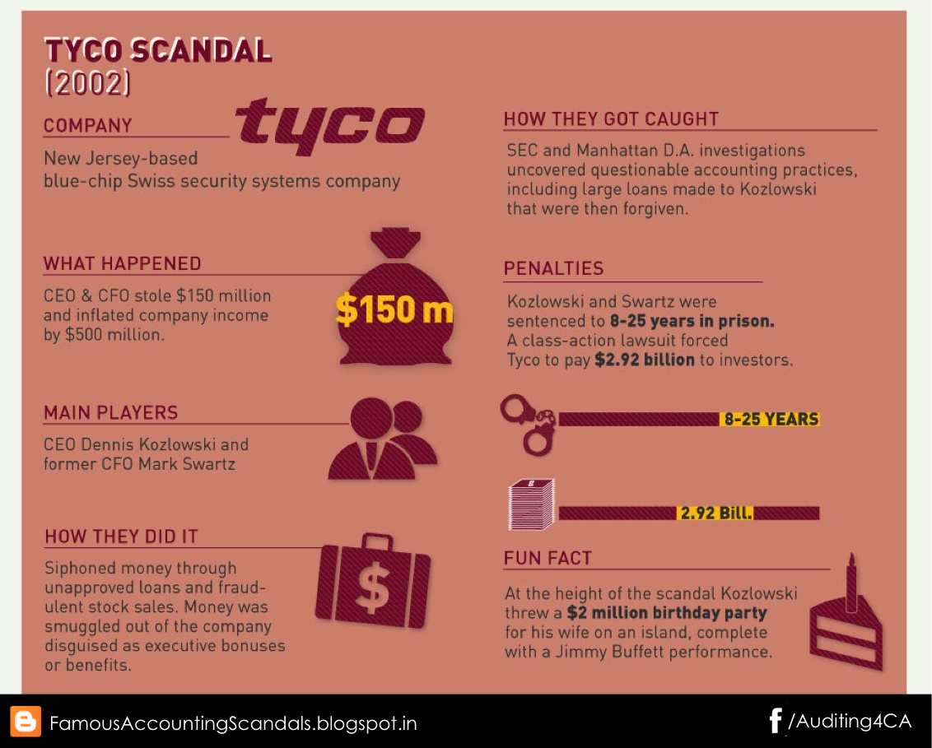

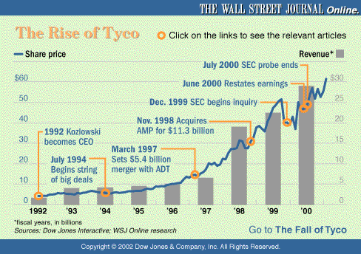

1. **WorldCom Case Study.**

**Background:**

* **Company Profile:** WorldCom was a major telecommunications company that grew rapidly through acquisitions and was a key player in the telecommunications industry.
* **Scandal Summary:** WorldCom engaged in an accounting fraud scheme to hide its declining earnings and inflate its financial statements.

**Key Events:**

* **Accounting Manipulations:** CFO Scott Sullivan and others capitalized operating expenses, which artificially inflated earnings. This misrepresentation made the company's financial health appear much better than it was.
* **Discovery:** Internal audits revealed the fraudulent activities, leading to a public disclosure of the accounting irregularities.
* **Bankruptcy:** WorldCom filed for bankruptcy in July 2002, the largest in U.S. history at the time, which resulted in substantial financial losses for investors.

**Impact:**

* **Regulatory Changes:** The scandal further strengthened the Sarbanes-Oxley Act's requirements, particularly regarding corporate accountability and financial transparency.
* **Market Impact:** The WorldCom scandal caused significant losses for investors and damaged confidence in the telecommunications sector.

**Diagram:**

* **Fraudulent Accounting Flowchart:** A flowchart detailing the fraudulent accounting practices employed by WorldCom, illustrating how operating expenses were capitalized to inflate earnings.

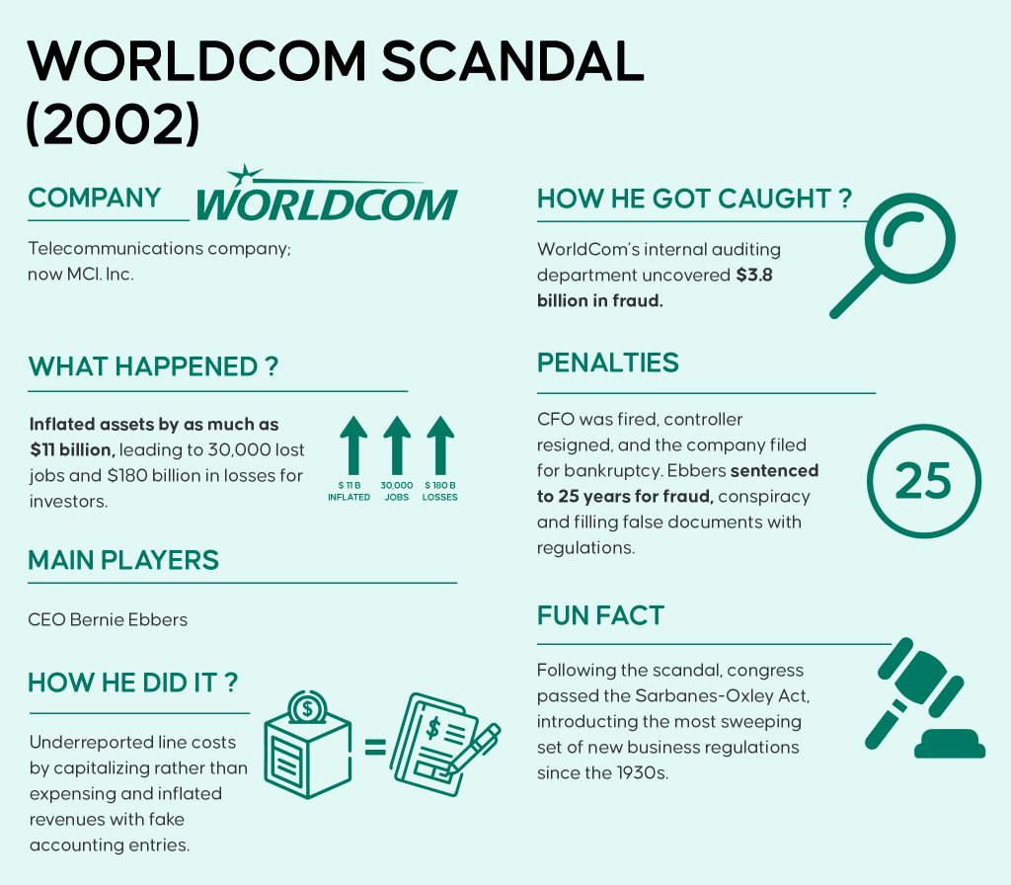

1. **Analysis of an Information Infrastructure in the SLO-2 Case.**

**Case Background:**

* **SLO-2:** A hypothetical or anonymized case study involving a detailed analysis of an organization's information infrastructure, aimed at identifying weaknesses and recommending improvements.
* **Objective:** The objective is to assess the current state of the information infrastructure, identify areas of improvement, and propose solutions to enhance efficiency, security, and scalability.

**Key Elements:**

* **Current Infrastructure:** The current state includes an array of legacy systems, decentralized databases, and outdated network configurations. There is a lack of integration between different systems, leading to inefficiencies and data silos.
* **Challenges Identified:** Major challenges include outdated technology, lack of integration, security vulnerabilities, and scalability issues. These factors contribute to operational inefficiencies and increased risk of data breaches.

**Recommendations:**

* **Upgrades:** Recommend upgrades to both hardware and software to modernize the infrastructure. This includes replacing legacy systems with modern, integrated solutions.
* **Integration:** Propose solutions for better integration of disparate systems to ensure seamless data flow. This could involve using middleware or adopting a unified platform.
* **Security Enhancements:** Implement advanced security measures such as end-to-end encryption, multi-factor authentication, and regular security audits to protect against cyber threats.
* **Scalability Solutions:** Plan for future growth by adopting scalable technologies such as cloud computing, which offers flexibility and the ability to scale resources up or down based on demand.