**Practical: 1**

1. **Prepare report on different web terminologies and introduction of PHP.**

**Basic Web terminologies:**

1. **Web client** 
   * The software application which displays web pages with the help of response and access the web server by using request.
2. **Web server** 
   * The computer or network of computers which stores web pages.
3. **URL** 
   * A web address; indicates the location of a web resource as well as the protocol needed to access it.
4. **WWW** 
   * World Wide Web, which is also known as a Web, is a collection of websites or web pages stored in web servers and connected to local computers through the internet.
5. **Browser** 
   * A web browser is application software for accessing websites.
6. **Internet** 
   * The Internet is needed to communicate with the server because all web pages is available at server side.
7. **Intranet** 
   * An intranet is a private network contained within an enterprise that is used to securely share company information and computing resources among employees.
8. **Web page** 
   * A Web page is a document for the World Wide Web that is identified by a unique uniform resource locator (URL).

**PHP :** The term PHP is an acronym for *PHP: Hypertext Preprocessor*. PHP is a server-side scripting language designed specifically for web development. It is open-source which means it is free to download and use. It is very simple to learn and use. The files have the extension “.php”.

1. **Do environment Setup of WAMP or XAMPP or LAMP or SAMP Server.**

To install XAMPP on a Windows machine, follow these steps:

# Step1: Download Xampp

Firstly, go to the official Xampp website and download the windows version

Ø <https://www.apachefriends.org/download.html>

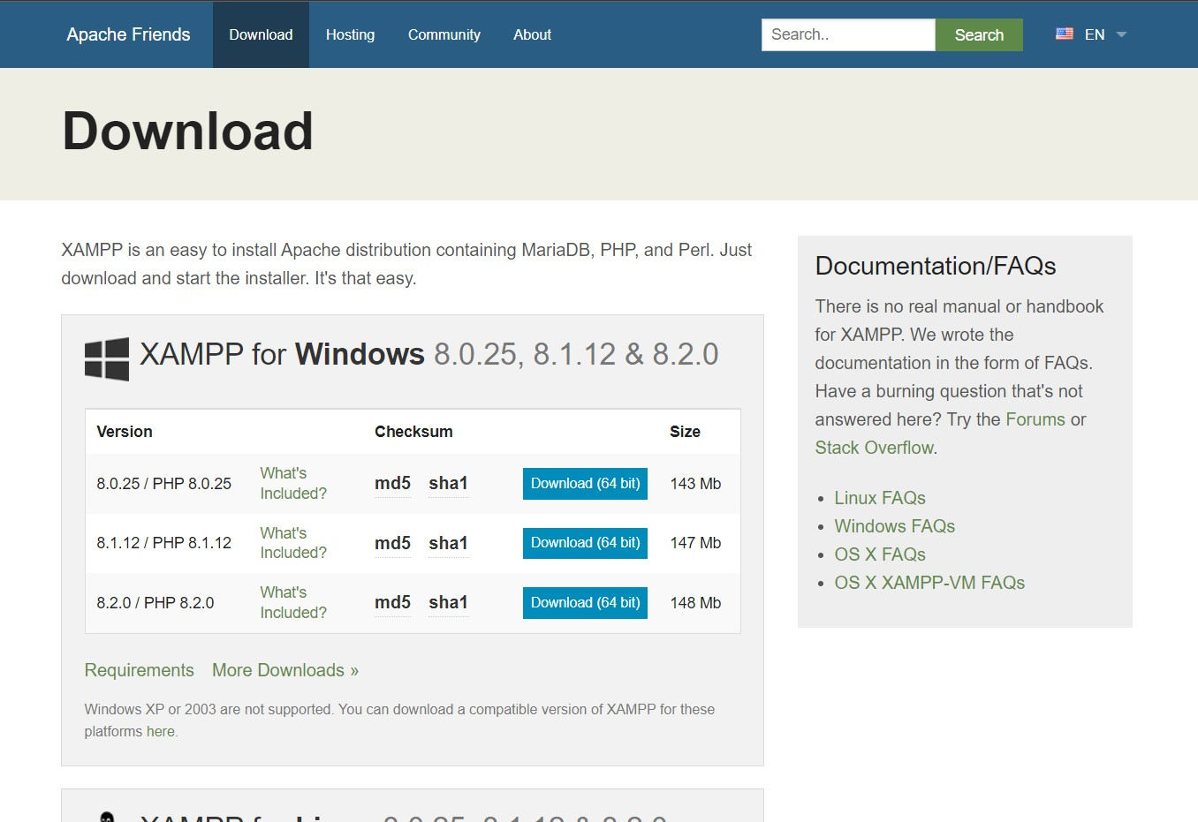

**Step 2: Run the installation package**

Double click on the installation package or right click and click 'run as administrator'

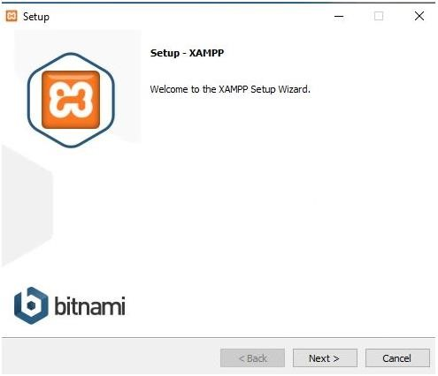

**Step 3: Choose the location for installation. It is recommended to use the default location. Click next**

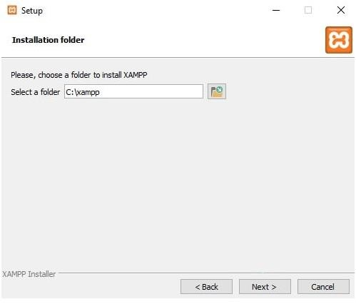

**Step 4: Select your default installation language in the dropdown on the top left**

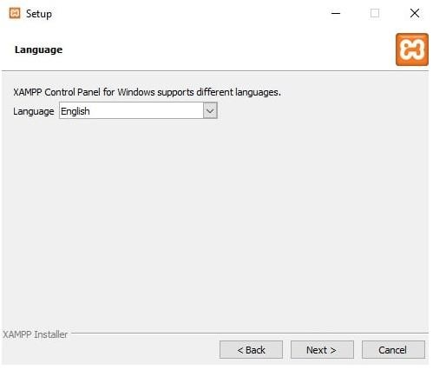

**Step 5: Setup is now ready to begin installing XAMPP on your computer.**

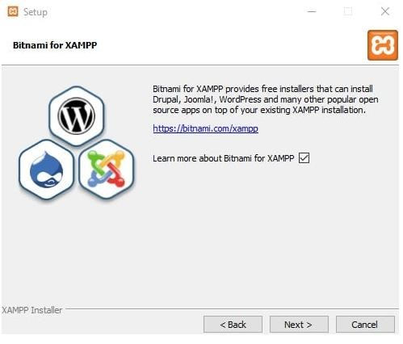

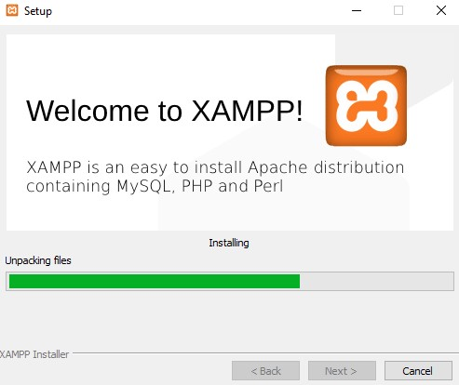

**Step 6: Prompt**

Occasionally, the installation process will prompt you to allow network access for the apache server. Once you permit this, the installation process will smoothly continue.

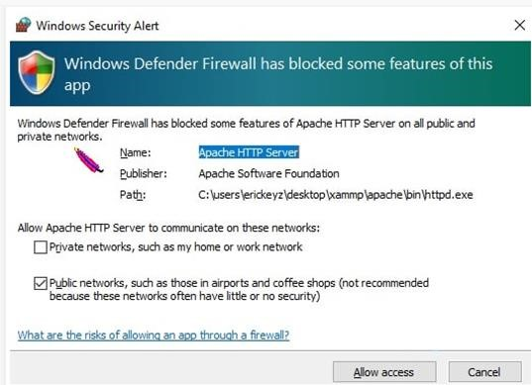

**Step 7: Finalizing the installation**

Once this is all done the finale installation page appears. If you want to run Xampp instantly, check the box and click on finish.

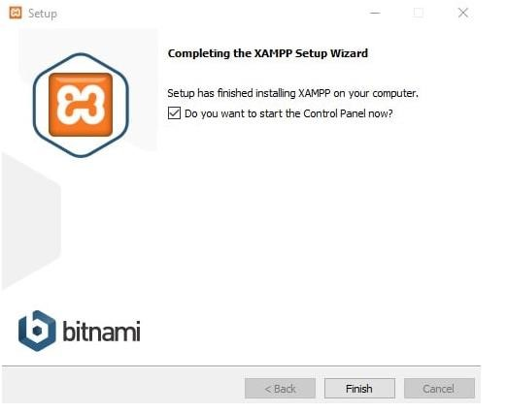

1. **Understand services of WAMP or XAMPP server.**

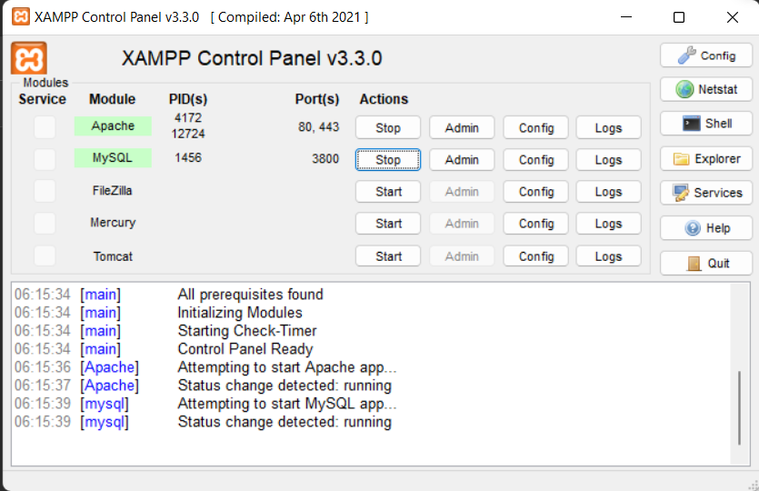

1. **Write a program to print “Welcome to PHP”.**

**CODE:**

|  |
| --- |
| <!DOCTYPE html>  <html lang="en">  <head>      <meta charset="UTF-8">      <meta name="viewport" content="width=device-width, initial-scale=1.0">      <title>Brijesh</title>  </head>  <body>      <?php      echo "Welcome to PHP";      ?>  </body>  </html> |

**OUTPUT:**

