**Practical - 3**

**Aim: Perform following programs of PHP Array & it’s inbuilt function. Exercise:**

1. **Write a PHP program to find out maximum and minimum number from an array.**

<?php

echo "Adeshara Brijesh_21012021001 <br>";

$array=[];

$n=10;

echo "Array is: ";

for($i=0;$i<$n;$i++){

if($i%10==0) echo "<br>";

$array[$i]=rand(-100,100);

echo $array[$i].",";

}

echo "<br><br>";

$max = max($array);

$min = min($array);

echo "Maximum number: $max<br>";

echo "Minimum number: $min<br>";

$max = $array[0];

$min = $array[0];

foreach ($array as $value) {

if ($value > $max) {

$max = $value;

}

if ($value < $min) {

$min = $value;

}

}

echo "Maximum number without in-built function: $max<br>";

echo "Minimum number without in-built function: $min";

?>

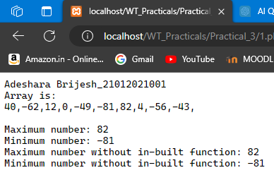

1. **Write a PHP program to reverse an array.**

<?php

echo "Adeshara Brijesh_21012021001 <br>";

$array=[];

$n=10;

echo "Array is: ";

for($i=0;$i<$n;$i++){

if($i%10==0) echo "<br>";

$array[$i]=rand(-100,100);

echo $array[$i].",";

}

echo "<br><br>";

$reversedArray = array_reverse($array);

echo "Original array: " . implode(", ", $array) . "<br>";

echo "Reversed array: " . implode(", ", $reversedArray) . "<br>";

$reversedArray = array();

$length = count($array);

for ($i = $length - 1; $i >= 0; $i--) {

$reversedArray[] = $array[$i];

}

echo "Original array without in-built function: " . implode(", ", $array) . "<br>";

echo "Reversed array without in-built function: " . implode(", ", $reversedArray);

?>

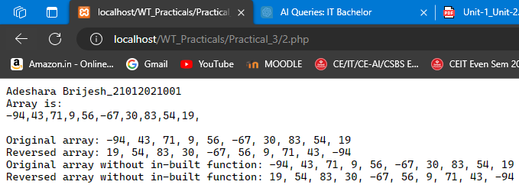

1. **Write a PHP program to merge two arrays.**

<?php

$array1=[];

$n=10;

echo "Array1 is: ";

for($i=0;$i<$n;$i++){

if($i%10==0) echo "<br>";

$array1[$i]=rand(-100,100);

echo $array1[$i].",";

}

$array2=[];

$n=10;

echo "<br>Array2 is: ";

for($i=0;$i<$n;$i++){

if($i%10==0) echo "<br>";

$array2[$i]=rand(-100,100);

echo $array2[$i].",";

}

echo "<br><br>";

$mergedArray = array_merge($array1, $array2);

echo "Merged array: " . implode(", ", $mergedArray) . "<br>";

$mergedArray = array();

foreach ($array1 as $value) {

$mergedArray[] = $value;

}

foreach ($array2 as $value) {

$mergedArray[] = $value;

}

echo "Merged array without using in-built function: " . implode(", ", $mergedArray);

?>

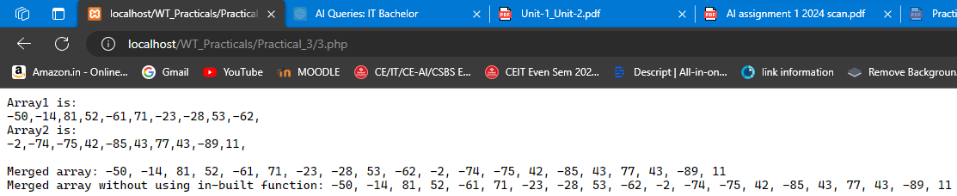

1. **Write a PHP program to sort an array.**

<?php

echo "Adeshara Brijesh_21012021001 <br>";

$array=[];

$n=10;

echo "Array is: ";

for($i=0;$i<$n;$i++){

if($i%10==0) echo "<br>";

$array[$i]=rand(-100,100);

echo $array[$i].",";

}

echo "<br><br>";

sort($array);

echo "Sorted array: " . implode(", ", $array) . "<br>";

$length = count($array);

for ($i = 0; $i < $length - 1; $i++) {

for ($j = 0; $j < $length - $i - 1; $j++) {

if ($array[$j] > $array[$j + 1]) {

$temp = $array[$j];

$array[$j] = $array[$j + 1];

$array[$j + 1] = $temp;

}

}

}

echo "Sorted array without using in-built function: " . implode(", ", $array);

?>

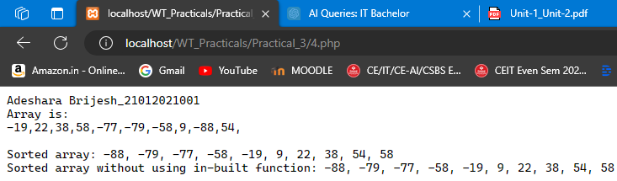

1. **Write a PHP program to search element from an array.**

<?php

echo "Adeshara Brijesh_21012021001 <br>";

$array=[];

$n=10;

echo "Array is: ";

for($i=0;$i<$n;$i++){

if($i%10==0) echo "<br>";

$array[$i]=rand(-100,100);

echo $array[$i].",";

}

echo "<br><br>";

$searchValue = 3;

if (in_array($searchValue, $array)) {

echo "$searchValue is found in the array. <br>";

} else {

echo "$searchValue is not found in the array. <br>";

}

$searchValue = 3;

$found = false;

foreach ($array as $value) {

if ($value === $searchValue) {

$found = true;

break;

}}

echo "Searching in the array without using in-built function. <br>";

if ($found) {

echo "$searchValue is found in the array.";

} else {

echo "$searchValue is not found in the array.";

}

?>

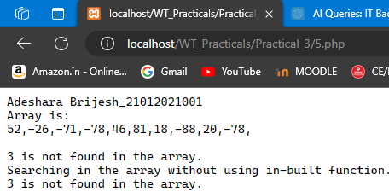

1. **Write a PHP program to remove duplicate values from an array.**

<?php

echo "Adeshara Brijesh_21012021001 <br>";

$array=[];

$n=10;

echo "Array is: ";

for($i=0;$i<$n;$i++){

if($i%10==0) echo "<br>";

$array[$i]=rand(-100,100);

echo $array[$i].","; }

echo "<br><br>";

$uniqueArray = array_unique($array);

echo "Original array: " . implode(", ", $array) . "<br>";

echo "Array after removing duplicates: " . implode(", ", $uniqueArray) . "<br>";

$uniqueArray = array();

foreach ($array as $value) {

if (!in_array($value, $uniqueArray)) {

$uniqueArray[] = $value;

}}

echo "Array after removing duplicates without using in-built function: " . implode(", ", $uniqueArray);

?>

