**Practical – 7**

**Aim: Perform following programs of PHP with database.**

**Exercise:**

1. **How do you create a connection between PHP and MySQL explain its step by step procedure?**
2. **Install PHP and MySQL:**

Ensure that PHP and MySQL are installed on your system. You can download and install PHP from the official PHP website (https://www.php.net/downloads.php), and MySQL from the official MySQL website (https://www.mysql.com/downloads/).

1. **Start MySQL Server:**

Make sure that the MySQL server is running. You can start the MySQL server using the appropriate command for your operating system.

1. **Create a MySQL Database:**

Use a MySQL client (such as phpMyAdmin or MySQL Command Line) to create a database that PHP will connect to. You can create a database using SQL commands like CREATE DATABASE dbname;.

1. **Create a MySQL User (Optional):**

It's a good practice to create a separate MySQL user with limited privileges for accessing the database from PHP. You can create a user using SQL commands like CREATE USER 'username'@'localhost' IDENTIFIED BY 'password'; and grant necessary privileges using GRANT statements.

1. **Write PHP Code to Connect to MySQL:**

Now, you need to write PHP code to establish a connection to the MySQL database. Here's an example of how to do it:

<?php

$servername = "localhost"; // Change this if MySQL server is running on a different host

$username = "username"; // Your MySQL username

$password = "password"; // Your MySQL password

$database = "dbname"; // Your MySQL database name

$conn = new mysqli($servername, $username, $password, $database);

if ($conn->connect_error) {

die("Connection failed: " . $conn->connect_error);

} else {

echo "Connected successfully";

}

// Perform database operations here...

// Close connection

$conn->close();

?>

1. **Write a PHP Program to create database at run time by passing database name in text box.**

<!DOCTYPE html>

<html>

<head>

<title>Create Database</title>

<style>

body {

font-family: Arial, sans-serif;

background-color: #f0f0f0;

margin: 0;

padding: 20px;

}

#container {

background-color: #fff;

padding: 20px;

border-radius: 10px;

box-shadow: 0px 0px 10px rgba(0, 0, 0, 0.1);

width: 400px;

margin: 0 auto;

}

input[type="text"] {

width: 100%;

padding: 10px;

margin: 8px 0;

box-sizing: border-box;

border: 1px solid #ccc;

border-radius: 4px;

}

input[type="submit"] {

background-color: #4CAF50;

color: white;

padding: 14px 20px;

margin: 8px 0;

border: none;

border-radius: 4px;

cursor: pointer;

width: 100%;

}

input[type="submit"]:hover {

background-color: #45a049;

}

.message {

margin-top: 20px;

text-align: center;

}

</style>

</head>

<body>

<div id="container">

<h2>Create Database</h2>

<form method="post">

<input type="text" name="database_name" placeholder="Enter database name" required><br>

<input type="submit" name="submit" value="Create Database">

</form>

<?php

if ($_SERVER["REQUEST_METHOD"] == "POST") {

// Retrieve database name from form submission

$database_name = $_POST['database_name'];

// Connect to MySQL server

$servername = "localhost"; // Change this if MySQL server is running on a different host

$username = "root"; // Your MySQL username

$password = ""; // Your MySQL password

$conn = new mysqli($servername, $username, $password);

// Check connection

if ($conn->connect_error) {

die("Connection failed: " . $conn->connect_error);

}

// Create the database

$sql = "CREATE DATABASE $database_name";

if ($conn->query($sql) === TRUE) {

echo "<div class='message'>Database '$database_name' created successfully.</div>";

} else {

echo "<div class='message'>Error creating database: " . $conn->error . "</div>";

}

// Close connection

$conn->close();

}

?>

</div>

</body>

</html>

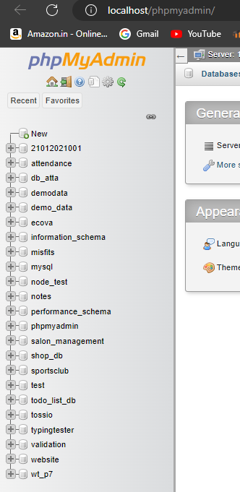 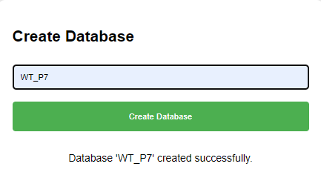

1. **Write a PHP Program to create Customer table at run time with C_Id, C_name, Name_Item_purchased and review_product fields.**

<!DOCTYPE html>

<html>

<head>

<title>Create Customer Table</title>

<style>

body {

font-family: Arial, sans-serif;

background-color: #f0f0f0;

margin: 0;

padding: 20px;

}

#container {

background-color: #fff;

padding: 20px;

border-radius: 10px;

box-shadow: 0px 0px 10px rgba(0, 0, 0, 0.1);

width: 400px;

margin: 0 auto;

}

.message {

margin-top: 20px;

text-align: center;

}

</style>

</head>

<body>

<div id="container">

<h2>Create Customer Table</h2>

<?php

// Connect to MySQL server

$servername = "localhost"; // Change this if MySQL server is running on a different host

$username = "root"; // Your MySQL username

$password = ""; // Your MySQL password

$database = "WT_P7"; // Your MySQL database name

$conn = new mysqli($servername, $username, $password, $database);

// Check connection

if ($conn->connect_error) {

die("Connection failed: " . $conn->connect_error);

}

// SQL query to create customer table

$sql = "CREATE TABLE Customer (

C_Id INT(6) UNSIGNED AUTO_INCREMENT PRIMARY KEY,

C_name VARCHAR(50) NOT NULL,

Name_Item_purchased VARCHAR(100) NOT NULL,

review_product TEXT

)";

if ($conn->query($sql) === TRUE) {

echo "<div class='message'>Customer table created successfully.</div>";

} else {

echo "<div class='message'>Error creating customer table: " . $conn->error . "</div>";

}

// Close connection

$conn->close();

?>

</div>

</body>

</html>

 

1. **Write a PHP program to create ‘customer feedback form’ and store data into Customer table.**

<!DOCTYPE html>

<html>

<head>

<title>Customer Feedback Form</title>

<style>

body {

font-family: Arial, sans-serif;

background-color: #f0f0f0;

margin: 0;

padding: 20px;

}

#container {

background-color: #fff;

padding: 20px;

border-radius: 10px;

box-shadow: 0px 0px 10px rgba(0, 0, 0, 0.1);

width: 400px;

margin: 0 auto;

}

input[type="text"], textarea {

width: 100%;

padding: 10px;

margin: 8px 0;

box-sizing: border-box;

border: 1px solid #ccc;

border-radius: 4px;

}

input[type="submit"] {

background-color: #4CAF50;

color: white;

padding: 14px 20px;

margin: 8px 0;

border: none;

border-radius: 4px;

cursor: pointer;

width: 100%;

}

input[type="submit"]:hover {

background-color: #45a049;

}

.message {

margin-top: 20px;

text-align: center;

}

</style>

</head>

<body>

<div id="container">

<h2>Customer Feedback Form</h2>

<form method="post">

<input type="text" name="customer_name" placeholder="Your Name" required><br>

<input type="text" name="item_purchased" placeholder="Item Purchased" required><br>

<textarea name="feedback" placeholder="Your Feedback" rows="4" required></textarea><br>

<input type="submit" name="submit" value="Submit Feedback">

</form>

<?php

if ($_SERVER["REQUEST_METHOD"] == "POST") {

// Retrieve form data

$customer_name = $_POST['customer_name'];

$item_purchased = $_POST['item_purchased'];

$feedback = $_POST['feedback'];

// Connect to MySQL server

$servername = "localhost"; // Change this if MySQL server is running on a different host

$username = "root"; // Your MySQL username

$password = ""; // Your MySQL password

$database = "WT_P7"; // Your MySQL database name

$conn = new mysqli($servername, $username, $password, $database);

// Check connection

if ($conn->connect_error) {

die("Connection failed: " . $conn->connect_error);

}

// SQL query to insert feedback into Customer table

$sql = "INSERT INTO Customer (C_name, Name_Item_purchased, review_product)

VALUES ('$customer_name', '$item_purchased', '$feedback')";

if ($conn->query($sql) === TRUE) {

echo "<div class='message'>Feedback submitted successfully. Thank you!</div>";

} else {

echo "<div class='message'>Error submitting feedback: " . $conn->error . "</div>";

}

// Close connection

$conn->close();

}

?>

</div>

</body>

</html>

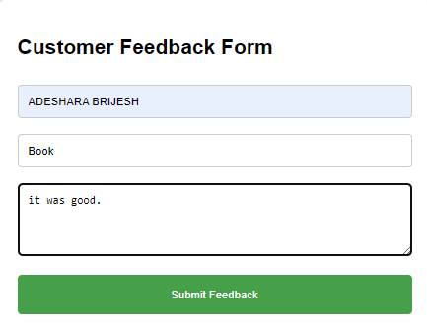 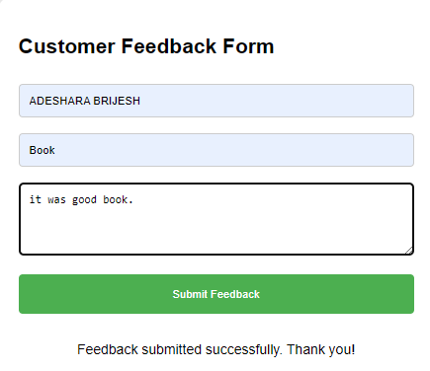

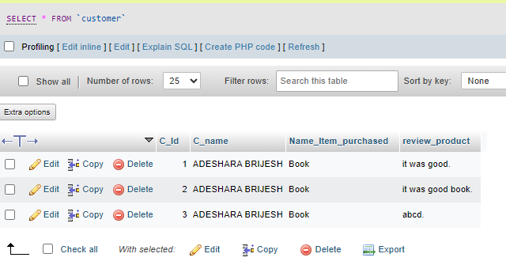

1. **Write a PHP program to display information of Customer table withwell formatting (table form) on output screen.**

<!DOCTYPE html>

<html>

<head>

<title>Customer Information</title>

<style>

body {

font-family: Arial, sans-serif;

background-color: #f0f0f0;

margin: 0;

padding: 20px;

}

table {

width: 100%;

border-collapse: collapse;

margin-bottom: 20px;

}

th, td {

border: 1px solid #ddd;

padding: 8px;

text-align: left;

}

th {

background-color: #f2f2f2;

}

</style>

</head>

<body>

<h2>Customer Information</h2>

<?php

// Connect to MySQL server

$servername = "localhost"; // Change this if MySQL server is running on a different host

$username = "root"; // Your MySQL username

$password = ""; // Your MySQL password

$database = "WT_P7"; // Your MySQL database name

$conn = new mysqli($servername, $username, $password, $database);

// Check connection

if ($conn->connect_error) {

die("Connection failed: " . $conn->connect_error);

}

// SQL query to retrieve data from Customer table

$sql = "SELECT * FROM Customer";

$result = $conn->query($sql);

if ($result->num_rows > 0) {

// Output data in table format

echo "<table>";

echo "<tr><th>C_Id</th><th>C_name</th><th>Name_Item_purchased</th><th>review_product</th></tr>";

while($row = $result->fetch_assoc()) {

echo "<tr>";

echo "<td>" . $row["C_Id"] . "</td>";

echo "<td>" . $row["C_name"] . "</td>";

echo "<td>" . $row["Name_Item_purchased"] . "</td>";

echo "<td>" . $row["review_product"] . "</td>";

echo "</tr>";

}

echo "</table>";

} else {

echo "No data found.";

}

// Close connection

$conn->close();

?>

</body>

</html>

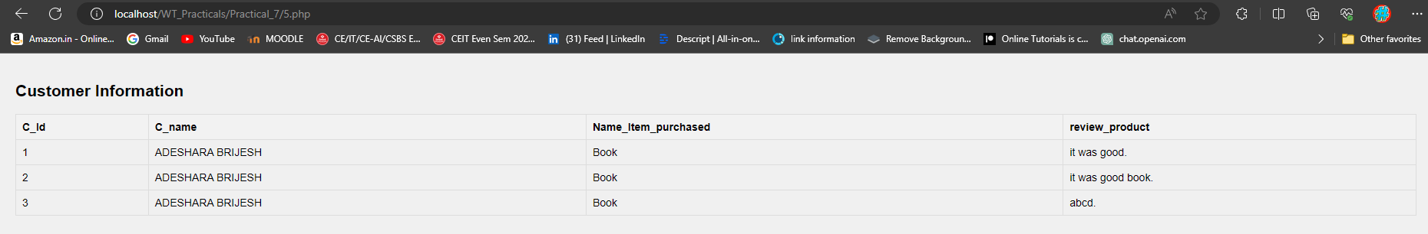

1. **Write a PHP Program to create table at run time by passing table name and no. of fields through text boxes same as PHPMYADMIN interface.**

<!DOCTYPE html>

<html>

<head>

<title>Create Table</title>

<style>

body {

font-family: Arial, sans-serif;

background-color: #f0f0f0;

margin: 0;

padding: 20px;

}

#container {

background-color: #fff;

padding: 20px;

border-radius: 10px;

box-shadow: 0px 0px 10px rgba(0, 0, 0, 0.1);

width: 400px;

margin: 0 auto;

}

input[type="text"] {

width: 100%;

padding: 10px;

margin: 8px 0;

box-sizing: border-box;

border: 1px solid #ccc;

border-radius: 4px;

}

input[type="number"] {

width: 100%;

padding: 10px;

margin: 8px 0;

box-sizing: border-box;

border: 1px solid #ccc;

border-radius: 4px;

}

input[type="submit"] {

background-color: #4CAF50;

color: white;

padding: 14px 20px;

margin: 8px 0;

border: none;

border-radius: 4px;

cursor: pointer;

width: 100%;

}

input[type="submit"]:hover {

background-color: #45a049;

}

.message {

margin-top: 20px;

text-align: center;

}

</style>

</head>

<body>

<div id="container">

<h2>Create Table</h2>

<form method="post">

<input type="text" name="table_name" placeholder="Enter table name" required><br>

<input type="number" name="num_fields" placeholder="Number of fields" min="1" required><br>

<?php

// Display input fields for field names

if ($_SERVER["REQUEST_METHOD"] == "POST") {

$num_fields = $_POST['num_fields'];

for ($i = 1; $i <= $num_fields; $i++) {

echo "<input type='text' name='field_name_$i' placeholder='Field $i Name' required><br>";

}

}

?>

<input type="submit" name="submit" value="Create Table">

</form>

<?php

if ($_SERVER["REQUEST_METHOD"] == "POST") {

// Retrieve table name and number of fields from form submission

$table_name = $_POST['table_name'];

$num_fields = $_POST['num_fields'];

// Construct SQL query to create the table

$sql = "CREATE TABLE $table_name (";

for ($i = 1; $i <= $num_fields; $i++) {

$field_name = $_POST["field_name_$i"];

$sql .= "$field_name VARCHAR(255) NOT NULL";

if ($i < $num_fields) {

$sql .= ",";

}

}

$sql .= ")";

// Connect to MySQL server

$servername = "localhost"; // Change this if MySQL server is running on a different host

$username = "root"; // Your MySQL username

$password = ""; // Your MySQL password

$database = "WT_P7"; // Your MySQL database name

$conn = new mysqli($servername, $username, $password, $database);

// Check connection

if ($conn->connect_error) {

die("Connection failed: " . $conn->connect_error);

}

// Execute SQL query to create the table

if ($conn->query($sql) === TRUE) {

echo "<div class='message'>Table '$table_name' created successfully.</div>";

} else {

echo "<div class='message'>Error creating table: " . $conn->error . "</div>";

}

// Close connection

$conn->close();

}

?>

</div>

</body>

</html>

 