**Practical 3**

**Aim:-** **Draw the Use case, Class, Activity, Sequence and state Diagram For given Case Study .**

**Note:** You will draw this diagrams for the system you have already chosen in the last practical of requirement elicitation.

**Online Food Ordering System**

**Use Case Diagram:**

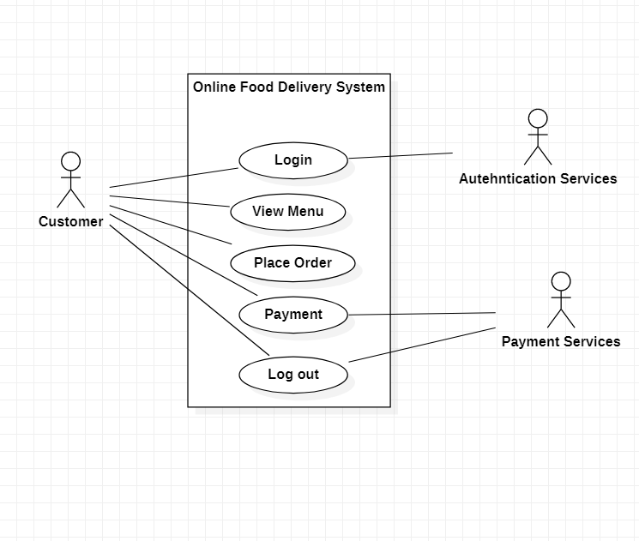

**Class Diagram:**

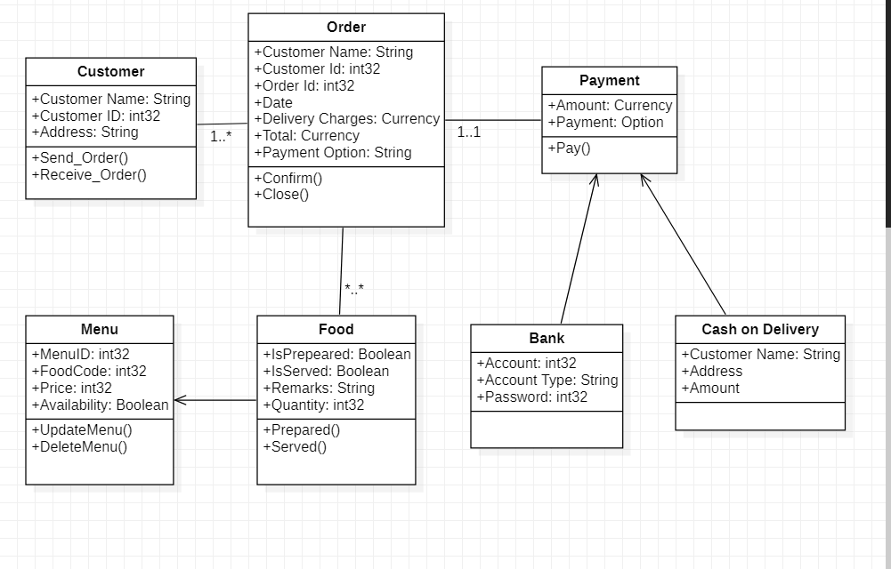

**Activity Diagram :**

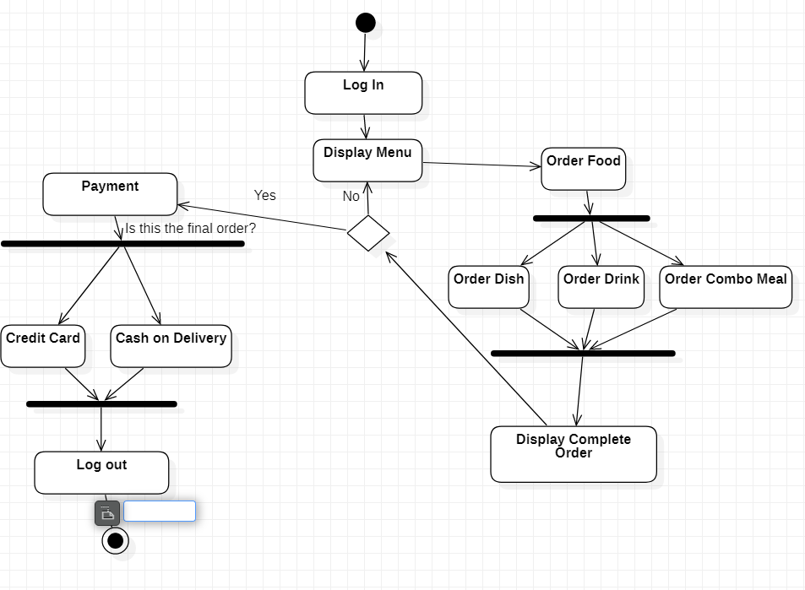

**Sequence Diagram:**

