**Practical 7**

**Aim**:- **To Study about Structure System analysis and Design method**

**( SSADM).**

**Objective :** To get familiar with Structure Approach Method and learn various Techniques

of SSADM to model a System.

**References**: Software Engineering by Roger Pressman, Software Engineering by K.K.

Aggarwal, Software Engineering by Rajib mall.

**Prerequisite:** Knowledge of Data Modeling, Functional Modeling.

**Summary:** Structured Systems Analysis and Design Methodology (SSADM) is a systems approach to the analysis and design of information systems. SSADM uses a combination of three techniques: Logical Data Modeling, Data Flow Modeling, and Entity Behavior Modeling. System analysis is major focus on “what” the system is accomplished, not how. SSADM uses various Modeling tools to represent the data flows, processing and data stores like data flow diagrams, data dictionary, process specification, entity-relationship diagrams.

**1 ) Online Library Management System ( LMS )**

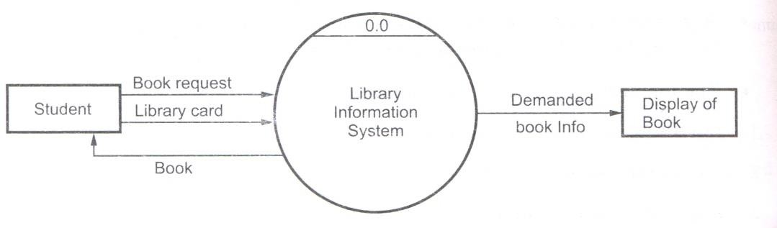

**Figure 1 DFD at level­0 Library Information System**

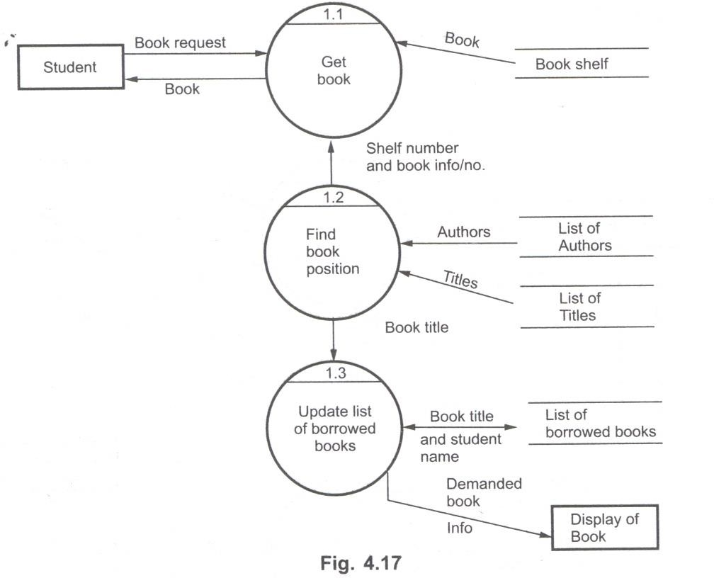

**Figure 3 DFD at level­1 of library management system**

**2 ) Online Railway Reservation System ( RRS )**

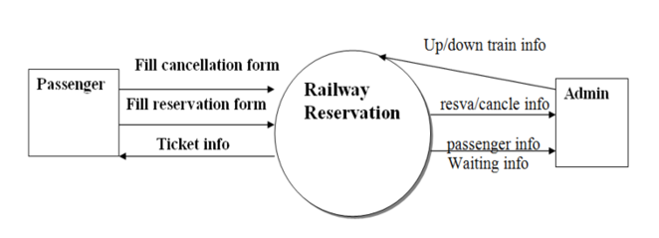

**Figure 4 DFD at level­0 Online Railway Reservation System**

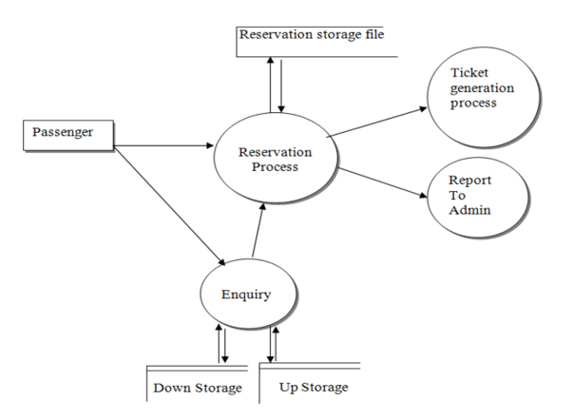

**Figure 5 DFD at level­1 Online Railway Reservation System**

**Lab Assignmrnt :**

**1] What is the Difference between CLD and DFD?**

Ans.

**Context Level DFD**

A context level DFD is the most basic form of DFD. It aims to show how the entire system works at a glance. There is only one process in the system and all the data flows either into or out of this process. Context level DFD’s demonstrates the interactions between the process and external entities. They do not contain Data Stores.

**Level 1 DFD**

Level 1 DFD’s aim to give an overview of the full system. They look at the system in more detail. Major processes are broken down into sub-processes. Level 1 DFD’s also identifies data stores that are used by the major processes

**2] Discuss about Various notation of DFD and DFD Rules.**

Ans.

**DFD Rules**

* Name of source, destination & data store must be capital letters.
* Process should be named & numbered.
* If a process is divided into sub-process, then each sub-process must be named & numbered.
* Name of process & data flow should have 1st character of each word must be capital & all other letters in small.

**DFD Notations**

* Circle is used to denote a process.
* Rectangle is used to denote source/destination.
* Arrow (->) is used to denote Data flow.
* Two Parallel Lines are used to denote Data Store.

|  |  |  |
| --- | --- | --- |
| **Symbol** | **Meaning** | **Example** |
|  | External Entity  The External Entity Symbol represents sources of data to the system or destination of data from system |  |
|  | Process  Process symbol represents an activity that transform or manipulate the data (combines ,recorders ,converts, etc ) |  |
|  | Data Store  This symbol represents the data that is not moving ,data can be written into the data store.Data can be read from a data store. |  |
|  | Data Flow  It Represents the Movement of data |  |