**Practical – 2**

**Aim: Draw the Use Case Diagram, Class diagram, Activity diagram and Sequence diagram for following Case studies.**

1. **BOOK Store in Shopping Mall**

**Consider a book store in a shopping mall. The customer selects the books from racks to purchase. The customer brings selected books to cashier. The cashier scans each item with checkout system to prepare an order. The cashier requests to customer for payment. The customer gives credit card to cashier. The verifier and checkout system scans the card. The verifier accepts the card and payment is accepted. Customer signs the credit card slip. The purchased books are handed over to customer.**

**Use case Diagram:**

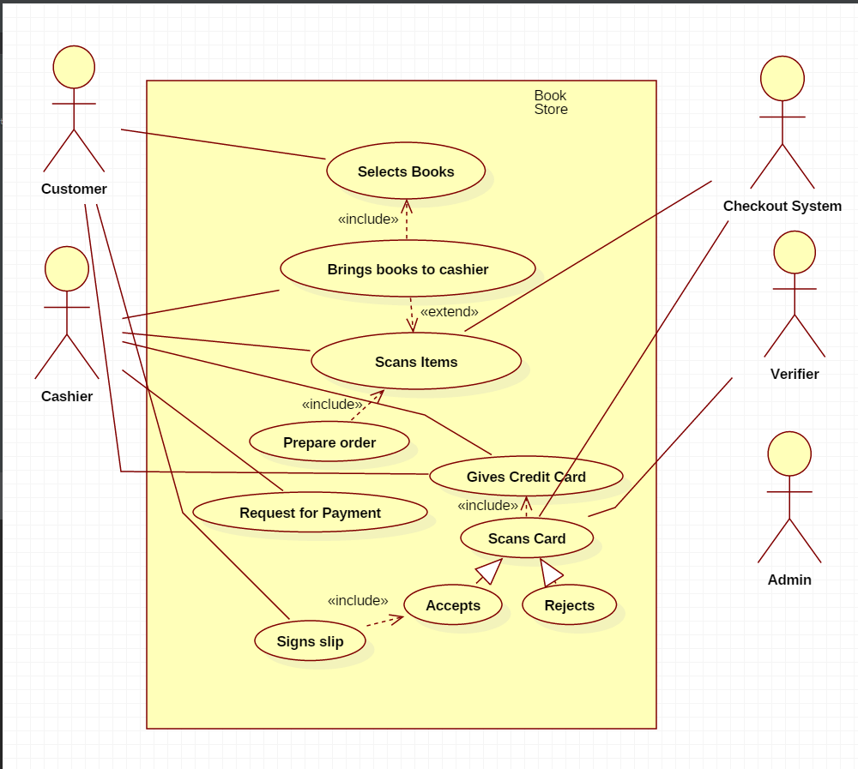

**Class Diagram:**

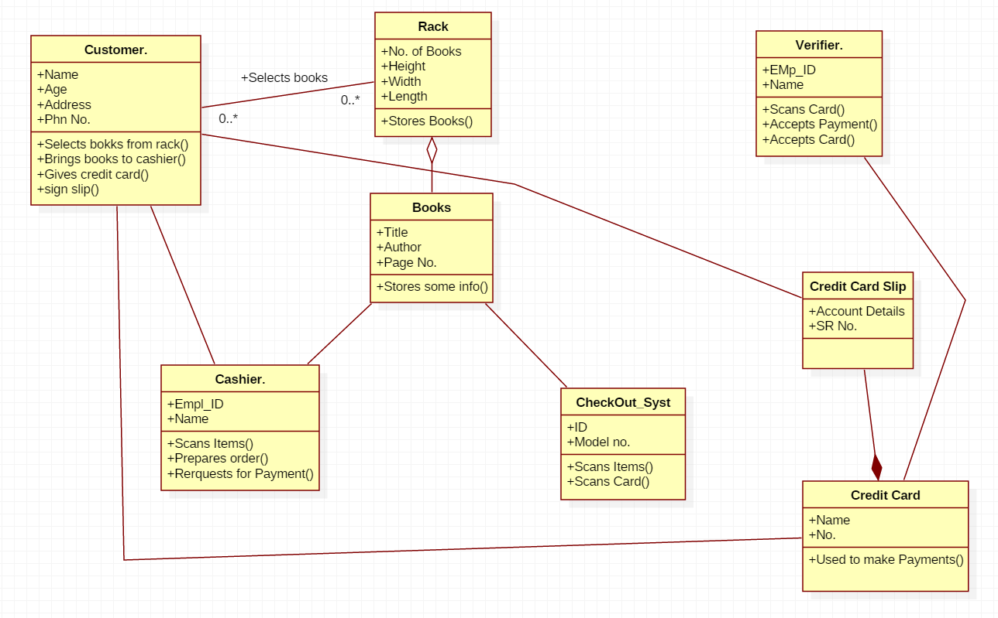

**Activity Diagram:**

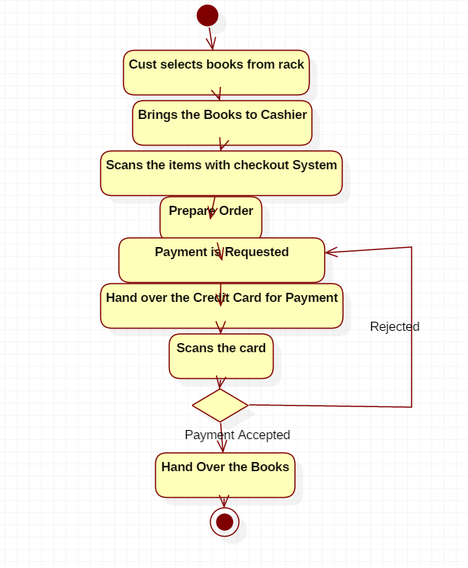

**Sequence Diagram:**

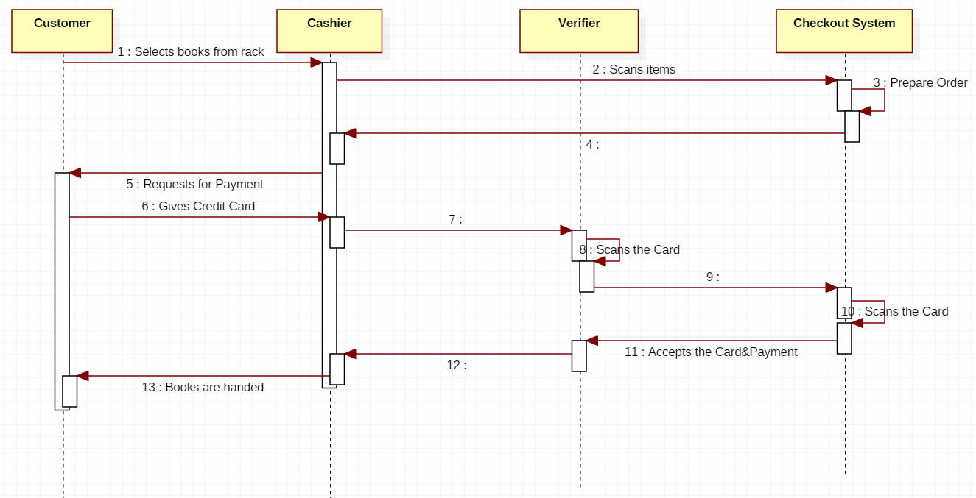

**State Diagram:-**

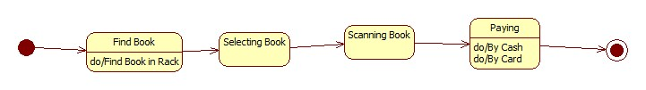

1. **HOSPITAL Management System**

**System helps in registering information about patients and handles patient’s query. A unique ID is generated for each patient after registration for maintains medical history of patient. System also monitors the doctor appointments, when the ID is generated the patient receives the appointment time and number from the receptionist and accordingly visits the doctor. This system also deals with testing appointments as and when ID is generated the patient receives the appointment time and number and accordingly undergoes the test. It also deals with bed allotments to various patients by checking their ID. It also undergoes various operations by diagnosing the patients. The system identifies whether the person is a doctor or staff and handles various activities such as draw salary and gives salary, also it adds doctor/staff information into database. This system is responsible for handling various other activities like deleting, editing doctor/staff information into the database. As per doctor diagnoses the patient, gives treatment and gives suggestions to patients and prescribe laboratory tests and medicines. This system also takes care of medical equipment, doctor visit, vitals recording, patient case sheet, diet ordering, blood requisition, transfer information and discharge information, maintenance of wards, inter and intrawards transfers also it generates patient’s discharge summary which includes patients health at the time of discharge, medical history, various diagnosis and drug prescriptions, history of patients illness and course in hospital. Patient can pay bill through credit card, cash or cheque whose information is maintained by this system.**

**Use case Diagram:**

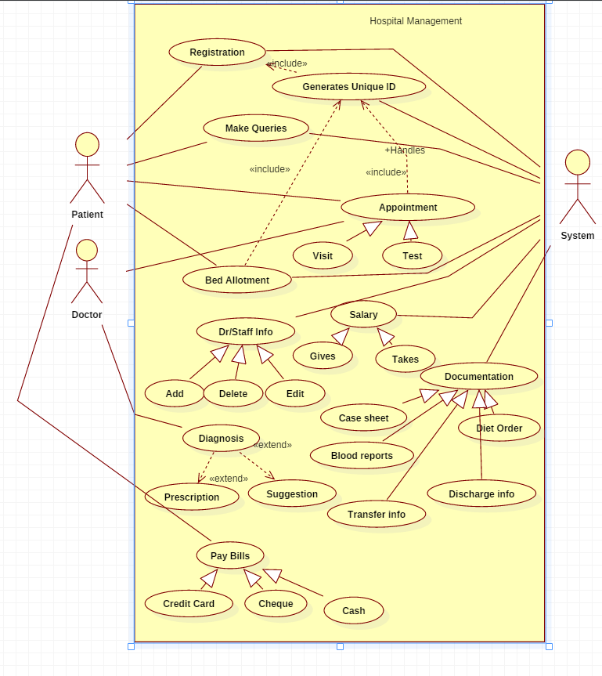

**Class Diagram:**

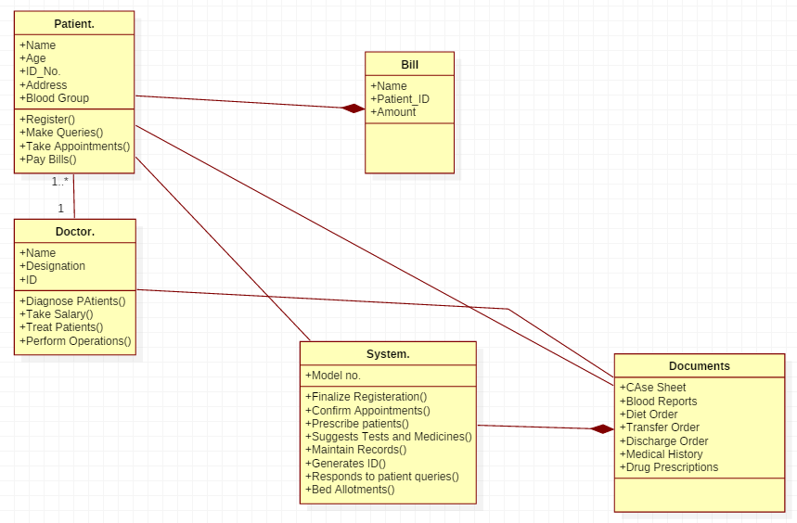

**Activity Diagram:**

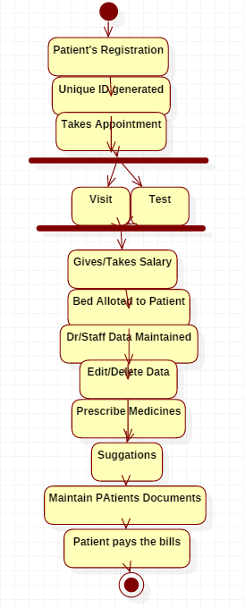

**Sequence Diagram:**

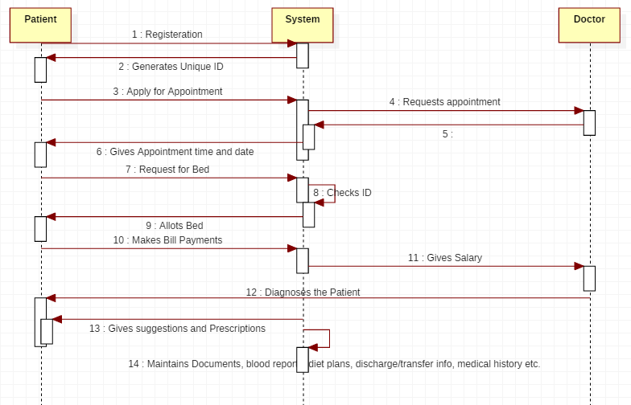

**State Chart Diagram :- Patient**

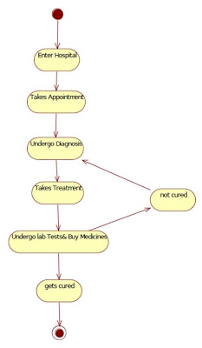

**State Chart Diagram :- Doctor**

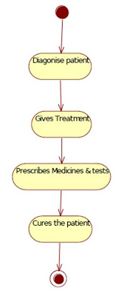

**State Chart Diagram:- System**

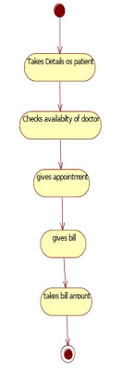

1. **RETAIL Store Management**

**The Retail Store Management System is a system designed for managing i.e. for ordering, arranging and selling goods. The Retailer checks for the availability of goods in the store. If the stock of goods is less then retailer places order for goods. While ordering the goods, goods area received at store, the retailer then arranges them by product or by price, and then retailer makes payment. If the stock of goods is available then he will arrange goods for selling. The retailer then sales the goods directly to the customer. The customer buys the items from retailer. The retailer prepares bill for goods purchased by the customer, he receives amount by credit or by cash from customer. The supplier supplies the goods to the store in the system. The overall system is used to manage the goods in the store.**

**Use case Diagram:**

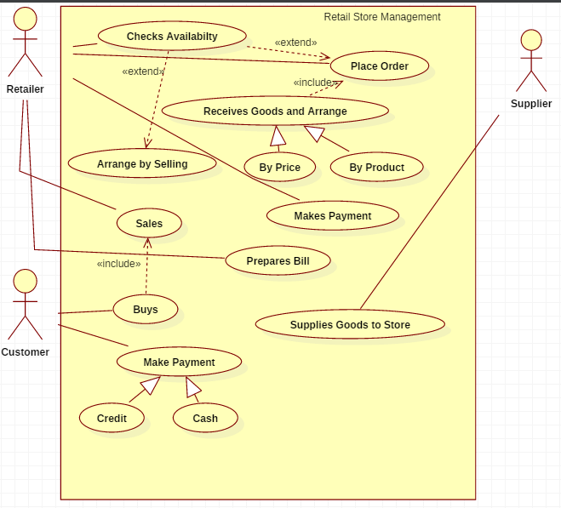

**Class Diagram:**

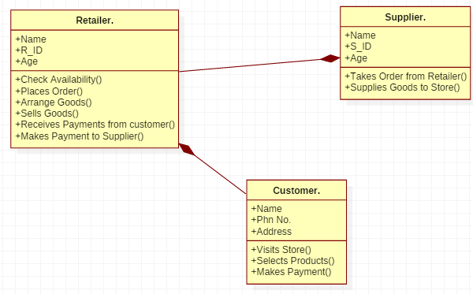

**Activity Diagram:**

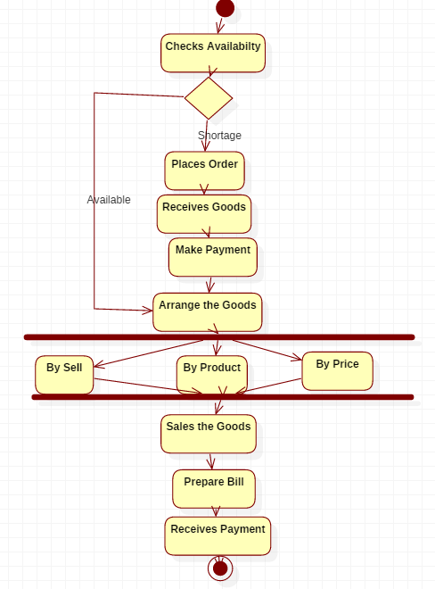

**Sequence Diagram:**

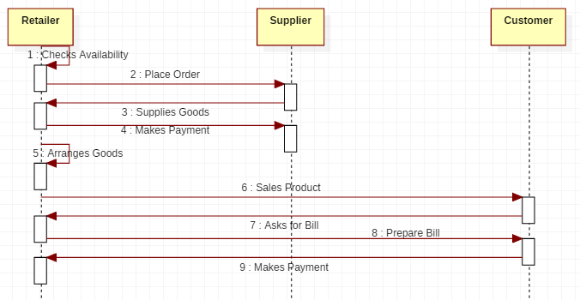

**State diagram:**

