**Practical 6**

**Aim**:- Prepare Software requirement specification (SRS) document.

**Online Leave Management System**

**Software Requirements**

**Specification**

**for**

**On-line Leave**

**Management System**

**Table of Contents**

|  |  |  |  |
| --- | --- | --- | --- |
| **Table of Contents.........................................................................................................** | | | **ii** |
|  | | |  |
| **1.** | **Introduction.............................................................................................................** | | **3** |
|  | 1.1 | Purpose................................................................................................................................ | 3 |
|  | 1.2 | Document Conventions ....................................................................................................... | 3 |
|  | 1.3 | Intended Audience and Reading Suggestions.................................................................... | 3 |
|  | 1.4 | Product Scope..................................................................................................................... | 3 |
|  | 1.5 | References........................................................................................................................... | 4 |
| **2.** | **Overall Description..................................................................................................** | | **4** |
|  | 2.1 | Product Perspective............................................................................................................. | 4 |
|  | 2.2 | Product Functions ................................................................................................................ | 5 |
|  | 2.3 | User Classes and Characteristics....................................................................................... | 6 |
|  | 2.4 | Operating Environment........................................................................................................ | 6 |
|  | 2.5 | Design and Implementation Constraints............................................................................. | 6 |
|  | 2.6 | User Documentation............................................................................................................ | 7 |
|  | 2.7 | Assumptions and Dependencies......................................................................................... | 7 |
| **3.** | **External Interface Requirements............................................................................** | | **7** |
|  | 3.1 | User Interfaces..................................................................................................................... | 7 |
|  | 3.2 | Hardware Interfaces............................................................................................................ | 8 |
|  | 3.3 | Software Interfaces.............................................................................................................. | 8 |
|  | 3.4 | Communications Interfaces................................................................................................. | 8 |
| **4.** | **System Features......................................................................................................** | | **8** |
|  | 4.1 | System Feature 1................................................................................................................. | 8 |
|  | 4.2 | System Feature 2 (and so on)............................................................................................. | 9 |
| **5.** | **Other Nonfunctional Requirements.......................................................................** | | **12** |
|  | 5.1 | Performance Requirements................................................................................................. | 12 |
|  | 5.2 | Safety Requirements........................................................................................................... | 12 |
|  | 5.3 | Security Requirements........................................................................................................ | 13 |
|  | 5.4 | Software Quality Attributes.................................................................................................. | 13 |
|  | 5.5 | Business Rules.................................................................................................................... | 13 |
| **6.** | **Other Requirements................................................................................................** | | **13** |
| **Appendix A: Glossary..................................................................................................** | | | **5** |
| **Appendix A: Analysis Models......................................................................................** | | | **13** |
| **Appendix C: To Be Determined List............................................................................** | | | **6** |

**1. Introduction**

**1.1Purpose**

This project is aimed at developing a PKI based work flow for on-line and mobile based leave management system that is of importance to an organization. The Leave Management System (LMS) is an Internet based application that can be accessed throughout the organization or a specified Group/Dept. This system can be used to automate the work flow of leave applications and their approvals. The periodic crediting of leave is also automated. There are features like email notifications, cancellation of leave, automatic approval of leave, report generators etc in this system.

**1.2 Document Conventions**

The format of this document is referred from the standard IEEE guidelines:

* Font face : Arial
* Font size

|  |  |
| --- | --- |
| · Heading | : 18 |

* Sub-heading : 14
* Bold face and indentation is used on general topics and or specific points of interest including the heading and sub-heading.

**1.3 Intended Audience and Reading Suggestions**

This document is mainly intended for project guides, developers and module coordinator (OOSP). The sequence for reading the document begins with the overview sections and proceeding through the sections that are most pertaining to each reader type.

**1.4 Product Scope**

The scope of this project:

A PKI based leave management system that automate the functionalities of the leave management.

The domain of this system is based on CDAC Bangalore Electronic city branch.

The target user is the HR Manager, Project Manager, Technical staffs and Non Technical staff.

The main objective to develop this system is to automate the current leave application and record that is manually processed in CDAC branch.

This system automatically calculates leave balance from a fix amount of annual leave and show to the user.

It enables the Managers to record inapplicable leave in systematic database system.

Generate statistical report of employees in order to be used in evaluating the performance of an employee in CDAC Bangalore branch.

Improve the mechanism of receiving, approving and rejecting leave application through system.

**1.5 References**

**Books :**

* 1. Jeffery A. Hoffer, Joey F. Geroge and Joseph S. Valacich, “Modern System Analysis And Design”, Ed. 3rd. India: Pearson Education (Singapore) Pte. Ltd, 2002.
  2. C.J. Date, “An Introduction to Database System”, Ed. 7th. India: Pearson Education Singapore).Pte. Ltd, 2002.
  3. Craig Larman, “Applying UML And Patterns”, Ed. 2nd. India: Pearson Education (Singapore) Pte. Ltd, 2002.

1. **Overall Description**

**2.1 Product Perspective**

***Leave Management Software*** facilitates the effective and smooth management of personnelleave. The Human Resources Department can always be up to date with their leave management. With comprehensive reporting and Web based applications. This system facilitates the total leave process, from completing leave applications by employees, leave application approval by HR & management to setting up your specific company parameters such as leave types (sick leave, Annual leave, etc.).

**Administrative Settings**

* Choose the **types of leave** allowed - Sick, Annual, Family Responsibility, Maternity, Study, Unpaid, etc.
* Choose the **number of days** allowed for each of the types. A **default** is set for all the employees, but admin can also modify it per employee.
* Leave can be **allocated** annually or monthly depending on your company policies.
* Choose the persons to be **notified** when leave requests are received.

**Employees**

* An leave **summary** shows the employee, how many leaves are available, how many they have taken and the status of their leave applications.
* Easily **apply** for leave choosing the required leave type and amount of hours or days.
* Employees can upload **supporting documentation**, such as university documents or sick notes when they apply for leave.
* The **Leave Management Software** is completely **secure**, thus employees can't view each other's leave statuses.

**Leave processing and reporting**

* A **notification** is received by relevant manager/s when a leave application is submitted by an employee.
* The relevant manager can then log in and choose to **approve or reject an** **application**. Reasons can also be provided. The employee will be notifiedonce the leave application is approved or rejected.
* A **summary** can be selected whereby management, HR or the persons tasked with managing the employees leave can **search** via an employee and leave year, to get a summary of the employees current leave applications as well as his outstanding leave days per category such as sick leave, maternity leave, yearly leave etc.
* We make **reports** on Leave Management System. Simply select data to include in your reports such as department, employee name, leave year, leave status, dates and the output format for example **HTML, PDF,Excel,** **XML** and **DOC** etc....

**2.2 Product Functions**

On-line application for leave without the need for paperwork. Email notifications to approving officer and applicants.

Applicant and Approving Officer can see complete leave records and approval history respectively.

Leave records are updated automatically once applications are approved. Leave records may be printed out or generated into reports.

Leave records may be exported to any back-end system.

Advanced Features such as block leave, document tracking, leave adjustment. Leave calendar provides a bird's eye view of who's on leave.

All leave policies are configurable (i.e no software customization required).

**2.3 User Classes and Characteristics**

There are three types of users :

|  |  |  |  |
| --- | --- | --- | --- |
|  |  |  |  |
| **Type Of User** | **Privilege Level** | **Experience Level** | **Technical Expertise** |
| Super Admin | High (Can access the | High (should have the | High (Should be a proficient |
|  | entire database) | knowledge DBMS and | with MYSQL and Java |
|  |  | system management) | Application Servers) |
| HR Manager | Medium (Can register | Medium (Should have | Medium (Should know the |
|  | and access the | the knowledge of the | system rules and well |
|  | employee records under | rules related to | trained/skilled to handle the |
|  | his department) | organization and the | system effectively) |
|  |  | functions of HR Manager) |  |
| Employee | Low ( Will be able to | Low ( No prior | Low (No technical expertise |
|  | access data pertaining to | experience required) | required) |
|  | himself only) |  |  |



**2.4 Operating Environment**

|  |  |  |
| --- | --- | --- |
| **Web Interface :** | Windows XP and later, Mac OS, Linux |  |
| Operating Systems : |  |
| Hardware Platform : | Pentium IV and later |  |
| Software (Web Browsers) : | Mozilla 2.0 and later, Google Chrome, IE 7.0 or later |  |
| **Mobile Interface:** | Android or Java Based Mobile OS |  |
| Operating Systems : |  |
| Hardware Platform : | Android Mobile/ Smart Phones with memory card. |  |
| Software : | CDAC Leave App |  |

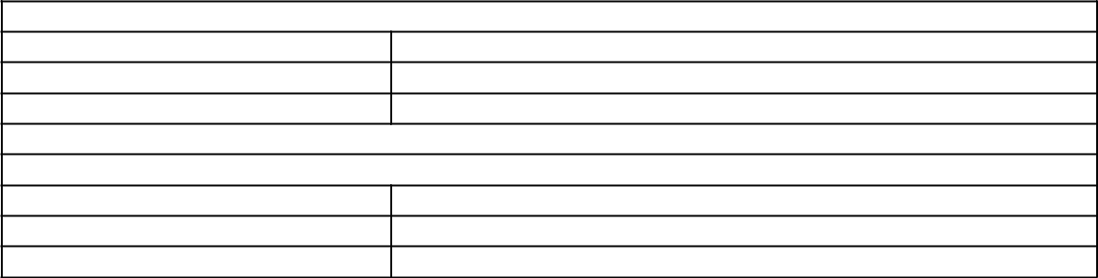

**2.5 Design and Implementation Constraints**

**For Web Interface:**

1. Browser must be allowed to access file system.
2. System must allow JVM to run the applet under the browser memory.
3. User must have his private key available on the local file system

**Mobile Interface:**

1. User must have his private key available on the local file system.
2. CDAC Leave App should be installed on the mobile.

**2.6 User Documentation**

|  |  |  |
| --- | --- | --- |
|  |  |  |
| **Documents** | **Description** | **Format** |
| User Manual | This document describes the how to use system | PDF,EPUB |
|  | features. |  |
| On-Line Help | Online help will contain the information about system | Web pages. |
|  | controls. |  |
| Tutorials | A document with snap-shots that describes each | PDF |
|  | function of the system in detail and how to perform |  |
|  | them. |  |



**2.7 Assumptions and Dependencies**

**It is assumed that :**

* 1. User has the basic knowledge of computer.
  2. Internet connectivity is intermittent in both system and mobile.

1. **External Interface Requirements**

**3.1 User Interfaces**

UI-1: The Leave Management System screen displays shall conform to the Process Impact Internet Application User Interface Standard, Version 2.0 [4].

UI-2: The system shall provide a help link from each displayed HTML page to explain how to use that page.

UI-3: The Web pages shall permit complete navigation and function selection using the keyboard alone, in addition to using mouse and keyboard combinations.

UI-4: Main Menu, Header, Footer will be common in all the pages.

**Header:** Header contains **logo** and the search box.

**Footer :** Footer contains the legal links and copyright information andfooter menu that contains links like **contact information**, **about us** and **site map** etc.

**3.2 Hardware Interfaces**

No hardware interfaces have been identified.

**3.3 Software Interfaces**

|  |  |
| --- | --- |
| Operating System | Windows XP and later, Ubuntu, Red Hat 7.0 or later, |
|  | fedora, Open Suse any version, Cent OS etc. |
|  |  |
| Softwares Tools : | Eclipse Helios , Android SDK 2.3, J2ME SDK 3.0 |
|  |  |
| Database : | MYSQL 5.1 |
|  |  |
| Application Server : | Apache Tomcat Version : 6.0 |
|  |  |
| Open Source Libraries : | Jasper Report, JQuery UI, iText, LWUTI, Java Mail |
|  | API |
|  |  |

**3.4 Communications Interfaces**

CI-1 A web based interface where user can interact with the system to perform various functions.

CI-2 **A mobile based interface for :**

**User**: Applying and viewing the status of the application.

**Admin**: Approving and denying application.

CI-3: The Leave Management System shall send notifications (via e-mail and SMS) to the applicant and managers related to various events like approval/deny of application, Expiration Alert in the case of user's Digital Certificate expiration.

CI-4: A monthly/weekly/yearly report is sent to the user through email.

**4. System Features**

System features are organized by use cases and functional hierarchy so that the main functions of the system will be understandable.

**4.1 Login**

4.1.1 Description and Priority

Users of the system can use the system features only after the login. Login is used for identify the user is authenticated or not.

Priority: High

|  |  |
| --- | --- |
| 4.1.2 Stimulus/Response Sequences | |
| 4.1.2.1 **Basic Flow:** | |
| 1. | Open the login page. |
| 2. | Enter login credential (user-Id and password). |
| 3. | Click on the Login button. |
| 4. | Validate the user. |
| 5. | User Homepage is shown. |

4.1.2.2 **Alternate Flow:**

*1.* If user and password does not match then it show error message.

2. Again same page is opened and asking for correct login credential.

4.1.3 Functional Requirements

REQ-1: User-id and Password is required.

**4.2 Employee Registration**

4.2.1 Description and Priority

Employee registration is done by HR Manager. It requires all the details related to that employee. It is necessary for all the employee.

Priority: High.

4.2.2 Stimulus/Response Sequences

|  |  |
| --- | --- |
| 4.2.2.1 Basic Flow: | |
| 1. | Login to the system as HR Manager. |
| 2. | Open the Employee Registration page. |
| 3. | Fill all the details of employee. |
| 4. | Click on the Register button. |
| 5. | Validate all the fields and ask for Confirmation. |
| 6. | Confirmation Message shown for Successfully Registered. |
| 4.2.2.2 Alternate Flow: | |
| *1.* | If any detail is missing or wrong then it show error message. |
| 2. | Again same page is opened and asking for correct input. |

4.2.3 Functional Requirements

REQ-2: Details of the employee.

**4.3 Recover Forgot Password**

4.3.1 Description and Priority

If user forgot the password then he can ask for reset of password.

Priority: High.

4.3.2 Stimulus/Response Sequences

|  |  |
| --- | --- |
| 4.3.2.1 **Basic Flow:** | |
| 1. | Open the login page. |
| 2. | Click on the Forgot Password button. |
| 3. | Fill the User -Id for recovery of password. |
| 4. | Click on the Reset password button. |
| 5. | New password is sent on his/her email. |
| 6. | Confirmation message is shown to user. |

4.3.2.2 **Alternate Flow:**

*1.* If user-Id does not exist in system then it show error message.

2. Again same page is opened and asking for correct User-Id.

4.3.3 Functional Requirements

REQ-3: User-Id of the user.

**4.4 View Profile**

4.4.1 Description and Priority

A user profile is collection of his/her personal details, leave application and leave information. In profile user can also view the available notifications.

Priority: Medium

4.4.2 Stimulus/Response Sequences

4.4.2.1 Basic Flow:

1. Login into the system.

2. Click on View Profile Button.

3. User profile is shown to user.

4.4.3 Functional Requirements

REQ-4: User has to login.

**4.5 Apply for Leave**

4.5.1 Description and Priority

Leave application is submitted by user for taking leave. User can select the type of the leave and also submit a document related to leave reason or any other document.

Priority: High.

4.5.2 Stimulus/Response Sequences

|  |  |
| --- | --- |
| 4.5.2.1 **Basic Flow:** | |
| 1. | Login into system. |
| 2. | Click on Apply Leave button. |
| 3. | Select the leave type. |
| 4. | Fill all the required details. |
| 5. | Click on Apply button. |
| 6. | Validate the form and ask for Confirmation. |
| 7. | Confirmation message is shown to user. |

4.5.2.2 **Alternate Flow:**

*1.* If any field is missing or incorrect then it shows error message.

2. Again same page is opened that asks for correct Data.

4.5.3 Functional Requirements

REQ-5: Leave type is required.

**4.6 Approve/Reject Leave**

4.6.1 Description and Priority

Leave application submitted by employee can be viewed by HR Manager. After that checking all the details of application Hr manager can approve or reject the leave application.

Priority: High.

4.6.2 Stimulus/Response Sequences

|  |  |
| --- | --- |
| 4.6.2.1 **Basic Flow:** | |
| 1. | Login into system. |
| 2. | Click on Apply Leave button. |
| 3. | Select the leave type. |
| 4. | Fill all the required details. |
| 5. | Click on Apply button. |
| 6. | Validate the form and ask for Confirmation. |
| 7. | Confirmation message is shown to user. |

4.6.2.2 **Alternate Flow:**

*1.* If any field is missing or incorrect then it show error message.

2. Again same page is opened and asking for correct Data.

4.6.3 Functional Requirements

REQ-6: Leave History is required.

**4.7 View Notification**

4.7.1 Description and Priority

Notification about leave application will sent to related authority. And Notification about status of the application is also sent to employee.

Priority: High.

4.7.2 Stimulus/Response Sequences

4.7.2.1 **Basic Flow:**

1. Login into system.

2. Click on Notification button.

3. List of notification is shown.

4.7.3 Functional Requirements

REQ-7: Notification is available for the user.

**4.8 View Leave History of Employees :**

4.8.1 Description and Priority

Leave history contains the details of all the Leave Application History and available Leaves for that user.

Priority: High.

4.8.2 Stimulus/Response Sequences

4.8.2.1 **Basic Flow:**

1. Login into system.

2. Click on Leave History button.

3. History of leaves applications is shown to the user.

4.8.2.2 **Alternate Flow:**

*1.* If any field is missing or incorrect then it show error message.

2. Again same page is opened and asking for correct Data.

4.8.3 Functional Requirements

REQ-8: Leave History is required.

**4.9 Set Rules**

4.9.1 Description and Priority

Administrator will set the leave rules. Administrator can also add new rules and modify existing rules.

4.9.2 Stimulus/Response Sequences

4.9.2.1 **Basic Flow:**

1. Open the administrator login page.

2. Login as administrator.

3. Add, Modify rules for employee.

4.9.3 Functional Requirements

REQ-9: User must have administrator privilege.

**5. Other Nonfunctional Requirements**

**5.1 Performance Requirements**

As this is a web application hence it is not a resource hog and will run on almost every computer. Its functions and features are not computationally intensive. It does not require a powerful processor or graphics card, much RAM, or disk space. It only requires a latest browser.

**5.2 Safety Requirements**

This application as all the other web application requires the Internet availability, and is also requires that the user should keep his private keys safe and secure and the same should not be shared with any one.

**5.3 Security Requirements**

User should keep his key safe. The system or the place where the key is stored should not be public. In the case if the user loses his key then he/she should immediately inform the system admin.

**5.4 Software Quality Attributes**

**Client Side Quality Attributes:**

The application provides a quite user-friendly interface with its operations accessible from the menu bar and the main toolbar. An average or casual user should not find any problem using the program to perform at least its main functions.

Interoperability is guaranteed since this program runs on both Mac and PC (Linux, Windows or other operating system).

**Server Side Quality Attributes:**

Along with that our system provides the server which is scalable so that it can meet up any future requirements and is easily upgradeable.

Admin can take a backup on a regular interval so in case of any failure or damage system can be restored easily.

**5.5 Business Rules**

**Administrative Tasks:**

1. Can approve or deny the leave applications of the employees working under his hierarchy.
2. Can see the leave history of a particular employee.
3. Can define the custom rules in the system.
4. Can generate the report.

**User Tasks :**

* 1. Can view his leave balance.
  2. Can apply for new leave and check the status of the application(s).

1. **Other Requirements**

LMS is not a free software, you can not use it without the prior permission of C-DAC Bangalore author

**Appendix A: Analysis Models**

**Use Case Diagram :**



**Context Diagram :**

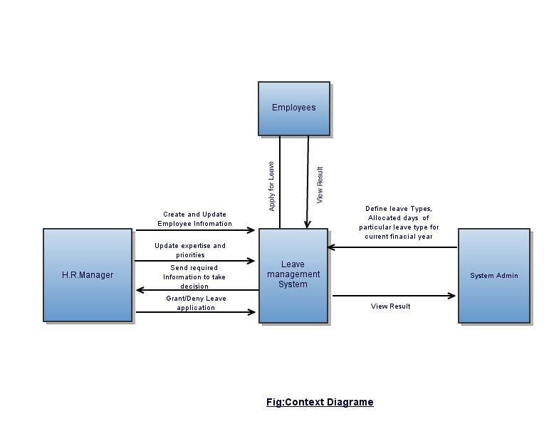

**System flow :**



**Class Diagram :**

|  |
| --- |
|  |

**Activity Diagram :**

|  |
| --- |
|  |

**Sequence Diagram :**

|  |
| --- |
|  |