**Practical 5**

**Aim**:- To study about various Project Management Software (tools) available in the market.

**Project Management Softwere Tools**

1 . ProofHub

2 . Paymo

3 . Scoro

4 . FreshBooks

5 . WorkBook

6 . Easy Project

7 . Redbooth

8 . nTask

9 . Asana

10. Podio

**ProofHub**

**What is ProofHub ?**

* ProofHub is a cloud – hosted project management solution that helps you to stay on top of deliverables and deadlines. It has scalable features and pay terms that match the requirements of any business size from small startups to large enterprise. The Walnut, CA-based company has attracted big ticket clients, such as, TripAdvisor, Harvard University, and Wipro, since the software was launched in 2011. Likewise, ProofHub was among the Cloudswave Awards 2014 top ten project management software for excellent features and performance. Recently, the company introduced ProofHub Bolt apps for Android and iOS users, which made their project management service available even out of the office.

|  |
| --- |
|  |

**Overview Of ProofHub Benefits**

**Easy to use**

* Functions and tools are straightforward and intuitive for a non-technical user.
* You can organize teams into separate groups by function or any parameter you like for a neater layout and added security for sensitive data.
* Get instant email notifications on changes about project status, task, or milestone to keep you on top of everything. You can also opt out of specific notifications and focus only on matters that concern you.

**Versatility**

* Sync calendar with iCal, Google Calendar, Outlook, and other external calendar apps to save time and enjoy greater flexibility. You can also import from Basecamp and Basecamp Classic files for free, including projects, people, discussions, tasks, and text documents.
* ProofHub is compatible with popular operating systems like iOS, Android, and Windows to help you access the software wherever and whenever you have Internet connection.
* The features and pay terms are scalable; upgrade or downscale your plan according to your present project needs.
* Its single platform-orientation and the readily accessible tools make it possible to handle multiple projects at once.
* You can customize the look and feel of its user interface to match your preferences.
* Advanced features like Casper Mode, proofing, and time tracking make the software more robust than standard project management solutions.
* Mobile and tablet compatibility means you can access your account even while on the go.

**New, advanced features**

* Ever since May, users are enjoying enhanced productiveness thanks to the system’s steady workflows and boards. Both of these features provide the clarity businesses need in order to move tasks in the right direction. But that’s not all there is to it: the system now offers a handy trash can from where you can retrieve deleted project items, and allows you to save filters on global tabs until you decide to clear local storage up. The last views of the user will also be saved, and he will be automatically redirected to them as he logs back in.
* Another new feature that deserves your attention is the custom SSL domain that lets you deliver your content over HTTPS using your own domain name and certificate. At the same time, you will be able to design changes in the file upload window, and adjust the position of the ‘select folder’ option.

**Extensive customer support**

* A knowledge base is provided in their site for FAQs, use cases, and video tutorials. In most cases, the answers you are looking for are already addressed in this section.
* The website also provides an Update Page to keep you informed about the latest features or issues about the software.
* Their Facebook page and Twitter handle are active and responsive. You can communicate with them via their social networks.

**Mobile Optimization & Connectivity**

* The recently introduced ProofHub Bolt app is now available to both Android and iOS users, who get to manage their projects and tasks, keep an eye on progress, and manage teams and clients while on the go. The company has just introduced its latest set of developer APIs which will allow you to connect the system to literally any third-party application.

**OverView Of ProofHub Features**

|  |  |
| --- | --- |
| * Discussion | * Workflows & Boards |
| * Gantt charts | * Reports |
| * Files | * Time Tracking |
| * Chat | * Customization |
| * Advance Search | * API |
| * Proofing | * Notes |
| * Security options | * Multiple languages |
| * Custom domain SSL | * Mobile and Tablet compatibility |

**FreshBooks**

**What is FreshBooks?**

* Freshbooks is popular among businesses for streamlining client invoicing and time tracking processes. Built with small and growing businesses in mind, the software packs a robust set of features that are offered in flexible, SMB-friendly pricing plans. In fact, freelancers who want to optimize their sales cycle and collection can easily deploy the software. This gives them the ability to customize the branding of their financial documents by modifying its design, colors, and logo to be more professional.
* FreshBooks is a reliable and fast accounting suite that turns otherwise complex financial management into an enjoyable experience. Creating professional-looking invoices can be done in a few clicks as the software doesn’t require experience in accounting. It automates tasks such as client follow up, time tracking, expenses organization to save you more time. Meanwhile, its online payment solutions help you get paid faster. The software integrates seamlessly with a variety of third-party apps such as Stripe, Shopify, PayPal, and G Suite, among others, to extend the app’s functionalities.

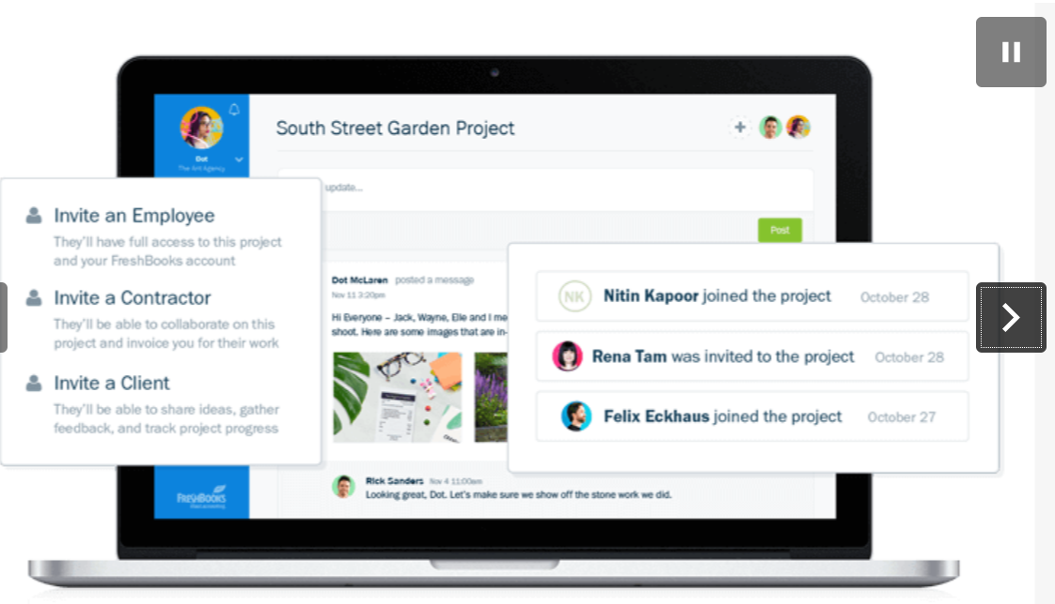

**Benefits Of FreshBooks**

1. **Dynamic solution for SMBs**

* The developers of Freshbooks keep small teams in mind when developing the software. Hence, they continue to constantly reinvent the wheel of how midmarket accounting should be done and eliminating even the slightest possibility of human errors that lead to harmful inconsistencies. The proof of this dedicated approach is their new FreshBooks version, which simplifies the function of the current system, and adds long-awaited, advanced features. The new version lets you enjoy a beautified and modernized interface, natural collaboration with your team companions and partners, and improved quality of work. Managing your business is much simpler than it used to be, having in mind their automated task prioritization, the redesigned dashboard with outstanding customization possibilities and late payment tracking features.

1. **Responsive mobile design**

* Freshbooks mobile apps ensure you stay connected and continue managing your business even when you’re away. Available on both iOS and Android devices, you can create and send invoices, take a photo of receipts, manage expenses, keep up with updates, communicate with clients, and sync data across all devices on-the-go. Both mobile platform function impeccably, and feature secure backups to keep your data safe. With the new version of the product, they are even empowered with a comprehensive Projects suite which empowers streamlined and seamless communication.

1. **Time-saving auto-bills and recurring payments**

* To save time, Freshbooks lets you set up a billing schedule. Automating recurring payments with auto-bills charges your client’s card automatically and securely. Invoices are also sent in any currency you and your client prefers. What is really facilitated in the system now is capturing expenses, as all tasks are prioritized by the system, and displayed in a way which helps you depict the most important assignments for your team.

1. **Preserved simplicity**

* Features are and, as designers promise, will continue being customizable, and allow you to attach all the files you want, trigger notifications and set alerts for delayed payments, assign expenses and different rates for each project, track billing, and brand invoices in an easy manner. This is one of the many fields in which FreshBooks is completely unsurpassed.

1. **Invoice-to-payment functionality**

* Freshbooks has a reliable invoice-to-payment functionality. For instance, you can see when a client receives and opens the invoice you sent. This can help you deal with customers who claim they didn’t get the invoice. FreshBooks effectively gives you the certainty that your invoices have been properly delivered to clients. In the latest version, you will also be able to set invoice due dates, charge late fees, and turn on new online payment options.

1. **Optimize expense tracking**

* Freshbooks makes it easy to keep track of expenses. Receipts can be attached and organized in the software. They will be prepared during tax time and help you stay in budget with an easy-to-read summary. You can also easily track which expense belongs to which client or add the expense to an invoice as a reimbursement deal with a particular client. It is also possible to link the Expense Tool to your bank or credit card account and import expenses directly from your bank. All these features make it really easy to track your company’s day-to-day expenses.

1. **Accurate time tracking**

* You can track time against specific clients and projects in Freshbooks. A Chrome extension is available to enable time tracking in apps such as Basecamp, Asana, and Trello. This gives you more confidence to bill clients for tracked hours with accuracy as you can add the hours you’ve logged into your client’s invoice. In addition, FreshBooks offers flexible billing features: you can charge an hourly or flat rate according to your agreement with the client. Your team members can also log in their time separately for projects, allowing you to track individual and team time worked, and calculate a running bill for payment.

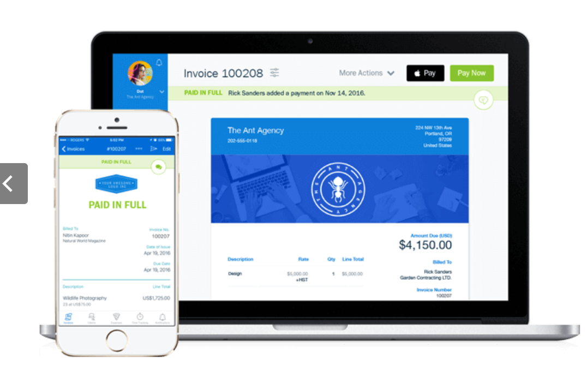

**Features Of FreshBooks**

1. **Online Invoicing**

* Customizing your invoice
* Tracking Invoice Views
* Puting Business on Auto-Pilot
* Getting paid with deposits
* Getting paid with credit cards
* Customizing due dates
* Quick discounts
* Estimates
* Online Payments
* Late Payment Fees
* Recurring Invoices & Auto Payment
* Multi Currency & Multi Language
* Client Portal
* Late Payment Reminders
* Sales Taxes
* Client Credit
* Track Offline Payments
* Send Emails or Snail Mail
* Automated Tax Circulations
* Invoice Previews
* Knowing when the customer has seen the invoice

1. **Expense Tracking**

* Automatic expense import
* Snaps
* Tracking spending per project
* Remember vendors
* Tax friendly categories
* Easy-to-read categorization
* Attach receipts (PDF or Image)
* Expense Report Filters
* File import
* Recurring Expenses
* Assign & Rebill Expenses

1. **Time Tracking**

* Timer
* Team timesheets
* Clear breakdown of the day
* Tracking against clients and projects
* Detailed Time entry notes
* Automated bills for tracked hours per project
* Project Managers
* Track Unbilled Time
* Different Rates for each Project
* Generate Invoices

1. **Projects**

* Sharing images and files
* Collaborating with clients, contractors, and employees
* Project due dates
* Centralized conversations
* Current Project overviews

1. **Payments**

* MasterCard, Visa, and American Express
* Quick bank deposits
* Automatically recorded payments
* Fees recorded as expenses
* Single-click setup
* Safe & secure
* Simple payment experience

1. **Accounting Reports & Taxes**

* Accounts Aging
* Profit & Loss
* Balance Sheet
* Expense Reports
* Item Sales
* Sales Tax
* Export to CSV or Excel
* Invoice Details Reports
* Accounts Aging Reports
* Filters for report customization
* Summary of outstanding revenue
* Clear spending breakdowns