Closure property is a helping technique to know the class of the resulting language when we do an operation on two languages of the same class. That is, suppose L1 and L2 belong to CFL and if CFL is closed under operation ∪, then L1∪L2 will be a CFL. But if CFL is not closed under ∩, that doesn’t mean L1∩L2 won’t be a CFL. For a class to be closed under an operation, it should hold true for all languages in that class. So, if a class is not closed under an operation, we cannot say anything about the class of the resulting language of the operation – it may or may not belong to the class of the operand languages. In short, closure property is applicable, only when a language is closed under an operation.

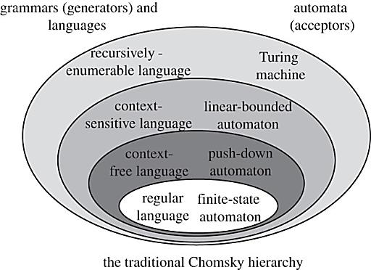

https://meet.google.com/utx-fekv-sur