**Practical- 5**

* 1. **The language of all strings contains exactly two 0’s**

%{

#include<stdio.h>

%}

%%

1*01*01* printf("valid");

.* printf("invalid");

%%

int yywrap()

{

return 1;

}

int main()

{

yylex();

return 0;

}

**OUTPUT**

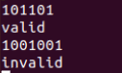

1. **The language of all strings contains atleast two 0’s**

%{

#include<stdio.h>

%}

%%

(0|1)*0(0|1)*0(0|1)* printf("valid");

.* printf("invalid");

%%

int yywrap()

{

return 1;

}

int main()

{

yylex();

return 0;

}

**OUTPUT**

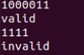

1. **The language of all strings ending in 1 and not containing 00**

%{

#include<stdio.h>

%}

%%

1|(1|01)*1* printf("valid");

.* printf("invalid");

%%

int yywrap()

{

return 1;

}

int main()

{

yylex();

return 0;

}

**OUTPUT**

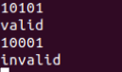

1. **String with odd number of 1’s**

%{

#include<stdio.h>

%}

%%

0*1(0|10*1|11)* printf("valid");

.* printf("invalid");

%%

int yywrap()

{

return 1;

}

int main()

{

yylex();

return 0;

}

**OUTPUT**

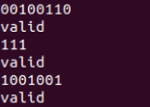

1. **The language of all strings that do not end with 01**

%{

#include<stdio.h>

%}

%%

0|1|(0|1)*(00|10|11) printf("valid");

.* printf("invalid");

%%

int yywrap()

{

return 1;

}

int main()

{

yylex();

return 0;

}

**OUTPUT**

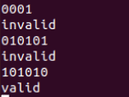

1. **The language of all string not containing 00**

%{

#include<stdio.h>

%}

%%

0|1|(1|010)* printf("valid");

.* printf("invalid");

%%

int yywrap()

{

return 1;

}

int main()

{

yylex();

return 0;

}

**OUTPUT**

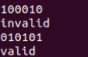

1. **The language of all string containing either 10 or 001**

%{

#include<stdio.h>

%}

%%

(0|1)*(10|001)(0|1)* printf("valid");

.* printf("invalid");

%%

int yywrap()

{

return 1;

}

int main()

{

yylex();

return 0;

}

**OUTPUT**

