**GANPAT UNIVERSITY**

**U.V. PATEL COLLEGE OF ENGINEERING**

**Computer Engineering / Information Technology Department**

**Subject: User Experience Design (2CEIT604)**

**Semester: 5th**

**Extra practice question**

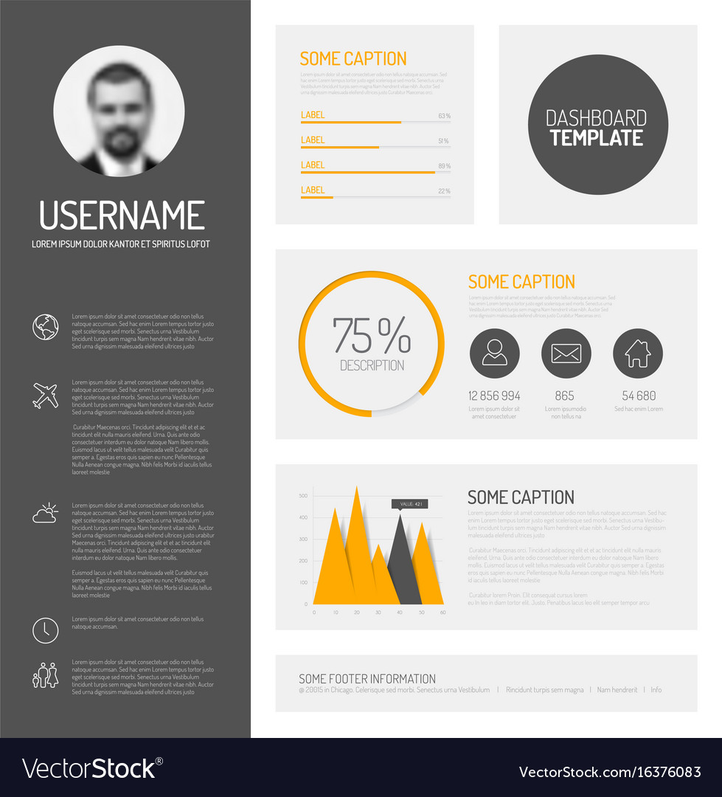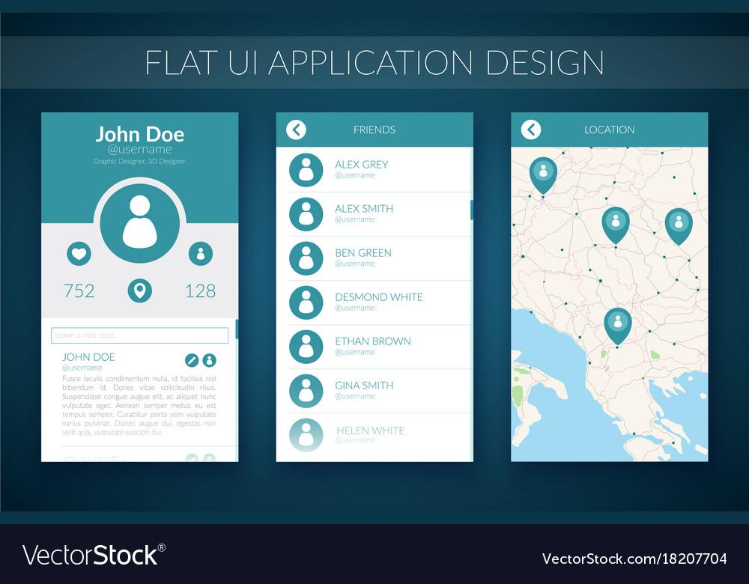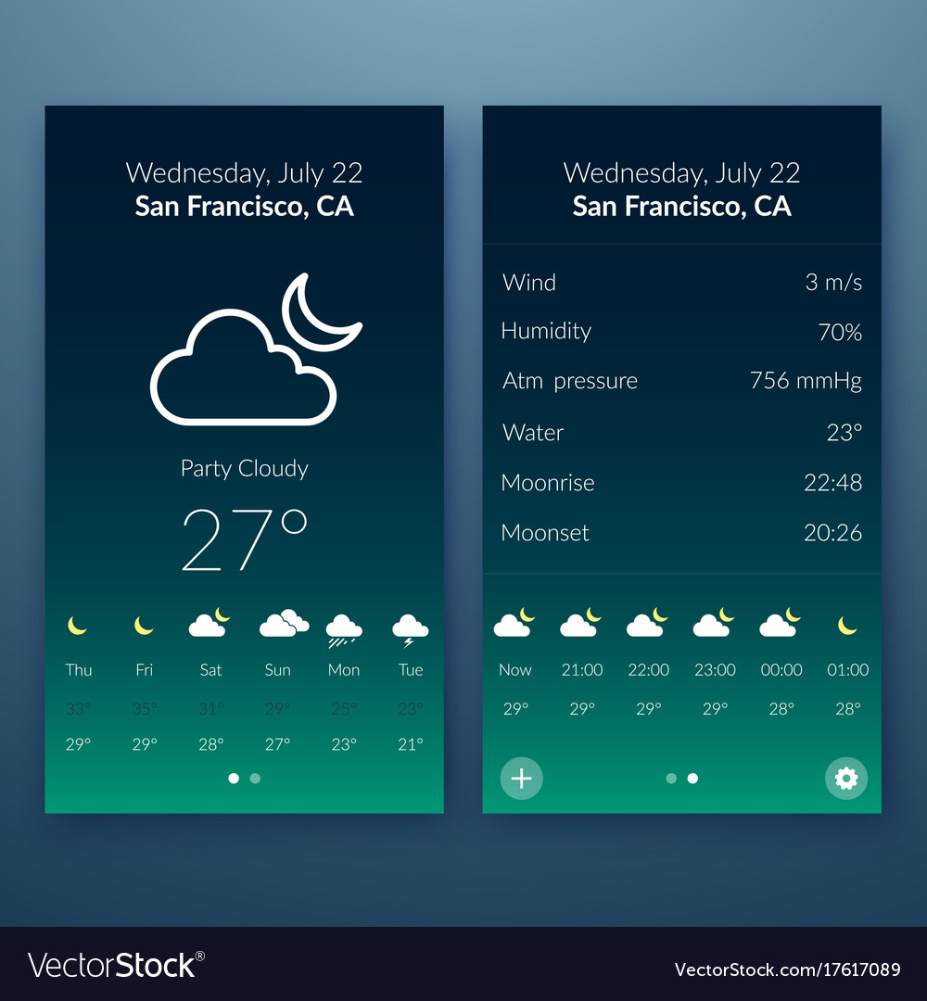

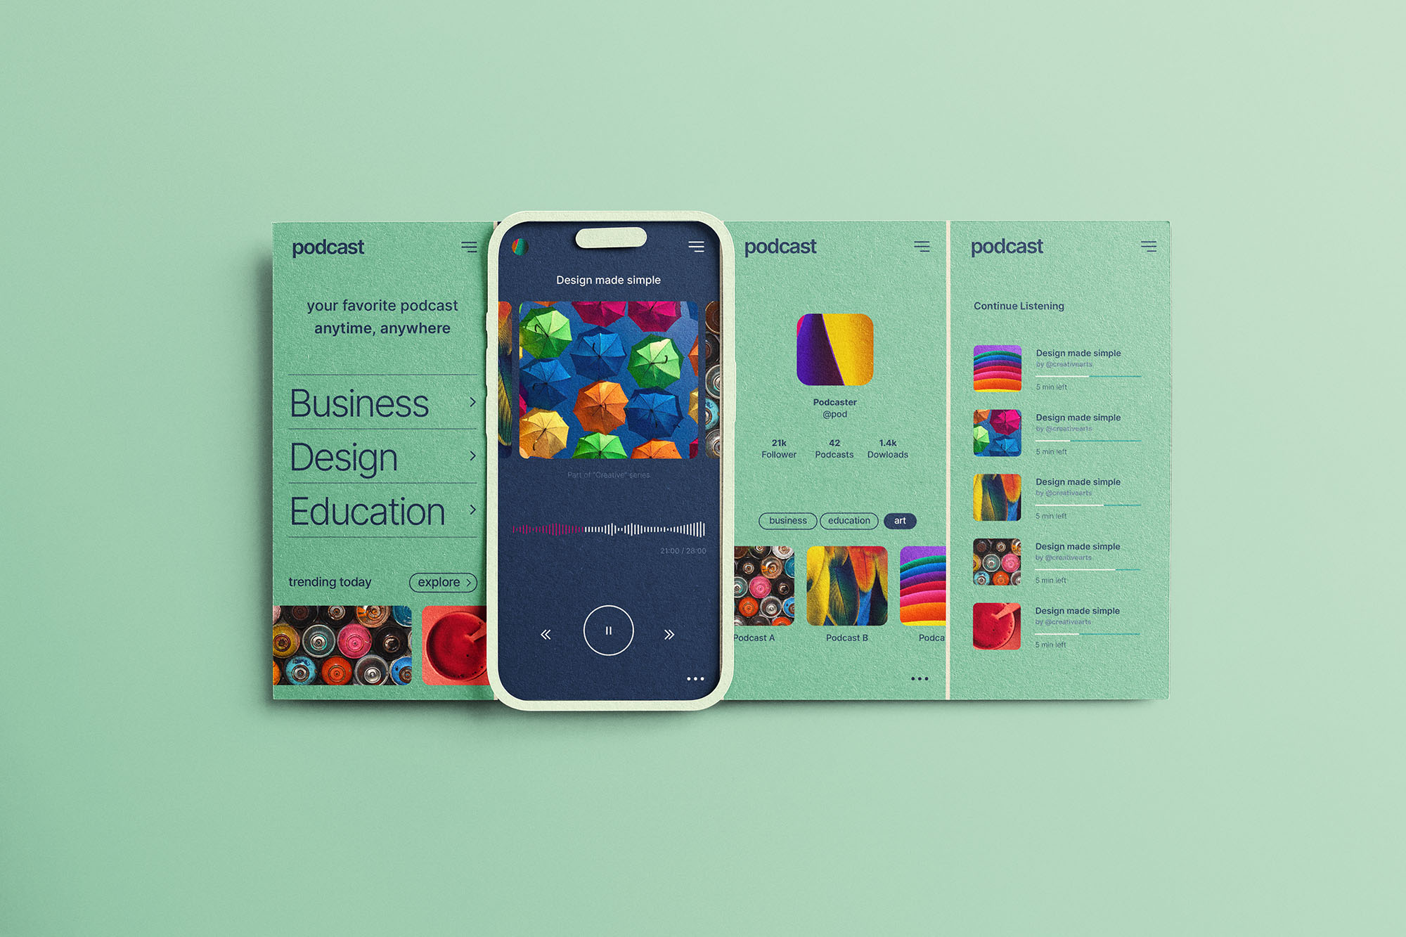



Submission Link:

https://docs.google.com/forms/d/e/1FAIpQLSenTsU4ZMN4a1KjCUgW_aj4lompWEdds01sMPABkGB9Ugml_A/viewform