**Practical - 2**

1. **Study the following functions & write a description for each: echo(), print(), phpinfo(), define(), var_dump(), date(), Time().**
2. **echo():**

Outputs one or more strings. It doesn't have a return value and can take multiple parameters separated by commas.

Ex : echo "Hello, world!";

1. **print():**

Outputs a string. It is similar to echo but it always returns 1, so it can be used in expressions.

Ex : print("Hello, world!");

1. **phpinfo():**

Outputs information about the PHP configuration, such as the version, extensions, and server information.

Ex : phpinfo();

1. **define():**

Defines a named constant with a specified name and value. Once defined, the value of the constant cannot be changed during the script's execution.

Ex : define("PI", 3.14);

1. **var_dump():**

Displays structured information about one or more variables, including its type and value. It's often used for debugging purposes.

Ex : var_dump($variable);

1. **date():**

Formats a local time or date based on the format specified. It can be used to display the current date and time or manipulate dates and times.

Ex : echo date("Y-m-d H:i:s");

1. **Time():**

Returns the current Unix timestamp, representing the number of seconds that have passed since January 1, 1970, 00:00:00 UTC. It's often used for timestamping events or measuring time intervals.

Ex : $timestamp = time();

1. **Demonstrate different ways to write a PHP code. 1. Without any HTML markups 2. Embedding HTML markups in PHP code.**

<!-- 1 -->

<?php

echo "Adeshara Brijesh_21012021001";

?>

<!-- 2 -->

<?php

echo "<h3>Adeshara Brijesh_21012021001</h3>";

?>

<!-- 3 -->

<html>

<body>

<?php

echo "Adeshara Brijesh_21012021001";

?>

 </body>

</html>

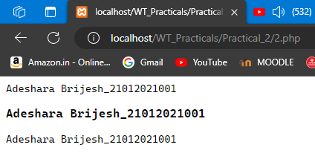

1. **Embedding PHP code in HTML 3. Write a program that displays a different message based on time of day. [Note: For example page should display “Good Morning” if it is accessed in the morning.]**

<?php

echo "Adeshara Brijesh_21012021001". "<br>";

// Get the current hour

date_default_timezone_set('Asia/Kolkata');

$h = date('G', time());

// Define messages based on the time of day

if ($h >= 5 && $h < 12) {

echo "Current time : ". $h . "<br>"." Good Morning";

} elseif ($h >= 12 && $h < 17) {

echo "Current time : ". $h . "<br>"." Good Afternoon";

} elseif ($h >= 17 && $h < 21) {

echo "Current time : ". $h . "<br>"." Good Evening";

} else {

echo "Current time : ". $h . "<br>"." Good Night";

}

?>

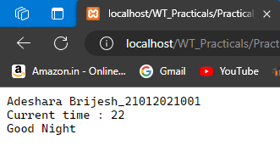

1. **Write a PHP function daysInMonth() that takes a month (between 1 and 12) as a parameter and returns the number of days in that month in a non-leap year. [For example daysInMonth(6) should return 30, because June has 30 days.].**

<?php

echo "Adeshara Brijesh_21012021001". "<br>";

function daysInMonth($month) {

// Ensure the month parameter is between 1 and 12

if ($month < 1 || $month > 12) {

return "Invalid month. Please provide a month between 1 and 12.";

}

// Define an array with the number of days in each month

$daysInMonth = [

1 => 31, // January

2 => 28, // February

3 => 31, // March

4 => 30, // April

5 => 31, // May

6 => 30, // June

7 => 31, // July

8 => 31, // August

9 => 30, // September

10 => 31, // October

11 => 30, // November

12 => 31 // December

];

// Return the number of days for the given month

return $daysInMonth[$month];

}

// Example usage:

$month = 6; // June

echo "Number of days in month $month is: " . daysInMonth($month);

?>

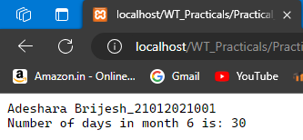

1. **Write a PHP program to make the sum of first 100 odd numbers.**

<?php

echo "Adeshara Brijesh_21012021001". "<br>";

// Initialize variables

$sum = 0;

$count = 0;

$number = 1;

// Loop until we count 100 odd numbers

while ($count < 100) {

// Check if the number is odd

if ($number % 2 != 0) {

// Add the odd number to the sum

$sum += $number;

// Increment the count of odd numbers

$count++;

}

// Move to the next number

$number++;

}

// Output the sum of the first 100 odd numbers

echo "The sum of the first 100 odd numbers is: $sum";

?>

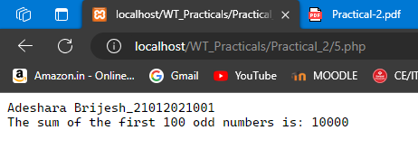

1. **Write a PHP program to list out Prime numbers in given range.**

<?php

echo "Adeshara Brijesh_21012021001". "<br>";

$range=100;

echo "The Range is: ".$range."<br>";

for($i=1; $i<=$range; $i++){

$flag=true;

for($j=2; $j<$i; $j++ ){

if($i % $j == 0){

$flag=false;

}

}

if($flag){

echo $i."<br>";

}

}

?>

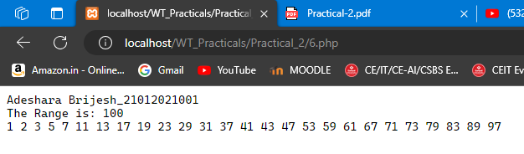

1. **Write a PHP program to print fibonacci series with and without using recursion and check which method is efficient. [Note: microtime() function is an inbuilt function in PHP which is used to return the current Unix timestamp with microseconds.]**

<?php

echo "Adeshara Brijesh_21012021001". "<br>";

// Fibonacci series with recursion

function fibonacciWithRecursion($n) {

if ($n <= 1) {

return $n;

} else {

return fibonacciWithRecursion($n - 1) + fibonacciWithRecursion($n - 2);

}

}

// Fibonacci series without recursion

function fibonacciWithoutRecursion($n) {

$fib = array();

$fib[0] = 0;

$fib[1] = 1;

for ($i = 2; $i <= $n; $i++) {

$fib[$i] = $fib[$i - 1] + $fib[$i - 2];

}

return $fib[$n];

}

// Measure time for Fibonacci with recursion

$startRecursion = microtime(true);

$n = 10; // Change n to test with different values

echo "Fibonacci series with recursion:<br>";

for ($i = 0; $i < $n; $i++) {

echo fibonacciWithRecursion($i) . " ";

}

echo "<br>";

$endRecursion = microtime(true);

$timeRecursion = $endRecursion - $startRecursion;

// Measure time for Fibonacci without recursion

$startWithoutRecursion = microtime(true);

echo "Fibonacci series without recursion:<br>";

for ($i = 0; $i < $n; $i++) {

echo fibonacciWithoutRecursion($i) . " ";

}

echo "<br>";

$endWithoutRecursion = microtime(true);

$timeWithoutRecursion = $endWithoutRecursion - $startWithoutRecursion;

// Output time taken for both methods

echo "Time taken for recursion: " . $timeRecursion . " seconds<br>";

echo "Time taken without recursion: " . $timeWithoutRecursion . " seconds<br>";

// Check which method is more efficient

if ($timeRecursion < $timeWithoutRecursion) {

echo "Recursion is more efficient.<br>";

} else {

echo "Recursion is less efficient.<br>";

}

?>

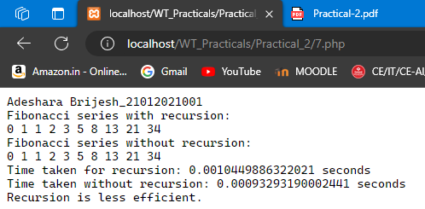

1. **Write a PHP program to enter the numbers of rows and columns and in the next page generate the table with given rows and cols.**

**Index.php**

<!DOCTYPE html>

<html lang="en">

<head>

<meta charset="UTF-8">

<meta name="viewport" content="width=device-width, initial-scale=1.0">

<title>Generate Table</title>

</head>

<body>

<form action="8_table.php" method="post">

<label for="rows">Enter the number of rows:</label>

<input type="number" id="rows" name="rows" required><br><br>

<label for="cols">Enter the number of columns:</label>

<input type="number" id="cols" name="cols" required><br><br>

<input type="submit" value="Generate Table">

</form>

</body>

</html>

**Table.php**

<!DOCTYPE html>

<html lang="en">

<head>

<meta charset="UTF-8">

<meta name="viewport" content="width=device-width, initial-scale=1.0">

<title>Generated Table</title>

<style>

table {

border-collapse: collapse;

}

table, th, td {

border: 1px solid black;

padding: 5px;

}

</style>

</head>

<body>

<?php

// Retrieve the number of rows and columns from the form

$rows = isset($_POST['rows']) ? (int)$_POST['rows'] : 0;

$cols = isset($_POST['cols']) ? (int)$_POST['cols'] : 0;

if ($rows > 0 && $cols > 0) {

echo "Adeshara Brijesh_21012021001". "<br>";

echo "<h2>Generated Table</h2>";

echo "<table>";

// Generate the table with the specified number of rows and columns

for ($i = 1; $i <= $rows; $i++) {

echo "<tr>";

for ($j = 1; $j <= $cols; $j++) {

echo "<td>Row $i, Col $j</td>";

}

echo "</tr>";

}

echo "</table>";

} else {

echo "<h2>Error: Invalid number of rows or columns.</h2>";

}

?>

</body>

</html>

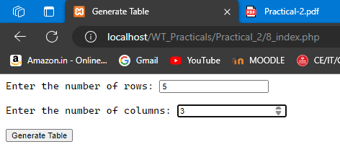

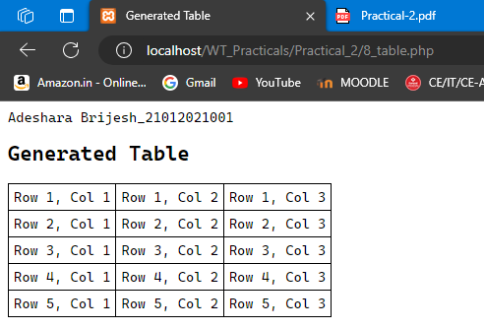

1. **Write a PHP program to print table of a number.**

**[For example: 9 * 1 = 9 9 * 2 = 18 ….]**

<!DOCTYPE html>

<html lang="en">

<head>

<meta charset="UTF-8">

<meta name="viewport" content="width=device-width, initial-scale=1.0">

<title>Print Table</title>

</head>

<body>

<form action="" method="post">

<label for="number">Enter a number:</label>

<input type="number" id="number" name="number" required>

<input type="submit" value="Print Table">

</form>

<?php

echo "Adeshara Brijesh_21012021001". "<br>";

if ($_SERVER["REQUEST_METHOD"] == "POST") {

$number = isset($_POST['number']) ? (int)$_POST['number'] : 0;

if ($number > 0) {

echo "<h2>Table of $number</h2>";

for ($i = 1; $i <= 10; $i++) {

$result = $number * $i;

echo "$number * $i = $result<br>";

}

} else { echo "<p>Please enter a valid number.</p>"; }

}

?>

</body>

</html>

