**Practical – 4**

**Aim: Perform following programs of PHP form handling.**

**Exercise:**

1. **Write a program to use of following global Variables:**

**$_REQUEST, $_POST, $_GET, $_ENV, $_GLOBAL, $_SERVER**

<!DOCTYPE html>

<html lang="en">

<head>

<meta charset="UTF-8">

<meta name="viewport" content="width=device-width, initial-scale=1.0">

<title>Global Variables Example</title>

</head>

<body>

<h2>Global Variables Example</h2>

<form method="post" action="<?php echo $_SERVER['PHP_SELF']; ?>">

<label for="name">Enter Your Name:</label><br>

<input type="text" id="name" name="name"><br>

<input type="submit" name="submit" value="Submit">

</form>

<?php

// Using $_REQUEST to retrieve form data

if ($_SERVER["REQUEST_METHOD"] == "POST") {

$name = $_REQUEST['name'];

echo "<p>Using \$_REQUEST: Hello, $name!</p>";

}

// Using $_POST to retrieve form data

if (isset($_POST['name'])) {

$name = $_POST['name'];

echo "<p>Using \$_POST: Hello, $name!</p>";

}

// Using $_GET to retrieve query parameters

if (isset($_GET['name'])) {

$name = $_GET['name'];

echo "<p>Using \$_GET: Hello, $name!</p>";

}

// Using $_ENV to retrieve environment variables

if (isset($_ENV['USER'])) {

$user = $_ENV['USER'];

echo "<p>Using \$_ENV: Hello, $user!</p>";

}

// Using $_GLOBALS to access global variables

$global_var = "I am a global variable!";

echo "<p>Using \$_GLOBALS: $global_var</p>";

// Using $_SERVER to access server-related information

$server_name = $_SERVER['SERVER_NAME'];

$server_port = $_SERVER['SERVER_PORT'];

echo "<p>Using \$_SERVER: Server Name - $server_name, Port - $server_port</p>";

?>

</body>

</html>

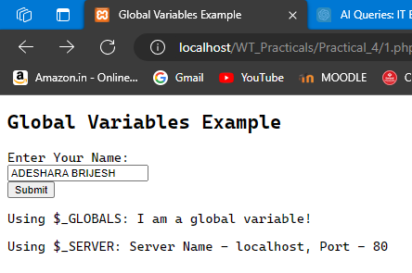 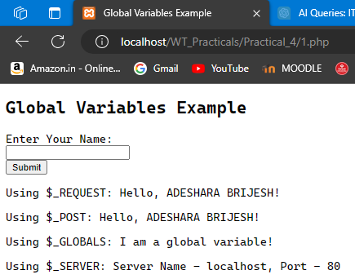

1. **Create a PHP script that implements a Billing Module with order and**

**confirmation pages. The order page should collect the Buyer's Name and**

**Mobile Number with validation and display the confirmed order details**

**on a separate page.**

**Order.php**

<!DOCTYPE html>

<html lang="en">

<head>

<meta charset="UTF-8">

<meta name="viewport" content="width=device-width, initial-scale=1.0">

<title>Order Page</title>

<style>

body {

font-family: Arial, sans-serif;

background-color: #f0f0f0;

margin: 0;

padding: 20px;

}

h2 {

margin-bottom: 20px;

color: #333;

}

form {

background-color: #fff;

padding: 20px;

border-radius: 8px;

box-shadow: 0 0 10px rgba(0, 0, 0, 0.1);

}

.name-inputs, .item-container {

display: flex;

align-items: center;

margin-bottom: 15px;

}

.name-inputs label, .item-container label {

width: 100px;

font-weight: bold;

}

.name-inputs input, .item-container input {

flex: 1;

padding: 8px;

margin-left: 10px;

border-radius: 4px;

border: 1px solid #ccc;

}

.item-container input[type="number"] {

width: 80px;

}

h3 {

margin-top: 20px;

margin-bottom: 10px;

color: #555;

}

input[type="radio"] {

margin-right: 5px;

}

input[type="submit"] {

padding: 10px 20px;

background-color: #4CAF50;

color: #fff;

border: none;

border-radius: 4px;

cursor: pointer;

transition: background-color 0.3s;

}

input[type="submit"]:hover {

background-color: #45a049;

}

</style>

</head>

<body>

<h2>Place Your Order</h2>

<?php

// Read item data from CSV file

$itemsData = [];

if (($handle = fopen("items.csv", "r")) !== FALSE) {

// Skip the header row

fgetcsv($handle);

while (($data = fgetcsv($handle, 1000, ",")) !== FALSE) {

$itemsData[] = $data;

}

fclose($handle);

}

?>

<form method="post" action="confirmation.php">

<div class="name-inputs">

<label for="firstname">First Name:</label>

<input type="text" id="firstname" name="firstname">

<label for="middlename">Middle Name:</label>

<input type="text" id="middlename" name="middlename">

<label for="lastname">Last Name:</label>

<input type="text" id="lastname" name="lastname">

</div>

<h3>Grocery Items</h3>

<?php foreach ($itemsData as $item): ?>

<div class="item-container">

<label for="<?php echo $item[0]; ?>"><?php echo $item[0] . ' - &#8377;' . number_format((float)$item[1], 2); ?></label>

<input type="number" id="<?php echo $item[0]; ?>" name="<?php echo strtolower(str_replace(' ', '_', $item[0])); ?>" value="0" min="0">

</div>

<?php endforeach; ?>

<h3>Payment Method</h3>

<input type="radio" id="cash" name="payment" value="Cash">

<label for="cash">Cash</label><br>

<input type="radio" id="card" name="payment" value="Card">

<label for="card">Card</label><br>

<input type="radio" id="paypal" name="payment" value="PayPal">

<label for="paypal">PayPal</label><br><br>

<input type="submit" name="submit" value="Submit">

</form>

</body>

</html>

**Confirmation.php**

<!DOCTYPE html>

<html lang="en">

<head>

<meta charset="UTF-8">

<meta name="viewport" content="width=device-width, initial-scale=1.0">

<title>Order Confirmation</title>

<style>

body {

font-family: Arial, sans-serif;

background-color: #f0f0f0;

margin: 0;

padding: 20px;

}

h2 {

margin-bottom: 20px;

color: #333;

}

table {

border-collapse: collapse;

width: 100%;

background-color: #fff;

border-radius: 8px;

box-shadow: 0 0 10px rgba(0, 0, 0, 0.1);

}

th, td {

border: 1px solid #dddddd;

text-align: left;

padding: 8px;

}

th {

background-color: #f2f2f2;

}

.total-price-row td {

font-weight: bold;

}

p {

margin-bottom: 10px;

}

form {

margin-top: 20px;

}

input[type="submit"] {

padding: 10px 20px;

background-color: #4CAF50;

color: #fff;

border: none;

border-radius: 4px;

cursor: pointer;

transition: background-color 0.3s;

}

input[type="submit"]:hover {

background-color: #45a049;

}

/* Red cancel button */

input[name="cancel"] {

background-color: #f44336; /* Red color */

}

</style>

</head>

<body>

<h2>Order Confirmation</h2>

<?php

if ($_SERVER["REQUEST_METHOD"] == "POST") {

$firstname = $_POST['firstname'];

$middlename = $_POST['middlename'];

$lastname = $_POST['lastname'];

$itemsData = [];

if (($handle = fopen("items.csv", "r")) !== FALSE) {

// Skip the header row

fgetcsv($handle);

while (($data = fgetcsv($handle, 1000, ",")) !== FALSE) {

$itemsData[] = $data;

}

fclose($handle);

}

echo "<p><strong>Name: $firstname $middlename $lastname</strong></p>";

// Display table header

echo "<table>";

echo "<tr>";

echo "<th>Item</th>";

echo "<th>Price</th>";

echo "<th>Quantity</th>";

echo "<th>Gross</th>";

echo "</tr>";

$totalPrice = 0; // Initialize total price

foreach ($itemsData as $item) {

$itemName = strtolower(str_replace(' ', '_', $item[0]));

$quantity = $_POST[$itemName];

if ($quantity > 0) { // Only display if quantity is greater than zero

$price = (float) $item[1];

$subtotal = $quantity * $price;

$totalPrice += $subtotal;

echo "<tr>";

echo "<td>{$item[0]}</td>";

echo "<td>$" . number_format($price, 2) . "</td>";

echo "<td>$quantity</td>";

echo "<td>$" . number_format($subtotal, 2) . "</td>";

echo "</tr>";

}

}

// Display total price row

echo "<tr class='total-price-row'>";

echo "<td colspan='3'><strong>Total Price to Pay</strong></td>";

echo "<td><strong>$" . number_format($totalPrice, 2) . "</strong></td>";

echo "</tr>";

echo "</table>";

// Display selected payment method

$payment = $_POST['payment'];

echo "<p><strong>Payment Method: $payment</strong></p>";

} else {

echo "<p>Sorry, no order details found.</p>";

}

?>

<form method="post" action="order.php">

<input type="submit" name="confirm" value="Confirm Order">

<input type="submit" name="cancel" value="Cancel Order">

</form>

</body>

</html>

**Items.csv**

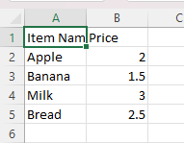

**Output :**

