**Aim: Write a program to implement Water Jug Problem using BFS.**

A Water Jug Problem: You are given two jugs, a 4-gallon one and a 3-gallon one, a pump which has unlimited water which you can use to fill the jug, and the ground on which water may be poured. Neither jug has any measuring markings on it. How can you get exactly 2 gallons of water in the 4-gallon jug?

Let X represents the content of the water in 4-gallon jug.

Let Y represent the content of the water in 3-gallon jug.

Write a program in python/Java to define a set of operators (Rules) that will take us from one state to another:

Start from initial state (X=0, Y=0) Reach any of the Goal states

(X=2, Y=0)

(X=2, Y=1)

(X=2, Y=2)

(X=2, Y=3)

Find the minimum number of steps to reach any the above mentioned goal states.



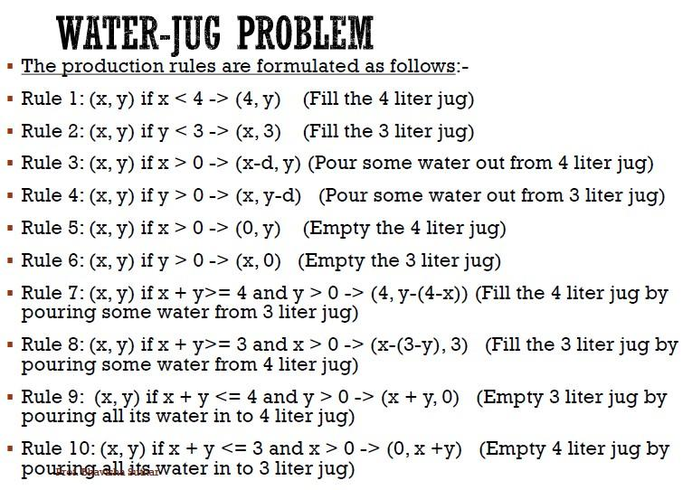

**Program:**

import queue

import time

bfsq = queue.Queue()

class node:

def __init__(self,data):

self.x=0

self.y=0

self.parent=data

def printnode(self):

print("(",self.x,",",self.y,")")

def generateAllSuccessors(cnode):

list1=[]

for rule in range (1,9):

nextnode = operation(cnode,rule) #current node

if nextnode != None :

list1.append(nextnode)

return list1

def operation(cnode,rule):

x = cnode.x

y = cnode.y

if rule == 1 :

if x < maxjug1 :

x = maxjug1

else :

return None

elif rule == 2 :

if y < maxjug2 :

y = maxjug2

else :

return None

elif rule == 3 :

if x > 0 :

x = 0

else :

return None

elif rule == 4 :

if y > 0 :

y = 0

else:

return None

elif rule == 5 :

if x+y >= maxjug1 :

y = y-(maxjug1-x)

x = maxjug1

else :

return None

elif rule == 6 :

if x+y >= maxjug2 :

x = x-(maxjug2-y)

y = maxjug2

else :

return None

elif rule == 7 :

if x+y < maxjug1 :

x = x+y

y = 0

else :

return None

elif rule == 8 :

if x+y < maxjug2:

x = 0

y = x+y

else :

return None

if(x == cnode.x and y ==cnode.y):

return None

nextnode = node(cnode)

nextnode.x = x

nextnode.y = y

nextnode.parent = cnode

return nextnode

def pushlist(list1):

for m in list1:

bfsq.put(m)

def popnode():

if(bfsq.empty()):

return None

else:

return bfsq.get()

def isGoalNode(cnode,gnode):

if(cnode.x == gnode.x and cnode.y == gnode.y):

return True

return False

def bfsMain(initialNode,GoalNode):

bfsq.put(initialNode)

while not bfsq.empty():

visited_node = popnode()

if isGoalNode(visited_node,GoalNode):

return visited_node

successor_nodes = generateAllSuccessors(visited_node)

pushlist(successor_nodes)

return None

def printpath(cnode):

temp = cnode

list1=[]

while(temp != None):

list1.append(temp)

temp = temp.parent

list1.reverse()

for i in list1:

i.printnode()

print("Path Cost:",len(list1))

if __name__ == '__main__':

list2 = []

maxjug1=int(input("Enter value of maxjug1:"))

maxjug2=int(input("Enter value of maxjug2:"))

initialNode = node(None)

initialNode.x = 0

initialNode.y = 0

initialNode.parent = None

GoalNode = node(None)

GoalNode.x = int(input("Enter value of Goal in jug1:"))

GoalNode.y = 0

GoalNode.parent = None

start_time = time.time()

solutionNode = bfsMain(initialNode, GoalNode)

end_time = time.time()

if(solutionNode != None):

print("Solution can Found:")

else:

print("Solution can't be found.")

printpath(solutionNode)

diff = end_time-start_time

print("Execution Time:",diff*1000,"ms")

**Output:**

