**PRACTICAL – 5**

**Aim: Hash & Hex Dump analysis**

l ***HASHMYFILES***

Step-1: Download & Setup the application; then open it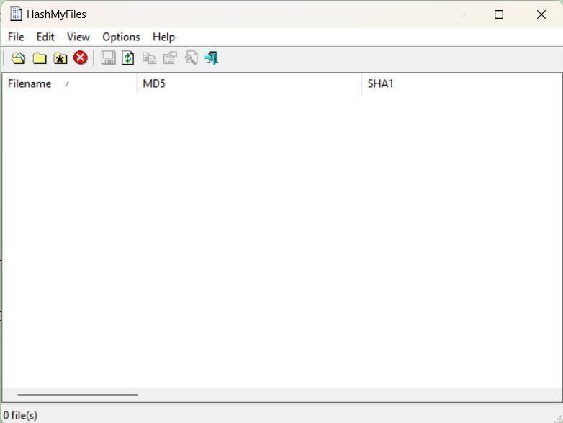

Step-2 : Goto “add file” or “add folder”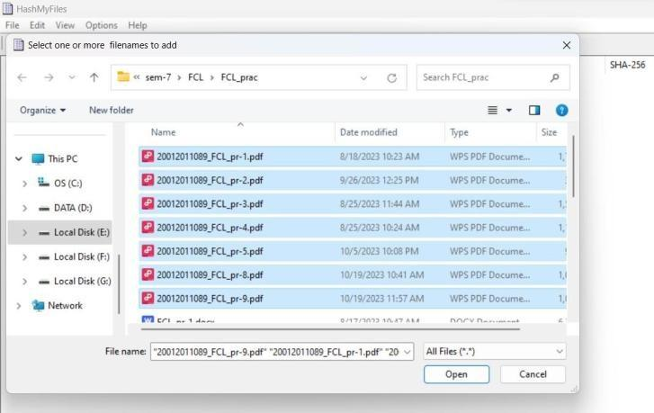

Step-3 : See the result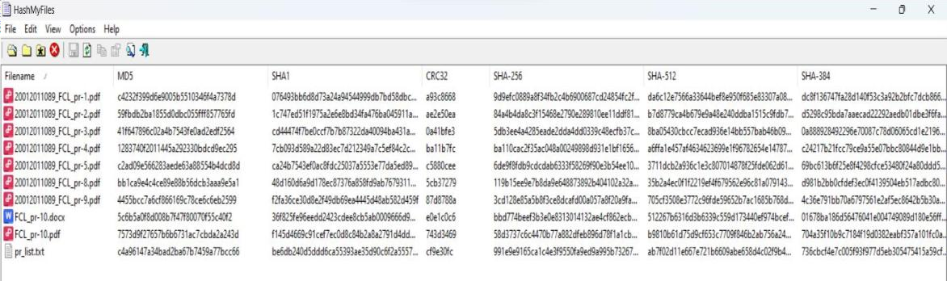

So after performing this we got hash’s of our selected files.

l ***WINHEX***

WinHex is a commercial disk editor and universal hexadecimal editor (hex editor) used for data recovery and digital forensics.

The following image will get you to understand proper interface

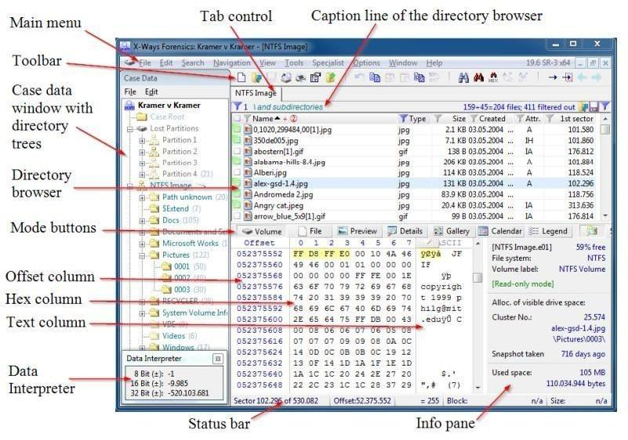

Step-1: Download & Setup the application; then open it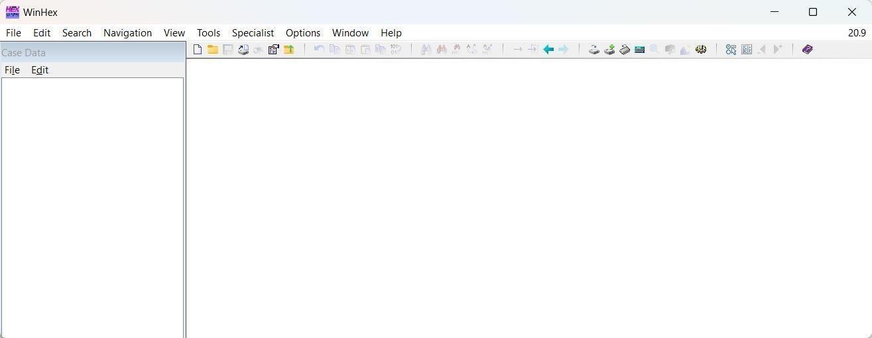

Step-2: Now add files or folder; or add a case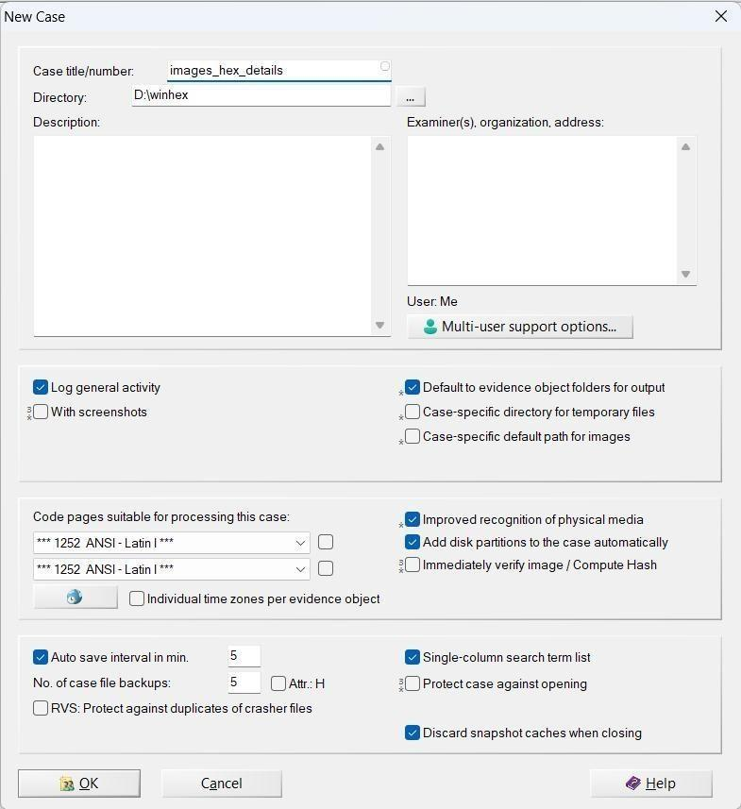

Step-3 : Now analyize the output; and you can edite the hex also