|  |
| --- |
| **[ Internet of things ]** |
|  |

Practical-1

**-:AIM:-**

**To Study about Electronic Components.**

Submitted By: Dharmay Sureja

Enrollment No:17012011056



**GANPAT UNIVERSITY**

**U. V. Patel College of Engineering**

**Computer Engineering Department**

**AIM:- To Study about Electronic Components.**

**OBJECTIVES**

1. To get familiar with basic electronic components such as Resistor, capacitors, Inductor, diodes, transistors, integrated circuits (IC), light emitter diode (LED), switches, fuses, batteries, power plugs, connectors, wires and cables.
2. To test and understand the function of various electronic components.

**RESISTORS**

A resistor is a passive two-terminal electrical component that implements electrical resistance as a circuit element. The current through a resistor is in direct proportion to the voltage across the resistor's terminals. This relationship is represented by Ohm's law. A device used in electrical circuits to maintain a constant relation between current flow and voltage. Resistors are used to step up or lower the voltage at different points in a circuit and to transform a current signal into a voltage signal or vice versa, among other uses. The electrical behaviour of a resistor obeys Ohm's law for a constant resistance; however, some resistors are sensitive to heat, light, or other variables.

Resistors are one of the most used components in a circuit. Most are color coded, but some have their value in Ohms and their tolerance printed on them. A multimeter that can check resistance can also be helpful, providing the resistor is already removed from the board (measuring it while still soldered in can give inaccurate results, due to connections with the rest of the circuit). They are typically marked with an “R” on a circuit board.

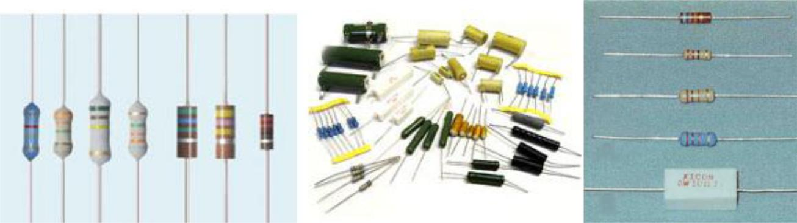

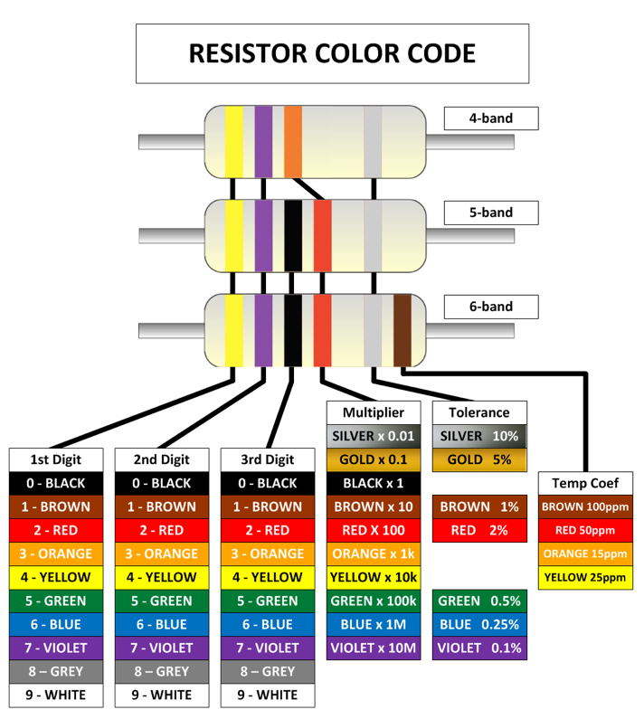

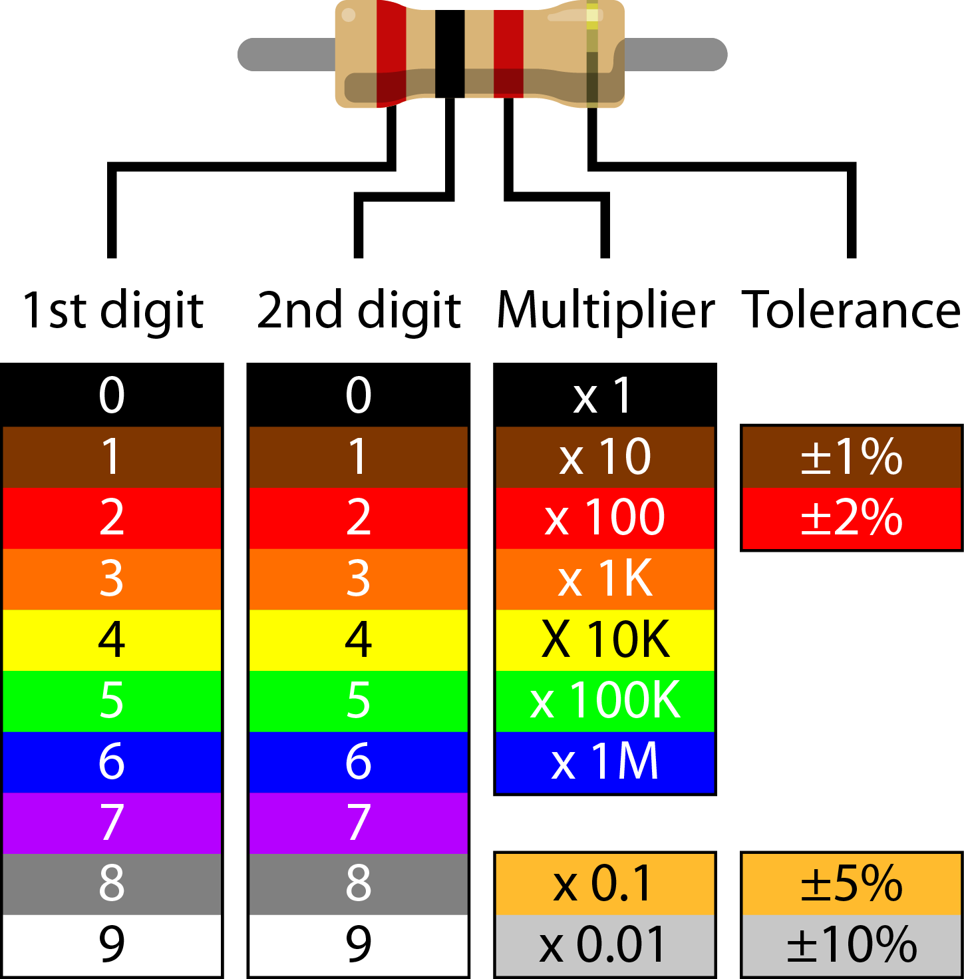

**POTENTIOMETERS**

Potentiometers are variable resistors. They normally have their value marked with the maximum value in Ohms. Smaller trimpots may use a 3-digit code where the first 2 digits are significant, and the 3rd is the multiplier (basically the number of 0′s after the first 2 digits). For example, code 104 = 10 followed by four 0′s = 100000 Ohms = 100K Ohms. They may also have a letter code on them indicating the taper (which is how resistance changes in relation to how far the potentiometer is turned). They are typically marked with an “VR” on a circuit board.

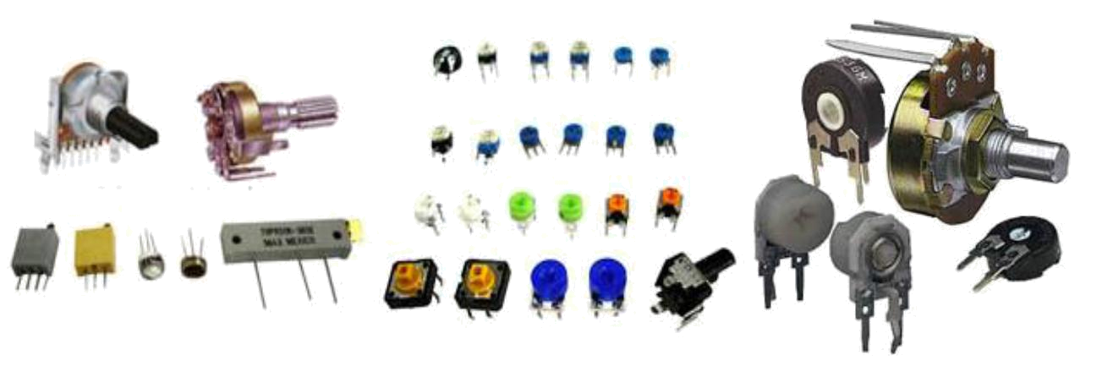

**CAPACITORS**

A capacitor (originally known as a condenser) is a passive two-terminal electrical component used to store energy electrostatically in an electric field. By contrast, batteries store energy via chemical reactions. The forms of practical capacitors vary widely, but all contain at least two electrical conductors separated by a dielectric (insulator); for example, one common construction consists of metal foils separated by a thin layer of insulating film. Capacitors are widely used as parts of electrical circuits in many common electrical devices.

Capacitors are also very commonly used. A lot have their values printed on them, some are marked with 3-digit codes, and a few are color coded. The same resources listed above for resistors can also help you identify capacitor values. They are typically marked with an “C” on a circuit board.

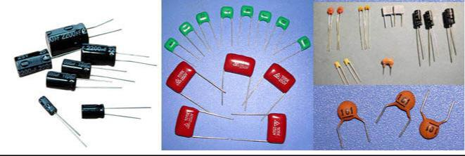

**INDUCTORS**

An inductor, also called a coil or reactor, is a passive two-terminal electrical component which resists changes in electric current passing through it. It consists of a conductor such as a wire, usually wound into a coil. When a current flows through it, energy is stored in a magnetic field in the coil. When the current flowing through an inductor changes, the time-varying magnetic field induces a voltage in the conductor, according to Faraday’s law of electromagnetic induction, which by Lenz's law opposes the change in current that created it.

Inductors, also called coils, can be a bit harder to figure out their values. If they are color coded, the resources listed for resistors can help, otherwise a good meter that can measure inductance will be needed. They are typically marked with an “L” on a circuit board.

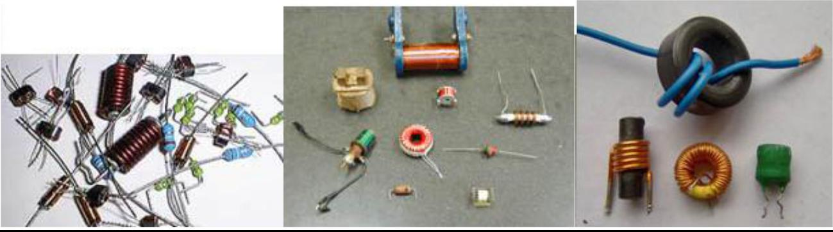

**TRANSFORMERS**

A transformer is a static electrical device that transfers energy by inductive coupling between its winding circuits. A varying current in the primary winding creates a varying magnetic flux in the transformer's core and thus a varying magnetic flux through the secondary winding. This varying magnetic flux induces a varying electromotive force (emf) or voltage in the secondary winding.

Transformers are normally pretty easy to identify by sight, and many have their specs printed on them. They are typically marked with an “T” on a circuit board.

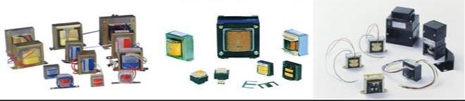

**FUSES**

In electronics and electrical engineering, a fuse is a type of low resistance resistor that acts as a sacrificial device to provide overcurrent protection, of either the load or source circuit. Its essential component is a metal wire or strip that melts when too much current flows, which interrupts the circuit in which it is connected. Short circuit, overloading, mismatched loads or device failure are the prime reasons for excessive current. A fuse interrupts excessive current (blows) so that further damage by overheating or fire is prevented.

Fuses can be easy to identify, and typically have their voltage and amperage rating marked on them.

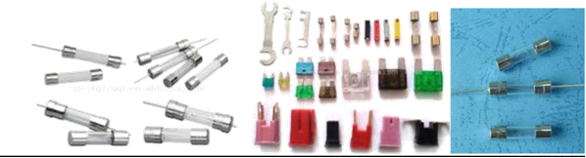

**DIODES**

In electronics, a diode is a two-terminal electronic component with asymmetric conductance, it has low (ideally zero) resistance to current flow in one direction, and high (ideally infinite) resistance in the other.

Semiconductors, such as Diodes (typically marked with an “D” on a circuit board).

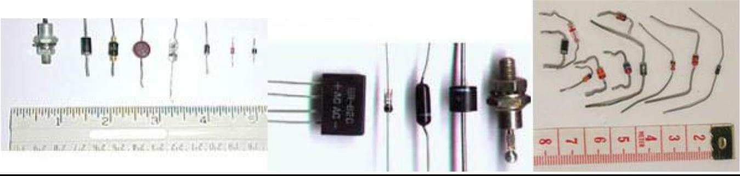

**TRANSISTORS**

A transistor is a semiconductor device used to amplify and switch electronic signals and electrical power. It is composed of semiconductor material with at least three terminals for connection to an external circuit. A voltage or current applied to one pair of the transistor's terminals changes the current through another pair of terminals. Because the controlled (output) power can be higher than the controlling (input) power, a transistor can amplify a signal. Today, some transistors are packaged individually, but many more are found embedded in integrated circuits.

Transistors (typically marked with an “Q” on a circuit board).

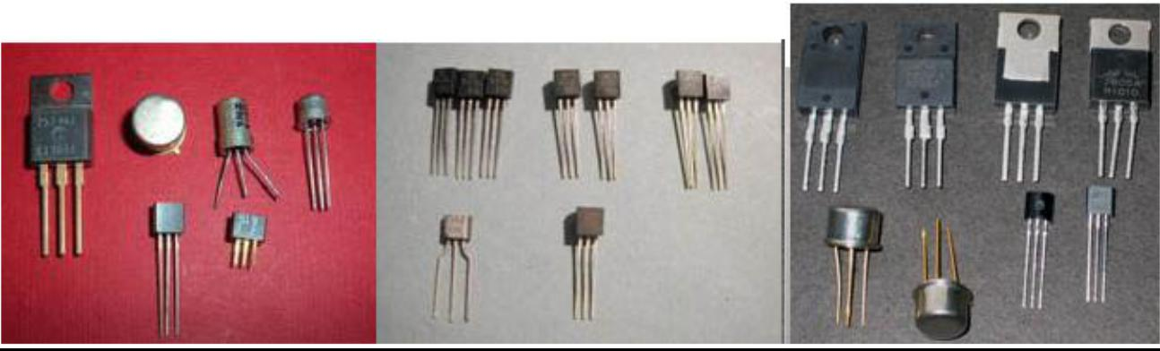

**BREADBOARD**

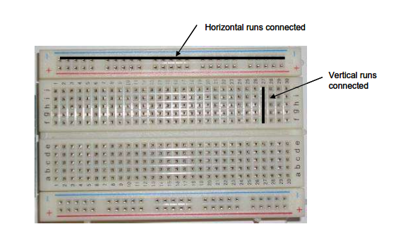A solderless breadboard is an essential tool for rapidly prototyping electronic circuits. Components and wire push into breadboard holes. Rows and columns of holes are internally connected to make connections easy. Wires run from the breadboard to the I/O pins on the Arduino board or raspberry PI. Make connections using short lengths of 22 g solid wire stripped of insulation about 0.25” at each end. Here is a photo of a breadboard showing which runs are connected internally. The pairs of horizontal runs at the top and bottom are useful for running power and ground. Convention is to make the red colored run +5 V and the blue colored run Gnd. The power runs are sometimes called “power busses”.

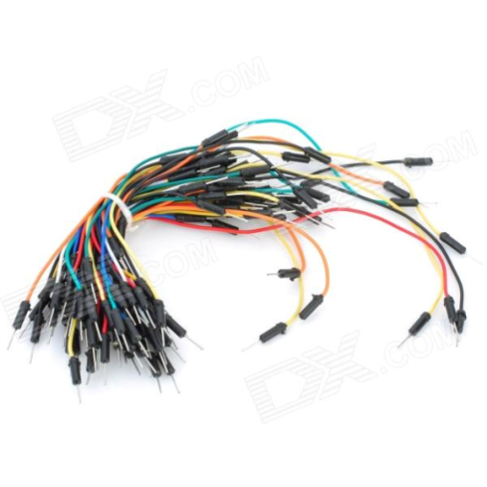**WIRE**

Wires are allowing you to connect IOT device to stuff. It is small enough to easily fit into the pins on your IOT devices. Male-to-Male, Female-to-Male and Female-to-Female are the wire types.

**INTEGRATED CIRCUITS**

An integrated circuit or monolithic integrated circuit (also referred to as an IC, a chip, or a microchip) is a set of electronic circuits on one small plate ("chip") of semiconductor material, normally silicon. This can be made much smaller than a discrete circuit made from independent components. Integrated circuits are used in virtually all electronic equipment today and have revolutionized the world of electronics. Computers, mobile phones, and other digital home appliances are now inextricable parts of the structure of modern societies, made possible by the low cost of producing integrated circuits.

Integrated Circuits (typically marked with an “U” or “IC” on a circuit board)

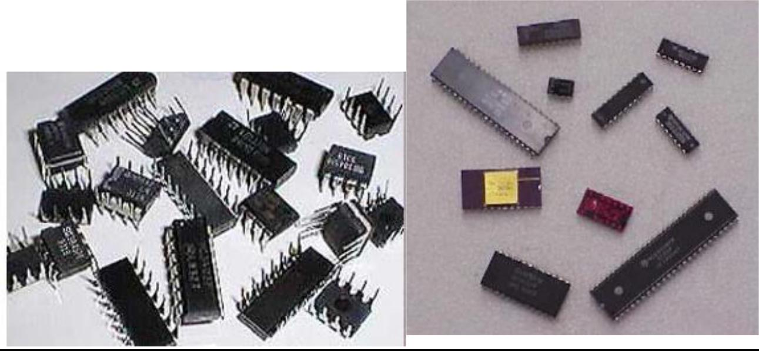

**LED AND LED DISPLAY**

A light-emitting diode (LED) is a semiconductor light source. LEDs are used as indicator lamps in many devices and are increasingly used for other lighting. LEDs emitted low-intensity red light, but modern versions are available across the visible, ultraviolet, and infrared wavelengths, with very high brightness.

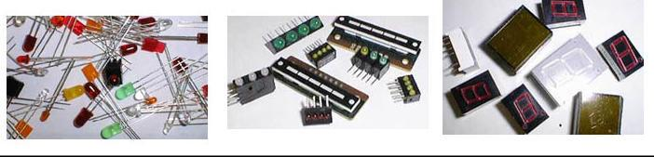

**SWITCHES**

In electrical engineering, a switch is an electrical component that can break an electrical circuit, interrupting the current or diverting it from one conductor to another. The most familiar form of switch is a manually operated electromechanical device with one or more sets of electrical contacts, which are connected to external circuits. Each set of contacts can be in one of two states: either "closed" meaning the contacts are touching and electricity can flow between them, or "open", meaning the contacts are separated and the switch is non-conducting.

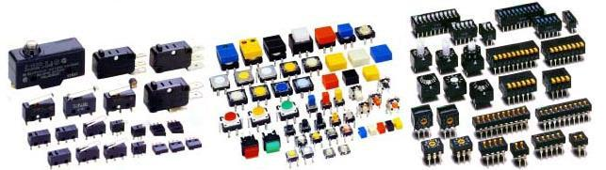

**BATTERIES**

In electricity, a battery is a device consisting of one or more electrochemical cells that convert stored chemical energy into electrical energy.Batteries are also pretty easy to identify, and are well marked with their specification.

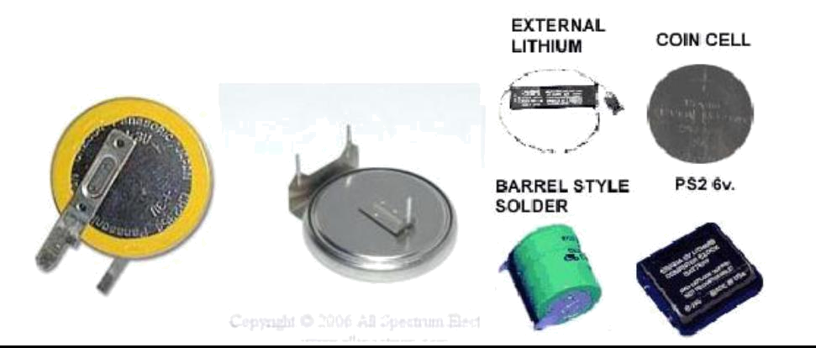

**RELAYS**

A relay is an electrically operated switch. Many relays use an electromagnet to operate a switching mechanism mechanically, but other operating principles are also used. Relays are used where it is necessary to control a circuit by a low-power signal (with complete electrical isolation between control and controlled circuits), or where several circuits must be controlled by one signal.

Relays are typically enclosed in plastic, and many have their specs printed on them. They are typically marked with a “K” on a circuit board.

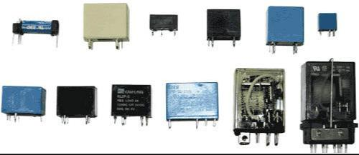

**DIGITAL MULTI METER**

**INTRODUCTION**

A Multimeter is an electronic device that is used to make various electrical measurements, such as AC and DC voltage, AC and DC current, and resistance. It is called a Multimeter because it combines the functions of a voltmeter, ammeter, and ohmmeter. Multimeter may also have other functions, such as diode test, continuity test, transistor test, TTL logic test and frequency test.

**PARTS OF MULTIMETER**

A Multimeter has three parts:

Display

Selection Knob

Ports

The **display** usually has four digits and the ability to display a negative sign. A few multimeters have illuminated displays for better viewing in low light situations.

The **selection knob** allows the user to set the multimeter to read different things such as milliamps (mA) of current, voltage (V) and resistance (Ω).

Two probes are plugged into two of the **ports** on the front of the unit. **COM** stands for common and is almost always connected to Ground or ‘-’ of a circuit. The **COM** probe is conventionally black but there is no difference between the red probe and black probe other than color. **10A** is the special port used when measuring large currents (greater than 200mA). **mAVΩ** is the port that the red probe is conventionally plugged in to. This port allows the measurement of current (up to 200mA), voltage (V), and resistance (Ω). The probes have a *banana* type connector on the end that plugs into the multimeter. Any probe with a banana plug will work with this meter.

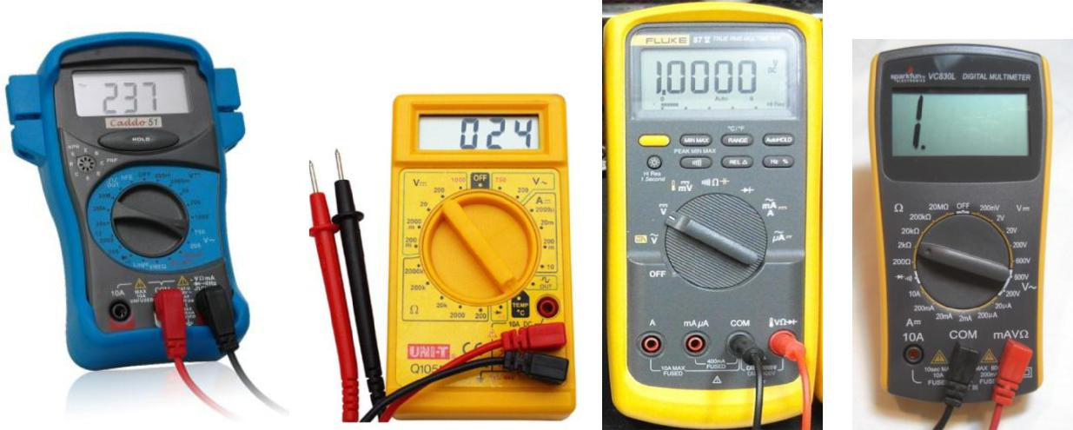

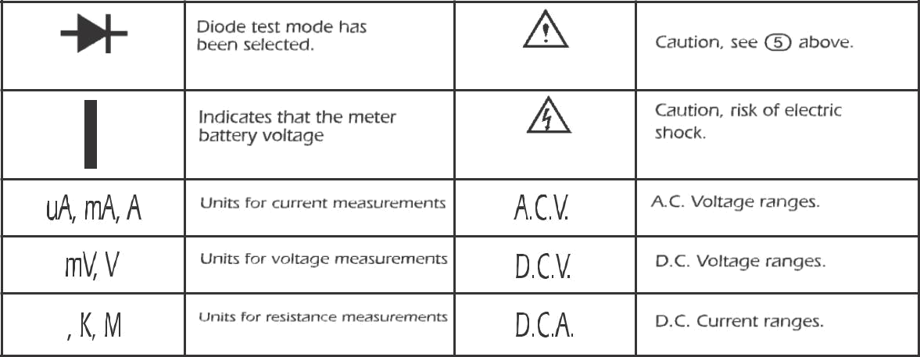

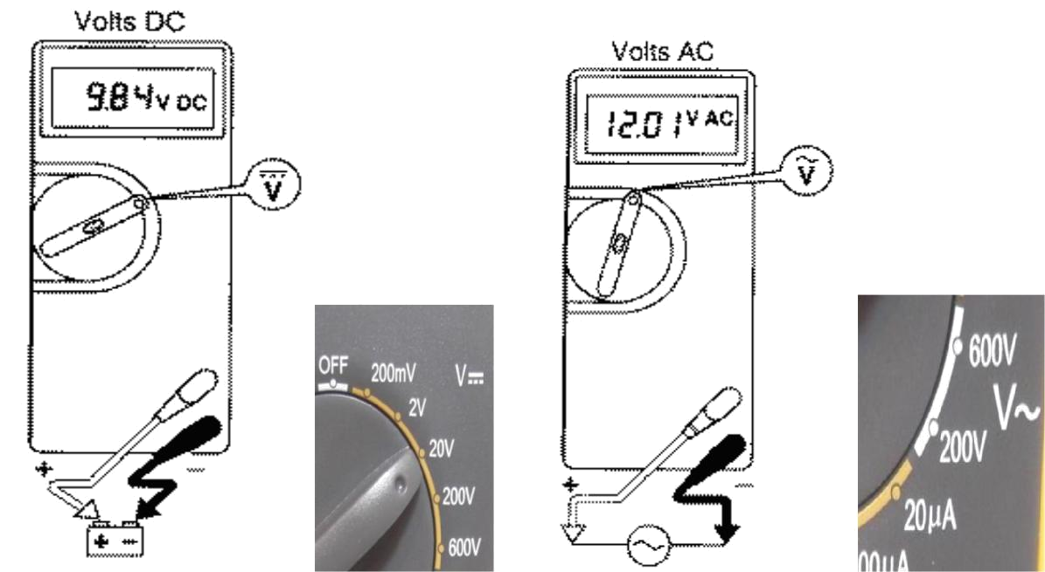

**SAFETY MEASURES**

Be sure the test leads and rotary switch are in the correct position for the desired measurement.



Never use the meter if the meter or the test leads look damaged.



Never measure resistance in a circuit when power is applied.



Never touch the probes to a voltage source when a test lead is plugged into the 10 A or 300 mA input jack.



To avoid damage or injury, never use the meter on circuits that exceed 4800 watts. Never apply more than the rated voltage between any input jack and earth ground. Be careful when working with voltages above 60 V DC or 30 V AC rms. Such voltages pose a shock hazard.



Keep your fingers behind the finger guards on the test probes when making measurements.



To avoid false readings, which could lead to possible electric shock or personal injury, replace the battery as soon as the battery indicator appears.



**INPUT JACKS**

The black lead is always plugged into the common terminal. The red lead is plugged into the 10 A jack when measuring currents greater than 300 mA, the 300 mA jack when measuring currents less than 300 mA, and the remaining jack (V-ohms-diode) for all other measurements.

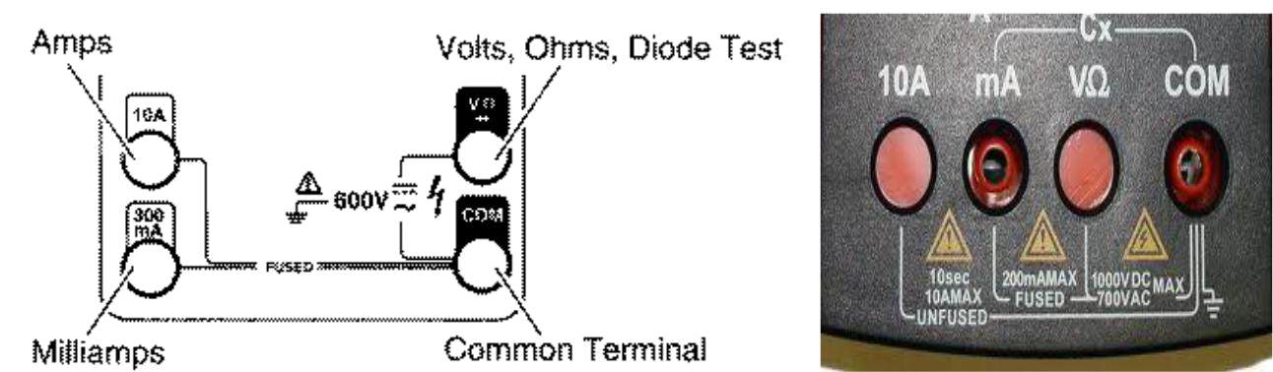

**RANGE FIXING**

The meter defaults to autorange when first turned on. You can choose a manual range in V AC, V DC, A AC, and A DC by pressing the button in the middle of the rotary dial. To return to autorange, press the button for one second.

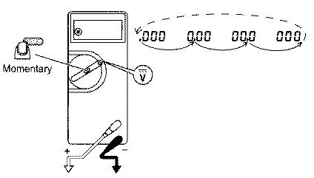

**PROCEDURE FOR MEASUREMENT**

**VOLTAGE MEASUREMENT**

D.C. / A.C. Voltage Measurment

1. Connect the positive(red) test lead to the ‘V/mA’ jack socket and the negative(black) lead to the ‘COM’ jack socket.
2. Set the selector switch to the desired mV D.C./D.C.V/A.C.V range.
3. Connect the test leads to the circuit to be measured.
4. Turn on the power to the circuit to be measured, the voltage value should appear on the digital display along with the voltage polarity(if reversed only).

**CURRENT MEASUREMENT**

1. Connect the positive(red) test lead to the ‘V/mA’ jack socket and the negative(black) lead to the ‘COM’ jack socket(for measurements up to 200mA).

For measurements between 200mA and 10A connect the red test lead to the

‘10mA’ socket.

1. Set the selector switch to the desired uA/mA/A range.
2. Open the circuit to be measured and connect the test leads in **SERIES** with the load in which current is to be measured.
3. To avoid blowing an input fuse, use the 10A jack until you are sure that the current is less than 300 mA. Turn off power to the circuit. Break the circuit. (For circuits of more than 10 amps, use a current clamp.) Put the meter in series with the circuit and turn power on.

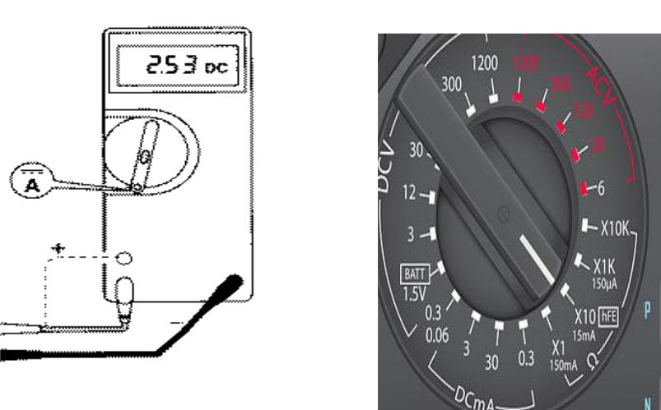

**RESISTANCE MEASUREMENT**

1. Connect the positive(red) test lead to the ‘V/mA’ jack socket and the negative(black) lead to the ‘COM’ jack socket.
2. Set the selector switch to the desired ‘OHM Ω’.
3. If the resistance to be measured ia part of a circuit, turn off the power and discharge all capacitors before measurement.
4. Connect the test leads to the circuit to be measured.
5. The resistance value should now appear on the digital display.
6. If the resistance to be measured is part of a circuit, turn off the power and discharge all capacitors before measurement.

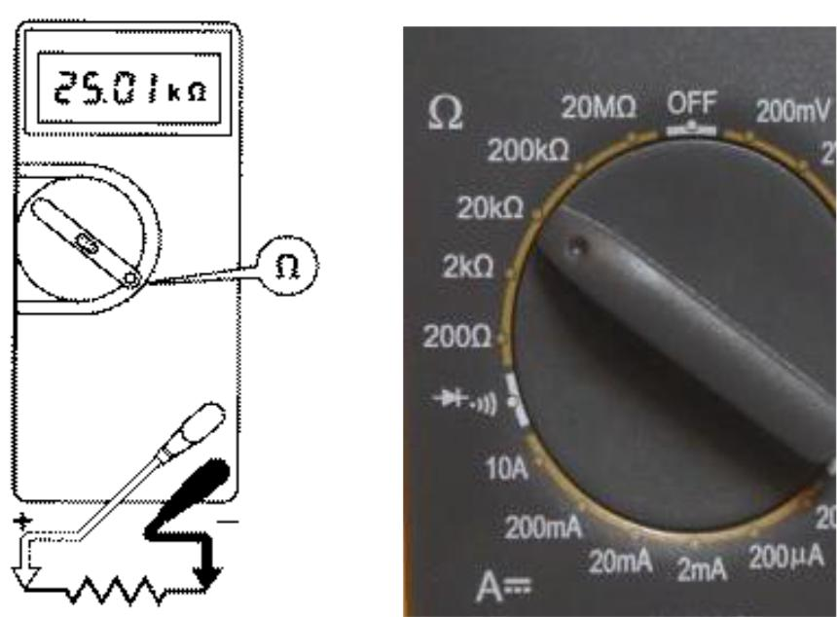

**CONTINUITY TEST**

This mode is used to check if two points are electrically connected. It is often used to verify connectors. If continuity exists (resistance less than 210 ohms), the beeper sounds continuously.

1. Connect the positive(red) test lead to the ‘V/mA’ jack socket and the negative(black) lead to the ‘COM’ jack socket.
2. Set the selector switch to the position.
3. Connect the test leads to two points of the circuit to be tested. If the resistence is Ohms the buzzer will sound.
4. If the resistance to be measured is part of a circuit, turn off the power and discharge all capacitors before measurement.

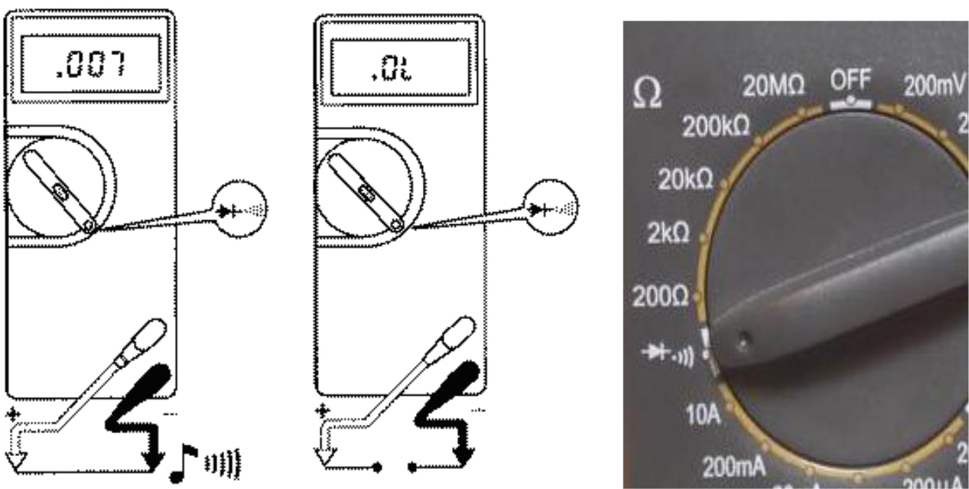

**DIODE TEST**

1. Connect the positive (red) test lead to the ‘V/mA’ jack socket and the negative(black) lead to the ‘COM’ jack socket.
2. Set the selector switch to the  position.
3. Connect the test leads to be measured.
4. Turn on the power to the circuit to be measured and the voltage value should

appear on the digital display.

